Combined Document for NXP for Flashing Building and Testing

BUILDING DOCUMENT

Building Document for EB Tresos

⚠️ Important Note
- Follow this document only if changes are required in the bootloader.
- The bootloader is already configured in the path mentioned below.
- Do not change memory addresses or configurations unless absolutely necessary. Any incorrect modification may crash the NXP board program.
- This document is provided only for reference and to outline the setup we have done in this project.

Bootloader Application for Cortex-M7 Cores
- Prepare the bootloader application specific to Cortex-M7 cores.
- Use the given images and configurations exactly as shown.
- Follow the same memory addresses as provided.
- Do not modify any addresses – they are project-specific and pre-validated.
Step-1 Load Configuration
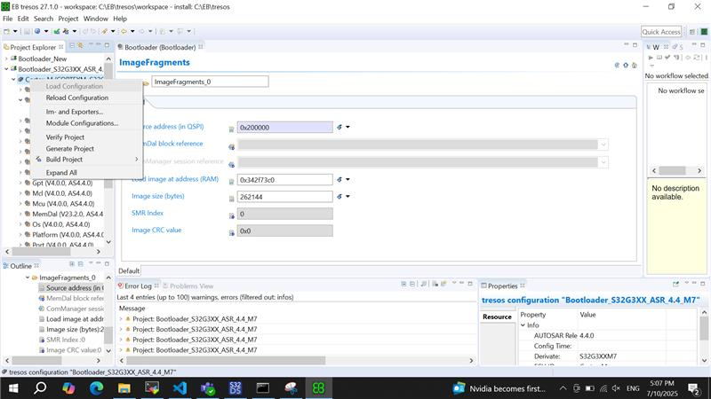

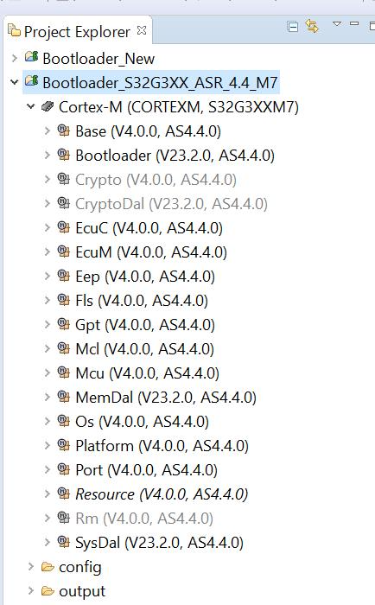

Double click on Bootloader and create below configurations
Boot Source click

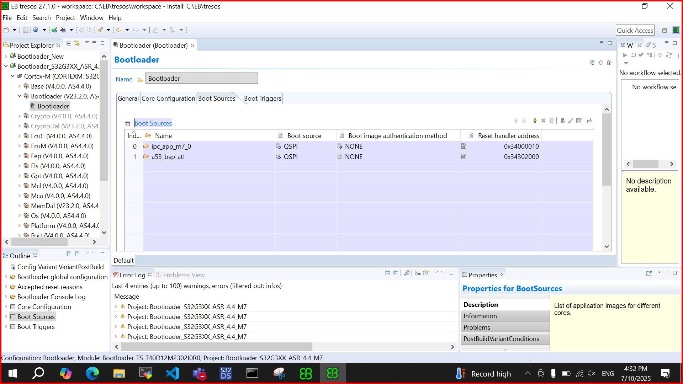
Core Configuration
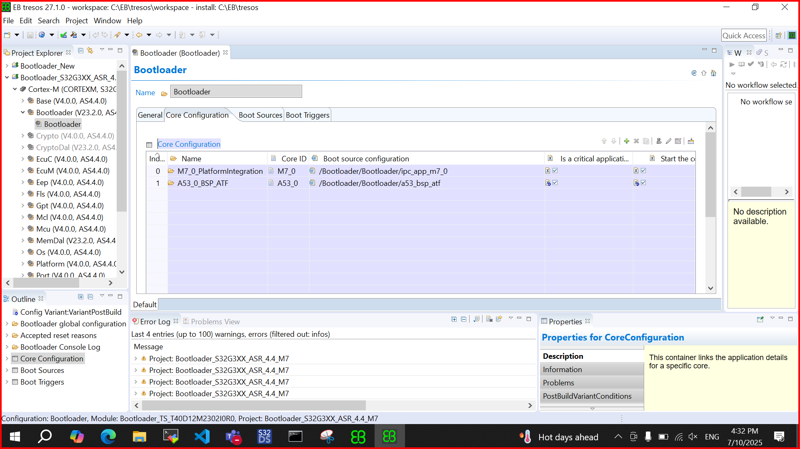

ImageFragment create
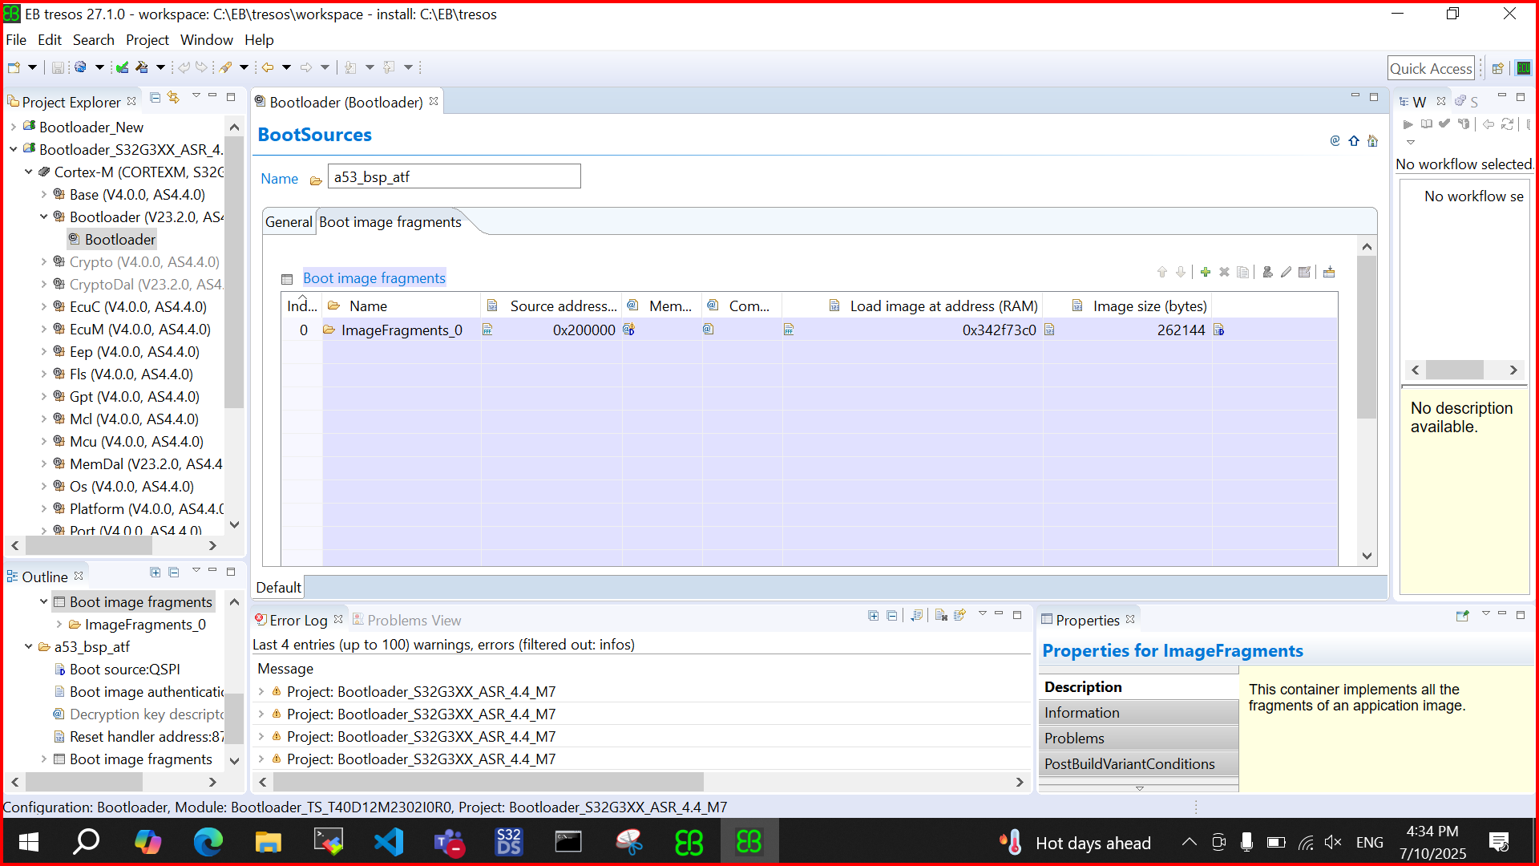
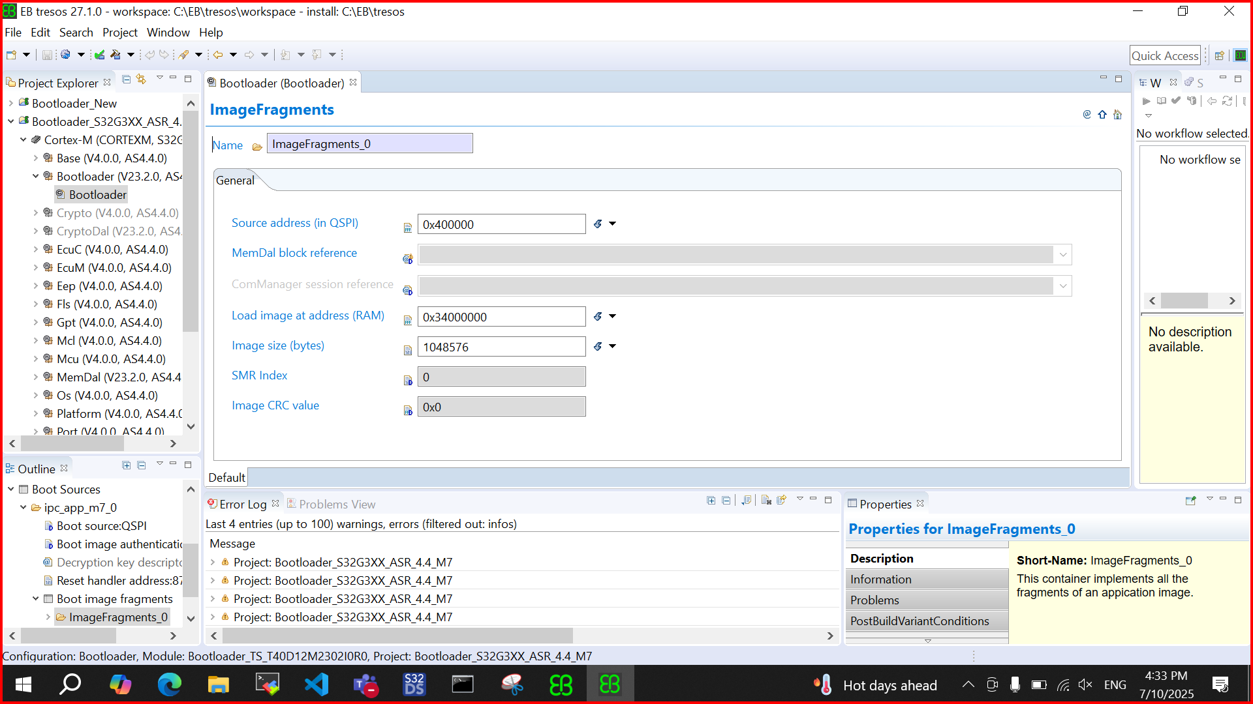

a53_bsp_atf double click and fill with below address
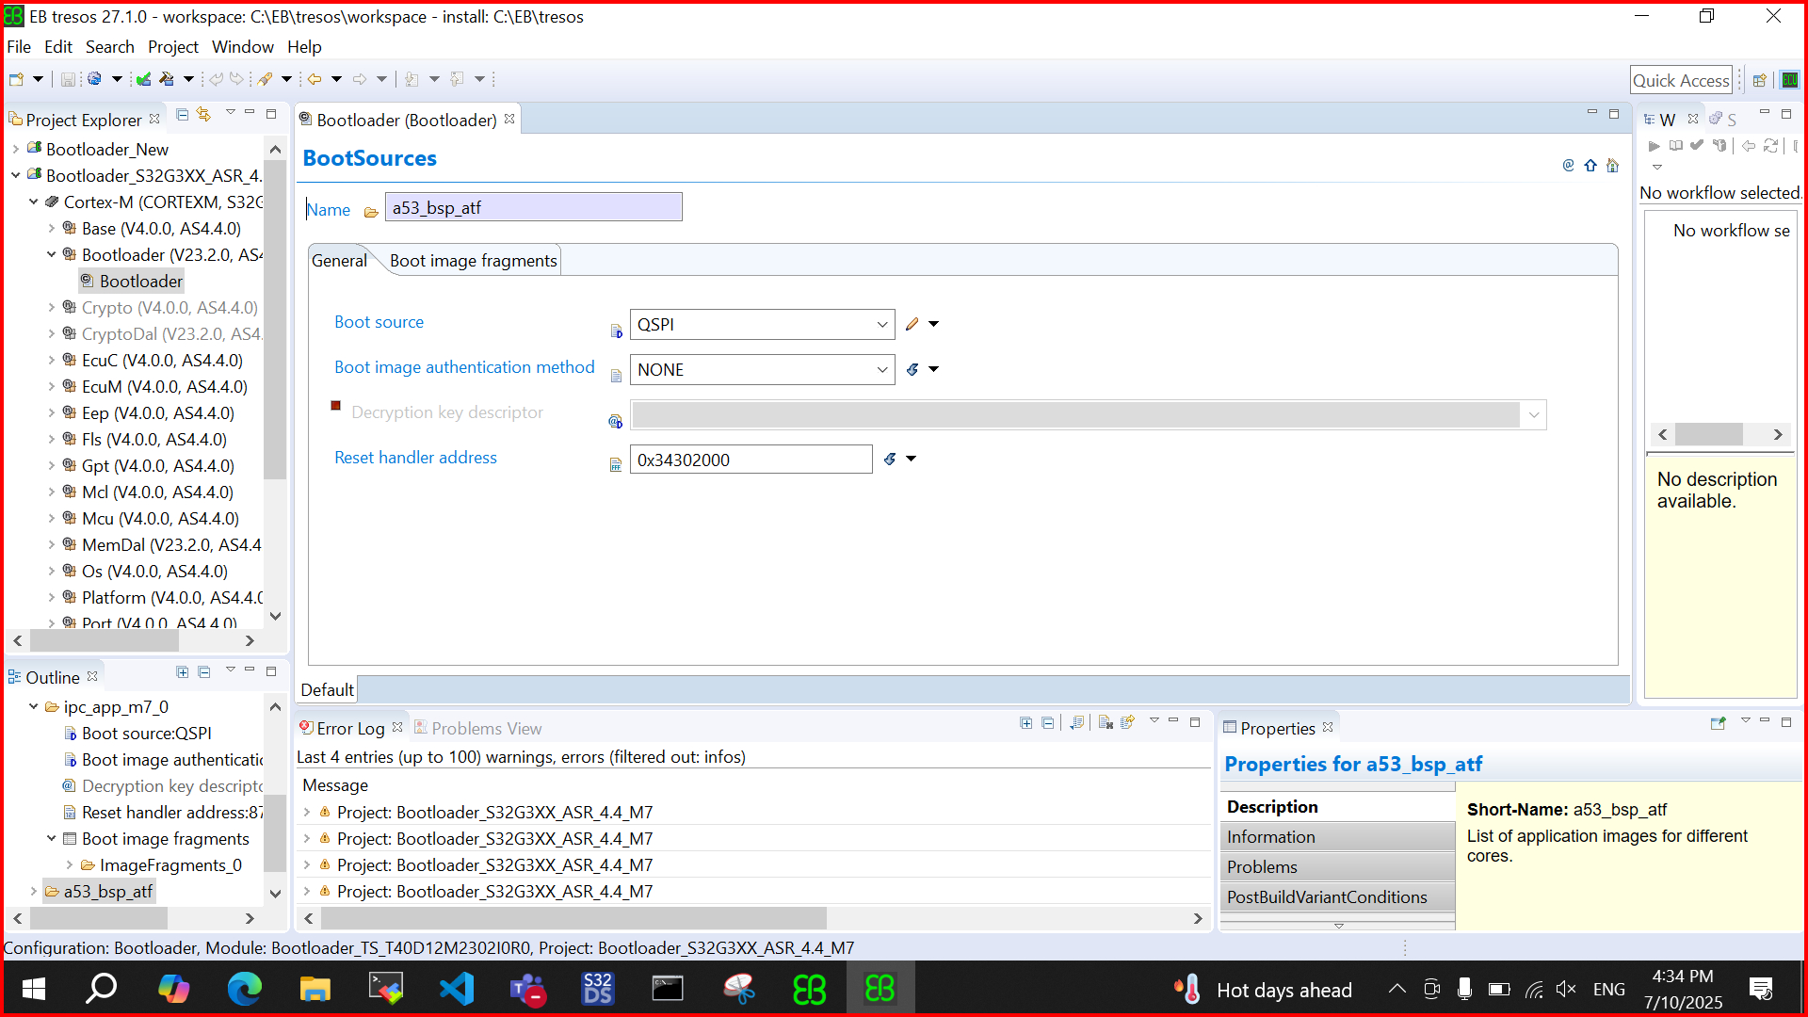

After all the setups Verify project and after verify generate it .

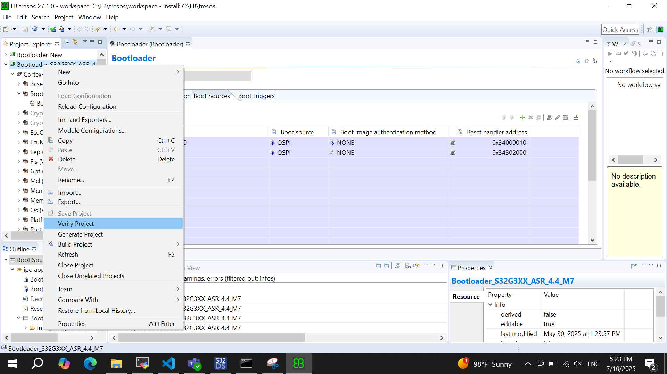

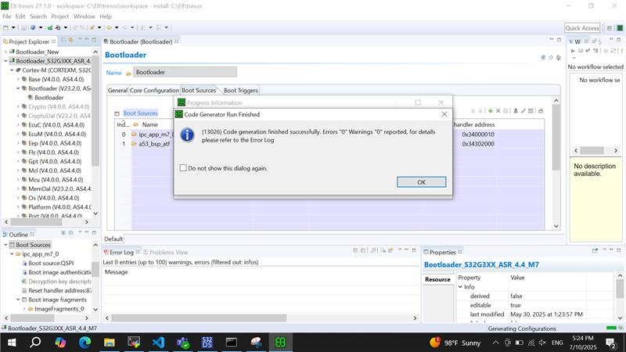

Build The Bootloader

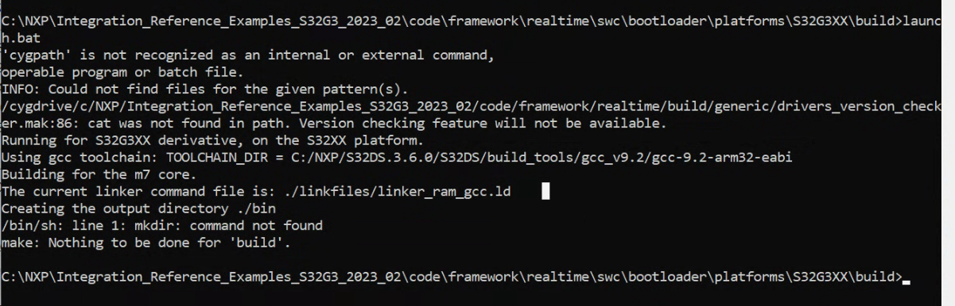

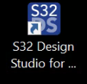
Building Document for NXP
step 1 : Lunch the S32 Design studio

Step 2 : Load below grey marked file

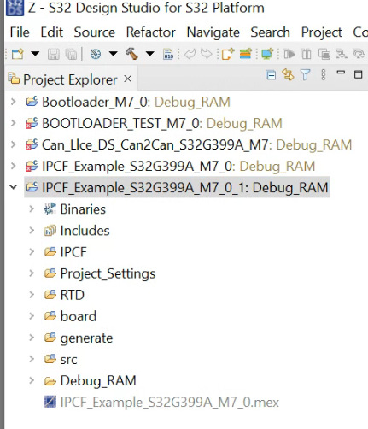

Step 3 : Build the code clicking below image

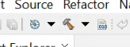
Step 4 : Generated binary file will be inside Debug_RAM folder

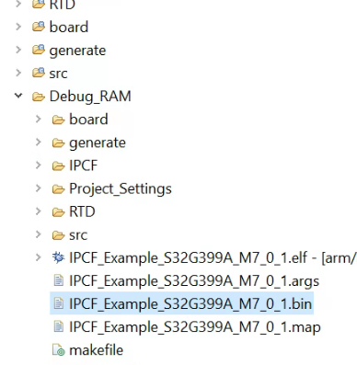
Step 5 : Generate S32G Boot Image Using S32DS IVT_TOOL

Click IVT like below image

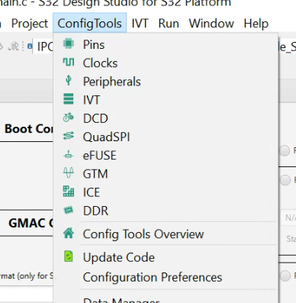

Step 6 : Configure all the blocks like below given image
BOOT Configuration : M7_0
Interface selection :
SPI Serial Flash
Configure QuadSPI parameters
paste this : C:\NXP\Integration_Reference_Examples_S32G3_2023_02\code\framework\realtime\swc\bootloader\platforms\S32G3XX\res\flash\S32G3XX_QuadSPI_133MHz_DDR_configuration.bin
Step 7 : DCD paste below path without any spaces
C:\NXP\Integration_Reference_Examples_S32G3_2023_02\code\framework\realtime\swc\bootloader\platforms\S32G3XX\res\flash\S32G3XX_QuadSPI_133MHz_DDR_configuration.bin
Step 8 : HSE paste below path
C:\NXP\HSE_FW_S32G2XX_0_2_51_0\hse\bin\rev2.1_s32g2xx_hse_fw_0.1.0_2.51.0_pb240404.bin.pink
addr :- 0x400 size :- 397664
HSE FW conf:-
0x61560
SysImage External Flash type : QSPI
Page size : 0x1000
Step 9 : Application Bootloader BOARD 1
C:\NXP\Integration_Reference_Examples_S32G3_2023_02\code\framework\realtime\swc\bootloader\platforms\S32G3XX\build\bin\Bootloader.bin

Start address : 0x77560 Size in bytes : 1049696

Step 10 : Application Boot Code image
Address : 0x34400000
Ram entry point
Address : 0x34500000
code length : 1049616
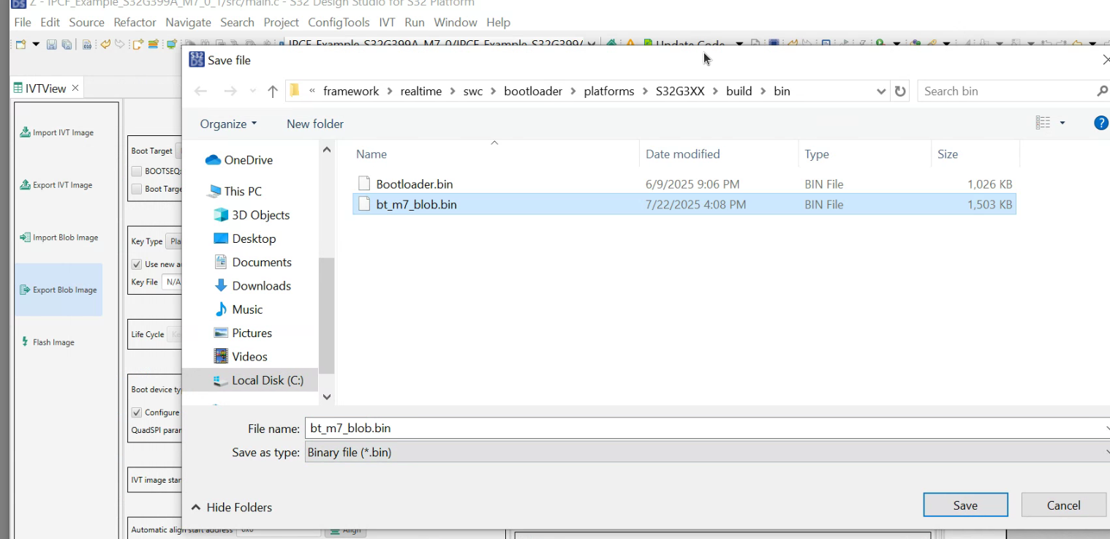
Click on export Blob Image

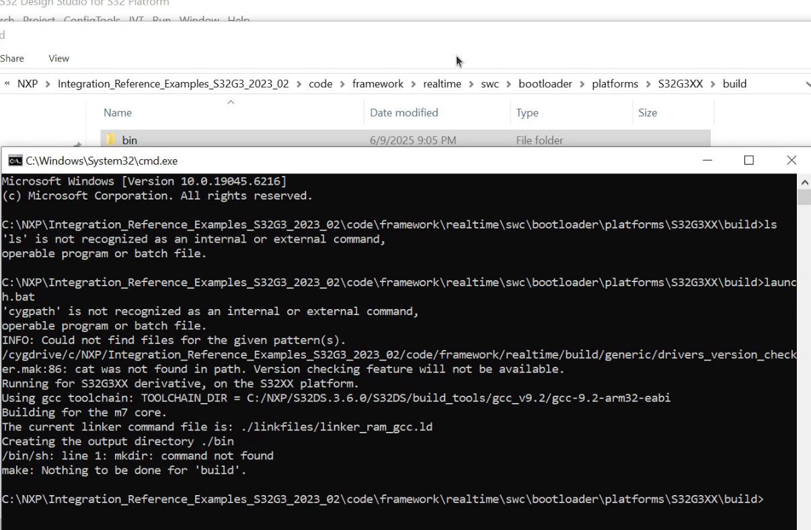
Final blob bin image generated path is C:\NXP\Integration_Reference_Examples_S32G3_2023_02\code\framework\realtime\swc\bootloader\platforms\S32G3XX\build\bin
If Bootloader.bin not found then build bootloader using following path
run script → launch.bat
# Flashing Guide for NXP S32G3 Board

This guide provides detailed instructions to flash the NXP S32G3 board (referred to as RDB2) and build the required applications on both Board1 and Board2. Follow the steps carefully to set up your environment, flash the images, and run the application.

## Prerequisites

- A laptop with administrative privileges (for `sudo` commands).
- S32 Flash Tool installed and accessible from the desktop.
- Serial terminal software (e.g., MobaXterm).
- SD card and USB-to-serial adapter.
- NXP S32G3 RDB2 board.
- Internet access to download required files.

---
Prebuid link : https://github.com/Hyconsoft-RND-Center/NXP_Board_Workspace.git
## Flashing Procedure

### Step 1: Download the U-Boot Image

The U-Boot image is common for both boards and is available locally or via a drive link:

- **Local Path on Laptop**: `C:\Users\hycon\Documents\pre-builds`
- **Download Link (if not available locally)**: [https://drive.google.com/drive/u/0/folders/1HXtAFqf1MlnWhvJq4s-B86SWi-ZvQ2vs]( https://drive.google.com/drive/u/0/folders/1HXtAFqf1MlnWhvJq4s-B86SWi-ZvQ2vs )

Download the image if it’s not already in the local path.

### Step 2: Flash the Image to the SD Card

1. Insert the SD card into your laptop.
2. Open a terminal and type the following command to identify your SD card device (e.g., `/dev/sdb`):
```bash
lsblk
```
- Note the device name (replace `/dev/sdb` with your SD card device if different).
3. Flash the base image:
```bash
sudo dd if=./fsl-image-ubuntu-s32g399ardb3.sdcard of=/dev/sdb bs=1M && sync
```
4. Flash the BL2 bootloader:
```bash
sudo dd if=bl2_w_dtb.s32 of=/dev/sdb skip=512 seek=512 iflag=skip_bytes oflag=seek_bytes conv=fsync,notrunc
```
5. Flash the FIP binary:
```bash
sudo dd if=fip.bin-sdcard of=/dev/sdb1 conv=fsync,notrunc
```
- Ensure the SD card is not mounted during this process to avoid errors.

### Step 3: Flash Bootloader and IPCF Using S32 Flash Tool

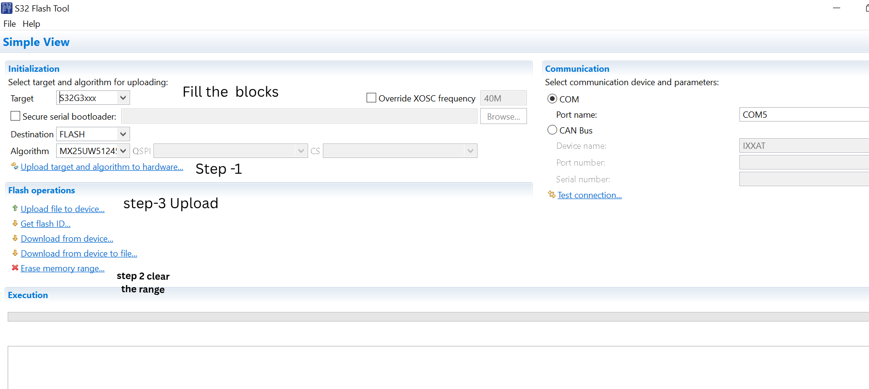

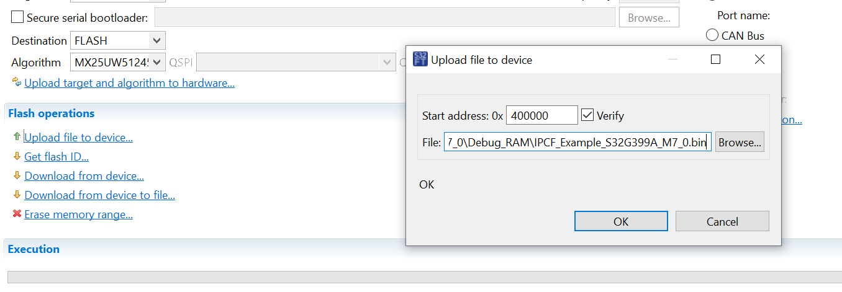
1. **Launch the Tool**:
- Double-click the S32 Flash Tool (S32FT) icon on your desktop to open it.

2. **Configure the Target**:
- Connect the RDB2 UART0 to your PC via a USB port.
- Set the COM port name (e.g., `COM4`—check your system for the correct port).
- Configure the RDB2 to Serial boot mode:
- SW10-1 = OFF
- SW10-2 = OFF
- Power on the RDB2.

3. **Upload the Algorithm**:
- In the S32 Flash Tool, upload the algorithm as prompted (Step 3 in the tool).

4. **Erase Memory**:
- Select "Erase memory range" and set the range from `0x0` to `0x800000`.
- Execute the erase command.

5. **Upload Files to Device BOARD1 and BOARD2 **:
- **Bootloader (M7)**:
- Start address: `0x000000`
- File location: `C:\NXP\Integration_Reference_Examples_S32G3_2023_02\code\framework\realtime\swc\bootloader\platforms\S32G3XX\build\bin\bt_m7_blob.bin`
- Press OK.
- **FIP Binary**:
- Start address: `0x200000`
- File location: Copy `fip.bin` and `fip.bin-sdcard` from `arm-trustedfirmware/build/s32g274ardb2/release` to the current folder. Use the newly built FIP image to replace the pre-built one.
- Press OK.
- **IPCF Application BOARD1**:
- Start address: `0x400000`
- File location: `C:\Users\hycon\Z\IPCF_Example_S32G399A_M7_0\Debug_RAM\IPCF_Example_S32G399A_M7_0.bin`
- Press OK.
BOARD2 :
follow the same above steps for Board2 only change is below bin
- **IPCF Application BOARD2**:
- Start address: `0x400000`
- File location: `C:\Users\hycon\NXP_S32G3_Project\IPCF_Example_S32G399A_M7_0\Debug_RAM\IPCF_Example_S32G399A_M7_0.bin`
- Press OK.
---

## Running the Application on NXP Board (RDB2)

Follow these steps to run the flashed application on the NXP S32G3 RDB2 board:

1. Insert the SD card into the RDB2 slot.
2. Set the RDB2 to boot from external NOR-Flash:
- SW10-1 = ON
- SW10-2 = OFF
- SW4 = All OFF

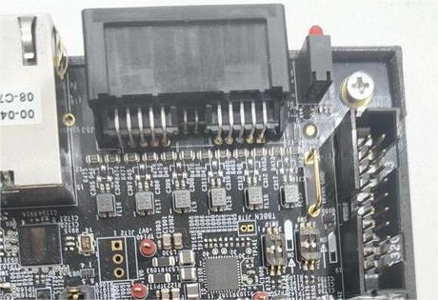

3. Connect the RDB2 UART0 to the PC USB port.
4. Launch a serial terminal (e.g., MobaXterm) on your PC:
- Baud rate: 115200
- Format: 8-n-1
5. Power on the RDB2. If successful, you will see the A53 booting log on the terminal.
6. After the kernel is up, enter `root` to log in.

---

## Building and Testing Procedures

### Step 1: Copy Workspace to Boards

Download and unzip the workspace files for Board1 and Board2 from the following link:
- **Drive Link**: [ https://drive.google.com/file/d/1ciW0JKQZWGmhSnNnWFU9lsJ3o1lXCQme/view?usp=drive_link ] ( https://drive.google.com/file/d/1ciW0JKQZWGmhSnNnWFU9lsJ3o1lXCQme/view?usp=drive_link ) link owner mr Jaeho jung
- Paste the `Workspace` folder into `/home/` on both Board1 and Board2.

### Step 2: Build Procedure for Board1

1. Log in to Board1 and navigate to the project directory:
```bash
cd /home/Workspace/git/sample_user/
```
2. Build the project:
```bash
colcon build --symlink-install --cmake-args -DCMAKE_BUILD_TYPE=Debug
```
- If the build fails, source the ROS Humble library:
```bash
source /opt/ros/humble/setup.bash
```
- Then retry the `colcon build` command.

### Step 3: Test Procedure for Board1

1. Navigate to the build directory:
```bash
cd /home/Workspace/git/sample_user/build/autoware_subscriber
```
2. Run the IPCF script or binary manually:
```bash
./ipc-shm-sample_uio
```

### Step 4: Build Procedure for Board2

1. Log in to Board2 and navigate to the build directory:
```bash
cd /home/workspace/git/sample_user/build
```
2. Build the project:
```bash
make
```

### Step 5: Run Procedure for Board2

1. Navigate to the build directory:
```bash
cd /home/workspace/git/sample_user/build
```
2. Run the application:
```bash
./ipc-shm-sample_uio
```

---

## Troubleshooting

- **SD card not detected**: Ensure the correct device name (e.g., `/dev/sdb`) is used and the card is not mounted.
- **Flashing fails**: Verify the RDB2 is in Serial boot mode and the COM port is correct.
- **Build errors**: Check that all dependencies (e.g., ROS Humble) are installed and sourced.

## Additional Notes

- Replace `COM4` with the COM port detected on your PC.
- Ensure the SD card is properly inserted and not in use during flashing.

GPU SERVER Setup

Below I have given GPU server Hard coded path you can change according to your path
colcon build --symlink-install --cmake-args -DCMAKE_BUILD_TYPE=Debug

cd install/autoware_subscriber/lib/autoware_subscriber/

unset AMENT_PREFIX_PATH
unset CMAKE_PREFIX_PATH
unset ROS_PACKAGE_PATH
unset PYTHONPATH

source /opt/ros/humble/setup.bash
export ROS_DOMAIN_ID=13
unset ROS_LOCALHOST_ONLY
export RMW_IMPLEMENTATION=rmw_cyclonedds_cpp

source /home/hyconsoft_rnd/actevia/eclipse_/eclipse/Workspace/CSMS_TTCN_Scripts-main/Autoware-tool-subscriber/install/setup.bash
cd /home/hyconsoft_rnd/actevia/eclipse_/eclipse/Workspace/CSMS_TTCN_Scripts-main/Autoware-tool-subscriber/build/autoware_subscriber/
./autoware_subscriber

RUN THE ROS BAG

unset AMENT_PREFIX_PATH
unset CMAKE_PREFIX_PATH
unset ROS_PACKAGE_PATH
unset PYTHONPATH
source /opt/ros/humble/setup.bash
export ROS_DOMAIN_ID=13
unset ROS_LOCALHOST_ONLY
export RMW_IMPLEMENTATION=rmw_cyclonedds_cpp
source /home/hyconsoft_rnd/actevia/eclipse_/eclipse/Workspace/CSMS_TTCN_Scripts-main/Autoware-tool-subscriber/install/setup.bash
ros2 bag play /home/hyconsoft_rnd/actevia/eclipse_/eclipse/Workspace/CSMS_TTCN_Scripts-main/14_LLCE_CAN_Protocol/ -r 0.2 -s sqlite3

QT Application ON Jetson

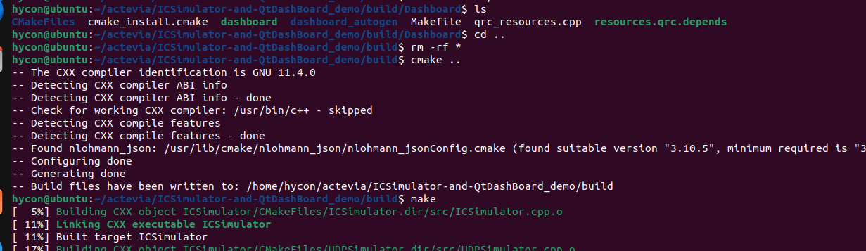

Location of the application
git location : https://github.com/Hyconsoft-RND-Center/NXP_Board_Workspace/tree/main/ICSimulator-and-QtDashBoard_demo
1. Do ssh -i ~/.ssh/json_02_prv_key hycon@211.208.42.20 -p 16222
2.cd ~/actevia/ICSimulator-and-QtDashBoard_demo/
3. mkdir build && cd build
4. cmake ..
5.make
6.cd ~/actevia/ICSimulator-and-QtDashBoard_demo/build/

7. run the binary ./Dashboard/dashboard 192.168.0.15 192.168.0.48 5000
First IP is Jetson IP and Second ip is GPU server IP (where you Autoware_subscriber is running) post is 5000
TEST METHOD
Connect Jetson,GPU server ,BOARD1 and Board2 according to architecture diagram given .(ethernet , can , lin ,flexray)
we can test 2 method
1. Mannual trigger
2. TTCN triggered
1. Mannual Trigger (I am using hardcodeed path )
GPU SERVER:
1. unset AMENT_PREFIX_PATH
unset CMAKE_PREFIX_PATH
unset ROS_PACKAGE_PATH
unset PYTHONPATH

source /opt/ros/humble/setup.bash
export ROS_DOMAIN_ID=13
unset ROS_LOCALHOST_ONLY
export RMW_IMPLEMENTATION=rmw_cyclonedds_cpp

source /home/hyconsoft_rnd/actevia/eclipse_/eclipse/Workspace/CSMS_TTCN_Scripts-main/Autoware-tool-subscriber/install/setup.bash
cd /home/hyconsoft_rnd/actevia/eclipse_/eclipse/Workspace/CSMS_TTCN_Scripts-main/Autoware-tool-subscriber/build/autoware_subscriber/
./autoware_subscriber

2. RUN ROSBAG
unset AMENT_PREFIX_PATH
unset CMAKE_PREFIX_PATH
unset ROS_PACKAGE_PATH
unset PYTHONPATH
source /opt/ros/humble/setup.bash
export ROS_DOMAIN_ID=13
unset ROS_LOCALHOST_ONLY
export RMW_IMPLEMENTATION=rmw_cyclonedds_cpp
source /home/hyconsoft_rnd/actevia/eclipse_/eclipse/Workspace/CSMS_TTCN_Scripts-main/Autoware-tool-subscriber/install/setup.bash
ros2 bag play /home/hyconsoft_rnd/actevia/eclipse_/eclipse/Workspace/CSMS_TTCN_Scripts-main/14_LLCE_CAN_Protocol/ -r 0.2 -s sqlite3
3. (Optional) if you want Injection Publisher then run this
unset AMENT_PREFIX_PATH
unset CMAKE_PREFIX_PATH
unset ROS_PACKAGE_PATH
unset PYTHONPATH

source /opt/ros/humble/setup.bash
export ROS_DOMAIN_ID=13
unset ROS_LOCALHOST_ONLY
export RMW_IMPLEMENTATION=rmw_cyclonedds_cpp

source /home/hyconsoft_rnd/actevia/eclipse_/eclipse/Workspace/CSMS_TTCN_Scripts-main/Autoware-tool-subscriber/install/setup.bash
ros2 launch injection_publisher injection_publisher.launch.py
4. Run the python script for kill all the process
python3 /home/hyconsoft_rnd/actevia/eclipse_/eclipse/Workspace/CSMS_TTCN_Scripts-main/14_LLCE_CAN_Protocol/autoware_shutdown.py
BOARD1 SetUP :
cd /home/Workspace/git/sample_user/build/autoware_subscriber
./ipc-shm-sample_uio
Board2 SetUP :
cd /home/workspace/git/sample_user/build
./ipc-shm-sample_uio
JETSON BOARD SETUP FOR QT
cd /home/hycon/actevia/ICSimulator-and-QtDashBoard_demo/build
run below on jetson
./Dashboard/dashboard 192.168.0.15 192.168.0.48 5000
check ip GPU server eth0 192.168.0.48
Jetson eth0 192.168.0.15

RESULT VERIFICATION
in GPU SERVER run this
python3 /home/hyconsoft_rnd/actevia/eclipse_/eclipse/Workspace/CSMS_TTCN_Scripts-main/14_LLCE_CAN_Protocol/testcase_result.py
RUN the below for move in TEST folder
python3 /home/dell/Desktop/projects/hycon/git/CSMS_TTCN_Scripts/14_LLCE_CAN_Protocol/move_test_log.py
your lattest log can be found here ~/actevia/eclipse_/eclipse/Workspace/CSMS_TTCN_Scripts-main/Autoware-tool-subscriber/All_logs
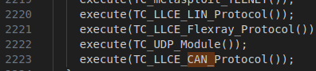
you can Verify in Consolidated report for any packet drop
METHOD 2 - TTCN SETUP
Clone this and checkout actevia branch
https://github.com/Hyconsoft-RND-Center/CSMS_TTCN_Scripts.git
Otherwise use TTCN laptop in our workspace no need to clone
Step -1 you will find ttcn script in below path there CAN,LIN,FlexRay,UDP test are mentioned
shell/src/PipeTest.ttcn
Step -2 Configured the test want to do by modify below section
in control funtion at the end

Step -3 Please check with Mr Jaeho as I am not able to access ttcn laptop he can guide how to run this script on ttcn this is same as your existing ttcn configuration only change is above 4 modules were added

