# Flashing Guide for NXP S32G3 Board

This guide provides detailed instructions to flash the NXP S32G3 board (referred to as RDB2) and build the required applications on both Board1 and Board2. Follow the steps carefully to set up your environment, flash the images, and run the application.

## Prerequisites

- A laptop with administrative privileges (for `sudo` commands).
- S32 Flash Tool installed and accessible from the desktop.
- Serial terminal software (e.g., MobaXterm).
- SD card and USB-to-serial adapter.
- NXP S32G3 RDB2 board.
- Internet access to download required files.

---
Prebuid link : https://github.com/Hyconsoft-RND-Center/NXP_Board_Workspace.git
## Flashing Procedure

### Step 1: Download the U-Boot Image

The U-Boot image is common for both boards and is available locally or via a drive link:

- **Local Path on Laptop**: `C:\Users\hycon\Documents\pre-builds`
- **Download Link (if not available locally)**: [https://drive.google.com/drive/u/0/folders/1HXtAFqf1MlnWhvJq4s-B86SWi-ZvQ2vs]( https://drive.google.com/drive/u/0/folders/1HXtAFqf1MlnWhvJq4s-B86SWi-ZvQ2vs )

Download the image if it’s not already in the local path.

### Step 2: Flash the Image to the SD Card

1. Insert the SD card into your laptop.
2. Open a terminal and type the following command to identify your SD card device (e.g., `/dev/sdb`):
```bash
lsblk
```
- Note the device name (replace `/dev/sdb` with your SD card device if different).
3. Flash the base image:
```bash
sudo dd if=./fsl-image-ubuntu-s32g399ardb3.sdcard of=/dev/sdb bs=1M && sync
```
4. Flash the BL2 bootloader:
```bash
sudo dd if=bl2_w_dtb.s32 of=/dev/sdb skip=512 seek=512 iflag=skip_bytes oflag=seek_bytes conv=fsync,notrunc
```
5. Flash the FIP binary:
```bash
sudo dd if=fip.bin-sdcard of=/dev/sdb1 conv=fsync,notrunc
```
- Ensure the SD card is not mounted during this process to avoid errors.

### Step 3: Flash Bootloader and IPCF Using S32 Flash Tool

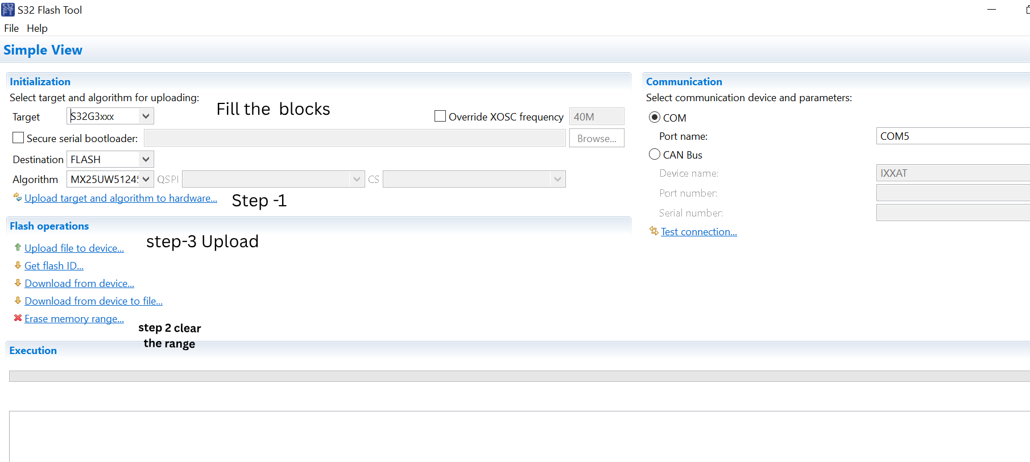

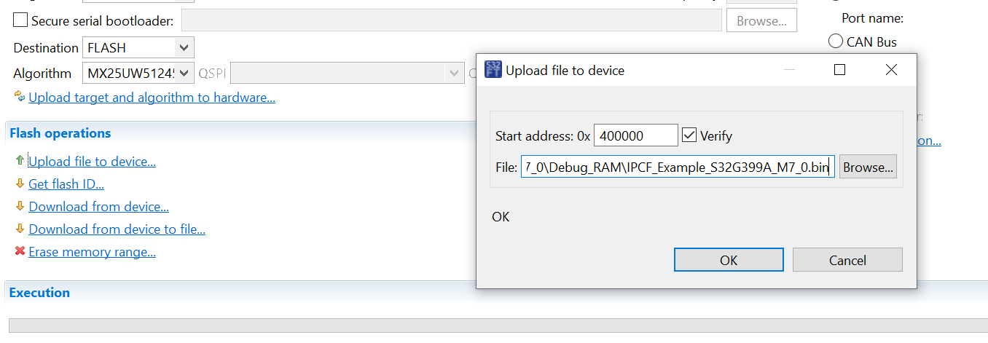
1. **Launch the Tool**:
- Double-click the S32 Flash Tool (S32FT) icon on your desktop to open it.

2. **Configure the Target**:
- Connect the RDB2 UART0 to your PC via a USB port.
- Set the COM port name (e.g., `COM4`—check your system for the correct port).
- Configure the RDB2 to Serial boot mode:
- SW10-1 = OFF
- SW10-2 = OFF
- Power on the RDB2.

3. **Upload the Algorithm**:
- In the S32 Flash Tool, upload the algorithm as prompted (Step 3 in the tool).

4. **Erase Memory**:
- Select "Erase memory range" and set the range from `0x0` to `0x800000`.
- Execute the erase command.

5. **Upload Files to Device BOARD1 and BOARD2 **:
- **Bootloader (M7)**:
- Start address: `0x000000`
- File location: `C:\NXP\Integration_Reference_Examples_S32G3_2023_02\code\framework\realtime\swc\bootloader\platforms\S32G3XX\build\bin\bt_m7_blob.bin`
- Press OK.
- **FIP Binary**:
- Start address: `0x200000`
- File location: Copy `fip.bin` and `fip.bin-sdcard` from `arm-trustedfirmware/build/s32g274ardb2/release` to the current folder. Use the newly built FIP image to replace the pre-built one.
- Press OK.
- **IPCF Application BOARD1**:
- Start address: `0x400000`
- File location: `C:\Users\hycon\Z\IPCF_Example_S32G399A_M7_0\Debug_RAM\IPCF_Example_S32G399A_M7_0.bin`
- Press OK.
BOARD2 :
follow the same above steps for Board2 only change is below bin
- **IPCF Application BOARD2**:
- Start address: `0x400000`
- File location: `C:\Users\hycon\NXP_S32G3_Project\IPCF_Example_S32G399A_M7_0\Debug_RAM\IPCF_Example_S32G399A_M7_0.bin`
- Press OK.
---

## Running the Application on NXP Board (RDB2)

Follow these steps to run the flashed application on the NXP S32G3 RDB2 board:

1. Insert the SD card into the RDB2 slot.
2. Set the RDB2 to boot from external NOR-Flash:
- SW10-1 = ON
- SW10-2 = OFF
- SW4 = All OFF

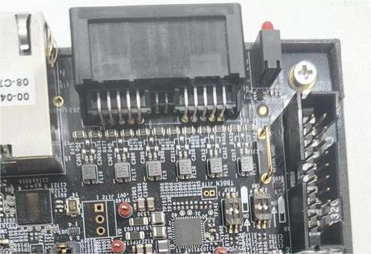

3. Connect the RDB2 UART0 to the PC USB port.
4. Launch a serial terminal (e.g., MobaXterm) on your PC:
- Baud rate: 115200
- Format: 8-n-1
5. Power on the RDB2. If successful, you will see the A53 booting log on the terminal.
6. After the kernel is up, enter `root` to log in.

---

## Building and Testing Procedures

### Step 1: Copy Workspace to Boards

Download and unzip the workspace files for Board1 and Board2 from the following link:
- **Drive Link**: [ https://drive.google.com/file/d/1ciW0JKQZWGmhSnNnWFU9lsJ3o1lXCQme/view?usp=drive_link ] ( https://drive.google.com/file/d/1ciW0JKQZWGmhSnNnWFU9lsJ3o1lXCQme/view?usp=drive_link ) link owner mr Jaeho jung
- Paste the `Workspace` folder into `/home/` on both Board1 and Board2.

### Step 2: Build Procedure for Board1

1. Log in to Board1 and navigate to the project directory:
```bash
cd /home/Workspace/git/sample_user/
```
2. Build the project:
```bash
colcon build --symlink-install --cmake-args -DCMAKE_BUILD_TYPE=Debug
```
- If the build fails, source the ROS Humble library:
```bash
source /opt/ros/humble/setup.bash
```
- Then retry the `colcon build` command.

### Step 3: Test Procedure for Board1

1. Navigate to the build directory:
```bash
cd /home/Workspace/git/sample_user/build/autoware_subscriber
```
2. Run the IPCF script or binary manually:
```bash
./ipc-shm-sample_uio
```

### Step 4: Build Procedure for Board2

1. Log in to Board2 and navigate to the build directory:
```bash
cd /home/workspace/git/sample_user/build
```
2. Build the project:
```bash
make
```

### Step 5: Run Procedure for Board2

1. Navigate to the build directory:
```bash
cd /home/workspace/git/sample_user/build
```
2. Run the application:
```bash
./ipc-shm-sample_uio
```

---

## Troubleshooting

- **SD card not detected**: Ensure the correct device name (e.g., `/dev/sdb`) is used and the card is not mounted.
- **Flashing fails**: Verify the RDB2 is in Serial boot mode and the COM port is correct.
- **Build errors**: Check that all dependencies (e.g., ROS Humble) are installed and sourced.

## Additional Notes

- Replace `COM4` with the COM port detected on your PC.
- Ensure the SD card is properly inserted and not in use during flashing.

