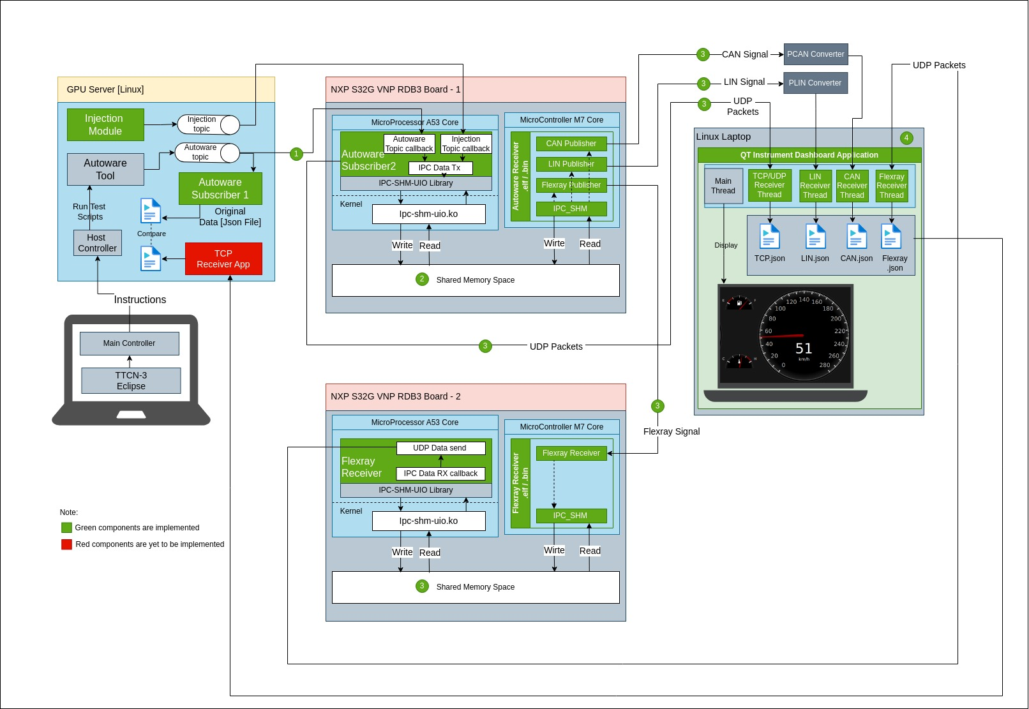
Hardware Setup
1. Jetson Board
2. 2 numbers of NXP board
3. Laptop installed with TTCN
4.Jtag cable connect laptop and NXP Board1 or Board2 which you want to debug
5.Connect all with Single Local network (ethernet) (Board1,Board2,laptop,Jetson)
6. CAN Connect from BOARD1 to other end Jetson where QT run
7 . Same way connect LIN also Board1 to jetson.
8.Configure CAN , LIN in Jetson
sudo ip link set can2 type can bitrate 500000 dbitrate 2000000 fd on
sudo ip link set up can2
lin start slave 9600 /dev/plin0
lin set id-filter all-opened /dev/plin0
9. Connect Flexray between Board1 and other end to Board2
10. 2 sd card 32 GB each required for boot board

