QT Application ON Jetson

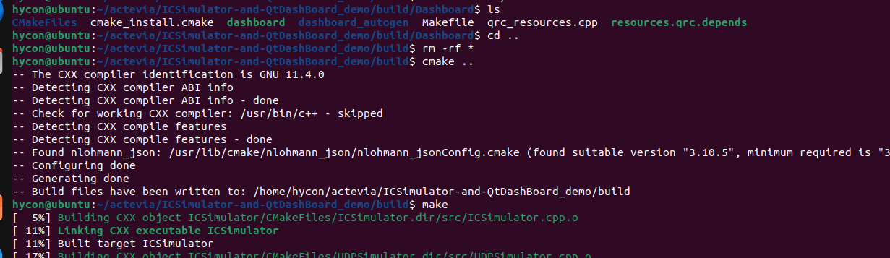

Location of the application
git location : https://github.com/Hyconsoft-RND-Center/NXP_Board_Workspace/tree/main/ICSimulator-and-QtDashBoard_demo
1. Do ssh -i ~/.ssh/json_02_prv_key hycon@211.208.42.20 -p 16222
2.cd ~/actevia/ICSimulator-and-QtDashBoard_demo/
3. mkdir build && cd build
4. cmake ..
5.make
6.cd ~/actevia/ICSimulator-and-QtDashBoard_demo/build/

7. run the binary ./Dashboard/dashboard 192.168.0.15 192.168.0.48 5000
First IP is Jetson IP and Second ip is GPU server IP (where you Autoware_subscriber is running) post is 5000

