Auto-Scaling & Multi-Tenancy on Kubernetes
How the Kiosk-QA Platform Isolates Customers and Scales on Google Kubernetes Engine

Document Title | Haibotix Agentic SDLC Platform — Kubernetes Scaling & Multi-Tenancy
Version | 1.0
Date | September 2026
Prepared by | Haibotix — Solutions Engineering
Classification | Customer Confidential

1 Purpose
This note answers a single question the team is asked in customer conversations: is the platform future-ready for Kubernetes-style auto-scaling and multi-tenancy with isolation between customers and their applications, and how much of that is our responsibility versus the cloud provider's (for example Google Kubernetes Engine, GKE)?
The short answer is that it is a shared responsibility, and both halves are already built into the cloud-agnostic edition of the platform. GKE supplies the scaling and network-isolation machinery; the application supplies the statelessness and the customer-data isolation that the platform — not the cloud — must enforce. Nothing here requires a rewrite; the capabilities described are present and config-gated today.
2 Two Independent Axes of Separation
“Isolation between customer apps” combines two different ideas. Keeping them separate makes the design easy to reason about:
Axis | Separates | Mechanism | When it is needed
app_id | Different applications within one customer | The app knowledge-graph and every test plan are scoped per app_id. | Always — even a single customer with many apps.
tenant_id | One customer organisation from another | Every database row, storage object and live channel is stamped and filtered by tenant_id. | Only when multiple customers share infrastructure (pooled SaaS).

Example 1 (one customer, ten apps) needs only app_id separation — it runs single-tenant, identical to the current deployment. Example 2 (ten customers, five apps each) additionally turns on tenant_id isolation.
3 Division of Responsibility — GKE vs. the Platform
GKE provides the mechanism; the platform must be built to exploit it. The table shows where each responsibility lands, and the current status on our side.
Concern | Google Kubernetes Engine handles | The platform must provide (status)
Pod auto-scaling | Runs the Horizontal Pod Autoscaler; schedules pods | An HPA manifest + stateless, horizontally-scalable pods — DONE (API HPA + Service; state externalised)
Node auto-scaling | Cluster Autoscaler adds/removes VMs on demand | Correct CPU/memory requests so GKE can bin-pack — present; tune per load
Independent tier scaling | Scales each Deployment separately | Separate API and worker Deployments with a queue between them — DONE (worker role + Redis queue)
Real-time across replicas | Load-balances client connections | Cross-replica fan-out so any pod serves any client — DONE (Redis pub/sub WebSocket; no sticky sessions)
Network isolation | Enforces NetworkPolicy, per-namespace RBAC and quotas | We choose the topology (pooled vs. namespace-per-customer) — DONE (manifests + kustomize)
Customer-data isolation | Nothing — GKE never sees your rows | tenant_id on every row + enforced query filter + tenant-prefixed blobs + tenant-scoped channels — DONE

The decisive line: GKE cannot isolate customer data for you. Two customers sharing one database are isolated only because the application stamps and filters tenant_id on every read and write.
4 What the Platform Already Provides
4.1 Built for horizontal scale
- Stateless services. Pods are stateless; all durable state lives in Postgres, object storage and Redis — so any replica is interchangeable and the platform scales out cleanly.
- API / worker split. The API tier and the test-execution worker tier are separate Deployments connected by a job queue, so browser-heavy test execution scales independently of the lightweight API.
- Cross-replica realtime. Live status is published to a shared bus and delivered by whichever replica holds the operator’s connection — removing the need for sticky sessions and making the console correct across many replicas.
4.2 Built for tenant isolation (config-gated)
- Row-level. Every business table carries a tenant_id; a central database rule adds a tenant filter to every read and stamps every write, so no query site can accidentally leak across tenants.
- Blob-level. Screenshots, knowledge graphs, plans and results are written under a per-tenant object-storage prefix.
- Realtime & memory. Live channels and reusable exploration memory are namespaced per tenant.
- Identity. The tenant is resolved per request from a signed token claim (with a header fallback), so identity is carried end-to-end.
All tenant behaviour is off by default: single-tenant runs are byte-identical to the original local product, so enabling multi-tenancy introduces no regression for existing single-customer deployments.
5 Two Deployment Topologies
The same container image and the same configuration keys support two go-to-market models. Only the isolation boundary changes.
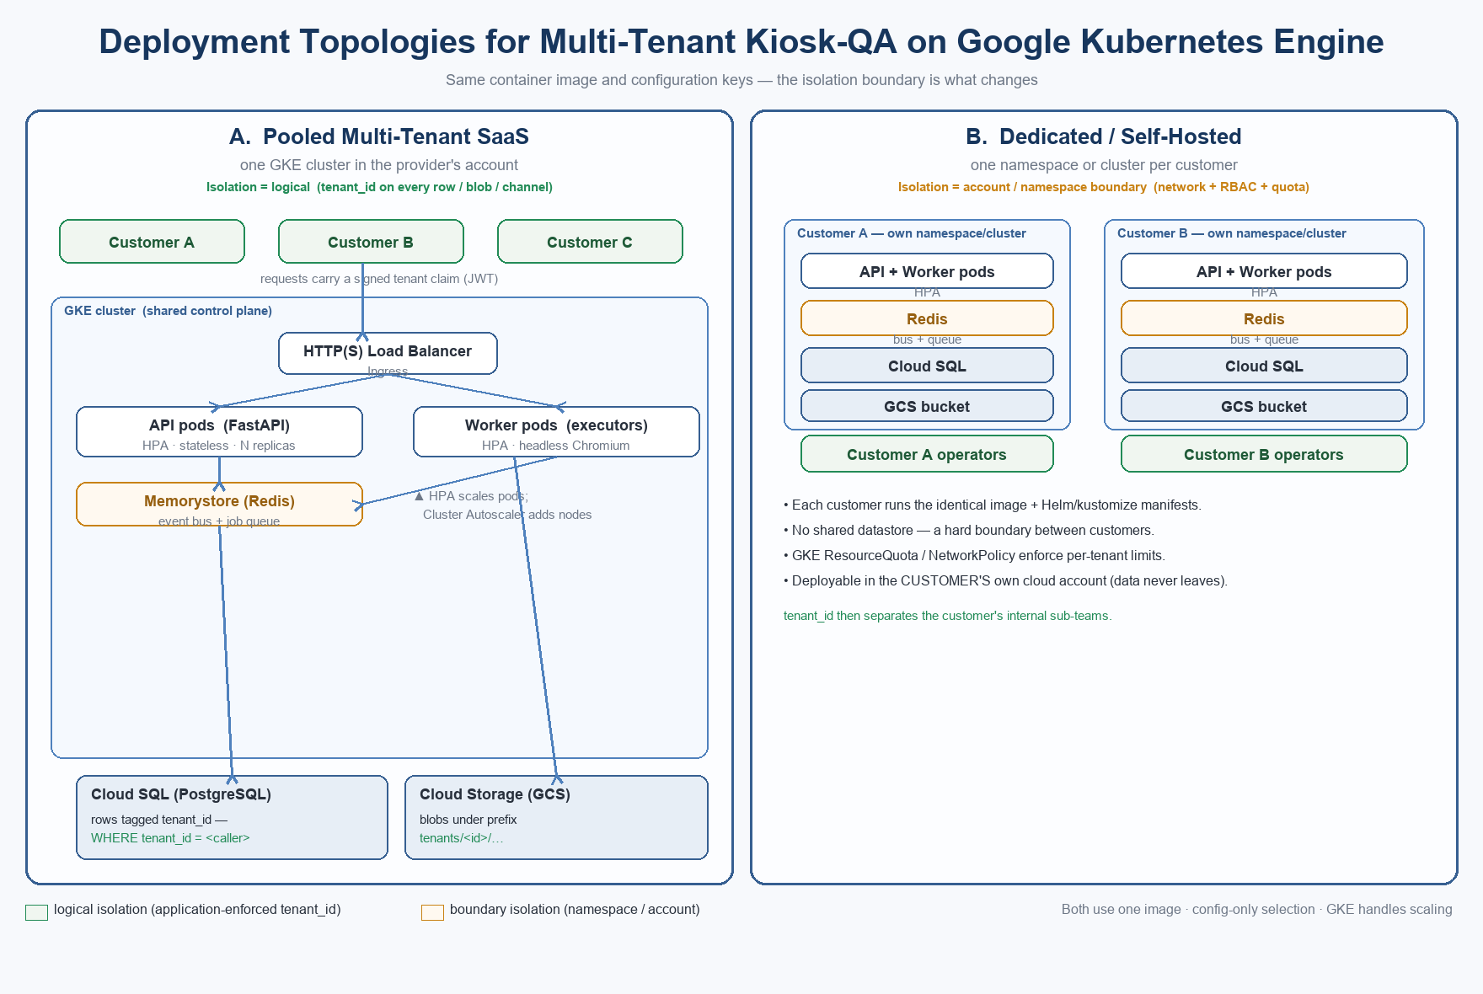
Figure 1 — Pooled multi-tenant SaaS (logical isolation) vs. dedicated / self-hosted (boundary isolation).
5.1 Pooled multi-tenant SaaS
All customers run in one GKE cluster in our account. Isolation is logical: tenant_id-leading keys and rows, per-tenant object prefixes and per-tenant channels. This is the cheapest to operate and gives the best cost-per-application as the programme grows, because the control plane, load balancer and managed datastores are shared and amortised across every tenant.
5.2 Dedicated / self-hosted
Each customer gets its own namespace, or its own cluster in its own cloud account. Isolation is the account or namespace boundary itself, enforced by GKE NetworkPolicy and ResourceQuota; tenant_id then only separates that customer’s internal sub-teams. This is what makes a fully customer-hosted deployment feasible — the same image and manifests run unchanged in the customer’s own account, so their data never leaves it.
6 The Two Worked Examples
6.1 One customer, ten applications
Needs no multi-tenancy. The ten applications are separated by app_id — each has its own knowledge graph, its own cached plans and its own evidence. If the customer wants all ten tested at once, the worker tier’s HPA scales out worker pods and the queue distributes the runs. Nothing new is required in the application.
6.2 Ten customers, five applications each
Turns on tenant isolation. In the pooled model, the fifty applications share one cluster and are kept apart by tenant_id on every row, object and channel. In the dedicated model, each customer runs the identical image in its own namespace or account. Either way the platform, not GKE, guarantees that one customer can never read another’s data.
7 How Auto-Scaling Behaves in Practice
- Horizontal Pod Autoscaler adds and removes API and worker pods based on load (CPU, or a queue-depth signal), so a burst of test runs is absorbed by more workers and released afterward.
- Cluster Autoscaler adds and removes VM nodes underneath the pods, so the cluster grows only while work is queued and shrinks back when idle — keeping the compute bill proportional to activity.
- Cost shape: because steady-state test execution uses cached plans and local matching with no AI calls, scaling out affects compute hours far more than AI cost.
8 Honest Gaps & Hardening Roadmap
Read and write isolation is complete. Before calling the pooled multi-tenant mode fully production-grade, four items remain — none affects single-tenant deployments, which are fully covered:
Item | Status / plan
Per-tenant resource quotas (fairness) | In the dedicated model GKE ResourceQuota covers this; in the pooled model add a per-tenant concurrency / queue-depth cap so one busy customer cannot starve the shared worker pool.
Composite unique keys on the pooled database | Enforced on PostgreSQL (the pooled target); local SQLite does not enforce cross-tenant key reuse.
Parallel-orchestrator path at scale | The multi-robot supervisor rebinds tenant per worker; exercise it under multi-tenant load.
Node right-sizing | Set CPU/memory requests and limits per profile so Cluster Autoscaler bin-packs efficiently.

9 Summary
The architecture is future-ready and cloud-compatible. Stateless pods, externalised state, horizontal and node auto-scaling, independent API and worker tiers, cross-replica realtime, and code-enforced tenant isolation are all in place. GKE supplies the scaling and network machinery; the platform supplies the statelessness and the data isolation that the cloud cannot. Example 1 works today with no flags; example 2 works by enabling multi-tenancy plus the small hardening list above — chiefly per-tenant quotas for the pooled model.

