Production Design Reference
  - Retail Product Station (RPS) and Value-Pass SmartCard Station (VPS)
Document ID | RPS-VPS-SDD-001
Version / Status | 1.0 / Baseline for GraphRAG ingestion
System | Retail Product Station (RPS) and Value-Pass SmartCard Station (VPS)
Source baseline | main branch implementation inspected on 2026-08-26

1. Design Purpose
This Software Design Description documents the actual main-branch implementation and supplies deterministic links from requirements and tests to code. It is intentionally explicit about symbols, state ownership, storage keys, endpoints, event sequences, and failure boundaries so a GraphRAG defect-analysis agent can retrieve a narrow, auditable repair context.

2. Architectural Overview
Frontend | React 19 + TypeScript + Vite. Most application orchestration and screen components are in src/App.tsx.
RPS root | src/App.tsx::App. Default browser mode; owns user, screen, cart, payment, order, popup, delay, and runtime configuration state.
VPS root | src/App.tsx::ValuePassSmartCardStationApp. Selected by legacy kiosk query aliases card-station or kiosk-1.
Shared data adapter | src/lib/storage.ts. Synchronous localStorage API with optional asynchronous refresh/write-through to the shared card service.
Shared service | card-service/server.js on port 4000; JSON persistence in card-service/cards.json.
Reader bridge | card-reader-bridge/src/server.js on port 4200 plus direct keyboard-wedge capture in TapCardScreen/VPS.
Automation contract | Stable data-testid attributes, STATUS text, typed Screen values, and configurable issue scenarios.
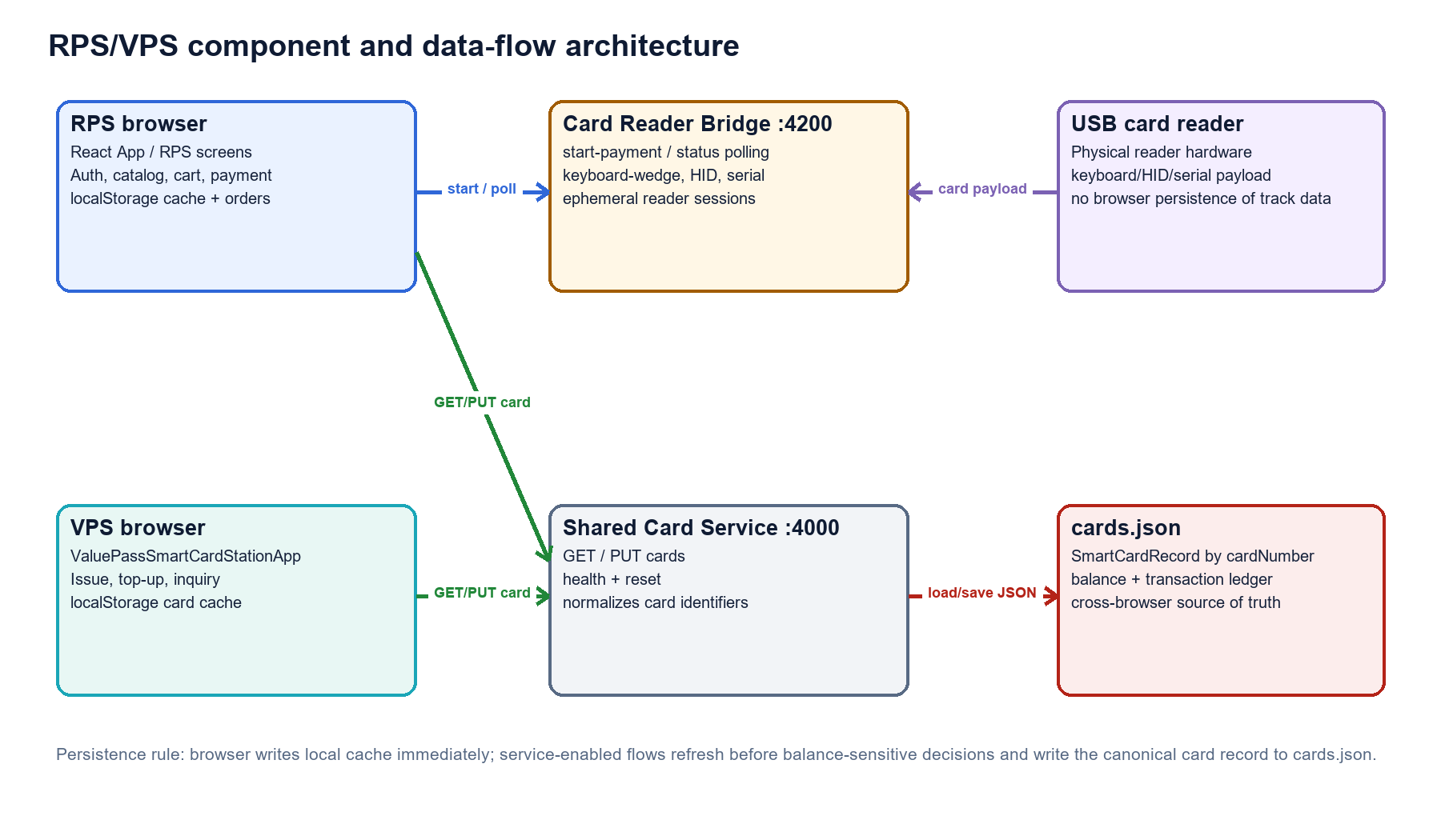
Figure 1. Component boundaries, read/write paths, and persistence ownership.

3. Runtime State and Navigation
Screen state | src/types.ts::Screen union; App.screen selects the rendered RPS component.
Authentication state | App.user initialized by getSessionUser; setSession/clearSession persist or remove session.
Cart state | App.cart: CartItem[]; calculateCart derives subtotal, tax, and total.
Payment state | App.payment: PaymentDetails | null; App.completeCardPayment is the only successful order-creation boundary.
VPS state | loadAmount, issuedCard, existingCardNumber, topUpAmount, checkedCard, stationReader, and operation errors are local to ValuePassSmartCardStationApp.
Remote card state | refreshCard/refreshCardsFromService update the local smart-card cache before balance-sensitive decisions.

4. Data Model and Persistence
Entity / Store | Key fields | Writer | Reader
User / robotics-pos-users | id, name, email, password | addUser | getUsers, findUserByEmail
Session / robotics-pos-session | User snapshot | setSession, clearSession | getSessionUser
Orders / robotics-pos-orders | userId -> Order[] | saveOrder | getOrders
SmartCardRecord / robotics-pos-smart-cards | cardNumber, balance, status, transactions | saveSmartCard, recordCardTransaction | findSmartCard, getSmartCards
Shared cards.json | cardNumber -> SmartCardRecord | PUT /api/cards/:number | GET /api/cards, GET /api/cards/:number
Runtime config | delay, popup, vision, keyboard | saveRuntimeConfig | readRuntimeConfig
Test-card balance cache | card token -> balance | saveStoredCardBalance | getStoredCardBalance

5. Cross-Application Sequence
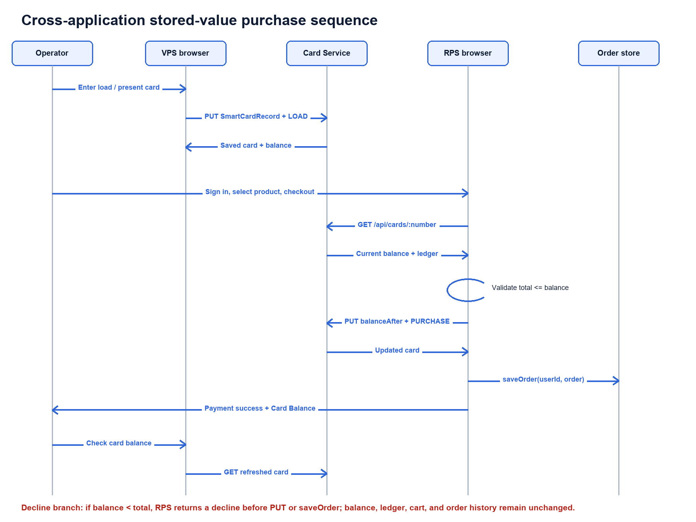
Figure 2. Successful shared-card load, purchase, persistence, and balance inquiry sequence.

6. Service and Reader Contracts
Card service health | GET /api/health -> {status, cards}. RPS mounts health status only after login; VPS may show it immediately.
Card collection | GET /api/cards -> SmartCardRecord[]. refreshCardsFromService replaces the local cache.
Single card | GET /api/cards/:number -> record or 404. refreshCard updates or removes the local cached record.
Card write | PUT /api/cards/:number with SmartCardRecord. Server normalizes the path identifier and writes cards.json.
Reader start | POST /reader/start-payment with amount/reference -> sessionId and waiting state.
Reader poll | GET /reader/payment-status/:sessionId -> waiting, approved, declined, error, or timeout.
Keyboard wedge | Browser captures input, normalizes track/PAN/token data, and does not persist raw reader payload.

7. GraphRAG Knowledge Model
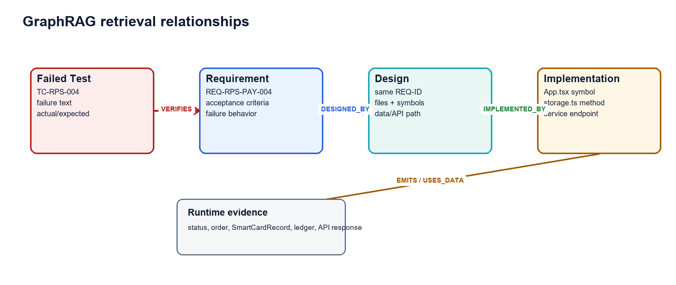
Figure 3. Recommended graph edges used to retrieve repair context from a failed test.
- TEST_CASE -[VERIFIES]-> REQUIREMENT using the workbook Requirement ID column.
- REQUIREMENT -[DESIGNED_BY]-> DESIGN_SECTION using the exact repeated REQ-ID heading.
- DESIGN_SECTION -[IMPLEMENTED_BY]-> CODE_SYMBOL using repository-relative file::symbol references.
- CODE_SYMBOL -[READS|WRITES|CALLS]-> DATA_STORE or API_ENDPOINT using the design detail fields.
- FAILURE_EVIDENCE -[OBSERVED_IN]-> TEST_CASE using the automation test ID and actual/expected output.

8. Requirement-Level Design

REQ-SYS-001 - Application mode routing
App reads URLSearchParams once at entry and selects the VPS root component before initializing RPS-only state.
Requirement contract | The browser application shall open RPS by default and shall open VPS when the kiosk query value is card-station or kiosk-1.
Implementation symbols | src/App.tsx::App  src/App.tsx::ValuePassSmartCardStationApp
State / persistence | URL query parameter kiosk; no persisted mutation.
Failure and debug boundary | Validation failure is shown in the current screen and must not corrupt persisted state.
Verification links | TC-SYS-001
Implementation invariants
- No kiosk query opens the RPS sign-in flow.
- ?kiosk=card-station and ?kiosk=kiosk-1 open VPS.
- Legacy query aliases remain supported to avoid breaking deployed bookmarks and automation.

REQ-SYS-002 - Internal product naming with UI compatibility
Internal TypeScript component and constant names use RPS/VPS terminology. JSX text, index.html title text, aria-label values, kiosk aliases, KIOSK-ID-1/KIOSK-ID-2 values, localStorage keys, and existing data-testid values retain their established compatibility values.
Requirement contract | Maintained requirements, design material, code identifiers, and code comments shall identify the point-of-sale application as Retail Product Station (RPS) and the card application as Value-Pass SmartCard Station (VPS), while preserving the previously explored browser-visible wording.
Implementation symbols | index.html::<title>  src/App.tsx::App  src/App.tsx::ValuePassSmartCardStationApp
State / persistence | None beyond UI state.
Failure and debug boundary | Validation failure is shown in the current screen and must not corrupt persisted state.
Verification links | TC-SYS-002
Implementation invariants
- Internal component and constant names use RPS/VPS terminology.
- New requirements, design, tests, and code comments use RPS/VPS terminology.
- Existing browser-visible titles, labels, status messages, and accessibility labels remain unchanged so learned automation remains valid.
- Stable query aliases, kiosk IDs, localStorage keys, and data-testid values remain unchanged.

REQ-SYS-003 - Stable automation contracts
JSX components attach data-testid values directly. STATUS provides deterministic messages. Dynamic product/order IDs are generated from stable entity IDs.
Requirement contract | Interactive controls and major screen states shall expose stable data-testid attributes and deterministic status text suitable for browser automation and robotic validation.
Implementation symbols | src/App.tsx::STATUS  src/App.tsx::ProductsScreen  src/App.tsx::PaymentScreen  src/App.tsx::TapCardScreen  src/App.tsx::ValuePassSmartCardStationApp
State / persistence | None beyond UI state.
Failure and debug boundary | Validation failure is shown in the current screen and must not corrupt persisted state.
Verification links | TC-NFR-001
Implementation invariants
- Every primary flow screen has a screen-level test ID.
- Primary actions have stable test IDs.
- Status changes are available through status-notice where the layout exposes it.
- Renaming the applications does not change existing automation selectors.

REQ-SYS-004 - Runtime configuration
readRuntimeConfig resolves query/local/default precedence; saveRuntimeConfig persists values; DeveloperSettingsScreen edits settings.
Requirement contract | Authorized lab users shall be able to configure page delay, action delay, popups, robot-vision mode, and authentication keyboard layout through query parameters or saved developer settings.
Implementation symbols | src/App.tsx::readRuntimeConfig  src/App.tsx::saveRuntimeConfig  src/App.tsx::DeveloperSettingsScreen  src/config/developerSettings.ts::DEVELOPER_RUNTIME_CONFIG
State / persistence | localStorage keys kiosk.pageDelayMs, kiosk.actionDelayMs, kiosk.popupsEnabled, kiosk.robotVisionMode, kiosk.authKeyboardLayout.
Failure and debug boundary | Validation failure is shown in the current screen and must not corrupt persisted state.
Verification links | TC-SYS-003
Implementation invariants
- Values are read from query parameters before localStorage defaults.
- Delays are clamped to the supported range.
- Saved values persist across reloads.
- Reset restores configured defaults.

REQ-SYS-005 - Defect scenario injection
PAGE_ISSUE_SCENARIOS defines typed defaults; readIssueScenarios merges saved partial values; IssueScenarioBanner and PopupModal render faults.
Requirement contract | The lab application shall support per-screen issue scenarios so automation can exercise warning, error, fatal, delay, popup, and recovery behavior without source edits.
Implementation symbols | src/config/developerSettings.ts::PAGE_ISSUE_SCENARIOS  src/App.tsx::readIssueScenarios  src/App.tsx::IssueScenarioBanner  src/App.tsx::PopupModal
State / persistence | localStorage key kiosk.issueScenarios.
Failure and debug boundary | Validation failure is shown in the current screen and must not corrupt persisted state.
Verification links | TC-SYS-004
Implementation invariants
- A scenario can be enabled for each Screen value.
- Configured messages and severity are rendered deterministically.
- Saved scenarios survive reload.
- Reset restores PAGE_ISSUE_SCENARIOS defaults.

REQ-SYS-006 - Non-blocking card-service status
RPS mounts CardServiceIndicator only when user is non-null. CardServiceIndicator performs a bounded health check and reports state without blocking application rendering.
Requirement contract | RPS shall not poll the shared card service before a user signs in; VPS may show service health because card operations are its first workflow.
Implementation symbols | src/App.tsx::App  src/App.tsx::CardServiceIndicator  src/lib/storage.ts::checkCardService
State / persistence | None beyond UI state.
Failure and debug boundary | Validation failure is shown in the current screen and must not corrupt persisted state.
Verification links | TC-NFR-002
Implementation invariants
- RPS sign-in page does not call /api/health.
- After RPS login, the card-service indicator can report connected, local, disabled, or error.
- VPS health status does not prevent local UI rendering.

REQ-RPS-AUTH-001 - Authenticate a valid RPS user
SignInScreen trims email, obtains the record with findUserByEmail, compares password, then invokes onSignedIn; App persists the session and navigates to Products.
Requirement contract | RPS shall authenticate the configured demo user and any user created through Sign Up when the supplied email and password match the stored record.
Implementation symbols | src/App.tsx::SignInScreen.submit  src/lib/storage.ts::findUserByEmail  src/lib/storage.ts::setSession  src/App.tsx::App.handleSignedIn
State / persistence | User records in localStorage key robotics-pos-users; session in robotics-pos-session.
Failure and debug boundary | Validation failure is shown in the current screen and must not corrupt persisted state.
Verification links | TC-RPS-001
Implementation invariants
- tester@kiosk.local / Password123 is accepted.
- Matching a signed-up user is accepted.
- Successful authentication establishes a session and opens Products.

REQ-RPS-AUTH-002 - Reject invalid RPS credentials
SignInScreen submit guards !user and password mismatch, sets STATUS.loginFailed, and requests popup-login-failed.
Requirement contract | RPS shall reject an unknown user or mismatched password and shall remain on the sign-in screen without creating a session.
Implementation symbols | src/App.tsx::SignInScreen.submit  src/App.tsx::PopupModal  src/lib/storage.ts::findUserByEmail
State / persistence | None beyond UI state.
Failure and debug boundary | The current form remains populated for correction; no session or order state is changed.
Verification links | TC-RPS-006
Implementation invariants
- Unknown email is rejected.
- Wrong password is rejected.
- Login Failed feedback is shown.
- Products and authenticated navigation are not displayed.

REQ-RPS-AUTH-003 - Create an RPS user
SignUpScreen validates uniqueness through findUserByEmail, constructs a User, calls addUser, then invokes onSignedIn.
Requirement contract | RPS shall allow a user to register a unique email, name, and password and then establish an authenticated session.
Implementation symbols | src/App.tsx::SignUpScreen.submit  src/lib/storage.ts::addUser  src/lib/storage.ts::findUserByEmail
State / persistence | User fields id, name, email, password; localStorage key robotics-pos-users.
Failure and debug boundary | Validation failure is shown in the current screen and must not corrupt persisted state.
Verification links | TC-RPS-007
Implementation invariants
- Unique email creates one User record.
- Duplicate email is rejected.
- Successful registration opens Products.
- The account can be used in a later sign-in.

REQ-RPS-AUTH-004 - Request password reset
ForgotPasswordScreen calls findUserByEmail only to exercise lookup, sets the status, and navigates to signin.
Requirement contract | RPS shall provide a deterministic lab password-reset request flow that returns the user to sign-in without disclosing whether an account exists.
Implementation symbols | src/App.tsx::ForgotPasswordScreen.submit  src/lib/storage.ts::findUserByEmail
State / persistence | None beyond UI state.
Failure and debug boundary | Validation failure is shown in the current screen and must not corrupt persisted state.
Verification links | TC-RPS-008
Implementation invariants
- Submitting an email displays password-reset-requested status.
- The flow returns to sign-in.
- No password or user record is changed.

REQ-RPS-AUTH-005 - Persist and clear RPS session
getSessionUser validates the saved session email against current users; clearSession removes the key; App owns user state.
Requirement contract | RPS shall restore a valid saved session on reload and shall clear it on Sign Out.
Implementation symbols | src/lib/storage.ts::getSessionUser  src/lib/storage.ts::setSession  src/lib/storage.ts::clearSession  src/App.tsx::App
State / persistence | localStorage key robotics-pos-session.
Failure and debug boundary | Validation failure is shown in the current screen and must not corrupt persisted state.
Verification links | TC-RPS-009
Implementation invariants
- Reload with a valid saved user restores authenticated state.
- Sign Out removes the session and returns to sign-in.
- A removed user record does not produce a valid restored session.

REQ-RPS-CAT-001 - Display product catalog
ProductsScreen maps the products array to product cards and stores selected quantities by product ID.
Requirement contract | After authentication, RPS shall display the configured products with category, name, description, price, and quantity controls.
Implementation symbols | src/data/products.ts::products  src/App.tsx::ProductsScreen
State / persistence | Product type fields id, name, category, description, price, accent, touchLabel.
Failure and debug boundary | Validation failure is shown in the current screen and must not corrupt persisted state.
Verification links | TC-RPS-010, TC-E2E-005
Implementation invariants
- Products originate from src/data/products.ts.
- Each product has a stable product-card test ID.
- The initial selected quantity is zero.

REQ-RPS-CAT-002 - Adjust product quantity
ProductsScreen updateQuantity applies Math.max(0, current + change) to component state.
Requirement contract | RPS shall increment and decrement each product quantity while preventing values below zero.
Implementation symbols | src/App.tsx::ProductsScreen.setQuantity
State / persistence | React quantities Record<string, number>.
Failure and debug boundary | Validation failure is shown in the current screen and must not corrupt persisted state.
Verification links | TC-RPS-011
Implementation invariants
- Increment adds one.
- Decrement subtracts one only above zero.
- Quantity remains an integer at or above zero.
- A quantity update emits deterministic status.

REQ-RPS-CAT-003 - Add selected product to cart
ProductsScreen validates selectedQuantity; App addToCart merges by product ID and updates cart state.
Requirement contract | RPS shall add the selected product and quantity to the cart and shall reject Add to Cart when quantity is zero.
Implementation symbols | src/App.tsx::ProductsScreen  src/App.tsx::App.addToCart
State / persistence | None beyond UI state.
Failure and debug boundary | Zero quantity invokes popup-quantity-required when configured and leaves cart unchanged.
Verification links | TC-RPS-012
Implementation invariants
- Positive quantity adds or merges the product in cart.
- Zero quantity creates no cart entry and shows quantity-required feedback.
- Cart count reflects total item quantity.

REQ-RPS-CAT-004 - Navigate RPS operational pages
POS_MENU declares route metadata; App.goTo coordinates delay/status; individual screen components render stable targets.
Requirement contract | Authenticated RPS users shall be able to open Products, Categories, Deals, Loyalty, Receipts, Support, Store Info, Order History, and Home using the available navigation controls.
Implementation symbols | src/App.tsx::POS_MENU  src/App.tsx::App.goTo  src/types.ts::Screen
State / persistence | None beyond UI state.
Failure and debug boundary | Validation failure is shown in the current screen and must not corrupt persisted state.
Verification links | TC-RPS-013
Implementation invariants
- Each menu item opens its corresponding Screen.
- Home returns to Products.
- Order History opens saved orders.
- Sign Out remains available in authenticated layouts.

REQ-RPS-CART-001 - Review and edit cart
CartScreen renders cart and delegates quantity changes to App, which filters zero quantities.
Requirement contract | RPS shall display cart line items and permit quantity changes or line removal before payment.
Implementation symbols | src/App.tsx::CartScreen  src/App.tsx::App.updateCartQuantity
State / persistence | CartItem[] held in App state.
Failure and debug boundary | Validation failure is shown in the current screen and must not corrupt persisted state.
Verification links | TC-RPS-014
Implementation invariants
- Cart shows product, unit price, quantity, and line total.
- Quantity changes recalculate totals.
- Zero quantity removes the line.
- Continue Shopping returns to Products.

REQ-RPS-CART-002 - Calculate order totals
calculateCart is the single calculation function; OrderSummary is reused in cart and order details.
Requirement contract | RPS shall calculate subtotal as sum of line price times quantity, tax at 8.25 percent, and total as subtotal plus tax.
Implementation symbols | src/App.tsx::TAX_RATE  src/App.tsx::calculateCart  src/App.tsx::OrderSummary
State / persistence | Derived values subtotal, tax, total; rounded for display by Intl.NumberFormat.
Failure and debug boundary | Validation failure is shown in the current screen and must not corrupt persisted state.
Verification links | TC-RPS-009
Implementation invariants
- Subtotal equals the sum of all lines.
- Tax equals subtotal multiplied by 0.0825.
- Total equals subtotal plus tax.
- Displayed values use USD currency formatting.

REQ-RPS-CART-003 - Start checkout
CartScreen disables checkout for empty cart; App.startPayment handles high-value popup and navigation.
Requirement contract | RPS shall prevent checkout from an empty cart and shall open Card Payment for a non-empty cart after any configured action delay or confirmation scenario.
Implementation symbols | src/App.tsx::CartScreen  src/App.tsx::App.handlePaymentNavigation  src/App.tsx::PopupModal
State / persistence | None beyond UI state.
Failure and debug boundary | Canceled confirmation leaves the user on the cart with cart state intact.
Verification links | TC-RPS-015
Implementation invariants
- Empty cart cannot proceed.
- Non-empty cart opens payment.
- High-value confirmation can be exercised when configured.
- No order is saved at checkout start.

REQ-RPS-PAY-001 - Initialize card payment
PaymentScreen receives totals and reads CARD_READER_CONFIG to render payment controls.
Requirement contract | RPS shall present the order total and offer the configured real-reader session and mock-card fallback payment paths.
Implementation symbols | src/App.tsx::PaymentScreen  src/config/developerSettings.ts::CARD_READER_CONFIG
State / persistence | PaymentDetails is created only after payment-path initialization.
Failure and debug boundary | Validation failure is shown in the current screen and must not corrupt persisted state.
Verification links | TC-RPS-002
Implementation invariants
- Payment screen displays totals.
- Back returns to cart.
- Reader path is available when configured.
- Mock path is available only when allowMockFallback is true.

REQ-RPS-PAY-002 - Collect mock card number
PaymentScreen mockMode controls visibility; confirmMockCard normalizes the value.
Requirement contract | When Use Mock Card is selected, RPS shall display a numeric card-number input and Pay with Mock Card action.
Implementation symbols | src/App.tsx::PaymentScreen  src/App.tsx::PaymentScreen.confirmMockCard
State / persistence | Local component state mockCardNumber, mockMode, mockError.
Failure and debug boundary | Validation failure is shown in the current screen and must not corrupt persisted state.
Verification links | TC-RPS-002
Implementation invariants
- Mock entry is hidden initially.
- Use Mock Card reveals mock-card-entry.
- Blank card number is rejected.
- Input is normalized to digits before lookup.

REQ-RPS-PAY-003 - Approve sufficient known card
refreshCard loads current shared state; createApprovedStatusFromCardNumber validates funds; recordCardTransaction writes balance and ledger; App.completeCardPayment persists the order.
Requirement contract | RPS shall approve a known VPS-issued card when its balance is greater than or equal to the order total, deduct the total, record a PURCHASE transaction, and create the order.
Implementation symbols | src/App.tsx::PaymentScreen.confirmMockCard  src/App.tsx::createApprovedStatusFromCardNumber  src/lib/storage.ts::refreshCard  src/lib/storage.ts::recordCardTransaction  src/App.tsx::App.completeCardPayment
State / persistence | SmartCardRecord.balance and transactions; Order.payment.balanceBefore/balanceAfter.
Failure and debug boundary | Validation failure is shown in the current screen and must not corrupt persisted state.
Verification links | TC-RPS-003, TC-E2E-001, TC-E2E-003, TC-E2E-004
Implementation invariants
- Exact balance is accepted.
- balanceAfter equals balanceBefore minus total.
- PURCHASE contains RPS station ID and newest timestamp.
- Success page is reached and order is saved.

REQ-RPS-PAY-004 - Decline insufficient known card
createApprovedStatusFromCardNumber returns declined before persistence; PaymentScreen surfaces mock decline; TapCardScreen supports retry for reader decline.
Requirement contract | RPS shall decline a known VPS-issued card when the available balance is below the order total.
Implementation symbols | src/App.tsx::createApprovedStatusFromCardNumber  src/App.tsx::PaymentScreen.confirmMockCard  src/App.tsx::TapCardScreen
State / persistence | None beyond UI state.
Failure and debug boundary | Decline is a business outcome, not a service error; cart remains available for retry.
Verification links | TC-RPS-004, TC-RPS-005, TC-E2E-002
Implementation invariants
- Decline message includes available balance and order total.
- Card balance is unchanged.
- No PURCHASE transaction is appended.
- No order is created.

REQ-RPS-PAY-005 - Reject unknown mock card
confirmMockCard refreshes the card and checks findSmartCard before payment decision logic.
Requirement contract | The RPS mock-card path shall reject a card number that has not been issued by VPS.
Implementation symbols | src/App.tsx::PaymentScreen.confirmMockCard  src/lib/storage.ts::refreshCard  src/lib/storage.ts::findSmartCard
State / persistence | None beyond UI state.
Failure and debug boundary | Message directs the operator to load the card at VPS first.
Verification links | TC-RPS-016
Implementation invariants
- Unknown mock card displays an issued-card error.
- No balance is created implicitly.
- No order is created.
- The user can correct the number and retry.

REQ-RPS-PAY-006 - Start real card-reader session
PaymentScreen.startCardReaderPayment calls the bridge and forwards session data to App; TapCardScreen owns polling.
Requirement contract | RPS shall create a card-reader payment session through the configured bridge and navigate to Tap Card when the bridge accepts the request.
Implementation symbols | src/App.tsx::PaymentScreen.startCardReaderPayment  src/App.tsx::TapCardScreen  src/config/developerSettings.ts::CARD_READER_CONFIG
State / persistence | PaymentDetails.cardReaderSessionId, cardReaderBridgeUrl, cardReaderStatus.
Failure and debug boundary | Validation failure is shown in the current screen and must not corrupt persisted state.
Verification links | TC-RPS-010
Implementation invariants
- POST /reader/start-payment includes order amount and order reference.
- Returned session ID and bridge URL are retained in PaymentDetails.
- Bridge failure is shown without losing cart state.
- Tap Card polls only when a session exists.

REQ-RPS-PAY-007 - Capture USB keyboard-wedge card data
TapCardScreen uses reader-wedge-input, buffering, delayed flush, and approvedRef. extractCardNumber and PAN helpers normalize payloads.
Requirement contract | On Tap Card, RPS shall continuously focus the reader input, parse common Track 1, Track 2, PAN, and lab-token payloads, and process one recognized card input.
Implementation symbols | src/App.tsx::extractCardNumber  src/App.tsx::findValidPanCandidate  src/App.tsx::TapCardScreen.approveFromKeyboardWedge  src/App.tsx::TapCardScreen.handleGlobalWedgeKeyDown
State / persistence | Ephemeral wedge buffer; no raw track data is persisted.
Failure and debug boundary | Unrecognized input remains in waiting state; decline displays retry without creating an order.
Verification links | TC-RPS-010
Implementation invariants
- Track 1 and Track 2 PANs are extracted.
- Digit-only valid PANs and lab token IDs are accepted.
- Input, key, paste, and global key events are handled.
- Approved input completes once; declined input can be retried.

REQ-RPS-PAY-008 - Process real known and lab cards
createApprovedStatusFromCardNumber combines findTestCard, findSmartCard, balance lookup, disposition, and transaction persistence.
Requirement contract | RPS shall apply balance validation to a known VPS-issued real card and shall apply configured test-card disposition to lab cards; unknown real-reader lab tokens may follow the configured unknown disposition.
Implementation symbols | src/App.tsx::createApprovedStatusFromCardNumber  src/config/testCards.ts::TEST_CARDS  src/config/testCards.ts::UNKNOWN_TEST_CARD_DISPOSITION
State / persistence | Test-card balances use kiosk.testCardBalances; VPS cards use SmartCardRecord.
Failure and debug boundary | Validation failure is shown in the current screen and must not corrupt persisted state.
Verification links | TC-RPS-010, TC-E2E-006
Implementation invariants
- Known issued card uses current shared balance.
- Known declined test card follows TEST_CARDS disposition.
- Unknown reader disposition follows UNKNOWN_TEST_CARD_DISPOSITION.
- Approved known card records PURCHASE and balanceAfter.

REQ-RPS-PAY-009 - Display remaining card balance
OrderResultScreen derives cardBalance from order.payment.balanceAfter and conditionally renders payment-success-card-balance.
Requirement contract | When an approved payment provides balanceAfter, RPS shall display the remaining card balance on the Payment Successful page.
Implementation symbols | src/App.tsx::OrderResultScreen  src/types.ts::PaymentDetails
State / persistence | Order.payment.balanceAfter.
Failure and debug boundary | Validation failure is shown in the current screen and must not corrupt persisted state.
Verification links | TC-RPS-011, TC-E2E-001, TC-E2E-004
Implementation invariants
- Known VPS card success shows Card Balance.
- The value equals the persisted balanceAfter.
- Payment types without a known balance omit the balance block.
- The balance remains part of the saved Order payment details.

REQ-RPS-ORD-001 - Persist successful order
App.completeCardPayment constructs Order, calls saveOrder, updates state, clears cart, and navigates to result.
Requirement contract | RPS shall create and save one order only after an approved payment.
Implementation symbols | src/App.tsx::App.completeCardPayment  src/lib/storage.ts::saveOrder  src/types.ts::Order
State / persistence | localStorage key robotics-pos-orders, keyed by user ID.
Failure and debug boundary | Validation failure is shown in the current screen and must not corrupt persisted state.
Verification links | TC-RPS-003, TC-E2E-001
Implementation invariants
- Order includes ID, timestamp, items, subtotal, tax, total, payment, and SUCCESS status.
- Order is associated with the authenticated user.
- Cart is cleared after save.
- Result opens with the saved order.

REQ-RPS-ORD-002 - Do not persist declined order
All decline guards return before App.completeCardPayment; only onApprove invokes the completion path.
Requirement contract | RPS shall not save an order or clear the cart when payment is declined or card validation fails.
Implementation symbols | src/App.tsx::createApprovedStatusFromCardNumber  src/App.tsx::PaymentScreen.confirmMockCard  src/App.tsx::TapCardScreen
State / persistence | None beyond UI state.
Failure and debug boundary | Decline state is displayed inline and is recoverable.
Verification links | TC-RPS-005, TC-E2E-002
Implementation invariants
- Order history count is unchanged.
- Cart remains available.
- Card balance and ledger are unchanged.
- Retry can be initiated.

REQ-RPS-ORD-003 - Display order history
getOrders returns the user array; saveOrder prepends; OrderHistoryScreen and OrderDetails render records.
Requirement contract | RPS shall display prior successful orders for the current user newest first with order details and totals.
Implementation symbols | src/lib/storage.ts::getOrders  src/lib/storage.ts::saveOrder  src/App.tsx::OrderHistoryScreen  src/App.tsx::OrderDetails
State / persistence | localStorage robotics-pos-orders.
Failure and debug boundary | Validation failure is shown in the current screen and must not corrupt persisted state.
Verification links | TC-RPS-017
Implementation invariants
- Only the current user's saved orders are shown.
- Newest saved order appears first.
- Each order shows ID, date, status, lines, totals, and payment card display.
- No-order state provides a return action.

REQ-VPS-CARD-001 - Issue fixed mock card
ValuePassSmartCardStationApp issueMockCard refreshes 0005322931 and calls issueCard with source mock.
Requirement contract | When Use Mock Card is selected for a new load, VPS shall issue or reload card number 0005322931 using the entered load amount.
Implementation symbols | src/App.tsx::ValuePassSmartCardStationApp.issueMockCard  src/App.tsx::ValuePassSmartCardStationApp.issueCard
State / persistence | SmartCardRecord cardNumber 0005322931, balance, sourceKioskId, transactions.
Failure and debug boundary | Validation failure is shown in the current screen and must not corrupt persisted state.
Verification links | TC-VPS-001, TC-VPS-007, TC-VPS-010
Implementation invariants
- The card number is exactly 0005322931.
- Balance equals the entered load amount.
- A LOAD transaction is newest.
- Existing record is refreshed before replacement.

REQ-VPS-CARD-002 - Validate initial load amount
issueCard converts loadAmount to Number, checks amount > 0, and rounds the stored value.
Requirement contract | VPS shall require a positive numeric load amount before issuing a new card.
Implementation symbols | src/App.tsx::ValuePassSmartCardStationApp.issueCard
State / persistence | None beyond UI state.
Failure and debug boundary | station-load-error reports the validation problem.
Verification links | TC-VPS-013
Implementation invariants
- Blank, nonnumeric, zero, and negative values are rejected.
- Valid amount is rounded to two decimals.
- Rejected input creates no card or transaction.

REQ-VPS-CARD-003 - Issue card using real reader
stationReader tap-load mode focuses station-reader-wedge-input; reader event handlers call issueCard with source real-reader.
Requirement contract | VPS shall support presenting a real card to the reader for initial load and shall issue the recognized card number with the entered balance.
Implementation symbols | src/App.tsx::ValuePassSmartCardStationApp  src/App.tsx::extractCardNumber
State / persistence | Ephemeral reader input; SmartCardRecord persisted after validation.
Failure and debug boundary | Validation failure is shown in the current screen and must not corrupt persisted state.
Verification links | TC-VPS-012
Implementation invariants
- Reader capture is armed for tap-load.
- Recognized payload is normalized to a card number.
- The card receives a LOAD transaction.
- The keyboard-wedge capture closes after a successful issue.

REQ-VPS-CARD-004 - Top up existing card
topUpCard refreshes the target, validates the shared amount state, calculates next balance, and calls recordCardTransaction with TOP_UP.
Requirement contract | VPS shall add a positive amount from the current Load Amount input to an existing card and append a TOP_UP transaction without replacing prior history.
Implementation symbols | src/App.tsx::ValuePassSmartCardStationApp.topUpCard  src/lib/storage.ts::recordCardTransaction
State / persistence | SmartCardRecord.balance; CardTransaction type TOP_UP.
Failure and debug boundary | Validation failure is shown in the current screen and must not corrupt persisted state.
Verification links | TC-VPS-008, TC-VPS-011
Implementation invariants
- Card must exist.
- The current implementation uses the Load Amount input as the amount to add.
- New balance equals old balance plus top-up.
- Newest transaction type is TOP_UP and uses VPS station ID.

REQ-VPS-CARD-005 - Check card balance
runCheck normalizes input, refreshes the card, then reads findSmartCard and stores checkedCard.
Requirement contract | VPS shall retrieve a known card by normalized card number and display its current balance and details.
Implementation symbols | src/App.tsx::ValuePassSmartCardStationApp.runCheck  src/lib/storage.ts::refreshCard  src/lib/storage.ts::findSmartCard
State / persistence | checkedCard state derived from SmartCardRecord.
Failure and debug boundary | Validation failure is shown in the current screen and must not corrupt persisted state.
Verification links | TC-VPS-003, TC-VPS-007, TC-VPS-009, TC-E2E-001
Implementation invariants
- Manual card-number lookup succeeds for known card.
- Reader presentation can initiate lookup.
- Shared service is refreshed before final display when enabled.
- Displayed balance matches the canonical record.

REQ-VPS-CARD-006 - Display transaction history
recordCardTransaction prepends and caps stored history; getCardTransactions slices; VPS maps the returned entries to Recent Transactions.
Requirement contract | VPS shall display at most the ten most recent card transactions in newest-first order using Load, Purchase, and Top-up labels with amount, station ID, date/time, and balance after.
Implementation symbols | src/lib/storage.ts::recordCardTransaction  src/lib/storage.ts::getCardTransactions  src/App.tsx::ValuePassSmartCardStationApp
State / persistence | CardTransaction id, at, type, amount, balanceAfter, kioskId, note.
Failure and debug boundary | Validation failure is shown in the current screen and must not corrupt persisted state.
Verification links | TC-VPS-005, TC-VPS-008, TC-VPS-009, TC-E2E-003
Implementation invariants
- Maximum displayed count is 10.
- Newest transaction appears first.
- LOAD renders as Load, PURCHASE as Purchase, TOP_UP as Top-up.
- Each row exposes transaction type and resulting balance.

REQ-VPS-CARD-007 - Report unknown card
runCheck and topUpCard guard missing findSmartCard results and set station error state.
Requirement contract | VPS shall report a clear not-found result when balance check or top-up targets a card that has not been issued.
Implementation symbols | src/App.tsx::ValuePassSmartCardStationApp.runCheck  src/App.tsx::ValuePassSmartCardStationApp.topUpCard
State / persistence | None beyond UI state.
Failure and debug boundary | station-check-error or station-load-error is shown.
Verification links | TC-VPS-006
Implementation invariants
- No balance or history is fabricated.
- The card number is included in feedback.
- The operator can correct and retry.
- No shared or local record is changed.

REQ-VPS-CARD-008 - Clear stale station results
VPS event handlers reset issuedCard and operation messages while retaining storage records.
Requirement contract | When the operator starts Add Money to Existing Card after issuing a card, VPS shall clear the prior card-loaded result so current-operation feedback is unambiguous.
Implementation symbols | src/App.tsx::ValuePassSmartCardStationApp
State / persistence | React UI state only.
Failure and debug boundary | Validation failure is shown in the current screen and must not corrupt persisted state.
Verification links | TC-VPS-014
Implementation invariants
- Opening or starting top-up removes stale issued-card result.
- Top-up feedback reflects only the target existing card.
- Clearing UI state does not delete persisted card data.

REQ-VPS-CARD-009 - Use real reader for existing-card operations
stationReader mode selects tap-check; station-check-wedge-input and shared reader handlers route the parsed card to lookup/top-up logic.
Requirement contract | VPS shall provide Present Card to Reader for existing-card top-up and balance lookup, using the same normalized reader capture path as initial load.
Implementation symbols | src/App.tsx::ValuePassSmartCardStationApp  src/App.tsx::extractCardNumber
State / persistence | Ephemeral reader state plus canonical SmartCardRecord.
Failure and debug boundary | Validation failure is shown in the current screen and must not corrupt persisted state.
Verification links | TC-VPS-015
Implementation invariants
- tap-check mode captures a card for lookup or top-up.
- Recognized card number populates the intended operation.
- Unknown card follows not-found behavior.
- Reader state resets after processing.

REQ-INT-001 - Share card state between VPS and RPS
storage.ts implements local write-through plus asynchronous PUT, and explicit GET refresh. card-service/server.js persists by normalized card number.
Requirement contract | When card service is enabled and both applications use the same URL, cards issued or topped up at VPS shall be available to RPS, and RPS purchases shall be visible at VPS.
Implementation symbols | src/lib/storage.ts::saveSmartCard  src/lib/storage.ts::refreshCard  src/lib/storage.ts::recordCardTransaction  card-service/server.js::http.createServer
State / persistence | Canonical service file card-service/cards.json; browser cache robotics-pos-smart-cards.
Failure and debug boundary | Validation failure is shown in the current screen and must not corrupt persisted state.
Verification links | TC-E2E-001, TC-E2E-002, TC-E2E-003, TC-E2E-004, TC-VPS-009
Implementation invariants
- VPS PUT is retrievable by RPS GET.
- RPS PURCHASE changes balance and transaction ledger.
- A subsequent VPS refresh displays the new balance and PURCHASE.
- Cross-browser and cross-machine operation works when the service URL is network reachable.

REQ-INT-002 - Refresh shared state before decisions
refreshCard performs GET /api/cards/:number and updates/removes local cache; callers await it before findSmartCard.
Requirement contract | RPS and VPS shall refresh a target card from the shared service before balance-sensitive payment, top-up, or balance-display decisions.
Implementation symbols | src/lib/storage.ts::refreshCard  src/App.tsx::PaymentScreen.confirmMockCard  src/App.tsx::ValuePassSmartCardStationApp.topUpCard  src/App.tsx::ValuePassSmartCardStationApp.runCheck
State / persistence | None beyond UI state.
Failure and debug boundary | Fetch errors are caught so the UI remains operable with local state.
Verification links | TC-INT-001
Implementation invariants
- Known service record replaces stale local copy.
- Service 404 removes stale local card for that number.
- Network failure preserves local fallback and returns null.
- Payment uses the refreshed balance when available.

REQ-INT-003 - Operate with local fallback
isCardServiceEnabled gates remote operations; all card functions read/write localStorage first; health checks are bounded.
Requirement contract | When shared card service is disabled or unreachable, the applications shall retain local browser behavior without blocking UI startup.
Implementation symbols | src/lib/storage.ts::isCardServiceEnabled  src/lib/storage.ts::checkCardService  src/lib/storage.ts::saveSmartCard
State / persistence | localStorage robotics-pos-smart-cards.
Failure and debug boundary | Validation failure is shown in the current screen and must not corrupt persisted state.
Verification links | TC-INT-002
Implementation invariants
- VITE_CARD_SERVICE_ENABLED=false suppresses service calls.
- Card read/write continues through localStorage.
- Health failure is reported but does not block rendering.
- Cross-browser sharing is not promised in fallback mode.

REQ-INT-004 - Expose shared card service API
card-service/server.js uses Node http, readBody, normalize, load, save, and send helpers; it binds to 0.0.0.0 on the configured port.
Requirement contract | The shared card service shall expose health, list, get, put, and reset endpoints with normalized card identifiers and JSON responses.
Implementation symbols | card-service/server.js::server  card-service/server.js::load  card-service/server.js::save  card-service/server.js::normalize
State / persistence | JSON object in card-service/cards.json keyed by normalized card number.
Failure and debug boundary | Malformed JSON body resolves to an empty object; unknown route returns 404 JSON.
Verification links | TC-INT-003
Implementation invariants
- GET /api/health returns status and card count.
- GET /api/cards returns all records.
- GET /api/cards/:number returns 200 or 404.
- PUT /api/cards/:number persists normalized cardNumber.
- POST /api/reset clears records.

REQ-INT-005 - Start development services
scripts/start-dev.cjs reads .env, tests health, starts card-service/server.js when local, and launches the local Vite executable.
Requirement contract | npm run dev shall start the shared card service when enabled and then start Vite without imposing a long startup wait when health is unavailable.
Implementation symbols | scripts/start-dev.cjs  package.json
State / persistence | None beyond UI state.
Failure and debug boundary | Validation failure is shown in the current screen and must not corrupt persisted state.
Verification links | TC-NFR-003
Implementation invariants
- Enabled local service is started or reused.
- Startup health wait uses a short bounded timeout.
- Vite starts with host 0.0.0.0.
- Disabled service starts only the UI.

REQ-NFR-001 - Responsive and touch-operable UI
src/styles.css defines responsive grids, media queries, panel constraints, touch sizing, overflow regions, and mode-specific selectors.
Requirement contract | RPS and VPS shall remain usable at supported laptop and 21-inch display dimensions, provide large touch targets, and prevent incoherent overlap; scrolling is allowed only where content cannot safely fit.
Implementation symbols | src/styles.css  src/App.tsx::VirtualKeyboard
State / persistence | None beyond UI state.
Failure and debug boundary | Validation failure is shown in the current screen and must not corrupt persisted state.
Verification links | TC-NFR-004
Implementation invariants
- Primary actions remain visible or reachable at supported sizes.
- Text does not clip or overlap.
- Touch controls provide visually consistent target boundaries.
- Arm-reachable and other configured layouts preserve existing automation coordinates within their mode.

REQ-NFR-002 - Fast non-blocking startup
App gates service indicator by user; DEVELOPER_RUNTIME_CONFIG defaults delays to zero; checkCardService and start-dev use short timeouts.
Requirement contract | The RPS sign-in screen shall render without waiting for card-service health, product actions, developer settings, or card-reader sessions.
Implementation symbols | src/App.tsx::App  src/config/developerSettings.ts::DEVELOPER_RUNTIME_CONFIG  src/lib/storage.ts::checkCardService  scripts/start-dev.cjs
State / persistence | None beyond UI state.
Failure and debug boundary | Validation failure is shown in the current screen and must not corrupt persisted state.
Verification links | TC-NFR-002, TC-NFR-003
Implementation invariants
- RPS does not mount CardServiceIndicator until authentication.
- Default runtime delays are zero.
- Health timeout is bounded at 750 ms where used.
- Card-reader polling starts only after payment-session creation.

REQ-NFR-003 - Lab-only payment data safeguards
CARD_READER_CONFIG.displayFullCardNumberForLabTesting gates display; getCardDisplayValue defaults to masking; reader buffers remain in memory.
Requirement contract | The reader and payment implementation shall be treated as a lab/test system and shall not imply production PCI compliance or use with real customer cards.
Implementation symbols | src/config/developerSettings.ts::CARD_READER_CONFIG  src/App.tsx::getCardDisplayValue  card-reader-bridge/README.md
State / persistence | None beyond UI state.
Failure and debug boundary | Validation failure is shown in the current screen and must not corrupt persisted state.
Verification links | TC-NFR-005
Implementation invariants
- Full card number display requires explicit lab configuration.
- Raw reader track input is not persisted by the browser.
- Documentation warns against production/customer-card use.
- Production deployment requires a compliant payment provider and hardened service.

REQ-NFR-005 - Build integrity
TypeScript project references and Vite build provide the regression gate; compatibility identifiers are documented and intentionally retained.
Requirement contract | The maintained TypeScript application shall compile and produce a Vite production bundle after naming or documentation-linked implementation changes.
Implementation symbols | package.json  tsconfig.json  vite.config.ts
State / persistence | None beyond UI state.
Failure and debug boundary | Validation failure is shown in the current screen and must not corrupt persisted state.
Verification links | TC-NFR-006
Implementation invariants
- npm run build completes without TypeScript errors.
- Existing stable data-testid values remain present.
- No storage key or legacy URL alias is removed by naming changes.

9. Debugging Index
Symptom | First implementation inspection | Requirement
RPS login failure | SignInScreen.submit; findUserByEmail; robotics-pos-users/session; popup-login-failed | REQ-RPS-AUTH-001/002
Product or quantity failure | products; ProductsScreen; quantities; addToCart | REQ-RPS-CAT-001/002/003
Wrong total | TAX_RATE; calculateCart; OrderSummary | REQ-RPS-CART-002
Known card incorrectly declined | refreshCard; createApprovedStatusFromCardNumber; SmartCardRecord.balance | REQ-RPS-PAY-003/004; REQ-INT-002
Order missing after approval | App.completeOrder; saveOrder; robotics-pos-orders | REQ-RPS-ORD-001
Balance missing on success | PaymentDetails.balanceAfter; OrderResultScreen | REQ-RPS-PAY-009
VPS top-up shown as load | ValuePassSmartCardStationApp.topUpCard; recordCardTransaction type TOP_UP | REQ-VPS-CARD-004/006
Cross-browser balance stale | cardServiceUrl; refreshCard; saveSmartCard; cards.json | REQ-INT-001/002
USB reader does not advance | TapCardScreen wedge input/buffer; reader bridge session endpoints | REQ-RPS-PAY-006/007
Slow sign-in startup | CardServiceIndicator mount gate; checkCardService timeout; runtime delays | REQ-SYS-006; REQ-NFR-002

Appendix A. Compatibility Identifiers
- Query aliases kiosk=card-station and kiosk=kiosk-1 remain supported by REQ-SYS-001.
- Deployment IDs KIOSK-ID-1 (VPS) and KIOSK-ID-2 (RPS) remain persisted in transaction records and test data.
- localStorage keys beginning robotics-pos or kiosk are retained to preserve existing browser data.
- Existing data-testid values such as valuepass-card-station and pos-side-menu are retained as automation contracts even when their wording predates RPS/VPS naming.

