SOLUTION ARCHITECTURE ON GOOGLE CLOUD
Haibotix Agentic QA Platform
Autonomous, AI-Driven Application Testing & Self-Healing
Google Cloud Platform Deployment · Single-Tenant and Multi-Tenant

Solution Architecture — Google Cloud Platform
Design, Components, Configurability and Scale

Document Title | Haibotix Agentic QA Platform — GCP Solution Architecture
Version | 1.0
Date | September 2026
Prepared by | Haibotix — Solutions Engineering
Classification | Customer Confidential

1 Executive Overview
The Haibotix Agentic QA Platform autonomously tests software applications and repairs the code when a test uncovers a defect. It discovers an application on its own, plans and runs test cases, validates the outcome visually, files defects, and proposes a code fix as a pull request — with very little human effort. At its core is Anthropic Claude, which understands application screens and reasons about test steps and fixes without any per-application model training.
This document describes how the platform is deployed and operated on Google Cloud Platform. It covers the component architecture, the end-to-end flow for a single customer and for many customers on shared infrastructure, how every part is chosen by configuration (so the same solution runs on another cloud or on-premises without a rewrite), what changes when Kubernetes is used to serve many tenants, and an optional in-house model configuration that keeps all code and data inside the customer’s environment.
- One image, managed services — the platform runs as one container image on managed Google Cloud services; every tier scales on its own.
- Caching-first, low run cost — stable tests execute from cache with local screen matching and no AI calls, so ongoing cost is low and predictable.
- Data residency — data stays in the customer’s chosen Google Cloud project and Region; an optional in-house configuration keeps even the AI reasoning on the customer’s own machines.
2 The Solution at a Glance
The platform is organised into independent tiers. Client applications reach a single managed entry point; a stateless API tier accepts requests; a worker tier runs the intelligent agents; and all state lives in managed Google Cloud data services. Claude is the reasoning and vision engine used by the agents. Because each tier is separate and stateless, the platform can run compactly on a single virtual machine for one customer, or scale out across a Kubernetes cluster for many.
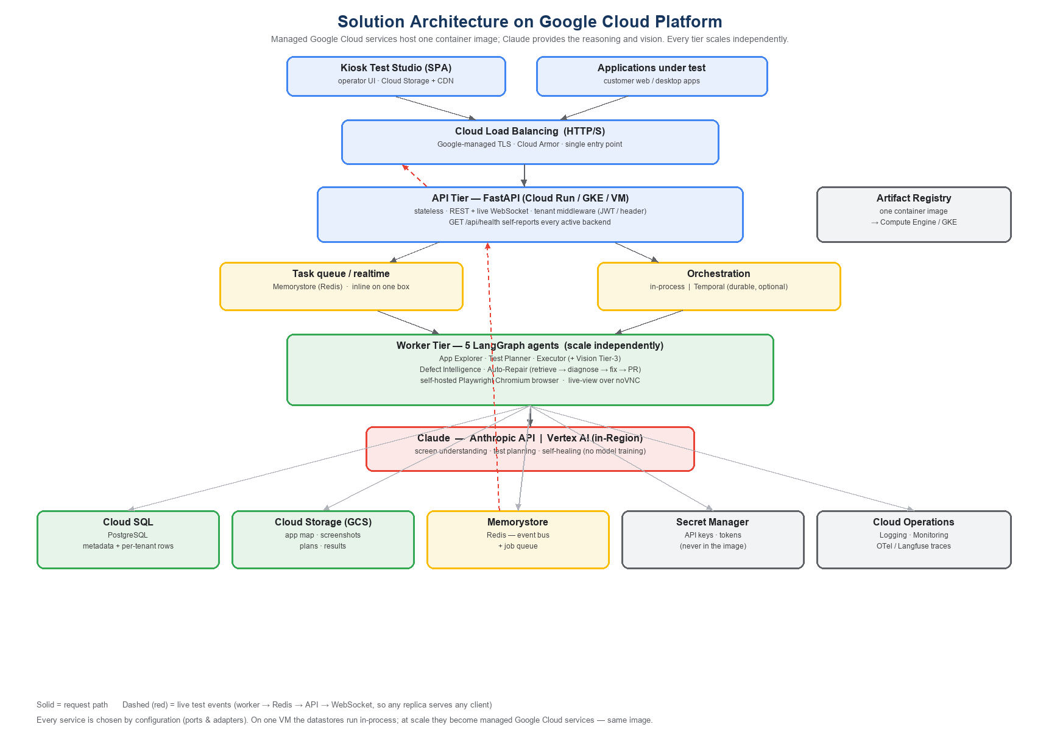
Figure 1 — Component view on Google Cloud Platform. Every box is selected by configuration; on a single VM the data services run in-process, and at scale they become managed Google Cloud services.
2.1 The five intelligent agents
The worker tier is built from five cooperating agents. Together they take an application from “never seen before” to “tested, with defects filed and a fix proposed.”
Agent | What it does
App Explorer | Crawls the application once and builds a knowledge graph of its screens, elements and transitions — no manual scripting.
Test Planner | Turns each test case into an executable plan from that knowledge graph. Planned once, then cached and reused.
Test Executor | Runs the plan against the live application, driving a browser; falls back to on-screen vision only when needed.
Defect Intelligence | Evaluates failures and generates a structured defect report automatically.
Auto-Repair | Retrieves the relevant code, asks Claude for the smallest safe fix, builds it, and prepares a pull request.

2.2 The three-tier execution model — why running cost stays low
Test execution is designed so that most steps cost nothing in AI terms:
- Tier 1 (cache) — a stable test replays a cached plan and matches screens locally — zero AI calls.
- Tier 2 (plan once) — an unplanned test is planned once with a single text request to Claude, then cached back to Tier 1.
- Tier 3 (vision) — only an unfamiliar screen or a failure triggers a per-screen visual call to Claude.
Steady-state execution is 0 AI calls. Claude is paid only for one-time discovery, first-time planning, and occasional Tier-3 vision — which is why running the same suites repeatedly does not increase cost.

3 Component Architecture on Google Cloud
Each responsibility maps to a managed Google Cloud service. The mapping below is what a deployment resolves to at scale; on a single VM the data services simply run co-located on the same machine.
Responsibility | Google Cloud service | Role in the platform
Compute (API + workers) | Compute Engine (VM) or Google Kubernetes Engine | Runs the one container image — a whole box for one customer, or auto-scaled pods for many.
AI reasoning & vision | Claude via Vertex AI (in-Region) or the Anthropic API | Screen understanding, test planning and self-healing. No model training.
Relational metadata | Cloud SQL for PostgreSQL | Kiosks, applications, test cases, runs, results and defects — with per-tenant rows.
Object storage | Cloud Storage (GCS) | Application maps, screenshots, cached plans and run evidence.
Realtime + job queue | Memorystore for Redis | Live test events to the operator, and the API→worker job queue when scaled out.
Ingress & TLS | Cloud Load Balancing (+ Cloud Armor) | A single managed HTTPS entry point with Google-managed certificates.
Secrets | Secret Manager | API keys and tokens — injected at runtime, never baked into the image.
Container images | Artifact Registry | Stores the built image consumed by Compute Engine or GKE.
Observability | Cloud Operations (+ OpenTelemetry / Langfuse) | Logs, metrics and end-to-end traces, including AI calls.
Browser under test | Self-hosted Playwright (in the worker) | Drives the application; a live view is available over a browser-based viewer.

The API tier is stateless, so it scales horizontally and needs no session affinity: live updates are delivered through Redis, which lets any API replica stream a test run that executed on any worker. A health endpoint reports, in plain terms, exactly which services a given environment resolved to — so every deployment is self-describing.
4 How a Customer Uses the Solution — Single Tenant
The simplest deployment is one Compute Engine virtual machine per customer, with the API, the worker, PostgreSQL, object storage and the cache all co-located. It is ideal for a single customer (with one or many applications) and for pilots. The end-to-end flow, from registering an application to reviewing a proposed fix, is shown below.
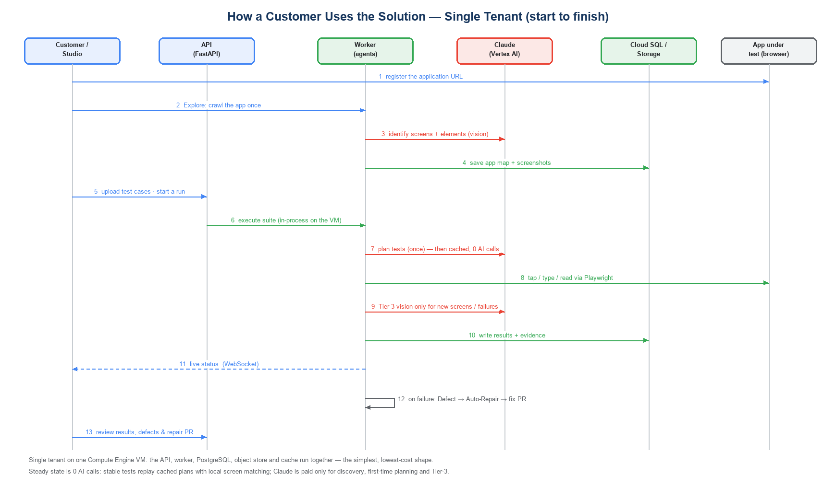
Figure 2 — Single-tenant flow on one Compute Engine VM, from application registration to results, defects and a repair pull request.
Discovery (step 2–3) happens once per application and repeats only on a major UI change. From then on, planned tests are cached and replay with local screen matching — so repeated runs are fast and essentially free of AI cost. When a test fails, Defect Intelligence and Auto-Repair run automatically and prepare a code fix for review.

5 How Customers Use the Solution — Multi-Tenant
To serve many customers economically, the same image runs on a shared Google Kubernetes Engine cluster with managed data services. Customers are separated logically: a tenant identity is resolved at the edge from a signed token (or a request header) and then automatically stamps every database row, every stored object and every live channel — so no customer can see another’s data, and there is no per-customer infrastructure to duplicate.
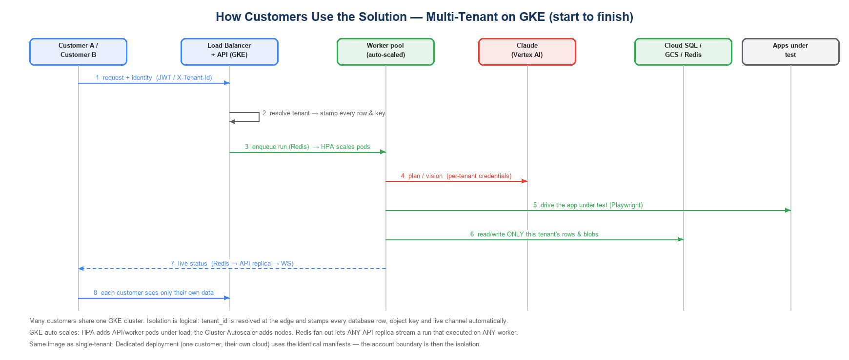
Figure 3 — Multi-tenant flow on GKE. Tenant identity is resolved once and enforced on every row, object and live event; the cluster auto-scales with demand.
The same solution supports two commercial models with no code change:
- Pooled SaaS — many customers share one Haibotix-operated cluster; isolation is by tenant identity. Lowest cost per application.
- Dedicated / self-hosted — one customer runs the identical image and manifests in their own Google Cloud project; the account boundary is the isolation, and tenant identity then separates their internal teams.
6 Cloud-Agnostic by Design — Configurable, No Lock-In
Every external service the platform depends on is reached through a small, swappable adapter chosen purely by configuration — there is no cloud-specific code in the application. The same container image therefore runs on Google Cloud, another public cloud, or on-premises; only configuration values change. Defaults reproduce a self-contained local deployment, so nothing external is required until a backend is explicitly selected.
6.1 The same capability on any platform
Capability | Configuration setting | Google Cloud | Other options
AI reasoning / vision | VISION_BACKEND | Vertex AI / Anthropic API | Anthropic API · AWS Bedrock
Relational metadata | DB_URL | Cloud SQL (PostgreSQL) | Any PostgreSQL · RDS · Azure DB · on-prem
Object storage | STORAGE_BACKEND / S3_ENDPOINT_URL | Cloud Storage | Amazon S3 · Azure Blob · MinIO · local disk
Realtime + queue | EVENT_BUS_BACKEND / TASK_QUEUE_BACKEND | Memorystore (Redis) | Any Redis · in-process (single box)
Orchestration | ORCHESTRATOR_BACKEND | In-process | Temporal | Temporal on any platform
Observability | TRACING_BACKEND | Cloud Operations | OpenTelemetry collector · Langfuse
Semantic memory | MEMORY_BACKEND | pgvector on Cloud SQL | Chroma · any pgvector
Multi-tenancy | MULTI_TENANT_ENABLED | on / off | identical on every platform
Runtime / scale | DEPLOYMENT_MODE | Compute Engine | GKE | Docker · any Kubernetes

Portability is a first-class design property, not a migration project. Moving to a different cloud is a change of configuration values — the database URL, the object-store endpoint, the cache address — not a change of code. This protects the customer from lock-in and lets the platform run wherever their data must live.

7 Scaling with Kubernetes for Multi-Tenancy
When one customer with many applications, or many customers, need to be served on shared, elastically-scaled infrastructure, the platform is deployed on Google Kubernetes Engine. The application code does not change — the same image is used — but the deployment shape and a few configuration values do. This section states exactly what changes.
7.1 What changes when moving to Kubernetes
Area | Single VM | Kubernetes (multi-tenant)
Compute | One VM runs everything | API and worker run as separate, independently-scaled Deployments (pods)
Data services | PostgreSQL, object store, cache co-located | Managed: Cloud SQL, Cloud Storage, Memorystore
Job handling | In-process (inline) | Redis-backed queue; API enqueues, workers consume
Live updates | Direct, in-process | Redis pub/sub fan-out — any API replica serves any client (no sticky sessions)
Auto-scaling | Vertical (bigger VM) | Horizontal Pod Autoscaler (pods) + Cluster Autoscaler (nodes)
Tenancy | Single tenant | Multi-tenant on: identity from JWT/header, enforced on every row, object and channel
Ingress | VM IP / single LB | Managed HTTP(S) Load Balancer + Ingress
Config | DEPLOYMENT_MODE=docker | DEPLOYMENT_MODE=k8s, MULTI_TENANT_ENABLED=true, Redis queue + bus enabled

7.2 How isolation and scaling work
- Isolation — a tenant identity is resolved at the edge and automatically applied to every database query, every stored object key and every live event — enforced centrally, so it cannot be forgotten at a call site.
- Elastic scale — the Horizontal Pod Autoscaler adds API and worker pods as load rises; the Cluster Autoscaler adds nodes when the pods need more room, and removes them when demand falls.
- Independent tiers — the API and worker tiers scale on different signals — a burst of test execution grows the worker pool without over-provisioning the API, and vice-versa.
- Per-tenant keys — at the database, natural keys are unique per tenant, so two customers may safely use the same internal identifiers without collision.
A shared Kubernetes cluster serving many applications is materially more economical than running one machine per customer, because the control plane, load balancer, database and worker pool are shared and scale to real demand rather than sitting idle.
Kubernetes is recommended when horizontal scale, independent API/worker scaling, or per-tenant elasticity is needed. For a single customer or a pilot, the single-VM shape (Section 4) is simpler and cheaper; moving between the two is a deployment choice, not a re-engineering effort.

8 Optional — In-House Auto-Repair with Local Models (Llama on a GPU + Microsoft GraphRAG)
By default, the Auto-Repair stage sends only a short failure description and the relevant code snippet to Claude, and receives back the smallest safe fix. For customers with strict data-sovereignty or air-gapped requirements, the platform offers a fully in-house configuration in which no source code, documents or reasoning ever leave the customer’s own Google Cloud project. This is a secondary, opt-in option; the default managed path remains the recommended choice for most customers.
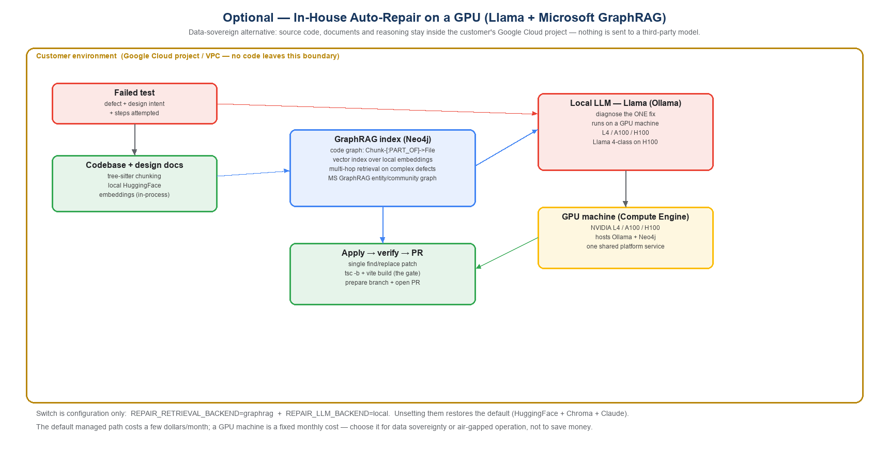
Figure 4 — In-house Auto-Repair. Retrieval, reasoning and code changes all run on the customer’s own GPU machine; nothing is sent to a third-party model.
8.1 What the in-house configuration uses
- Context retrieval (Microsoft GraphRAG + Neo4j) — a knowledge graph of the codebase and design documents is built in Neo4j — each code chunk is linked to the file it came from — enabling higher-precision, multi-hop retrieval on complex defects. Microsoft GraphRAG can enrich the same graph with entity and community summaries.
- Local embeddings — the code chunks are embedded locally with an open sentence-transformer model; the embeddings are computed in-process and never sent anywhere.
- Local reasoning (Llama) — an open Llama model, served locally through Ollama, diagnoses the one fix. Lightweight Llama models run on CPU for demonstration; Llama 4-class models run on a GPU machine.
- Same apply / verify / PR — the fix is applied, type-checked and built exactly as in the default path, and a pull request is prepared — all inside the customer’s environment.
8.2 The GPU machine
The local models run on a single GPU virtual machine in the customer’s Google Cloud project, hosting both the Neo4j graph and the Ollama model server. It is one shared platform service — not a per-application cost. Indicative Google Cloud GPU options (always-on):
GPU machine | Suitable for | Indicative monthly (on-demand)
1× NVIDIA L4 (24 GB) | Small / quantized models (marginal for Llama 4) | ~$650
1× NVIDIA A100 (80 GB) | Llama 4 Scout (quantized), lower throughput | ~$3,700
1× NVIDIA H100 (80 GB) | Llama 4 Scout (recommended) | ~$8,000
8× NVIDIA H100 (640 GB) | Llama 4 Maverick (full, largest models) | ~$64,000

This is a data-sovereignty and control choice, not a cost saving. The default managed path costs a few dollars a month at typical repair volumes; an always-on GPU machine is a fixed monthly cost from roughly $650 (L4) to $2,500–8,000 for a Llama 4-class model. Choose it when code must never leave the environment, or for air-gapped operation.
8.3 Switching it on
The switch is configuration only — two settings select the in-house retrieval and reasoning path; unsetting them restores the exact default behaviour (local embeddings + Chroma + Claude). No application code changes, and the default path is completely unaffected.
- REPAIR_RETRIEVAL_BACKEND = graphrag (Neo4j graph-RAG instead of the default local vector store)
- REPAIR_LLM_BACKEND = local (a local Llama via Ollama instead of Claude)
9 Security & Data Residency
- Data stays in-Region — all data — application maps, screenshots, results and metadata — stays in the customer’s chosen Google Cloud project and Region.
- Secrets — API keys and tokens live in Secret Manager and are injected at runtime; they are never baked into the container image or committed to source control.
- Tenant isolation — in multi-tenant mode, tenant identity is enforced centrally on every database row, object and live channel, so isolation cannot be bypassed by an individual code path.
- Full sovereignty option — the in-house model option (Section 8) removes any third-party model call, for air-gapped or sovereign deployments.
- Managed edge — a single managed HTTPS entry point (Cloud Load Balancing + Cloud Armor) fronts the platform; internal data services are not exposed to the internet.
10 Summary
The Haibotix Agentic QA Platform runs as one container image on managed Google Cloud services, with Claude as its reasoning and vision core. It discovers applications, plans and runs tests, validates outcomes, files defects and proposes fixes — keeping ongoing cost low through a caching-first execution model. It deploys compactly on a single VM for one customer and scales out on Kubernetes for many, with strong tenant isolation. Because every dependency is chosen by configuration, the same solution runs on any cloud or on-premises, and an optional in-house configuration keeps all code, data and reasoning inside the customer’s own environment.
Term | Meaning
App Explorer | The agent that crawls an application once and builds a reusable map of its screens and elements.
Three-tier execution | Cache → plan-once → vision; steady-state runs use no AI calls.
Tenant / multi-tenant | A tenant is one customer; multi-tenant means many customers share infrastructure with logical isolation.
Compute Engine / GKE | Google Cloud virtual machines / managed Kubernetes — the single-VM and scaled deployment shapes.
Cloud SQL / Cloud Storage / Memorystore | Managed PostgreSQL / object storage / Redis on Google Cloud.
Vertex AI | Google Cloud’s managed AI platform, through which Claude can be consumed in-Region.
GraphRAG | A graph-based retrieval method that builds a knowledge graph of code and documents for precise context retrieval.
Auto-Repair | The agent that retrieves code, diagnoses the fix, builds it and prepares a pull request.

Figures are indicative and based on published Google Cloud and Vertex AI list prices; final architecture and pricing depend on the customer’s Region, availability requirements and workload.

