Cloud-Agnostic Architecture — Kiosk-QA Platform
Branch: cloud-agnostic-agent · Backend of the robotic-vision-agent kiosk QA system
This platform is the run-anywhere counterpart of the AWS-native build. Every managed-AWS component is replaced by an open-source, portable equivalent selected purely by configuration (ports & adapters), so the same codebase deploys on Azure, Google Cloud, AWS EC2 or on-prem with no lock-in. Claude (via the Anthropic API or Bedrock) remains the reasoning and vision core for the App Explorer, Test Planner and Auto-Repair. Defaults reproduce the single-node local MVP byte-for-byte; nothing changes until a backend is switched.

1. Component View
The tiers below are each independently swappable and scalable. The API tier is stateless and horizontally scalable; heavy agent work runs in a separate worker tier; all state lives in external services (PostgreSQL, an object store, Redis).
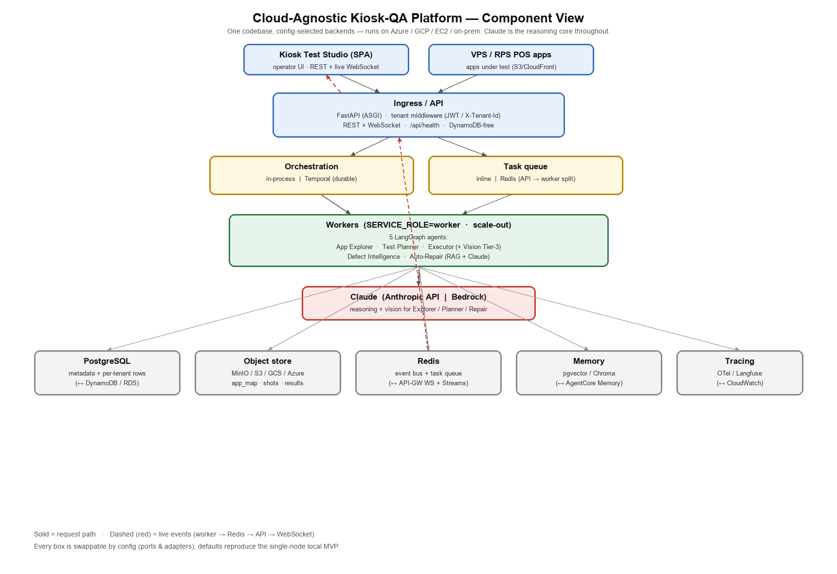

AWS component → cloud-agnostic replacement
Capability | AWS-native | Cloud-agnostic (config)
Reasoning / vision | Bedrock | Anthropic API (VISION_BACKEND)
Relational metadata | DynamoDB | PostgreSQL (PERSISTENCE_BACKEND, DB_URL)
Object store | S3 | MinIO / S3 / GCS / Azure (STORAGE_BACKEND, S3_ENDPOINT_URL)
Realtime + queue | API-GW WebSocket + Streams | Redis pub/sub + list (EVENT_BUS / TASK_QUEUE)
Agent runtime | AgentCore Runtime | Containers + worker tier (SERVICE_ROLE=worker)
Orchestration | Step Functions | In-process | Temporal (ORCHESTRATOR_BACKEND)
Observability | CloudWatch GenAI | OpenTelemetry / Langfuse (TRACING_BACKEND)
Semantic memory | AgentCore Memory | pgvector / Chroma (MEMORY_BACKEND)
Multi-tenancy | per-account | tenant_id rows + JWT/header (MULTI_TENANT_ENABLED)
IaC / runtime | CDK | Docker Compose | Kubernetes (same image)

2. Sequence View — Running a Test Suite
A simple end-to-end use case: an operator starts a suite from the Studio and watches it run live. The request path is solid; live events (dashed) flow back over Redis → API → WebSocket, which is what lets any API replica serve a client whose run executed on a different worker. Steady-state execution uses Tier-1 cached plans (0 LLM calls); Claude is invoked only for planning and Tier-3 vision fallbacks.
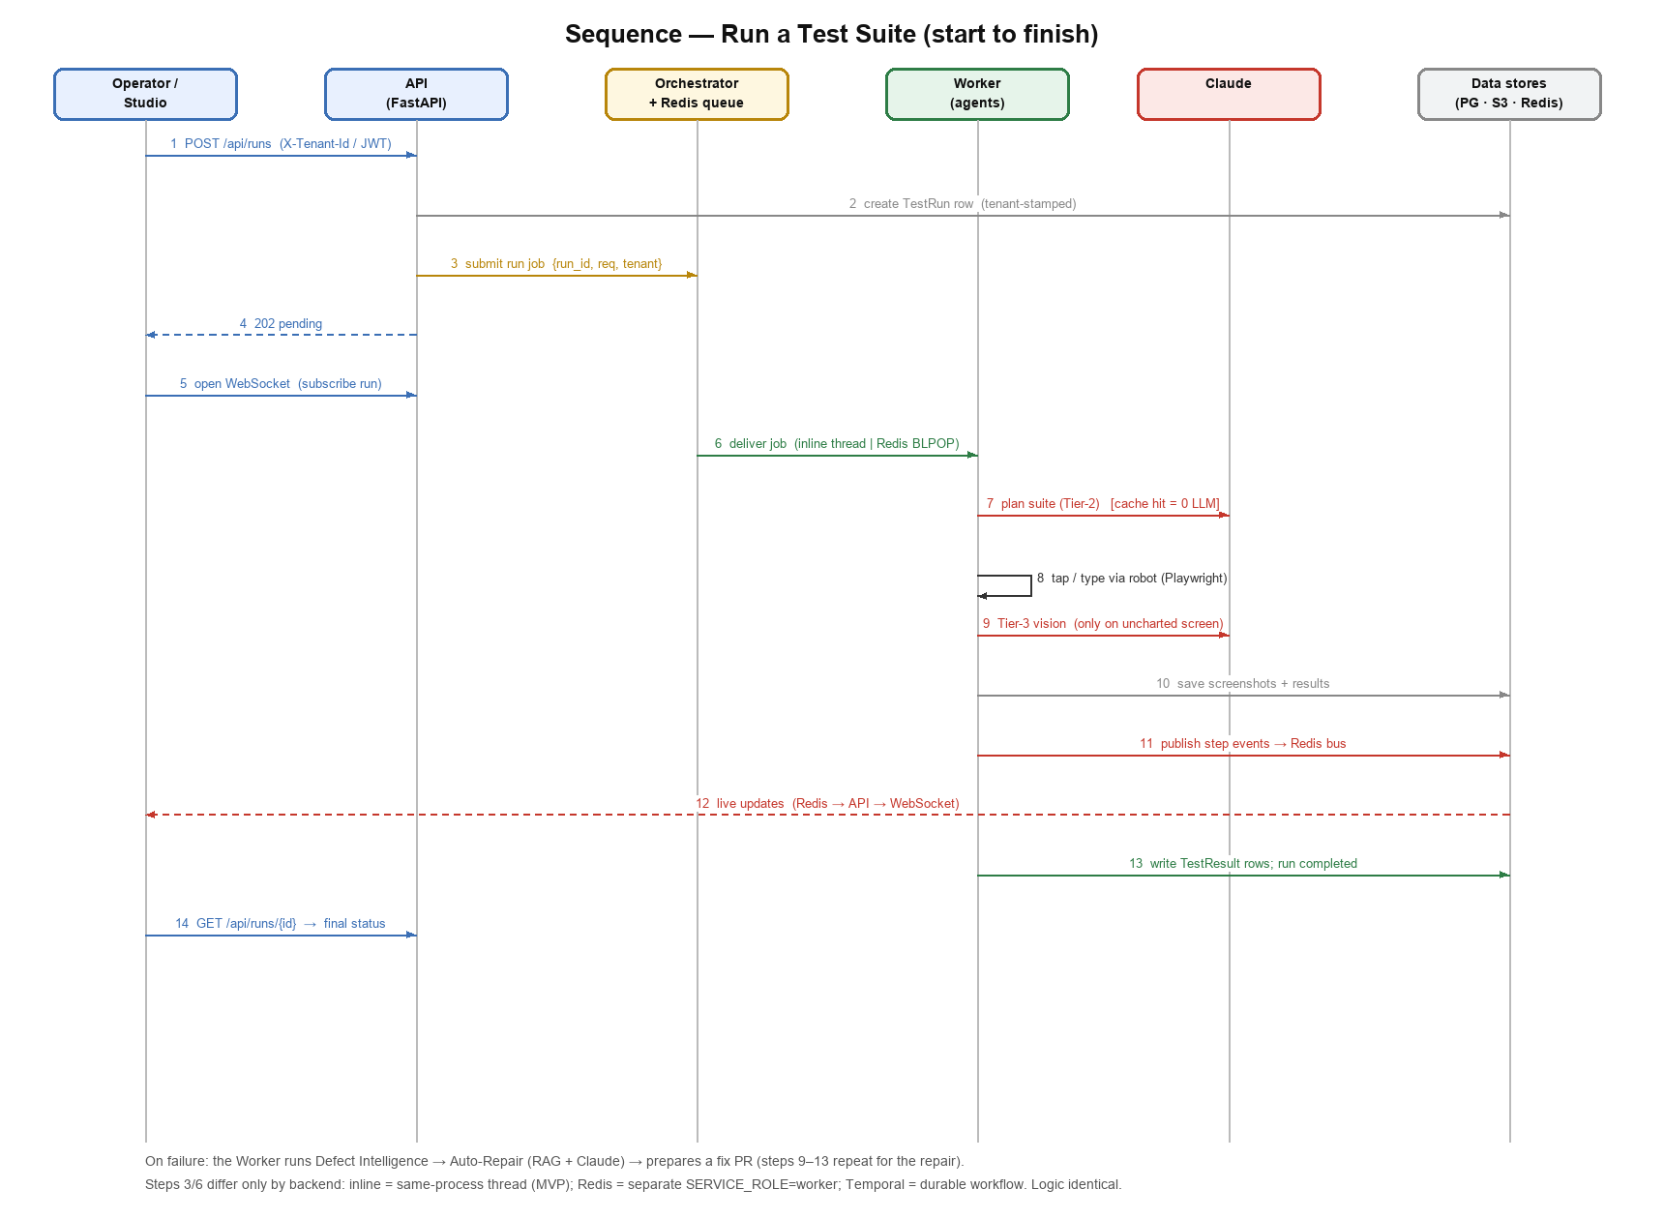
Backend variations (identical logic): step 3/6 is an in-process thread (inline, the MVP), a Redis-queued separate worker, or a durable Temporal workflow — chosen by config. In multi-tenant mode every DB row and blob key is namespaced by the tenant resolved in step 1.

