Self-Healing Test Automation
Auto-Repair with Microsoft GraphRAG + Neo4j + a local Qwen model
A demo walk-through — how it works, and the engineering behind it

Who this is for
You are giving (or watching) a demo and are NEW to Microsoft GraphRAG and Neo4j. This guide explains, in plain terms, what the system does, how the knowledge graph is built for our POS app, and how a failing test gets fixed automatically. It deliberately focuses on the work an AI engineer does by hand — choosing and shaping the data, building the graph, designing retrieval and prompts — rather than the model itself (the models are off-the-shelf; we just point the pipeline at them).

The one-line story: when an automated UI test fails, the system reads our own code + design docs as a knowledge graph, finds the responsible code, asks a local coding model for a minimal fix, applies it, and re-builds the app to prove the fix — with nothing leaving our machine.
1. A two-minute primer (for newcomers)
Retrieval-Augmented Generation (RAG)
An LLM is only as good as the context you give it. RAG means: before asking the model to do something, first fetch the most relevant pieces of your own material and put them in the prompt. The quality of that fetch decides the quality of the answer.
What makes Microsoft GraphRAG different
- Ordinary RAG: plain-text search finds passages that look similar to the query — but it doesn't understand how things connect.
- Microsoft GraphRAG: an LLM first READS all your material and builds a knowledge graph — a set of ENTITIES (the important things), the RELATIONSHIPS between them, and COMMUNITIES (clusters of related entities, each with an AI-written summary). Retrieval can then follow connections and use the big-picture summaries, not just look-alike text.
What Neo4j is
Neo4j is a graph database: it stores data as nodes (circles) joined by relationships (arrows), and lets you SEE it as a picture and query it. We load the GraphRAG output into Neo4j purely so the graph is explainable — you can point at it during the demo and say "here is the card, here is the transaction, here is the function that connects them."
The three GraphRAG words to remember
ENTITY = an important thing (a card, a transaction, a function). RELATIONSHIP = how two entities connect ("records", "has balance", "calls"). COMMUNITY = a cluster of closely-related entities plus a short AI-written summary of what that cluster is about.

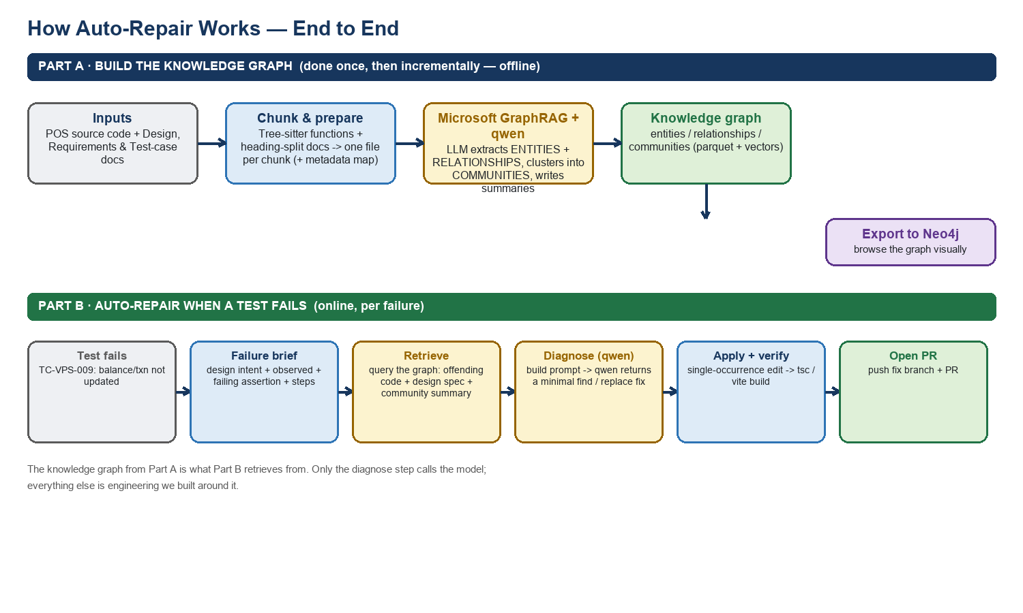
Figure 1 — End to end. Part A builds the knowledge graph once (then updates it incrementally). Part B uses that graph to repair a failing test.
2. Part A — Building the knowledge graph (the offline work)
This is where most of the hands-on engineering lives. The model does the extraction, but WHAT it reads, HOW it is chunked, HOW we describe the domain, and WHERE the results go are all decisions we make.
2.1 Choose and chunk the corpus
- What we feed it: the POS application source code, plus three documents: the Design, the Requirements, and the Test-Cases workbook (kept with the app under docs/Expanded_Version). These three + the code are the graph's entire world.
- How we chunk it: code is split by a code-aware parser (tree-sitter) into whole functions/components — so a function and its logic stay together. Documents are split by heading into focused sections. We skip noise (dependencies, build output, lock files) so it never pollutes the graph.
Why it matters: the graph can only ever "know" what we put in and how cleanly we cut it. This is a deliberate curation step, not an automatic one.
2.2 Prepare the inputs + a metadata map (the glue we build)
GraphRAG reads a folder of text files. So for each chunk we write one small text file, and — crucially — we keep a side map from every chunk back to its REAL source file and line numbers.
- Why the map: so that when the model later proposes a fix, we can apply it to the exact file and line in the real repo.
- Content-stable names: each chunk file is named by a hash of its CONTENT, so an unchanged function keeps the same identity between runs — this is what makes rebuilds INCREMENTAL (only changed code/docs are re-processed).
2.3 Point GraphRAG at our own model (run it fully in-house)
We generate GraphRAG's configuration to use our local models instead of a cloud service:
- Graph-building model: qwen2.5-coder:14b, served locally by Ollama through an OpenAI-compatible endpoint — this is the model that reads chunks and extracts the graph.
- Embeddings: a small local embedding model (nomic-embed-text) turns text into vectors for similarity search.
- Sizing: chunk size and the model's context window are set so prompts fit without truncation.
One model, two jobs
The SAME local model (qwen2.5-coder) that BUILDS the graph also DIAGNOSES the fix later. That keeps the whole pipeline on one in-house model — nothing is sent to any external service.

2.4 Define the domain — entities, relationships, communities for POS
This is the heart of shaping GraphRAG for OUR application. GraphRAG's extraction step asks the model, for every chunk: "list the entities of these TYPES, and the relationships between them." The entity TYPES and the examples we give are the lever that makes the graph meaningful for a Point-of-Sale app.
For the POS domain, the entities and relationships that matter look like this:
Entity type (POS) | Examples in our app | Typical relationships
Function / code unit | createApprovedStatusFromCardNumber(), recordCardTransaction() | CALLS, SHOULD-CALL, PERSISTS-TO
Domain object | SmartCard, PurchaseTransaction, Balance | HAS, RECORDS, UPDATES
Kiosk station | RPS Station (buy), VPS Station (validate) | RUNS, CHECKS, ISSUES
Module / endpoint | storage.ts, the shared card service | READS-FROM, WRITES-TO

GraphRAG then automatically clusters connected entities into COMMUNITIES and asks the model to write a short summary of each. For our app the natural community is the "Payment & Card-Reader flow" — the cluster that ties cards, balances, purchase transactions, the two kiosk stations, and the functions that connect them.
The key AI-engineer lever
Out of the box GraphRAG uses generic entity types and still produced a good graph for us. To sharpen it for POS, the engineer edits the extraction configuration: define domain entity TYPES (Function, SmartCard, Transaction, KioskStation, Endpoint…) and add a couple of worked POS examples to the extraction prompt. That single change is what steers the model to build a graph in the language of our product.

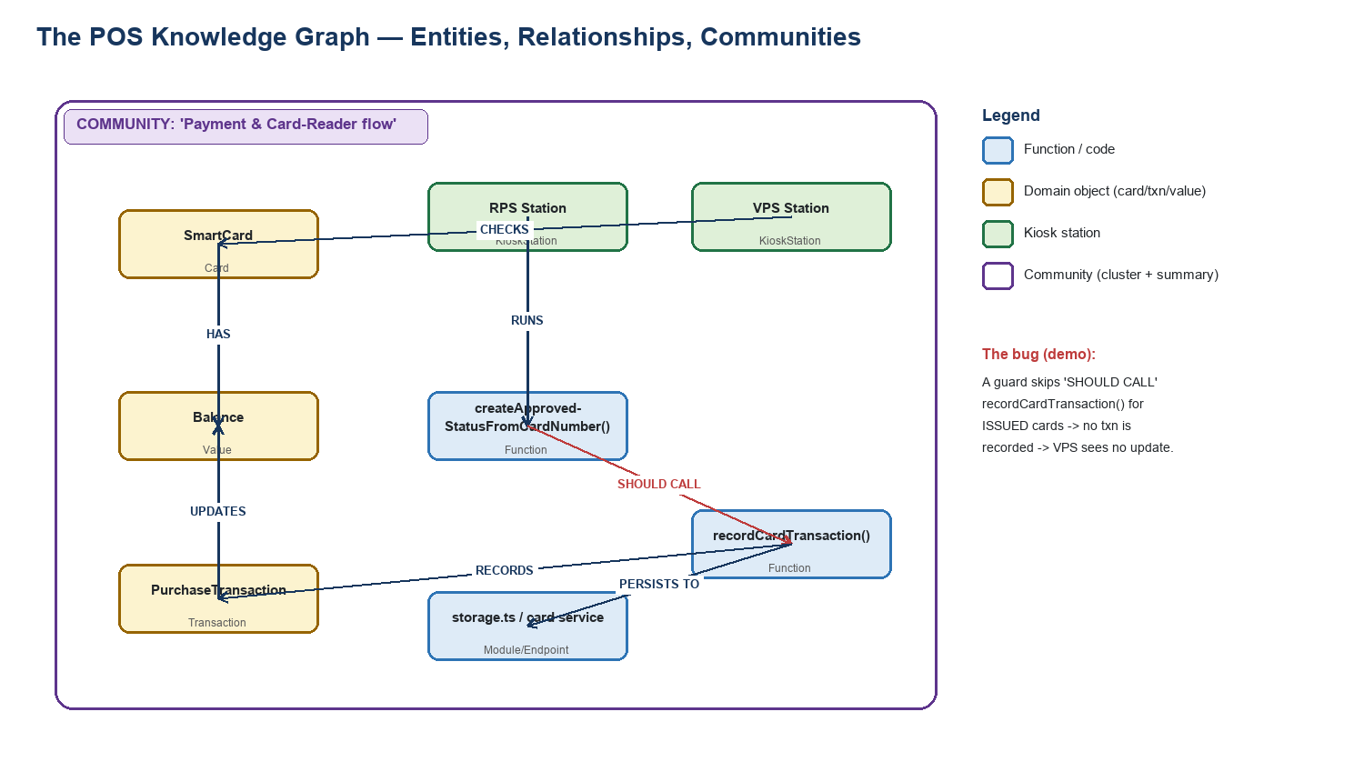
Figure 2 — The POS knowledge graph. Entities (cards, transactions, functions, stations), the relationships between them, and the community that groups the payment flow. The red edge is the link the demo bug breaks.
2.5 Run it — first full build, then incremental
- First build: the model makes one extraction call per chunk, then summarises each community. This is the slow, one-time step (~a couple of hours for our app on the GPU).
- After that: after a code or document change, we run GraphRAG's update — only NEW or CHANGED chunks are re-processed and merged. Routine re-indexing is therefore cheap.
2.6 Export the graph to Neo4j (so it is explainable)
GraphRAG's native output is data files. We wrote a small step that loads the entities, relationships and community summaries into Neo4j as browsable nodes and edges — this is engineering we added; GraphRAG does not do it for you.
Nodes: (:Entity {name, type, description}) (:Community {title, summary})
Edges: (:Entity)-[:RELATED {description, weight}]->(:Entity)
Explore in the Neo4j Browser:
MATCH (n) RETURN n LIMIT 200
MATCH (e:Entity)-[r:RELATED]->(x) RETURN e, r, x
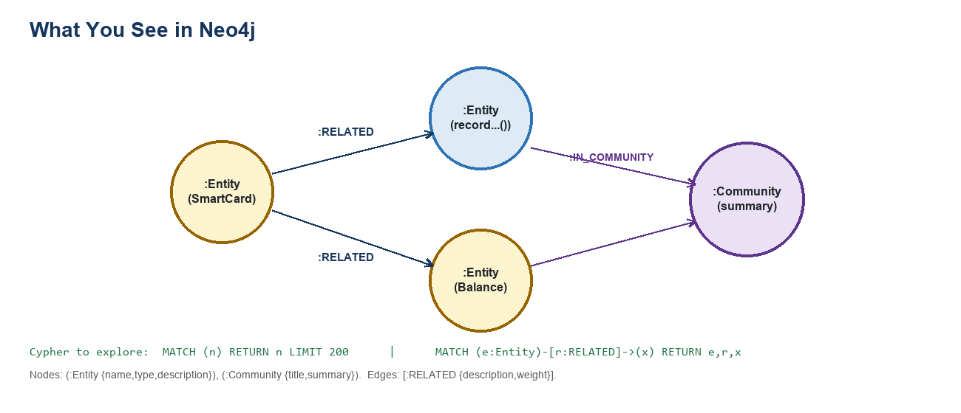
Figure 3 — The Neo4j view: entities linked by RELATED edges, grouped under community summaries.
3. Part B — Repairing a failing test (the online work)
Now the payoff. When a test fails, we use the graph to find and fix the bug. Only one step here calls the model; the rest is retrieval and verification we engineered.
3.1 Turn the failure into a clear brief
A raw test failure is not enough to reason from. We build a plain-English brief that leads with the DESIGN INTENT, then the observed result, the exact failing assertion, and the steps taken:
TC-VPS-009 failed. Check updated balance/history on the VPS station.
EXPECTED (design intent): a purchase at RPS reduces the card balance AND records a
PURCHASE transaction, visible when the card is checked at VPS.
OBSERVED: balance unchanged, no PURCHASE transaction.
Fix the ROOT CAUSE that PRODUCES/PERSISTS this state, not the text that displays it.
Why it matters: leading with intent (from the design doc, which is IN the graph) steers retrieval and the model toward the cause, not the surface symptom.
3.2 Retrieve the right context from the graph
We query the knowledge graph for the pieces most relevant to the failure and assemble them into the model's context:
- Code: the offending function(s) and their close siblings in the same module.
- Design spec: the exact design-doc rule the code must obey ("a purchase records a PURCHASE transaction").
- Community summary: the graph's summary of the payment cluster — the big-picture GraphRAG advantage.
Each retrieved piece is mapped back — via the metadata map from 2.2 — to its real file and line numbers, so a resulting fix is directly applyable.
3.3 Build the diagnose prompt and ask the model
We wrap the brief and the retrieved context in a tightly-worded instruction. The rules are what keep the model from "cheating" a test green:
- return ONE JSON object: { file_path, find, replace, explanation }.
- make the SMALLEST change; keep every unrelated guard/clause intact.
- "find" must be a distinctive, verbatim snippet that occurs exactly once (so it applies unambiguously).
- fix the ROOT CAUSE — do NOT relabel or hardcode a value just to match the expected text.
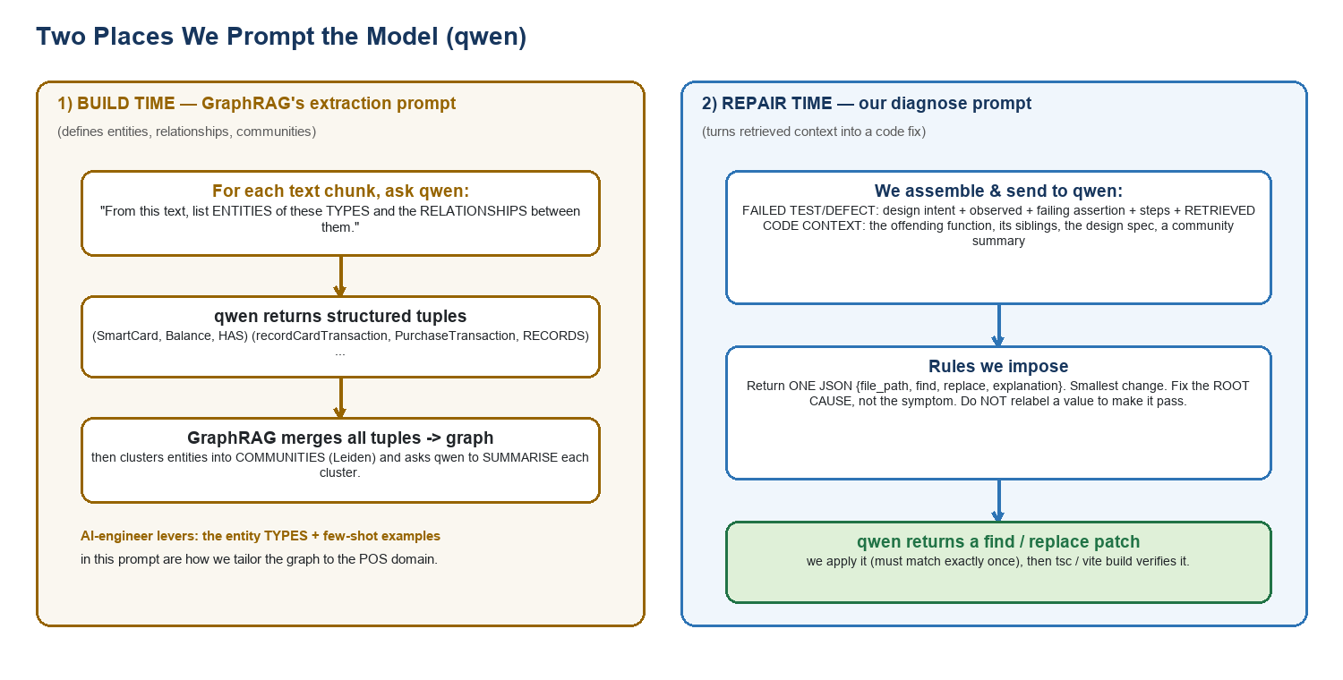
Figure 4 — The two places we prompt the model: (1) at build time to DEFINE the graph, and (2) at repair time to PRODUCE the fix.
3.4 Apply, verify, and open a PR
- Apply: the find/replace is applied to the real file (it must match exactly once, or we refuse).
- Verify: we run the TypeScript type-check and a production build (tsc + vite). The build passing is the objective proof.
- Propose: on a green build we commit the fix to a branch and open a pull request for human review.
Guardrails (so a bad fix can't slip through)
The patch is sanity-checked before it is applied (no no-ops, no bare tokens). The build must pass. In air-gapped mode nothing ever leaves the machine, and a slow/failed model call falls back safely instead of hanging.

4. The engineering behind it — what we do by hand
The models are ready-made; integrating them is a small part. The value is in these deliberate engineering tasks:
Task | What we build / tune | Why it matters
Curate & chunk the corpus | Pick the code + 3 docs; tree-sitter function chunks; heading-split docs; skip noise | Defines everything the graph can know
Prepare inputs + metadata map | One file per chunk; content-hash names; map chunk → real file & lines | Lets a fix target the exact code; enables incremental builds
Wire the local models in | Point GraphRAG at qwen (via Ollama) + a local embedder; set sizes/context | Runs fully in-house on one model
Define the POS domain | Entity TYPES + few-shot examples for cards, txns, functions, stations | Makes the graph meaningful for our product
Design retrieval | Fetch offending code + design spec + community summary; map back to source | Gets the RIGHT context to the model
Engineer the diagnose prompt | Failure brief + strict rules (root-cause, no relabel, single find/replace) | Steers the model to a correct, applyable fix
Apply, verify, guard | Exact-match apply; tsc/vite build gate; patch sanity checks; air-gap | Ensures the fix is real and safe

5. Demo script — what to show and say
- Open Neo4j — Show the graph (MATCH (n) RETURN n LIMIT 200). Point at an Entity (SmartCard), a RELATED edge, and a Community summary. Message: "the model read our code + docs and built this itself — no manual mapping."
- Show the inputs — Briefly show the 3 docs + the POS code — "this is all it was given; unstructured, no predefined links."
- Run the failing test — Trigger TC-VPS-009. It fails: the purchase isn't reflected on the VPS station.
- Watch Auto-Repair — The pipeline runs its stages live: Retrieve → Diagnose → Apply → Build → PR. Point out the "Retrieve" stage shows Microsoft GraphRAG + the local model.
- Open the diagnosis — Show the model's explanation + the find/replace patch, and the build result.
- Explain the outcome — If correct: the root-cause guard was fixed and the build passes. If not: explain it's a model-capability limit on the hardest bug (see box) — retrieval was right, reasoning is the lever.
Honest framing for the code-fix step
Building the graph and retrieving the right context works well. Producing the FIX depends on the model's reasoning. A 14B model handles simpler bugs but can miss the hardest root-cause bug (it may fix a symptom). The lever there is model size — we are evaluating qwen2.5-coder:32b on the same GPU — not more engineering. Being clear about this is a strength: the hard part (the knowledge graph + retrieval) is solved and model-agnostic.

Appendix — where things live
- parse_code_and_store.py: collect + chunk the corpus (code + design/requirements/test docs).
- ms_graphrag_store.py: build the GraphRAG inputs + metadata map, generate config, run index/update, export to Neo4j, retrieve.
- repair_failed_test.py: the diagnose prompt + apply/build/PR pipeline.
- docker-compose.yml / start-all.sh: one switch selects the stack — the local Microsoft GraphRAG + Qwen path is fully env-configurable.
- Models: qwen2.5-coder:14b (builds the graph AND fixes code) + nomic-embed-text (embeddings), served locally by Ollama on the GPU.

