Kiosk POS and SmartCardStation
Production Design Reference
System | Generic Kiosk POS and SmartCardStation
Primary Runtime | React, TypeScript, Vite, browser local storage, optional Node services

System Overview
The application is a browser-first kiosk platform containing two closely related experiences: the customer-facing Generic Kiosk POS and the operator-facing SmartCardStation. Both experiences are delivered by the same React/Vite application and switch behavior through query configuration.
- Kiosk POS handles sign-in, product selection, cart, payment, card tap flow, order result, and order history.
- SmartCardStation handles card issuance, real-card tap lookup, balance checks, money loading, and transaction-history display.
- The shared card service provides cross-kiosk visibility so a card issued at kiosk-1 can be validated and charged at kiosk-2.
- The card reader bridge isolates hardware-specific card input from browser UI logic.

Application Composition
Area | Design Detail
Frontend runtime | React 19, TypeScript, and Vite. The application is implemented primarily in src/App.tsx with supporting types, product data, storage helpers, and developer settings.
Kiosk selection | Default route opens the POS. Query values such as kiosk=card-station or kiosk=kiosk-1 open the SmartCardStation experience.
Storage model | Browser localStorage stores users, sessions, orders, smart cards, balances, and runtime settings for lab operation and fallback behavior.
Service model | Node/Express services support shared card records and local reader integration without coupling UI components to hardware APIs.

Kiosk POS Design
Screen | Responsibility | Primary State
signin / signup / forgot-password | Authenticate local users and manage basic account recovery paths. | users, currentUser, auth form state
products / cart | Select products, adjust quantity, and prepare checkout. | products, cartItems, selected category
payment / tap-card | Collect payment details or wait for a real card tap. | paymentDetails, activeReaderSession, cardReaderStatus
result / order-history | Show final payment result, order ID, balance, and prior orders. | orders, paymentStatus, smartCardRecord

SmartCardStation Design
- Issue Card creates a SmartCardRecord with card number, balance, source kiosk, status, and issued timestamp.
- Tap Real Card reads a card number through the reader path and loads the matching card record and ledger.
- Add Money updates the selected card balance and appends a LOAD transaction.
- Balance and transaction history are read from the shared card model when service mode is available.

Component and Data Flow Diagram
This component diagram shows where data is entered, where it is persisted, and how the two kiosk experiences fetch and update shared card state.
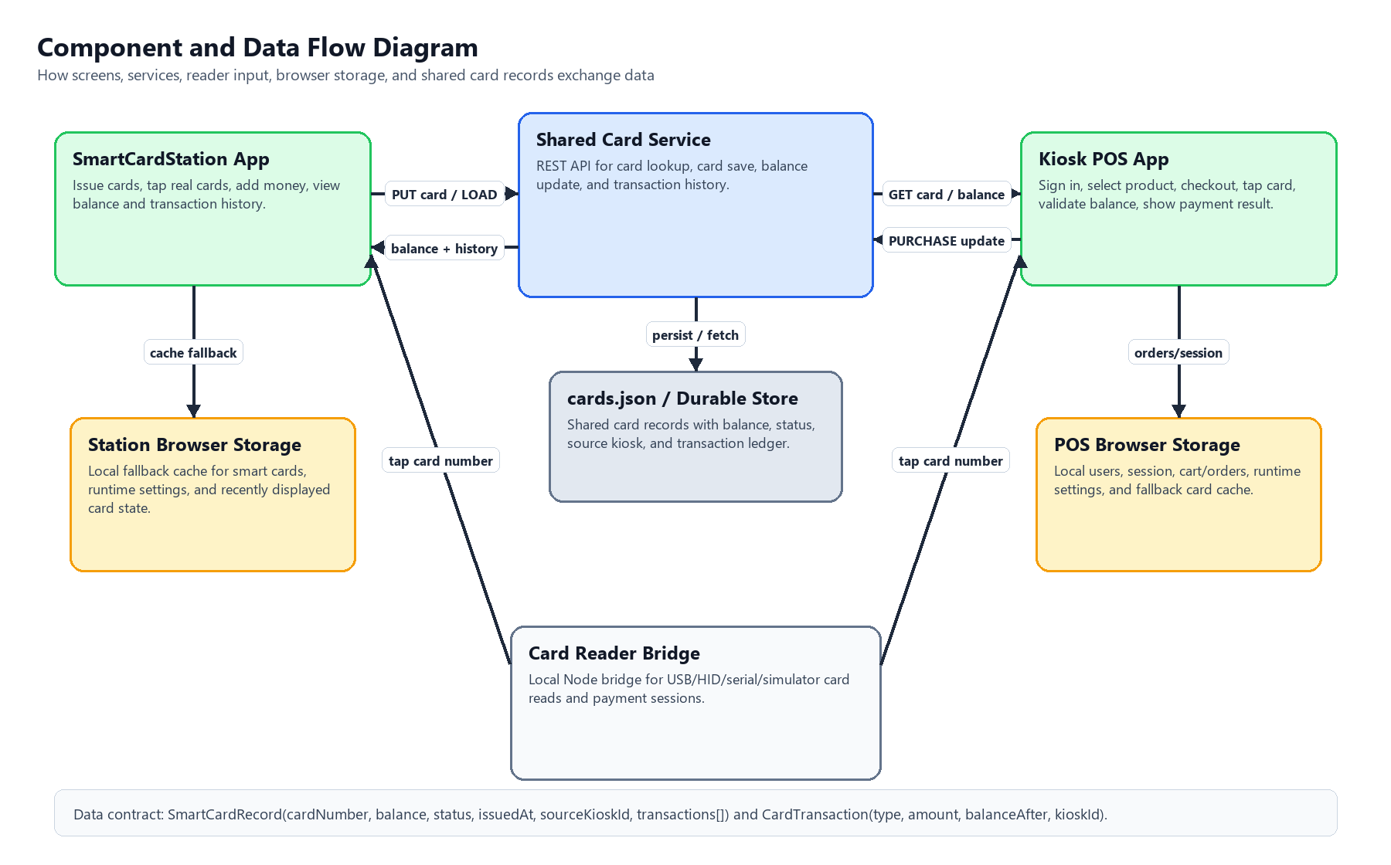

Cross-Kiosk Payment Sequence Diagram
This UML-style sequence diagram follows a card from issue/load at SmartCardStation through payment at Kiosk POS and final balance lookup back at SmartCardStation.
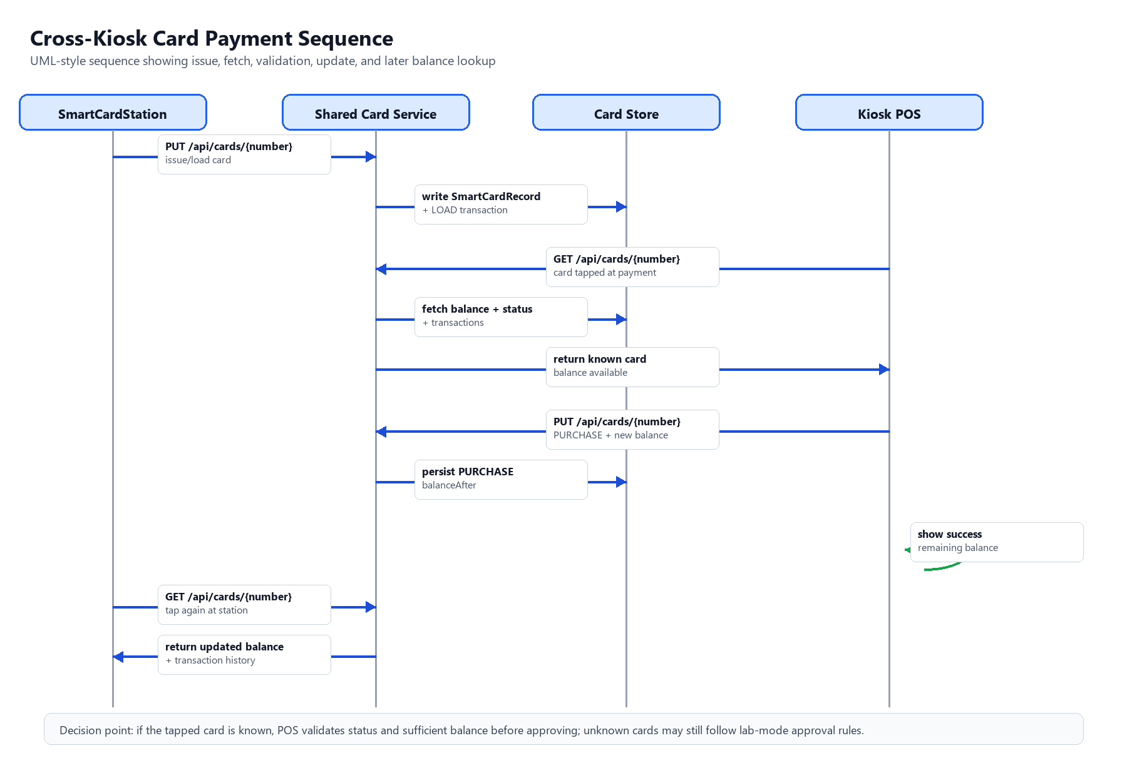

Shared Card and Balance Design
Entity | Fields | Operational Use
SmartCardRecord | cardNumber, balance, issuedAt, sourceKioskId, status, transactions | Canonical card balance and state.
CardTransaction | id, at, type, amount, balanceAfter, kioskId, note | Audit trail for LOAD, PURCHASE, and ADJUST activity.
Order | id, createdAt, items, subtotal, tax, total, payment, status | Customer transaction record linked to POS purchase result.

Payment and Card Reader Design
The payment path first normalizes the card number, then checks whether it is a known test card or an issued smart card. Known issued cards are balance validated. If the purchase succeeds, the card balance is reduced and a PURCHASE transaction is recorded.
Integration | Behavior
Card reader bridge | Runs as a local Node service and exposes reader status, payment-session start, polling status, and simulated tap endpoints.
Reader modes | Supports keyboard-wedge, HID, serial, and simulator modes so production hardware can be introduced without changing POS screen logic.
Fallback | Mock card and lab test cards remain available for controlled testing when hardware is not connected.

Service Design
Service | Default Port | Key Endpoints | Persistence
Shared Card Service | 4000 | GET /api/health, GET /api/cards, GET /api/cards/:number, PUT /api/cards/:number, POST /api/reset | card-service/cards.json
Card Reader Bridge | 4200 | GET /reader/status, GET /reader/hid-devices, POST /reader/start-payment, GET /reader/payment-status/:sessionId, POST /reader/simulate-tap | In-memory session state

Runtime Configuration
Configuration | Purpose | Typical Debug Check
VITE_CARD_SERVICE_ENABLED | Enables cross-kiosk card sharing. | If kiosk-2 cannot see kiosk-1 cards, confirm this is enabled.
VITE_CARD_SERVICE_URL / cardServiceUrl query value | Points the browser to the shared card service. | Confirm both kiosks use the same reachable service URL.
VITE_CARD_READER_BRIDGE_URL | Points the browser to the local reader bridge. | Check when tap-card waits indefinitely.
Developer runtime settings | Control delays, robot vision mode, keyboard layout, popups, and reader behavior. | Use to reproduce lab issues without code changes.

Operational Debugging Map
Symptom | Likely Area | Recommended First Inspection
Card issued at kiosk-1 is missing at kiosk-2 | Shared Card Service | Check service health, browser service URL, and cards.json contents.
Payment approves unknown cards but not issued cards | Payment decision logic | Inspect normalized card number and SmartCardRecord balance.
Tap card screen does not advance | Card Reader Bridge | Check bridge mode, active session ID, status endpoint, and reader timeout.
Balance is not reflected at station after purchase | Transaction persistence | Check PURCHASE transaction and balanceAfter on the shared card record.
Login or navigation behaves differently in lab modes | Runtime query configuration | Verify screenLayout, flowMode, and developer setting overrides.

