CSM

✅ WHEN SIMULATION IS THE APPROPRIATE TOOL
Simulation is useful when:
- The system is too complex to study directly.
- You want to test changes (rules, designs, or processes) without disturbing the real system.
- To check “what-if” scenarios (e.g., what if more machines are added?).
- To train people without real-world risks.
- To visualize how a system works (through animation).
- To study interactions between variables and find which factors matter most.

🚫 WHEN SIMULATION IS NOT APPROPRIATE
Avoid simulation when:
- The problem can be solved with simple logic or formulas.
- You can do real experiments easily and cheaply.
- There is not enough data, time, or resources.
- Costs are more than benefits.
- Expectations are unrealistic (wanting quick answers).
- The system behavior is too complex to even define properly.

👍 ADVANTAGES OF SIMULATION
- You can test new ideas without affecting real systems.
- Saves cost by avoiding trial-and-error in reality.
- Helps understand how a system really works.
- Can speed up or slow down time to study results.
- Finds bottlenecks (where delays happen).
- Good for answering “what-if” questions.

👎 DISADVANTAGES OF SIMULATION
- Building models requires special skills and time.
- Results may be hard to interpret (due to randomness).
- Expensive and time-consuming sometimes.
- People may use simulation even when simple methods are better.

🌍 AREAS OF APPLICATION
Simulation is used in many fields:
- Manufacturing (factory operations, machine performance).
- Business (sales forecasting, retail management).
- Construction & Project Management.
- Logistics & Transportation (inventory, supply chains, airports).
- Military (training, logistics, battle simulations).
- Healthcare (hospital management, emergency rooms).
- Others (call centers, workforce planning, even sports like golf).

🏷️ TYPES OF MODELS
- Mathematical vs. Physical
  - Mathematical: equations and symbols.
  - Physical: scaled models (toy plane, solar system).
- Static vs. Dynamic
  - Static: represents one point in time.
  - Dynamic: shows changes over time.
- Deterministic vs. Stochastic
  - Deterministic: no randomness, fixed results.
  - Stochastic: includes randomness (e.g., random arrivals in a bank).
- Discrete vs. Continuous
  - Discrete: changes at specific times (e.g., customers entering a bank).
  - Continuous: changes all the time (e.g., water level in a dam).

🪜 STEPS IN A SIMULATION STUDY
- Problem Formulation → Define the problem clearly.
- Set Objectives & Plan → Decide goals, cost, time, and people.
- Model Conceptualization → Start simple, then add details.
- Data Collection → Gather data for the model.
- Model Translation → Convert the model into computer code.
- Verification → Check if the program works correctly.
- Validation → Compare with real system to ensure accuracy.
- Experimental Design → Decide which models/alternatives to test.
- Production Runs & Analysis → Run the model and analyze results.
- More Runs? → Repeat if more data is needed.
- Documentation & Reporting → Record methods, results, and insights.
- Implementation → Use the results in the real system.

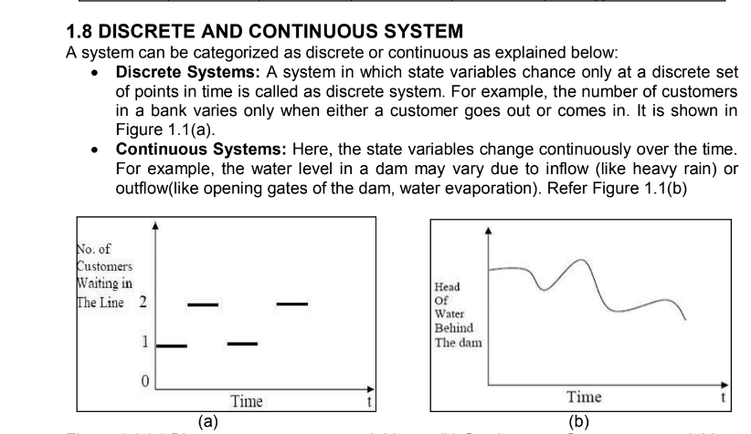

Got it 👍 You need definitions + one example for any 5. I’ll write them short and simple so they are exam-friendly.

1) Simulation
Imitation of a real-world process/system over time to study its behavior.
👉 Example: Simulating traffic flow in a city.

2) Model
A simplified representation of a system used for study and analysis.
👉 Example: A computer model of a bank showing customer arrivals and service.

3) System
A group of objects working together to achieve a purpose.
👉 Example: A hospital with doctors, patients, and equipment.

4) System Environment
External factors that affect a system.
👉 Example: Weather affecting crop growth in a farming system.

5) Entity
An object of interest in the system.
👉 Example: A customer in a bank simulation.

6) Attribute
A property/characteristic of an entity.
👉 Example: A customer’s account balance in banking.

7) Activity
A process that takes time in the system.
👉 Example: A cashier serving a customer.

8) State
Collection of variables describing the system at a given time.
👉 Example: Number of customers waiting in a queue.

9) Event
An instantaneous occurrence that changes the system state.
👉 Example: A new customer arriving at the bank.

10) Endogenous
Events/activities happening inside the system.
👉 Example: A machine breakdown in a factory.

11) Exogenous
Events/activities happening outside the system but affecting it.
👉 Example: A power failure stopping factory production.

Perfect 👍 Here are the 5 easiest ones written in a neat exam-friendly 3–4 line style with examples:

1) Simulation
Simulation is the imitation of a real-world system to study its behavior over time. It helps in predicting performance without disturbing the actual system.
👉 Example: Simulating traffic flow in a city.

2) Model
A model is a simplified representation of a system that helps in understanding and analyzing it. It includes only the important parts of the real system.
👉 Example: A computer model of a bank showing customer arrivals and services.

3) System
A system is a collection of objects that work together to achieve a purpose. Each part interacts with others to produce results.
👉 Example: A hospital system with doctors, patients, and staff.

4) Entity
An entity is an object of interest in a system. It is the item we want to observe or study.
👉 Example: A customer in a bank simulation.

5) Event
An event is an instantaneous occurrence that changes the state of the system.
👉 Example: Arrival of a new customer in a bank queue.

Got it 👍 Here’s a 5-mark answer for Simulation applications in Logistics and Transportation written in a short and simple exam style:

Simulation Applications in Logistics and Transportation
Simulation is widely used in logistics and transportation to improve efficiency and reduce costs.
- It helps in inventory analysis for warehouses and supply chains.
- Used for planning and managing supply networks (e.g., semiconductor or computer manufacturing).
- Helps in analyzing passenger flows in airports and public transport systems.
- Useful in designing and testing distribution systems before implementation.
- Applied for traffic and pedestrian flow simulations in public areas.
👉 In short: Simulation helps to optimize movement of goods and people, reduce delays, and improve overall logistics and transportation efficiency.

Would you like me to also make this in a bullet-point only style (just 5 clear points, no explanation) for very quick writing in exam?

