

**EduFarm**

**PROJECT FINAL REVIEW**

Submitted for CAL in B. Tech Human Computer Interaction

Faculty: - Dr. Jagadeesh Kannan

Slot-B1+TB1

(SCHOOL OF COMPUTER SCIENCE AND ENGINEERING)

**GROUP MEMBERS**: -

Piyush Bamel 16BCE1221

Kaustubh Nagar 16BCE1338

**ACKNOWLEDGEMENT:**

We would like to express our special thanks of gratitude to our **Human Computer Interaction** faculty, **Dr. Jagadeesh Kannan**, who gave us the golden opportunity to do this wonderful project on the topic “**EduFarm**”, which also helped us in doing a lot of research and we came to know about so many new things. We are really thankful to you. Secondly, we would also like to thank our group members in finalising this project within the limited time frame.

INDEX

1 Introduction ……………………………………………………………………………………Page 1

2 Literature Survey ………………………………………………………………………………Page 2-3

3 Architecture Diagram …………………………………………………………………………..Page 4-5

4 Methodology ……………………………………………………………………………………Page 6-7

5 Results ………………………………………………………………………………………….Page 8

6 Discussion ………………………………………………………………………………………Page 9

7 References ………………………………………………………………………………………Page9

**Introduction**

Farmers still follow their conventional ways and don’t have adequate resources about which crop to grow when and where, due to which plantation of inappropriate crops is done resulting in loss of huge amount of grains. They also don’t have knowledge of natural disasters or sudden climatic changes.

So, this website will educate farmers and other agricultural students the best crop that can be grown in a certain climatic region with factors like amount of rainfall, type of soil, temperature and many more playing a major role in the result. It also has course material to educate farmers in smarter farming techniques using modern technology and also gives agricultural students access to course material posted by different universities that offer agriculture related courses. The farmers are notified about the disasters and solutions they can take in order to minimise the damage caused. It also informs the local agriculture officers in the region so that the farmers that do not have the access may be notified by the authorities and preventive measures can be taken in time.

**Literature Survey**

It is a well-established fact that the Indian economy is an agrarian one & thus it is imperative that modern technology helps in improving agriculture. When we speak about a digital India, our focus shouldn’t only be on making digital wallets mainstream or storing our biometric information in an online database. Instead a true digital India will be one, where even an occupation as conventional as agriculture is influenced by technology in a positive manner.

The main challenge facing our farmers today is that of efficiently growing crops that are commercially rewarding. So, to make agriculture a more productive sector we need to ensure that the concerned stakeholders are aware of the crops that are best suited to their conditions and can be grown frugally. This is something that this website aims to achieve. Given information about the rainfall, temperature and soil, our unique algorithm predicts the crop that will be best suited to the conditions. Obviously, it is not a magic solution to change the fortunes of the farmers overnight but then again it is something that will tell the farmers where to start from.

However, only suggesting crops to farmers will be futile unless there are suitable innovations in the farming techniques. Just as, prudent driving can only prevent accidents, but improved fuel efficiency is something that can only be achieved through automotive engineering. Thus, for the betterment of agricultural sector it is equally important that technology aids those involved in the study of agriculture. So, our website will also have weekly education video and study material intended to benefit the erudite students of agricultural sciences. These materials will save the students from the onerous task of surfing through thousands of pages for getting the required information.

However, all these will only be fruitful when the users can completely comprehend the functionalities of the website. We understand that all our users may not possess the technological acumen to make best use of our software. To eradicate any complications whatsoever in using our software, we have provided a Frequently Asked Questions(FAQ) section to answer some of the most common questions. Additionally, there is a facility to get assistance from a technical expert for more advanced understanding of this software. Apart from these, a toll-free helpline is provided to get verbal help from any of our trained technicians.

We have made this product with the aim of helping farmers and the agricultural sector in general, which forms the backbone of our economy, and we hope that it will be successful in achieving its intended purpose and be another step towards the realisation of the dream of a Digital India.

**Architecture diagram**

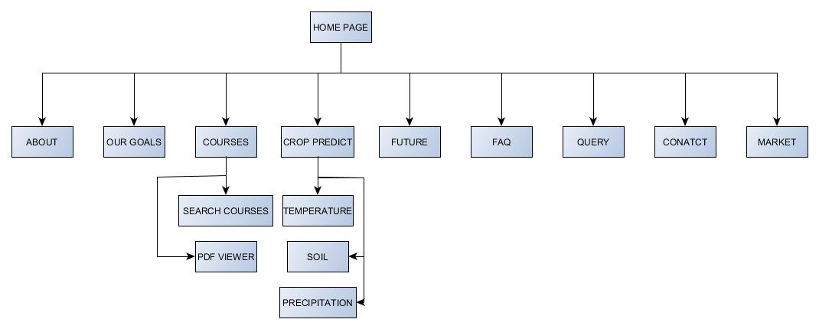

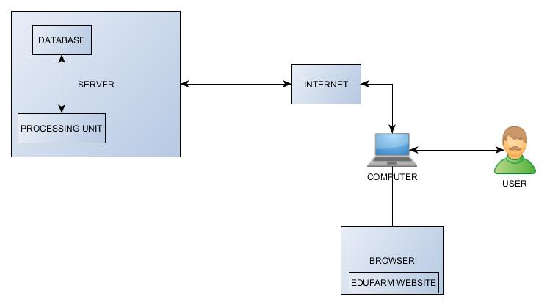

**Client Server Architecture:**

This architecture partitions the tasks between the providers of the resource (the website server or the backend) and clients (the user systems using the website). By accessing the server, clients are then able to reach shared files and information saved on the serving computer. Client server architecture makes it possible for multiple computers or people to connect to the server and access the services and information available. Major use of the client server network is allowing a shared database or site to be accessed and used by multiple computers while maintaining only one control centre for the action. This makes it possible for companies to distribute information, upload data, or reach the client systems (users) without being tied down to one individual computer site.

EduFarm portal has back-end code that is written in php. The php code runs in the server. The user interacts with the html components of the website, and the server processes the query using the server. The records of the user and other details are stored in a MySQL database which also exists on the server. Every successful user action is reflected by a change in the database.

**Methodology (Phase wise description)**

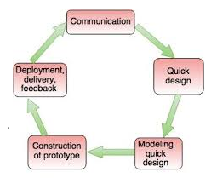

We have used the evolutionary prototyping model in our project:

It refers to building a basic system with the minimal functionalities in the beginning which acts as the heart of the system on which the entire project is build. It helped us to improve the website by adding various functionalities at each iteration, the system went through severe user interaction at the end of each iteration improving the platform each time. The user feedback after each iteration helped in making interface much more user friendly and improving the user response.

**Iteration 1 :** We implement the basic idea of the website for EduFarm, which includes basic web pages made with the help of HTML, CSS, Javascript. We provide text area for writing temperature, rainfall, type of soil for prediction of suitable crop. We also provide some pdf’s on farming techniques and crop production. We provide all the functionalities along with all the validations.

**Analysis after user interaction post deployment**

Since our users are mostly novice users(farmers), they require the website to be very simple and straight forward. User should not have any confusion or difficulty in finding the stuff whatever they want to like any courses to learn or to do crop prediction process. They should be guided by the website in the correct manner.

**Iteration 2:** The users may also get difficulty in operating the website and may also get queries regarding any topic. So, we also include query box in which they can write whatever difficulty they are facing on the website or questions they want to ask about agricultural techniques.

Further, we also provide users with option to contact experts in case of any confusion or difficulty regarding website or any topic related to farming.

We make the website more interactive and icons clearly visible like writing temperature in separate text area, rainfall in other text area and so on. We also provide FAQ’s for learning purposes. Also they get notification on their phones or email id after they submit their queries in very less time.

**Analysis after user interaction post deployment**

The users need to have an alert regarding weather and climate. Sometimes they are unaware of any natural calamity or drastic weather changes which can damage their crops.

**Iteration 3 (FINAL):** We add a weather alert in the website which updates on a regular basis which can make them aware of chances of any natural calamity or sudden changes in weather. So , this interactive and simple website proves to be useful for the farmers as well as agricultural students. We used AJAX in the website so that we can the desired results without reloading.

For the prediction of the crop**, multinomial regression algorithm** is used.

Since it is a public website, we can deploy it to the customers and get feedback and reviews for the website to make it bug free and successful.

Once the customers starts using the developed system then the actual problems comes up and needs to be solved from time to time. This process where the care is taken for the developed product is known as maintenance.

**Results**

As a result, we have successfully built the ‘EduFarm’ website as expected. This will prove beneficial to the farmers in terms of increase in crop production through crop prediction methods involving temperature, type of soil, and precipitation.

Farmers still use the conventional crops and conventional methods for the crop production which may not be efficient according to today’s environment. So, the website also provides some basic courses related to farming which can enhance farming techniques.

It also helps in clearing any doubts related to the topic by using query box. So, the user can write the query in the given space and the problem can be solved. It also provides the feature of weather alert for natural calamities.

Also, it can be beneficial to the agricultural students who lack good resources and it can be used by them as a guide as it has various pdf’s related to subject of farming and they can also predict crop best fitted production with the help of the website.

And at last if the user wants to get their doubts cleared about anything related to website, then they can also contact to the numbers given in the website.

**Discussion**

This is not a final implementation. There is a lot of scope for improvement both in terms of user interactivity and general features**. Augmented Reality** can be included to give suggestions on methods of farming.

This website proves to be beneficial for the farmers as they get chance to learn modern techniques of farming which is very efficient in terms of crop production. They also get to know about which crops will be suitable to grow by checking temperature, type of soil, precipitation and various other factors.

**References**

https://www.youtube.com/

https://www.w3schools.com/

https://www.willyweather.com/