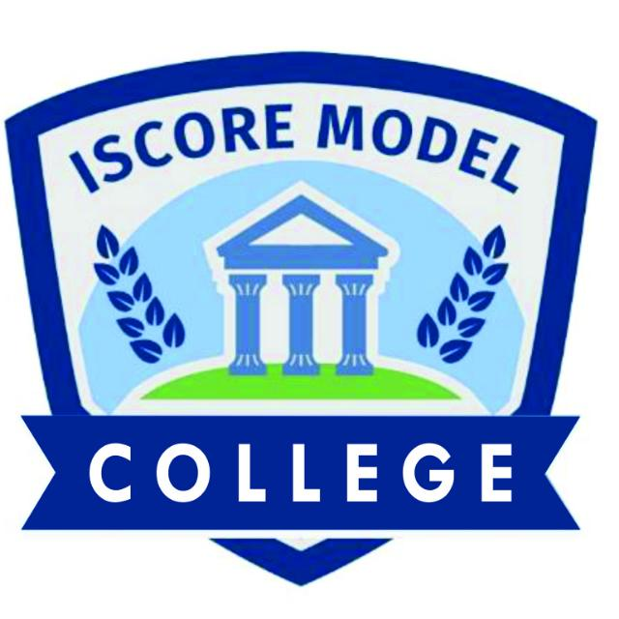
ISCORE MODEL COLLEGE REPORT CARD  Motto: Integrity and Excellence  13, Alagbole rd Ajuwon Near Kayode Plaza, Ajuwon Bus-Stop, Ogun State  Tel: 09032396312, 08130186400 | {{image}}

Class: {{student_class}} | Student ID: | {{student_id}}
Name of student: | {{student_name}}
Number of Day(s) school resumed: | 65
Number of days(s) present:
School term | {{term}}
Academic session | {{session}}

S/N | SUBJECT | TEST | PRACTICAL | EXAM | TOTAL | GRADE | INTERPRETATION

NUMBER OF SUBJECTS OFFERED: | {{number_of_subject}} | 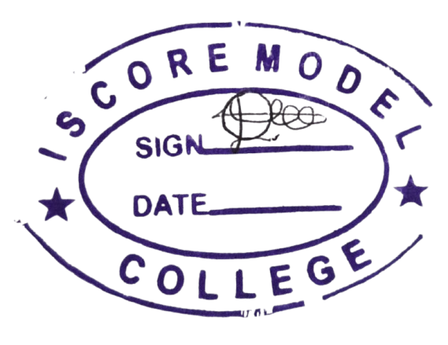
CUMMULATIVE SCORE: | {{cumulative_score}}
EXPECTED TOTAL: | {{expected_total}} | {{date_printed}}
PERCENTAGE: | {{percentage}}%
NUMBER OF DISTINCTIONS: | {{number_of_distinction}}

TEACHERS COMMENT: {{teachers_comment}}

PRINCIPAL’S SIGNATURE: ____________________ DATE: ______________________

