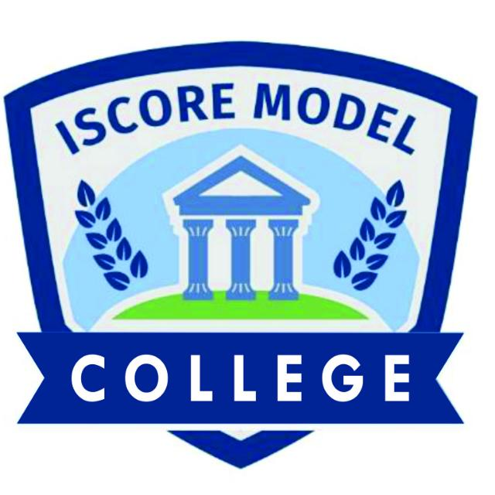
ISCORE MODEL COLLEGE REPORT CARD  Motto: Integrity and Excellence  13, Alagbole rd Ajuwon Near Kayode Plaza, Ajuwon Bus-Stop, Ogun State  Tel: 09032396312, 08130186400 | 

Class: SS1 | Student ID: | ISMC2024SS1001
Name of student: | Clement John
Number of Day(s) school resumed: | 65
Number of days(s) present:
School term | 1st
Academic session | 2024/2025

S/N | SUBJECT | TEST | PRACTICAL | EXAM | TOTAL | GRADE | INTERPRETATION
1 | MATHEMATICS | 23 | - | 54 | 77 | A | EXCELLENT
2 | CHEMISTRY | 26 | - | 38 | 64 | B | VERY GOOD

NUMBER OF SUBJECTS OFFERED: | 2 | 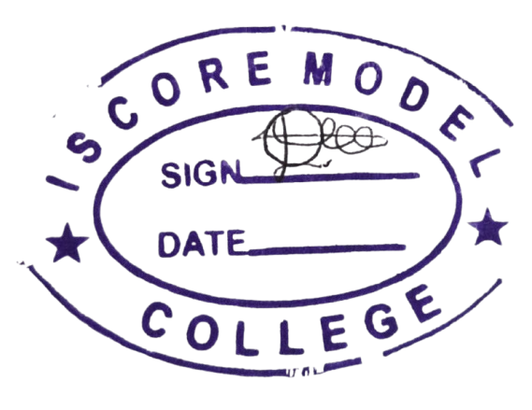
CUMMULATIVE SCORE: | 141
EXPECTED TOTAL: | 200 | 20/11/2024
PERCENTAGE: | 70.5%
NUMBER OF DISTINCTIONS: | 1

TEACHERS COMMENT: An excellent perfomance

PRINCIPAL’S SIGNATURE: ____________________ DATE: ______________________

