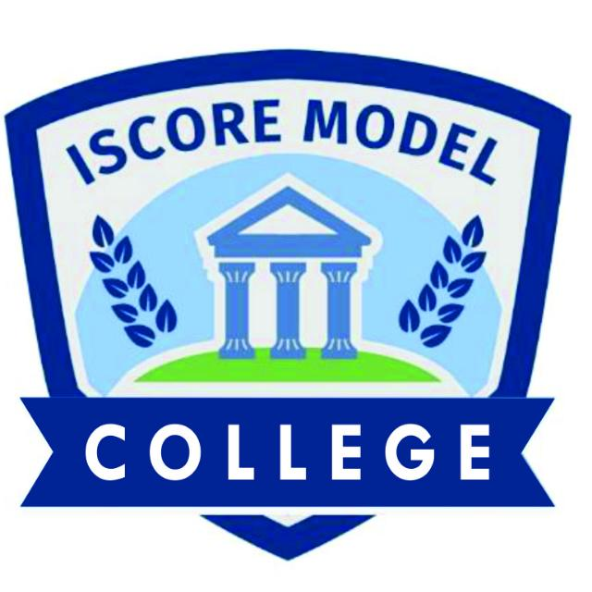

|  |  |
| --- | --- |
| **ISCORE MODEL COLLEGE REPORT CARD**  Motto: Integrity and Excellence  13, Alagbole rd Ajuwon Near Kayode Plaza, Ajuwon Bus-Stop, Ogun State  Tel: 09032396312, 08130186400 | {{image}} |

|  |  |  |
| --- | --- | --- |
| Class: {{student_class}} | **Student ID**: | {{student_id}} |
| Name of student: | {{student_name}} | |
| Number of Day(s) school resumed: | 65 | |
| Number of days(s) present: |  | |
| School term | {{term}} | |
| Academic session | {{session}} | |

|  |  |  |  |  |  |  |
| --- | --- | --- | --- | --- | --- | --- |
| **S/N** | **SUBJECT** | **TEST** | **EXAM** | **TOTAL** | **GRADE** | **INTERPRETATION** |
| **40%** | **60%** | **100%** |

|  |  |  |
| --- | --- | --- |
| NUMBER OF SUBJECTS OFFERED: | {{number_of_subject}} |  |
| CUMMULATIVE SCORE: | {{cumulative_score}} |  |
| EXPECTED TOTAL: | {{expected_total}} | {{date_printed}} |
| PERCENTAGE: | {{percentage}}% |  |
| NUMBER OF DISTINCTIONS: | {{number_of_distinction}} |  |

|  |
| --- |
| TEACHERS COMMENT: {{teachers_comment}} |
|  |

PRINCIPAL’S SIGNATURE: ____________________ DATE: ______________________