**题目描述**

A Binary Search Tree (BST) is recursively defined as a binary tree which has the following properties:  
The left subtree of a node contains only nodes with keys less than the node's key.  
The right subtree of a node contains only nodes with keys greater than or equal to the node's key.  
Both the left and right subtrees must also be binary search trees.

Given the structure of a binary tree and a sequence of distinct integer keys, there is only one way to fill these keys into the tree so that the resulting tree satisfies the definition of a BST. You are supposed to output the level order traversal sequence of that tree. The sample is illustrated by Figure 1 and 2.

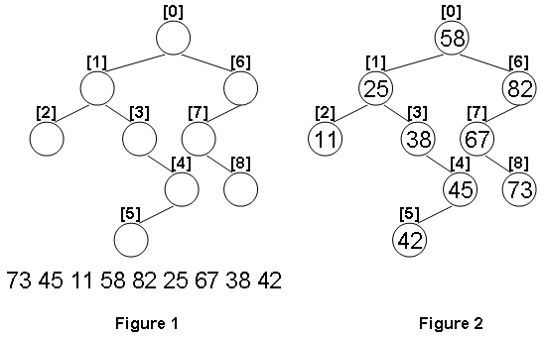

**输入描述:**

Each input file contains one test case. For each case, the first line gives a positive integer N (<=100) which is the total number of nodes in the tree. The next N lines each contains the left and the right children of a node in the format "left_index right_index", provided that the nodes are numbered from 0 to N-1, and 0 is always the root. If one child is missing, then -1 will represent the NULL child pointer. Finally N distinct integer keys are given in the last line.

**输出描述:**

For each test case, print in one line the level order traversal sequence of that tree. All the numbers must be separated by a space, with no extra space at the end of the line.

**输入例子:**

9

1 6

2 3

-1 -1

-1 4

5 -1

-1 -1

7 -1

-1 8

-1 -1

73 45 11 58 82 25 67 38 42

**输出例子:**

58 25 82 11 38 67 45 73 42