An AVL tree is a self-balancing binary search tree. In an AVL tree, the heights of the two child subtrees of any node differ by at most one; if at any time they differ by more than one, rebalancing is done to restore this property. Figures 1-4 illustrate the rotation rules.

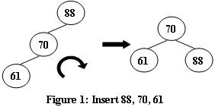

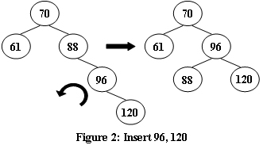

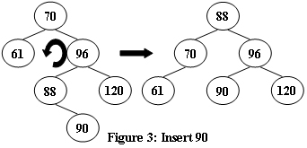

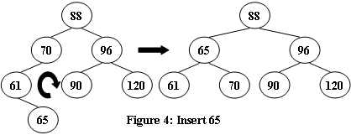  
Now given a sequence of insertions, you are supposed to tell the root of the resulting AVL tree.

**输入描述:**

Each input file contains one test case. For each case, the first line contains a positive integer N (<=20) which is the total number of keys to be inserted. Then N distinct integer keys are given in the next line. All the numbers in a line are separated by a space.

**输出描述:**

For each test case, print the root of the resulting AVL tree in one line.

**输入例子:**

5

88 70 61 96 120

**输出例子:**

70