Quantifying the human influence on drought

Worked example 10.1

Table of Contents

A comparison of two time series from the Upper-Guadiana catchment, one with and one without human influence, is done to demonstrate the catchment-scale observation-based methods to quantify the human influence on hydrological drought (Section 10.4.1; Fig. 10.6). These time series can be calculated from a paired catchment analysis, an upstream-downstream comparison, observed-naturalised comparison, or pre-post disturbance analysis (Section 10.4.1). In this example, we use the observed-naturalised approach.

# Loading the data

We begin by loading the two time series from the Upper-Guadiana dataset: the benchmark (natural) time series and the human-influenced time series.

library(tidyverse)  
library(lubridate)  
library(hydroDrought)  
  
### Filter to the period 1960-2000   
### Rename the columns  
### Calculate the water year  
guadiana_full <- guadiana %>%  
 dplyr::select(time, benchmark = Qsim, influenced = Qobs) %>%  
 mutate(  
 year = water_year(time)  
 ) %>%  
 filter(year >= 1960, year <= 2000)   
  
print(guadiana_full)

## # A tibble: 14,976 x 4  
## time benchmark influenced year  
## <date> <dbl> <dbl> <dbl>  
## 1 1960-01-01 0.153 0.146 1960  
## 2 1960-01-02 0.148 0.146 1960  
## 3 1960-01-03 0.144 0.143 1960  
## 4 1960-01-04 0.14 0.154 1960  
## 5 1960-01-05 0.136 0.148 1960  
## 6 1960-01-06 0.133 0.154 1960  
## 7 1960-01-07 0.13 0.154 1960  
## 8 1960-01-08 0.128 0.148 1960  
## 9 1960-01-09 0.129 0.146 1960  
## 10 1960-01-10 0.139 0.133 1960  
## # … with 14,966 more rows

range(guadiana_full$time)

## [1] "1960-01-01" "2000-12-31"

The benchmark time series is simulated as described in Section 9.3.3. In this case, the observed time series from the Upper-Guadiana catchment is the human-influenced time series (Section 4.5.X).

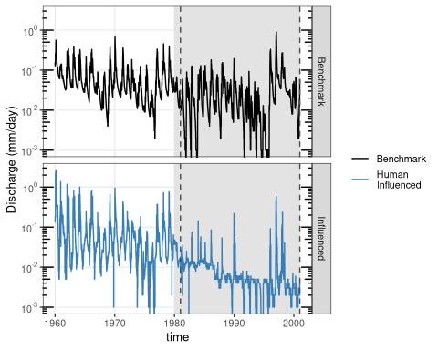

Figure 10.xxxx: Time series showing the benchmark and human-influenced time series. Discharge is plotted on a log scale to emphasize low flow behavior. The grey region shows the comparison period for human influence (1981-2000).

# Threshold calculation

In this example we use a daily varying threshold, the Q80, calculated based on a smoothed 30-day moving average series over the period 1960-2000. The threshold is derived based on the benchmark time series.

### First apply a 30-day moving average smoother  
### Then compute the Q80 for each day of the year  
threshold <- guadiana_full %>%  
 mutate(discharge = moving_average(benchmark, n = 30, sides = "center")) %>%  
 var_threshold(vary.by = "day", fun = lfquantile, exc.freq = 0.80)   
  
print(threshold)

## # A tibble: 366 x 2  
## day threshold  
## * <date> <dbl>  
## 1 -01-01 0.0172  
## 2 -01-02 0.0184  
## 3 -01-03 0.0184  
## 4 -01-04 0.0187  
## 5 -01-05 0.0190  
## 6 -01-06 0.0194  
## 7 -01-07 0.0197  
## 8 -01-08 0.0200  
## 9 -01-09 0.0203  
## 10 -01-10 0.0206  
## # … with 356 more rows

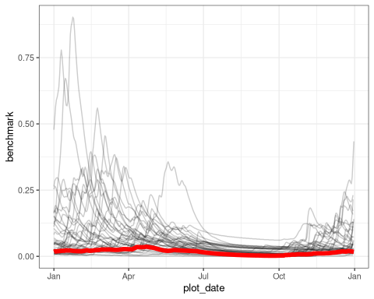

Figure 10.xxxx: Benchmark discharge for the period 1960-2000 showing seasonality, with each line representing a year. The smoothed Q80 threshold is shown in bold red.

# Calculate the benchmark drought indices

Apply the benchmark threshold (Step 2) to identify drought events in the benchmark time series using the threshold level method (Section 5.4.1) for a selected period. Note that this time period can differ from the reference period used to calculate the benchmark threshold. In this example, we use the period 1981-2000, which equals the period with the main human intervention in the Upper Guadiana catchment.

# initialize empty list for events  
events <- list(benchmark = NULL, influenced = NULL)  
  
# initialize empty list for final drought characteristics  
drought.char <- list(benchmark = NULL, influenced = NULL)   
  
# function that computes the drought characteristics given a table of events  
summarize_dc <- function(x) {  
 c("mean.duration" = as.double(mean(x$duration)),   
 "mean.deficit" = mean(x$volume))  
}

Consecutive drought events with an inter-event time less than or equal to 10 days are pooled into a single drought event. To remove minor droughts, only drought events with a duration of more than 10 days are kept. The resultant drought indices of the naturalised benchmark time series are: (a) mean duration 91 days, and (b) mean deficit volume 58,000 mm.

### Calculate the drought events for the benchmark time series  
### Filter to 1981-2000  
### use the benchmark column as discharge  
events$benchmark <- guadiana_full %>%  
 filter(year >= 1981, year <= 2000) %>%  
 rename(discharge = benchmark) %>%  
 drought_events(  
 threshold = threshold,  
 pooling = "inter-event",  
 pooling.pars = list(min.duration = 10, min.vol.ratio = Inf)  
 ) %>%  
 filter(duration > 10)  
  
# calculate the drought characteristics for the benchmark time series  
drought.char$benchmark <- summarize_dc(events$benchmark)  
  
print(events$benchmark)

## # A tibble: 32 x 9  
## event first.day last.day duration dbt volume qmin tqmin pooled  
## <int> <date> <date> <drtn> <drtn> <dbl> <dbl> <date> <dbl>  
## 1 1 1981-01-01 1981-04-22 112 days 112 days 100349. 0.01 1981-02-04 0  
## 2 2 1981-06-09 1981-12-28 203 days 187 days 84024. 0 1981-11-23 4  
## 3 5 1982-05-01 1982-06-01 32 days 30 days 7235. 0.017 1982-05-25 1  
## 4 6 1982-06-25 1982-10-19 117 days 106 days 14406. 0 1982-10-07 3  
## 5 7 1983-01-31 1983-11-22 296 days 296 days 202991. 0 1983-09-20 0  
## 6 8 1983-12-03 1983-12-17 15 days 15 days 5915. 0.009 1983-12-13 0  
## 7 9 1984-02-17 1984-02-27 11 days 11 days 3787. 0.018 1984-02-22 0  
## 8 10 1984-10-22 1984-11-03 13 days 11 days 533. 0.007 1984-10-22 1  
## 9 12 1985-10-12 1985-12-25 75 days 66 days 17653. 0.004 1985-11-12 2  
## 10 13 1986-11-29 1987-01-11 44 days 44 days 22026. 0.009 1987-01-08 0  
## # … with 22 more rows

# Calculate the human-influenced drought indices

Apply the benchmark threshold (Step 2) to identify drought events in the human-influenced time series. Note that we are using the same period (1981-2000) as was used to derive drought indices for the benchmark time series. Furthermore, we are applying the same inter-event criterion and exclusion of minor drought events (Step 3). The resultant drought indices of the human-influenced time series are: (a) mean duration 304 days, and (b) mean deficit volume 310,000 mm

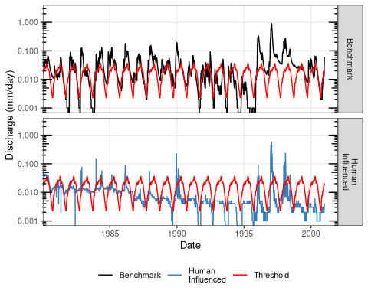

Figure 10.xxxx: Benchmark (top) and human-influenced (bottom) flows during the comparison period 1981-2000. The smoothed Q80 threshold is shown in red. Discharge is plotted on a log scale to emphasize low flow behavior.

### Calculate the drought events for the benchmark time series  
### Filter to 1981-2000  
### use the influenced column as discharge  
events$influenced <- guadiana_full %>%  
 filter(year >= 1981 & year <= 2000) %>%  
 rename(discharge = influenced) %>%   
 drought_events(threshold = threshold,  
 pooling = "inter-event",  
 pooling.pars = list(min.duration = 10, min.vol.ratio = Inf)) %>%  
 filter(duration > 10)  
  
# calculate the drought characteristics for the human influenced time series  
drought.char$influenced <- summarize_dc(events$influenced)

# Comparison of drought characteristics

In this final step, we compare the drought indices between the benchmark and human-influenced time series. We calculate the percentage difference between the two sets of drought indices, :

where is the percentage difference in drought index (DC) between the human-influenced () and benchmark () time series

drought.char

## $benchmark  
## mean.duration mean.deficit   
## 90.59375 57967.00200   
##   
## $influenced  
## mean.duration mean.deficit   
## 304.45 309833.02

(drought.char$influenced - drought.char$benchmark) / drought.char$benchmark * 100

## mean.duration mean.deficit   
## 236.0607 434.4990

We find that the difference in mean duration is 236%, and in mean deficit volume it is 434%. To conclude, the mean duration of streamflow droughts in the Upper-Guadiana catchment has increased with about 236% and the mean deficit with 434% in the human-influenced situation compared to the naturalised situation.