Testing SDI Sensors

1. Initial Setup
   1. Turn on 8310 of Test Station 49999 by pressing the up button
   2. Login to 8310
      1. User: tidal Password: CABE
   3. Disconnect the Sensor fuses (marked on fuse panel sheet on the door of the box)
      1. The Test Gauge (49999) Fuses are 5, 6, 7.
2. Finding SDI address.

***Do this for each sensor Individually before dropping into the Well as some sensor may have the same SDI address and may require mapping to new SDI address***

* 1. Connect an SDI sensor for Testing in the
     1. Red – Positive, Blue – Negative, Grey – Data

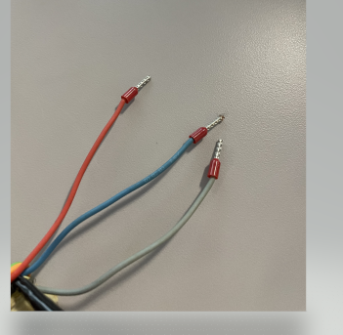

Positive

Negative

Data

* + 1. SDI socket 9, 11, 13 – Positive
    2. SDI socket 10,12,14 – Negative
    3. SDI socket 15-17- Data
  1. Connect the corresponding sensor fuse to allow power from the battery
  2. Scroll through the 8310 and find “*Diagnostics”*
  3. Scroll through the diagnostics and find “*SDI Tools”*
  4. Find the option “*Find SDI Devices”* in SDI Tools
     1. Here the 8310 will check the addresses to find connected sensors, the 8310 usually finds the sensor within the first 5 addresses searched.
  5. If Found:
     1. Go back to the SDI Tools Menu and select “*Show found (1) SDI.”* Take note of the SDI address and serial number as you may need to switch it later.
     2. Disconnect sensor fuse and disconnect wires for sensor
  6. If not found
     1. Cancel Search
     2. Check the SDI connections and fuse
     3. Ensure there are Furrals (little red nubs) on the Red, blue and grey ends
     4. Create new ends with Furrals
     5. Try the Finding SDI Process again if still no communication note (NO CONNECTION to 8310)

1. Connecting sensor for extended period testing
   1. Drop sensors into well and connect wiring

***Recommended to drop and connect sensors individually***

* + 1. Place sensor cord through whole on bottom of gauge box and connect the wiring according to last connection instruction. (Step 2(a))
    2. Connect corresponding sensor fuse to allow power from battery
    3. If required re-map sensor address that require change. These will be sensor that are mapped to the same SDI locations. For example 350326 and 3510443 are both noted to be SDI address 0. When these are connected one will need to be mapped to either address 1 or 2 to enable 8310 to read both sensors. (see 4(a) for mapping of sensor addresses)

1. Mapping sensor to new SDI address
   1. Scroll through the 8310 and find “*Diagnostics”*
   2. Scroll through the diagnostics and find “*SDI Tools”*
   3. Find the option “*Send SDI-12 command”* in SDI Tools
   4. The *aAb!* command is used to change sensor addressed “a” to address “b”.

The following command *0A2!* entered Into the 8310 will change a sensor addressed from 0 to address 2, and result of “*2*” will appear indicating the change.

* 1. Confirm the SDI address change by following 2(c) to 2(e)

1. Entering Offset Value
   1. Turn on and login to BIO station (0491)
   2. Have the real time TIDE measurement (LASER) from Station 0491 ready and open

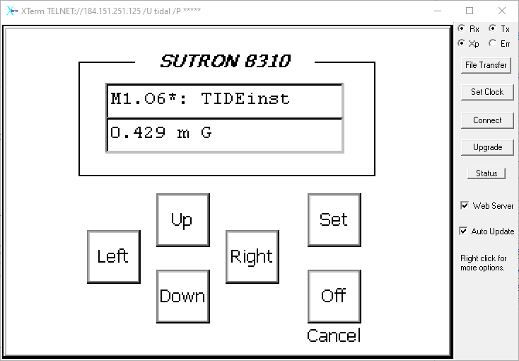

* 1. Scroll to “*Station Setup”*
  2. Within Station Setup scroll to Measurements (#+#)
  3. Select the Measurement you want to change the offset for
     1. M1 - TIDE – SDI Address 0
     2. M3 - TIDE1 - SDI Address 1
     3. M5 - TIDE2 – SDI Address 2
     4. …..
  4. Scroll to “*\*Cur Val”* – Press the right key
  5. Set current value to match the LASER reading from 0491 TIDE measurement
     1. The 8310 will ask for a 2 point offset and slope, select “*Cancel*” to apply a 1 point offset.
  6. Monitor the real time measurement for a few minutes. If doesn’t match try these steps again. If sensor still not tracking with the Laser likely a malfunction with the sensor and requires calibration or disposal. If tracking with Laser leave in test well for desired length of time for testing. Minimum 3-5 hours, and for deployment test it is suggested a few days of data collected to ensure long term functionality before deploying into field operation.

1. Downloading Laser Data (WLO) from IWLS
   1. Download Laser data via IWLS Station 0491

(<https://neptune.iwls-sine.azure.cloud-nuage.dfo-mpo.gc.ca/stations/dashboard/new/station/5cebf1e23d0f4a073c4bbfac/data>)

* 1. Set the Period to desired time extent. Doesn’t need to be exact (This will be done in the Comparison Script). The data downloaded just need to overlap and cover the desired time period.

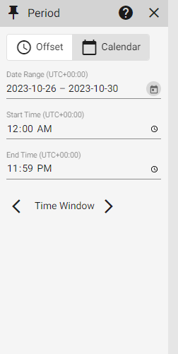

* 1. Press the three … and select “*Export to CSV File”*

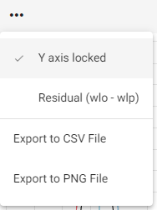

***Improvement will be to Query IWLS via script and this step will no longer be required ***

1. Downloading 8310 data from Test Station 04999
   1. Open Hyperterminal and connect to 8310 using TCP/IP method with the IP address and press OK.
   2. Log in using Tidal login: tidal and password: cabe.
   3. When “\Flash Disk >” appears, type in “**ui**” and press **enter**.
   4. Log in again when blue 8310 screen appears, using the enter key for “SET” and the backspace key for “END”
   5. Arrow down to “**Terminal Operations**” and press the **right** arrow key.
   6. Select “**Download Log**” and press **enter**.
   7. Select desired log and press **enter** again.
   8. Use the up and down arrow keys to select the download type and press **enter**.
   9. Set date range or number of days using the arrow keys if looking for specific time range, Use number of days.
   10. When the bottom of the screen says “Ready to send Ymodem files” you are ready to download.
   11. From the top menu bar of Hyperterminal, select the “**Transfer**” drop down menu and select “**Receive** **file**”
   12. Select file location where you want to save the log, and then under the Use Receiving Protocol drop down menu select **Ymodem**.
   13. Once download completes the file should be in the set location.
2. Running Comparison Script

The Documentation for running and installing the script can be found on GITHUB Repository for the script. <https://github.com/HydroPanadas/SensorCompairson>

1. Data Analysis Examples.