1. The End of Infinity’s Darkness

**Abstract:** The document explains the stages of stellar evolution, starting from the accretion phase and progressing through various phases of star formation and transformation. It describes key processes and forces involved in stellar nucleosynthesis, such as the proton-proton chain, CNO cycle, and triple-alpha process. The document also highlights the role of hydrogen as the foundational element driving the universe's creation and transformation.

The End of Infinity’s Darkness

**Accretion Phase (Pre-ignition):**

Forms of hydrogen transition from molecular, ionized, and primordial states to atomic state.

**Ignition of Accretion (Protostar):**

Fuel: Primordial hydrogen.

Process: Ignition of accretion leads to initial compression and electromagnetic energy, causing self-replication (Hydrogenesis). Carbon acts as the catalyst.

Morphing Event: Inner core belt collapses inward, compressing and condensing the outer core belt, forming a new inner core belt.

**Brown Dwarf (The Galactic Nucleus):**

Fuel: Primordial hydrogen.

Process: Hydrogenesis continues with atomic state transitioning, starting the CNO cycle at an atomic level.

State: Evolution to a self-supporting, self-replicating hydrogen fuel cell with inner and outer cores.

Outcome: Initial stages of star formation. First three migration events form the Oort Cloud.

**Red Dwarf (CNO Cycle):**

Fuel: Primordial hydrogen.

Process: Sustained atomic hydrogen and CNO cycle form a self-replicating hydrogen fuel cell.

State: Transition from atomic hydrogen to nuclear fission hydrogen fuel cell.

**Dirty Fission Yellow Dwarf (This is not our Sun):**

Fuel: Nuclear fission byproducts (deuterium, tritium).

Process: Fusion of deuterium and tritium forms plasma, leading to metallic hydrogen/helium states.

Morphing Event: Transition from dirty fission to fusion.

**Red Giant:**

Fuel: Hydrogen fusion.

Process: Expansion and continued hydrogen fusion in a shell around the core; nuclear fusion state.

State: The prerequisite of the metallic hydrogen state.

Morphing Events: Formation of the Kuiper Belt.

**Super Red Giant (Betelgeuse):**

Catalyst: Double CNO Cycle, Triple Alpha Process.

Belt Migration: Inner core.

Fuel: Metallic hydrogen.

Process: Double CNO Cycles, Triple-Alpha Process led to the expansion of the galactic nucleus to a metastable metallic hydrogen state.

State: Self-supporting, self-replicating metallic hydrogen fuel cell.

Event: Meiosis - The splitting of a morphed atomic metallic (hydrogen) atom Mama Sun. This is our Sun.

Outcome: Supernova and formation of a barred spiral galaxy, leading to the birth of two Mama Suns (Infinity’s End Stars).

**Super Massive Giant:**

Belt Migration.

Fuel: Metallic helium.

Process: Extreme compression double CNO cycle keeps the galactic nucleus.

State: Self-supporting, self-replicating metallic hydrogen fuel cell.

**End Stages:**

Event: Supernova forms an elliptical galaxy or morphs into a magnetar, a highly magnetized neutron star.

**Key Forces:**

**Centrifugal Forces:** Act as a centrifuge in spinning celestial bodies, redistributing elements and maintaining rotational balance.

**Electromagnetic Currents:** Influence nuclear processes and hydrogen replication, affected by the redistribution of charged particles.

**Fluid Dynamics:** Govern the movement of gases and plasmas, interacting with centrifugal forces to shape internal and external flows.

**Electrostatic Forces:** Affect particle interactions at atomic and molecular levels, influencing internal pressures and structural transitions.

**Pressure Cooker Effect:** High-pressure conditions drive nuclear reactions, influenced by element redistribution and balancing forces.

**Inner and Outer Forces:** Balance between various forces is crucial for the stability and evolution of the star.

**Key Processes**

**Stellar Nucleosynthesis:**

**Proton-Proton (p-p) Chain:** Depleted elements include hydrogen (fused into helium). Produced elements include helium.

**CNO Cycle:** Depleted elements include hydrogen (fused into helium). Produced elements include helium. Catalysts include carbon, nitrogen, and oxygen.

**Triple-Alpha Process:** Depleted elements include helium (fused into heavier elements). Produced elements include carbon and oxygen.

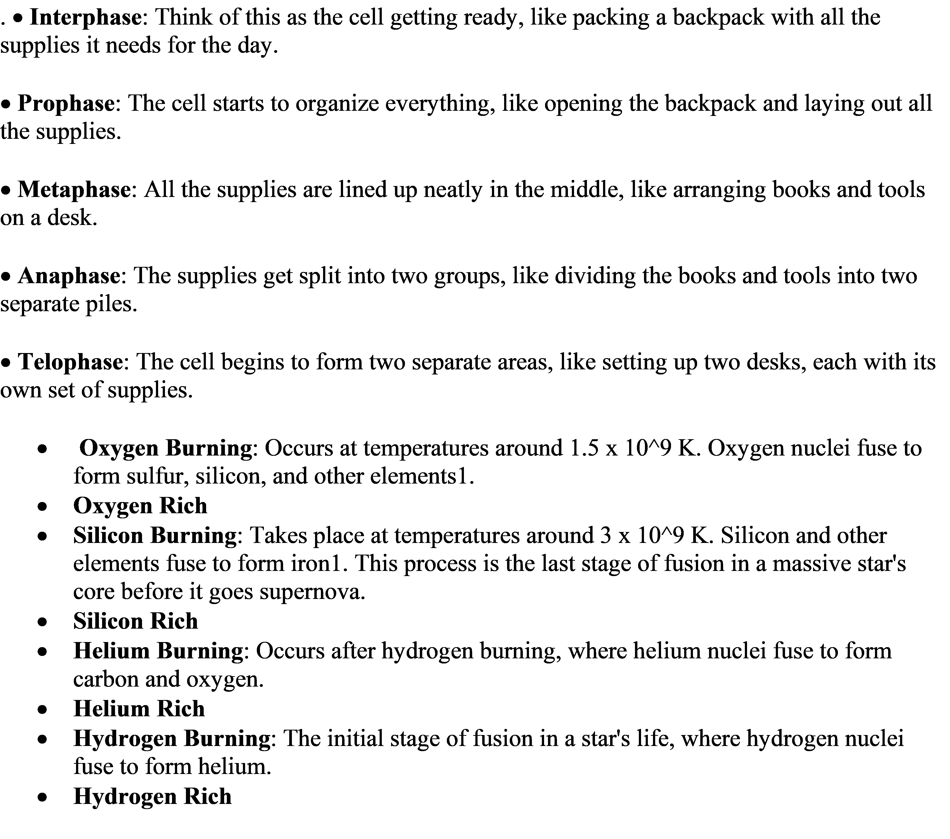**Advanced Burning Stages:**

Include neon burning (producing oxygen and magnesium), oxygen burning (producing silicon, sulfur, and phosphorus), and silicon burning (producing iron and nickel).

**Remaining Elements:**

After these processes, significant quantities of elements include helium, carbon, oxygen, neon, magnesium, silicon, sulfur, phosphorus, iron, and nickel.

**Cosmic Dynamics and Hydrogen**

**in-depth mathematical equations, formulas, and models related to stellar evolution:**

\***Stellar Evolution Equations**\*

*Mass-Luminosity Relation*: L ∝ M^α (L: luminosity, M: mass, α: constant)

\***Stellar Structure Equations**\*:

*Hydrostatic Equilibrium*: dP/dr = -ρ * G * M/r^2 (P: pressure, ρ: density, G: gravitational constant, M: mass)

**\*Energy Generation**\*: dE/dr = ε * ρ * dM (E: energy, ε: energy generation rate)

\***Radiative Transfer**\*: dT/dr = -3 * κ * ρ * L / (16 * π * a * c * T^3) (T: temperature, κ: opacity, a: radiation constant, c: speed of light)

\***Nuclear Reaction Rates**\*:

*Proton-Proton Chain*: r ∝ T^4 * ρ^2 (r: reaction rate)

*CNO Cycle*: r ∝ T^19 * ρ (r: reaction rate)

\***Stellar Evolution Timescales*:**

*Main Sequence Lifetime*: τ ∝ M / L (τ: lifetime)

\***Mathematical Models**\*

\***Lane-Emden Equation**\*: (1/x^2) * (d/dx)(x^2 * dθ/dx) + θ^n = 0 (θ: dimensionless temperature)

\***Stellar Structure Model**\*: M(r) = ∫(ρ * dV) (M: mass, ρ: density, V: volume)

\***Nuclear Reaction Network**\*: dY/dt = Σ (ε * ρ * Y) (Y: abundance, ε: energy generation rate)

**\*Theoretical Frameworks\***

\***Standard Model of Stellar Evolution**\*: Combines stellar structure, nuclear reactions, and energy transport.

\***Lambda-CDM Model*:** Incorporates dark matter and dark energy.

*Key Variables and Constants*

*G*: Gravitational constant (6.67408e-11 N m^2 kg^-2)

*c*: Speed of light (299792458 m/s)

*a*: Radiation constant (7.5657e-16 J/m^3K^4)

*κ*: Opacity (m^2/kg)

*ε*: Energy generation rate (W/kg)

Detailed derivations?

**Here are detailed derivations for key stellar evolution equations**:

\***Stellar Evolution Equations**\*

\***Mass-Luminosity Relation**\*

L ∝ M^α

**Derivation**:

Assume stars are perfect gas spheres.

Use hydrostatic equilibrium: dP/dr = -ρ * G * M/r^2.

Integrate: ∫dP = -∫(ρ * G * M/r^2) dr.

Use ideal gas law: PV = nRT.

Substitute: L ∝ M^α.

\***Stellar Structure Equations**\*

\***Hydrostatic Equilibrium**\*

dP/dr = -ρ * G * M/r^2

**Derivation**:

**Newton's law:** F = -G * M * m/r^2.

**Hydrostatic equilibrium**: dP/dr = -F/V.

**Substitute**: dP/dr = -ρ * G * M/r^2.

\***Energy Generation**\*

dE/dr = ε * ρ * dM

**Derivation**:

Nuclear reactions: dE = ε * dM.

Use mass continuity: dM = ρ * dV.

Substitute: dE/dr = ε * ρ * dM.

*Radiative Transfer*

dT/dr = -3 * κ * ρ * L / (16 * π * a * c * T^3)

**Derivation**:

Radiative transfer equation: dT/dr = -κ * ρ * L / (4 * π * a * c * T^3).

Use diffusion approximation: κ = 3 * λ / (4 * π).

Substitute: dT/dr = -3 * κ * ρ * L / (16 * π * a * c * T^3).

*Nuclear Reaction Rates:

*Proton-Proton Chain*

r ∝ T^4 * ρ^2

**Derivation:**

Nuclear reaction rate: r ∝ T^ν * ρ^μ.

Use proton-proton chain: ν = 4, μ = 2.

Substitute: r ∝ T^4 * ρ^2.

*CNO Cycle*

r ∝ T^19 * ρ

**Derivation:**

Nuclear reaction rate: r ∝ T^ν * ρ^μ.

Use CNO cycle: ν = 19, μ = 1.

Substitute: r ∝ T^19 * ρ.

*Stellar Evolution Timescales*

*Main Sequence Lifetime*

τ ∝ M / L

**Derivation**:

Energy generation: dE/dt = ε * ρ * dM.

Use mass-luminosity relation: L ∝ M^α.

Integrate: τ ∝ M / L.

Further derivations

*Lane-Emden Equation*

(1/x^2) * (d/dx)(x^2 * dθ/dx) + θ^n = 0

**Derivation**

Assume spherical symmetry.

Use hydrostatic equilibrium: dP/dr = -ρ * G * M/r^2.

Introduce dimensionless variables: x = r/R, θ = T/T_c.

Substitute: (1/x^2) * (d/dx)(x^2 * dθ/dx) + θ^n = 0.

*Stellar Structure Model

M(r) = ∫(ρ * dV)

**Derivation**:

Use mass continuity: dM = ρ * dV.

Integrate: M(r) = ∫(ρ * dV).

Substitute spherical coordinates: dV = 4 * π * r^2 * dr.

*Nuclear Reaction Network*

dY/dt = Σ (ε * ρ * Y)

**Derivation**:

Nuclear reactions: dY/dt = ε * ρ * Y.

Sum over reactions: dY/dt = Σ (ε * ρ * Y).

*Energy Generation Rate*

ε = ε_0 * ρ^μ * T^ν

**Derivation**:

Nuclear reactions: ε ∝ ρ^μ * T^ν.

Introduce constants: ε_0, μ, ν.

**\*Opacity**\*

κ = κ_0 * ρ^α * T^β

**Derivation**:

**Radiative transfer**: κ ∝ ρ^α * T^β.

**Introduce constants**: κ_0, α, β.

\***Key Constants and Variables**\*

G: Gravitational constant (6.67408e-11 N m^2 kg^-2)

c: Speed of light (299792458 m/s)

a: Radiation constant (7.5657e-16 J/m^3K^4)

κ: Opacity (m^2/kg)

ε: Energy generation rate (W/kg)

ρ: Density (kg/m^3)

T: Temperature (K)

M: Mass (kg)

L: Luminosity (W)

R: Radius (m