LANDING PAGE TEST DOCUMENT
Test ID: FT-LP-01
Test Name:
Landing Page Loads With Production Navigation and Script
Purpose:
Verify that the Moffat Bay landing page loads successfully and contains the required production navigation, room section, booking links, and JavaScript without references to the removed mock files.
Test Steps:
1. Start the Moffat Bay Python landing-page server.
2. Navigate to http://127.0.0.1:8000/.
3. Verify the landing page loads successfully.
4. Verify the navigation menu, login/register controls, room cards, room pricing, and booking links are displayed.
5. Run the automated FT-LP-01 pytest test.
Expected Result:
The landing page loads successfully with the required production content and navigation. The landing.js script is included and the removed mock-data.js, api-contract.js, and app.js files are not referenced.
Actual Result:
PASSED. The Moffat Bay landing page loaded successfully through the Python web server. The navigation, room information, pricing, account controls, and booking links displayed correctly. The production landing.js file loaded and the page did not rely on the removed mock JavaScript files.

Screenshot Evidence:
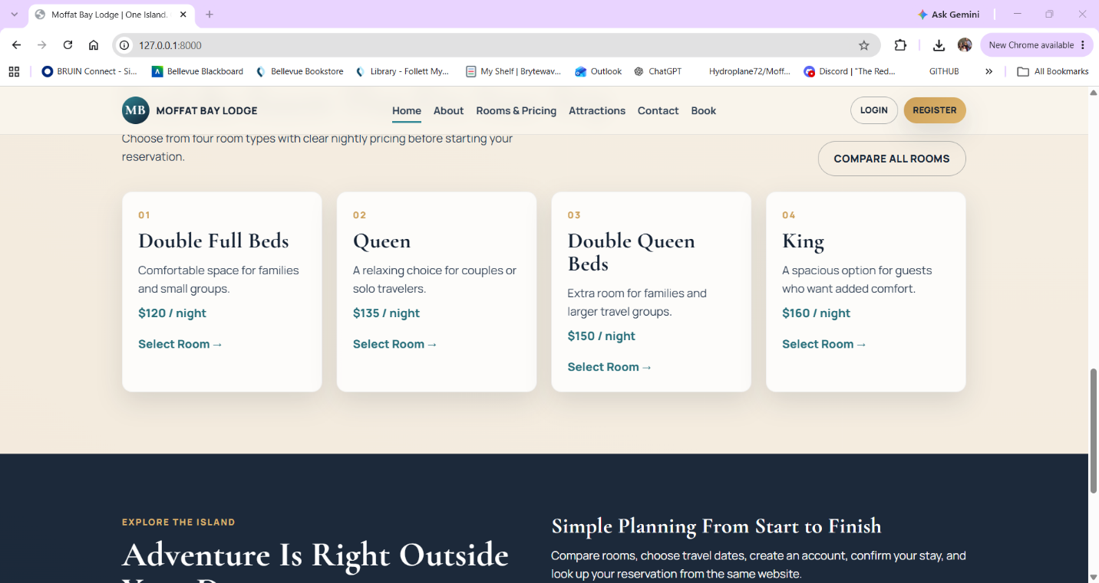
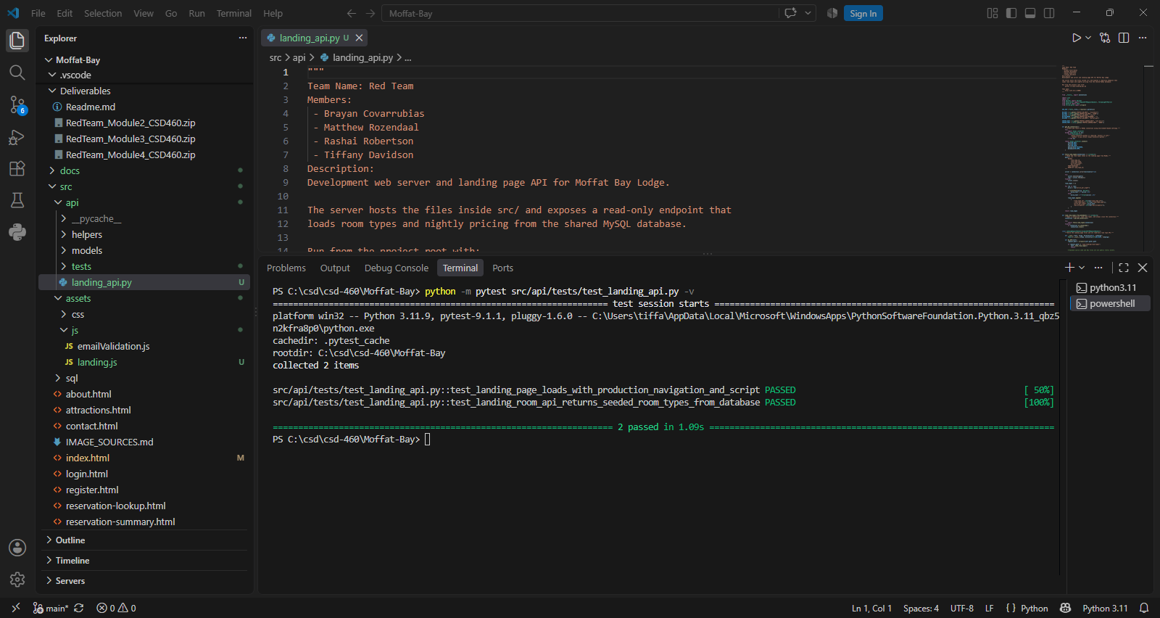

Test ID: FT-LP-02
Test Name:
Landing API Returns Seeded Room Types From Database
Purpose:
Verify that the landing-page Python backend successfully connects to the Moffat Bay MySQL database and retrieves the room types used by the landing page.
Test Steps:
1. Start MySQL through XAMPP.
2. Start the Python landing-page server.
3. Navigate to http://127.0.0.1:8000/api/landing/room-types.
4. Verify that the API returns the four seeded room types.
5. Verify that the nightly prices match the RoomTypes table.
6. Run the automated FT-LP-02 pytest test.
Expected Result:
The API returns HTTP status 200 and retrieves Double Full Beds, Queen, Double Queen Beds, and King room types with the expected nightly prices.
Actual Result:
PASSED. The Python landing-page API successfully connected to the moffat_bay MySQL database. The /api/landing/room-types endpoint returned HTTP status 200 and provided the expected room-type data used by the landing page.
Screenshot Evidence:
