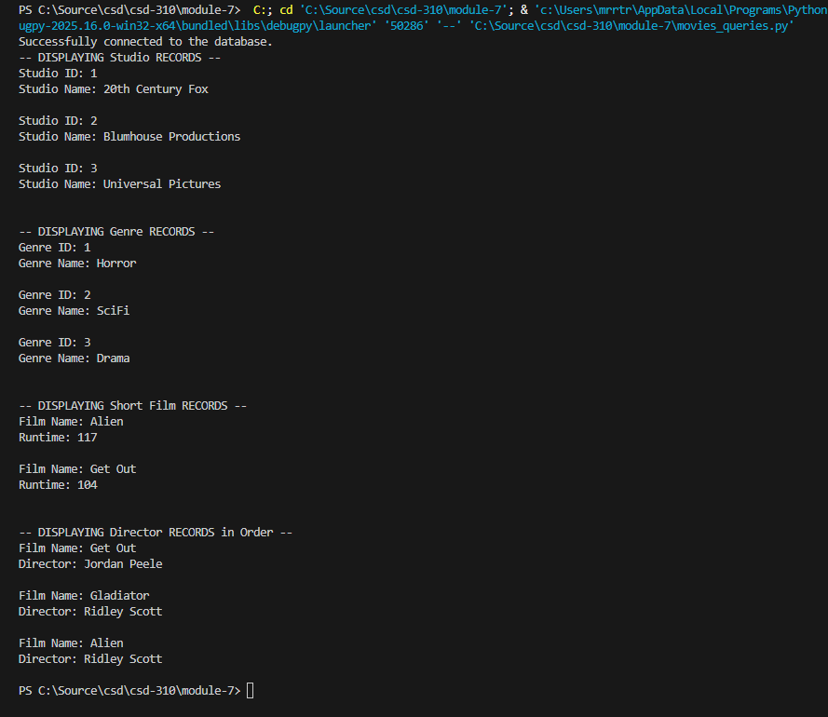

https://github.com/Hydroplane72/csd-310/tree/main/module-7

