# Lab 4: Sending Data to Android from Pure Data

In this weeks lab we will expand what we’ve looked at. Previously, our android would send data to our patch. We are going to look at sending floats from our patch to a receiver in android.

## Setup

Download the example from Github: <https://github.com/Hydroxate/Lab04_Template>

Open the provided template in android studio.

## Edit The PD Patch

Lets create a simple counter PD patch.

1. Locate the raw folder in Android Studio.
2. Right click and locate the counter.zip in finder.
3. Unzip the archive.
4. Delete the archive.
5. Open the counter.pd file in pure data.
6. Edit the patch. Make the following changes:

Create a [metro] object with a default time of 1000ms.

Create a [float] object .

Create a [+ 1] object.

Connect the output of the [float] to the left inlet of the [+ 1] object.

Connect the output of the [+ 1] to the right inlet of the [float] object.

Create a [mod 10] object.

Connect the output of the float to the [mod 10] object.

Create a Number.

Connect the output of the [mod 10] object to the Number.

Connect the output of the Number to the inlet of the provided [send sendCounter] object.

Test your patch in pd using the toggle provided

Your patch should be similar to the following figure.

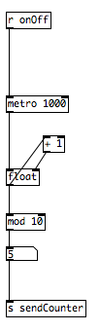

### Include the new patch in the project

This is the same process as last week. The patch must be zipped to be included in the android app.

1. Save the patch
2. Close the patch
3. Right click the synth patch, and click “Compress counter.pd”.
4. This will create a zip file called “counter.pd.zip”. Rename it “counter.zip”.
5. Delete counter.pd

## Creating a GUI in Android Studio and Connecting it to a PD Patch.

Now we need to create a textView GUI widget in our app that will communicate with the new [send ] object in our PD patch. This is a two step process

1. First we place the object graphically on the screen of the app and set its properties such as location, color and most importantly, we give it a unique id.
2. Then we create an instance of the widget type (e.g. textView) in our code with a unique name and we link this to the graphical object we made in step 1.

### Add a TextView

Lets follow the two step process and add a textView to our apps GUI. When this button is clicked it will send a value of “1” to the pd patch.

### Step 1: Add the widget graphically

1. Click on activity_main.xml in the project pane, it is located under res/layout.

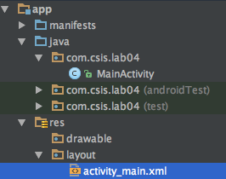

Drag and drop a TextView from the Widget Palette to create your GUI.

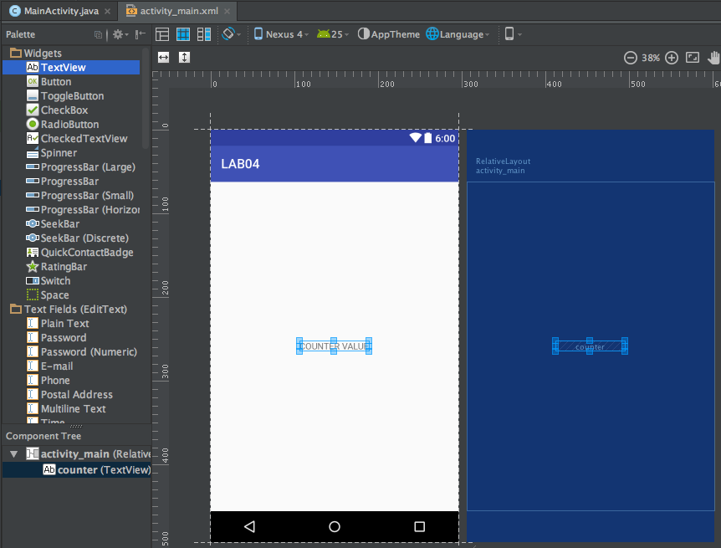

Click on the TextView widget that is now in place . Its properties should now be shown in the properties tab to the right hand side.

Now we need to set the properties for this new textView.

1. Go to the properties tab.

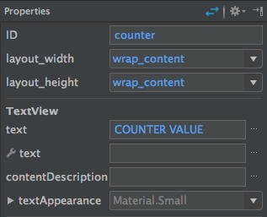

1. Rename the TextView’s ID to counter.
2. Rename the TextViews’s text to COUNTER VALUE

We have completed step 1 of our 2 step process for adding a widget to the gui.

### Step 2: Create an instance in code

At this stage our widget only exists as a graphical object, essentially a picture on the canvas. We have finished step 1 of our 2 step process. On to step two, “create an instance of the widget type in code with a unique name and link this to the graphical object we just made.”

1. Double click the MainActivity.java file in the project pane. This is located under the java folder.



Lets declare our Textview. Go to line 39 and type the below:



Now let’s create the instance of the code at line 46 in the OnCreate() method. It will look like the below:



When this line of code is executed it will create an instance of the TextView family called “myCounter” that is connected with the graphical button that has an ID of “counter”.

We have now completed step 2 of our two step process. We have created a TextView instance with a unique name (myCounter) and linked it to the graphical TextView object that we placed on the canvas in step 1.

Now we need to create our pure data listener!

### Add the pure data listener.

Now we need to add the listener. We want our app to receive data from our [send] objects in pure data. To do this we must add a listener: code that listens for data coming from a [send] object.

1)Go to line 101 Type the below:

dispatcher.addListener("sendCounter",receiver1);  
PdBase.*subscribe*("sendCounter");

It should look like the following:

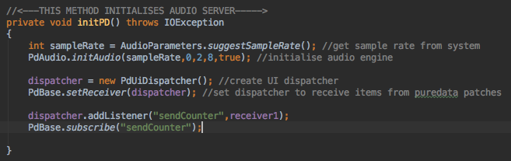

These lines set the listener’s receiver.

The line dispatcher.addListener(“sendCounter”,receiver1) tells the listener to listen to the [send] object called “sendCounter” and binds receiver1 to process the data.

The line PdBase.subscribe(“sendCounter”) makes the app continuously listen for data from the [send] object called “sendCounter”.

### Create the receiver’s functionality

Now that we have added a listener, we must create the functionality of the receiver that processes the data.

1) Go to line 101 and type the following:

private PdReceiver receiver1 = new PdReceiver() {  
  
 private void pdPost(final String msg) {  
 Log.*e*("RECEIVED:", msg);  
  
 new Handler().post(new Runnable() {  
 @Override  
 public void run() {  
 }  
 });  
 }  
  
 @Override  
 public void print(String s) {  
 Log.*i*("PRINT",s);  
 Toast.*makeText*(getBaseContext(),s,Toast.*LENGTH_LONG*);  
 }  
  
 @Override  
 public void receiveBang(String source)  
 {  
 pdPost("bang");  
 }  
  
 @Override  
 public void receiveFloat(String source, float x) {  
 pdPost("float: " + x);  
 if(source.equals("sendCounter")) {  
 myCounter.setText(String.*valueOf*(x));  
 }  
 }  
  
 @Override  
 public void receiveList(String source, Object... args) {  
 pdPost("list: " + Arrays.*toString*(args));  
  
 }  
  
 @Override  
 public void receiveMessage(String source, String symbol, Object... args) {  
 pdPost("message: " + Arrays.*toString*(args));  
 }  
  
 @Override  
 public void receiveSymbol(String source, String symbol) {  
 pdPost("symbol: " + symbol);  
 }  
};

It will look like the following:

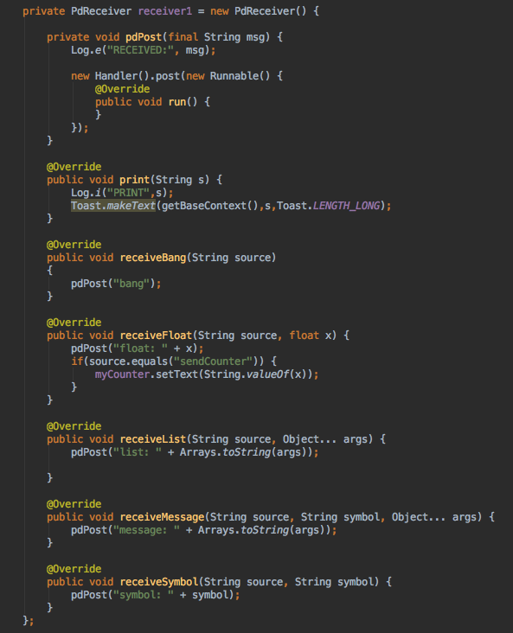

The functionality is seen in the receiveFloat() method. Let’s take a look.



The receiveFloat method is called automatically if the data that is sent from the [send] object is a number.

The method has two variables we can use. The String source and Float x. The source is the name of the [send] object that the receiver got data from. Here it is checking to see if that matches the name “sendCounter”.

If this is true, it sets the text of the TextView created earlier to be the received float. This will display the counter’s value!

1. Run your patch and see if there are errors.

You will see the text in the center updated from 0.0 to 9.0.

## Listening to more [send] object.

Back when we declared the listener in initPD() we specified the name of the [send] object and the receiver that would handle the incoming data.



To listen to other [send] objects we just add a listener and subscribe to that [send] object.

For example, listening to a [send] object in our patch called [s sendFrequency]:

Dispatcher.addListener(“sendCounter”,receiver1);

pdBase.subscribe(“sendCounter”);

Dispatcher.addListener(“sendFrequency”,receiver1);

pdBase.subscribe(“sendFrequency”);

The receiver we created earlier will listen for this other [send] object now!

Inside the receiver, we need to specify what happens with the data from [s sendFrequency]:

In the receiveFloat(String source, float x) method we can add the following code:

if(source.equals(”sendFrequency”))

{

//Functionality goes here.

}

This checks to see what is the source send object, if it equals “sendFrequency” then it will execute the code in the {}.

Your task is:

1. Edit your task to send random numbers between 1 and 400 to a [send] object called sendFrequency.
2. Add a textView to your GUI with ID frequency.
3. Declare the textView in the mainActivity.java with name myFrequency.
4. Update the text of myFrequency to have the value of the received float from [s sendFrequency].

### Going Onwards

The homework for this lab will be sent out shortly. You’ll be required to add TextViews that will take data from [send] objects in a patch.

Use the rest of the lab to practice the listening to [send] objects and handling data that comes in.