**SQL Database**

**Report**

**Program Description :**

**Database management system (DBMS) that saves data in the form of tables Using SQL queries received from user**

**User Manual :**

1. **Opening Program :**
2. When user opens program , There’d be two options ,

The first : Command line : Opens a CMD window ,User submits Queries by writing them and hitting enter .

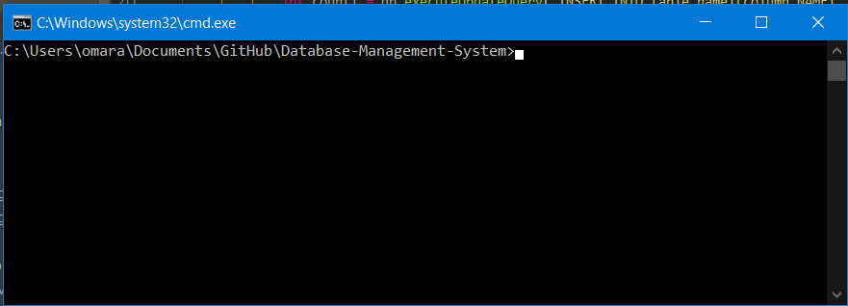

The second : GUI interface : Opens a GUI , javaFx based window , User submits Queries by Writing them in Text field ,then chooses Run

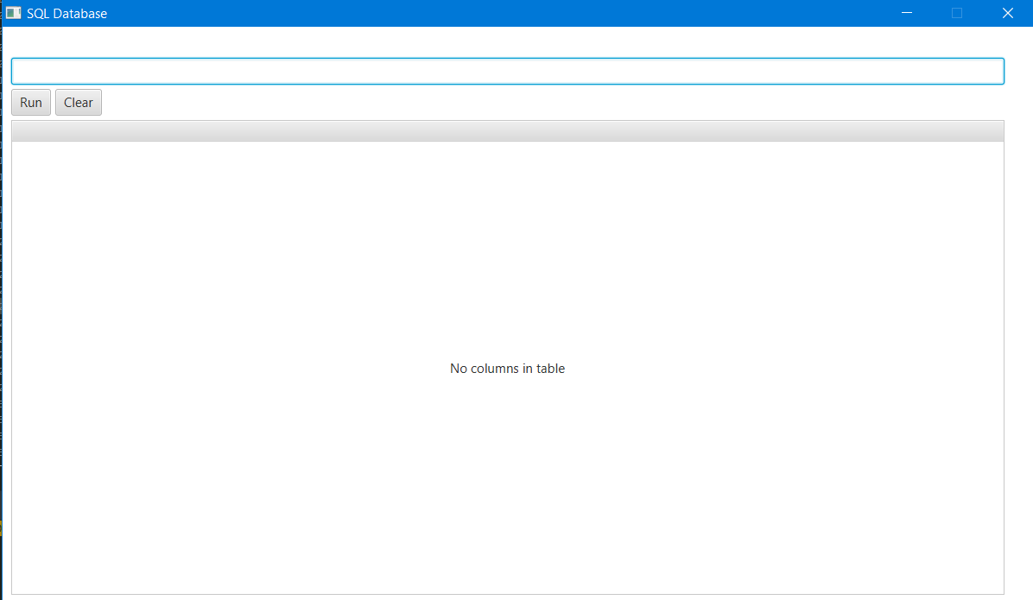

1. **Queries :**
2. **Select :**
3. **Description :**

The SELECT statement is used to select data(Certain Rows and Columns) from a database and preview them to the user .

1. **Syntax :**

Basic Syntax :

SELECT column1, column2, ... FROM table_name where some Conditions …. ;

* Displays Column data of some rows from a table if a row satisfies the conditions exist after where clause.   
  eg : SELECT population FROM Customers WHERE Country='Mexico';  
    
  here it will display column named “Population” from some rows of table ‘Customers’  
   if the column named “Country” of this row has data equivalent to ‘Mexico’ .

1. **Query additional Options :**

* If user replaced Column Section by Astrix Symbol ‘*’ , if the row satisfied Condition that exists after where clause , Program will display all columns’ data of this row

**Hna ye7ia 7yhbd 2lly 3mlh**

1. **Insert into :**
2. **Description :**

Inserts new Data row by row into the table .

1. **Syntax :**

Basic Syntax :

INSERT INTO table_name (column1, column2, ...) VALUES (value1, value2...);

* Insert a new row into the table with values (value1 , value2,…) into columns (column1,column2,…) respectively .

Eg: insert into students (name , age) values (‘omar’,16);

It will insert row with columns name = ‘omar’ , age = 16 into Students table ;

1. **Query additional Options :**

* If user removed Columns brackets , new values will be inserted into columns that exist in the table in ascending order with respect to their order of appearing in the table .
* Columns of type varchar will only apply values of form ‘Value’ , while Columns of type int will only apply values of form (Number) with out the brackets .

1. **Update :**
2. **Description :**

The UPDATE statement is used to modify the existing data in a table.

1. **Syntax :**

Basic Syntax :

UPDATE table_name SET column1 = value1, column2 = value2, ...WHERE condition;

* Updates Columns (column1 , column2) with values (value1,value2) respectively if it satisfies condition after where clause .

Eg : UPDATE Students SET age = 16, name = ‘omar’ , ...WHERE age=15 | name = ‘yehia’;

This will update a row if satisfies the condition that column age = 15 or column name = ‘yehia’ ,replacing it’s content with age =16 and name =’omar’ .

1. **Query additional Options :**

* If where clause wasn’t provided , program will update all rows in table with values that exist after set clause .
* Columns of type varchar will only apply values of form ‘Value’ , while Columns of type int will only apply values of form (Number) without the brackets .
* after where clause multiple conditions could be applied separated with AND\OR logic statement where AND has a priority of being preformed over the OR .

1. **Delete from :**
2. **Description :**

The DELETE statement is used to delete existing data in a table.

1. **Syntax :**

Basic Syntax :

DELETE FROM table_name WHERE condition;

* Deletes from the table Rows which satisfies condition after where clause .

Eg : delete from Students where age = 15 ;

This will delete a row if Values of age column is 15 ;

1. **Query additional Options :**

* If where clause wasn’t provided , program will delete all rows in table
* Columns of type varchar will only apply values of form ‘Value’ , while Columns of type int will only apply values of form (Number) without the brackets .
* after where clause multiple conditions could be applied separated with AND\OR logic statement where AND has a priority of being preformed over the OR .

1. **What Lies after Where Clause :**

* multiple conditions could be applied separated with AND\OR logic statement where AND has a priority of being preformed over the OR.

**Allowed Conditions :**

1. Column_name Between value1 AND value2 ;

Returns true if a Column_name’s value more than value1 and less than value2

(N.B : for INT type it compares it’s numerical value ,while for VARCHAR type it compares it’s lexicographical order of it’s characters )

1. Column_name IN (‘Value1’,’Value2’,’Value3’ ,….)

Returns true if a Colum_name’s value exists exactly like certain value in the set provided between the brackets.

1. Column_name {=,<=,>=,!=/<>,>,<} Value ;

Applies the arithmetic operation provided from the set of operators mentioned before and returns true it satisfies this operation .

(Both != and <> means (not equal to) and can both be used )