2017110263 선혜주

Lab12

1_28.

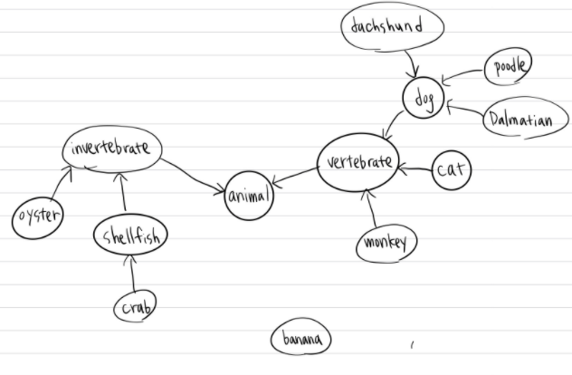

1_29.

|  |  |  |  |  |  |  |  |  |  |  |  |  |  |
| --- | --- | --- | --- | --- | --- | --- | --- | --- | --- | --- | --- | --- | --- |
|  | animal | vertebrate | invertebrate | dog | cat | monkey | oyster | shellfish | dachshund | poodle | dalmatian | crab | banana |
| animal | 0 | 0 | 0 | 0 | 0 | 0 | 0 | 0 | 0 | 0 | 0 | 0 | 0 |
| vertebrate | 1 | 0 | 0 | 0 | 0 | 0 | 0 | 0 | 0 | 0 | 0 | 0 | 0 |
| invertebrate | 1 | 0 | 0 | 0 | 0 | 0 | 0 | 0 | 0 | 0 | 0 | 0 | 0 |
| dog | 0 | 1 | 0 | 0 | 0 | 0 | 0 | 0 | 0 | 0 | 0 | 0 | 0 |
| cat | 0 | 1 | 0 | 0 | 0 | 0 | 0 | 0 | 0 | 0 | 0 | 0 | 0 |
| monkey | 0 | 1 | 0 | 0 | 0 | 0 | 0 | 0 | 0 | 0 | 0 | 0 | 0 |
| oyster | 0 | 0 | 1 | 0 | 0 | 0 | 0 | 0 | 0 | 0 | 0 | 0 | 0 |
| shellfish | 0 | 0 | 1 | 0 | 0 | 0 | 0 | 0 | 0 | 0 | 0 | 0 | 0 |
| dachshund | 0 | 0 | 0 | 1 | 0 | 0 | 0 | 0 | 0 | 0 | 0 | 0 | 0 |
| poodle | 0 | 0 | 0 | 1 | 0 | 0 | 0 | 0 | 0 | 0 | 0 | 0 | 0 |
| dalmatian | 0 | 0 | 0 | 1 | 0 | 0 | 0 | 0 | 0 | 0 | 0 | 0 | 0 |
| crab | 0 | 0 | 0 | 0 | 0 | 0 | 0 | 1 | 0 | 0 | 0 | 0 | 0 |
| banana | 0 | 0 | 0 | 0 | 0 | 0 | 0 | 0 | 0 | 0 | 0 | 0 | 0 |

1_30.

a. true

b. false

c. false

d. false

e. true

f. false

1_31. b