IMPACT CREDIT GUARANTEE LIMITED

ICGL Website
System Architecture, Quality Assurance & User Acceptance Report

Prepared for stakeholder review
Documentation baseline: 28 September 2026
System: Impact Credit Guarantee Limited public website

STATUS: IMPLEMENTATION AND LOCAL TEST EVIDENCE
This report describes the repository implementation and local checks. It is not production certification, completed business UAT, or an accessibility conformance statement.

Contents
1. Executive summary
2. System architecture
3. Software quality assurance
4. User acceptance testing plan
5. Test evidence and screenshots
6. Operations and release guide
7. Open decisions and production readiness
8. Source documentation register

1. Executive summary
The ICGL website is a client-rendered React single-page application (SPA) built with Vite, Tailwind CSS and React Router. It provides public information across 15 primary routes, including organisation and service information, impact reporting, eligibility, careers, contact and resource pages. Most content is source-controlled local data and static assets; the repository contains no application API, database, authentication or server-side form handler.
The local production build passed and browser smoke checks rendered all 15 sampled routes. The News keyword sample returned three stories for MSME; the Publications sample returned one 2025 Annual Report. Formal business UAT, complete accessibility/cross-browser testing and production deployment checks remain pending.
Stakeholder attention is required for form submission semantics, publication download targets, policy document mapping, consent-script gating, and bundle-size optimization.

System Architecture
Baseline: 28 September 2026 System type: Client-rendered, static single-page application (SPA)

1. Purpose and scope
The ICGL website presents the organisation, its guarantee services, eligibility information, impact, news, publications, policies, ratings, careers, contact information, and complaint/whistleblowing channels. It is a public information and marketing website. The repository contains no application server, database, user accounts, or private operational portal.

2. Context diagram

System interaction flow
Visitor -> Browser -> Static host -> React SPA -> Shared layout/router -> Route page
Connected services: bundled content/assets; browser storage for preferences; Google Maps; visitor email application; external organisation/social links.
The static host serves the built files. React Router handles client-side navigation. A production host must provide SPA fallback/rewrite behavior so direct requests to routes such as /resources/news return the app entry point.

3. Runtime and build components
Layer | Implementation | Responsibility
Document shell | index.html | Root mount point, viewport, title and description metadata
Bootstrap | src/main.jsx | React root, strict mode, global stylesheet, application mount
Routing | src/App.jsx | BrowserRouter route table and shared layout boundary
Shared shell | src/components/layout/Layout.jsx | Navbar, main route outlet, footer, route-scroll reset, cookie preferences
Navigation | src/components/layout/Navbar.jsx | Desktop/mobile navigation, Resources submenu, eligibility CTA
Shared UI | src/components/, src/components/motion/ | Page hero, cards, counters, image/reveal and staggered motion primitives
Pages | src/pages/ | Home, About, Services, Impact, Eligibility, Careers, Contact and team bio
Resource pages | src/pages/resources/ | News, FAQs, Ratings, Publications, Policies, Privacy, Whistleblowing, Complaints
Local data | src/data/content.js, src/data/pfiLogos.js | Navigation, contact details, impact values, services, news and shared content
Static assets | src/assets/, public/ | Images, icons, videos and policy PDFs
Styling/build | Tailwind CSS 4, Vite 5 | Utility styling, asset processing and production bundling

High-level request and rendering flow

System interaction flow
Visitor -> Browser -> Static host -> React SPA -> Shared layout/router -> Route page
Connected services: bundled content/assets; browser storage for preferences; Google Maps; visitor email application; external organisation/social links.

4. Route catalogue
All listed pages use the shared Layout route unless otherwise noted. The route table is defined in src/App.jsx.
Route | Page/component | Main purpose
/ | Home | Organisation identity, values, impact, PFI support CTA and news
/about | About | Organisation profile, governance and leadership
/about/:group/:slug | TeamMemberBio | Individual board or management profile
/services | Services | Guarantee and support offerings
/impact | Impact | Impact metrics, stories and dashboard
/eligibility | Eligibility | PFI eligibility criteria and information
/career | Career | Career information, opportunities and testimonial carousel
/career/:slug | JobDescription | Role details and application/contact information
/contact | Contact | Office contact details, message form and map embed
/resources/news | News | Local news list with keyword, year and category filters
/resources/faqs | Faqs | Frequently asked questions
/resources/ratings | Ratings | Ratings and certification information
/resources/publications | Publications | Local publication catalogue with filters
/resources/policies | Policies | Policy summaries and PDF links
/resources/privacy-policy | PrivacyPolicy | Privacy information including cookies
/resources/whistleblowing | Whistleblowing | Speak-up information and external channels
/resources/complaints | Complaints | Complaint process, categories and mailto form
Any unmatched route | NotFound | Not-found page

5. Data and state ownership

Content
â€¢ Most shared text, navigation, contact details, impact values, services, FAQs and news entries are source-controlled JavaScript data. There is no CMS or content API.
â€¢ Publication cards are a local in-component array in src/pages/resources/Publications.jsx.
â€¢ Images and policy documents are bundled or served as static assets. Vite assigns production asset names and copies imported assets into dist/assets/.

Browser state
State | Owner | Persistence
Mobile menu, filters, FAQ panels, carousels, contact confirmation | React page/component state | In-memory; resets on reload
Cookie preference object | CookieConsent | localStorage, key icgl-cookie-preferences-v1
Route and URL fragment | React Router/browser | Browser URL/history
Cookie preference shape:
Code / configuration excerpt:
{
"necessary": true,
"analytics": false,
"marketing": false
}
Necessary is required to be true. This implementation records consent preferences only. No analytics or marketing scripts are configured in this repository, so those categories do not currently gate third-party tracking code.

6. Integrations and trust boundaries
Integration | Usage | Boundary / operational behavior
Google Maps | Embedded iframe on Contact page | Requires visitor network access and Google's map service; verify map pin and privacy disclosure
Email application | mailto: links, including complaints form | Opens the visitor's configured mail application; does not provide server-side submission or delivery receipt
External organisations and social platforms | Outbound links | External availability/content is outside this SPA's control
Local storage | Cookie preference choice | Browser-local and origin-specific; unavailable/private-mode storage errors are surfaced in the consent UI
There is no application API, database, authentication, payment processing, or server-side form handler in the current repository.

7. Styling, motion, and accessibility considerations
â€¢ Tailwind CSS utility classes and shared theme tokens in src/index.css define responsive layout and brand colors.
â€¢ Framer Motion powers reveal, carousel, hover, and transition effects. Some interactive motion responds to the reduced-motion preference; check each component during accessibility review rather than assuming a global motion policy.
â€¢ Semantic landmarks, headings, form labels, image alternative text, and accessible button names are used in many key surfaces. A complete WCAG audit has not been run.
â€¢ News/publications filter controls include labels for screen readers and expose a result count and empty state.
â€¢ Consent controls use native checkboxes and buttons; keyboard-only navigation and screen-reader behavior remain formal UAT/QA work.

8. Security and privacy design notes
â€¢ This is a public client-side site; all bundled source and assets should be treated as publicly readable.
â€¢ Do not place credentials, private data, or server-only configuration in client code or public assets.
â€¢ The consent record is not evidence of server-side consent collection or proof that optional cookies are blocked; that requires integration and network verification before tracking tools are introduced.
â€¢ Form interfaces must not be described as server-submitted unless an approved backend is implemented and tested.
â€¢ The policy page currently reuses the Anti-Bribery & Corruption PDF for its Whistleblowing card. Confirm with the policy owner that the shared file is intended; otherwise replace it with the approved Whistleblowing document.

9. Architecture images

Home page

ICGL homepage in the local browser

Impact page
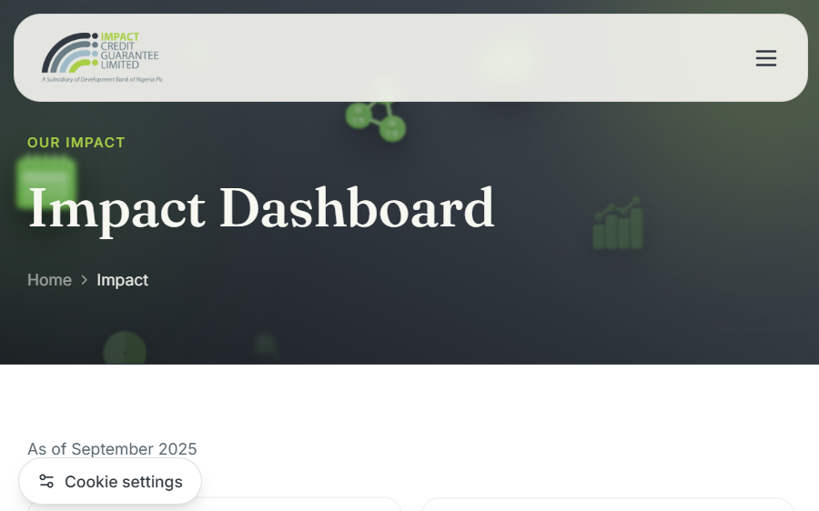
ICGL impact dashboard route in the local browser

Cookie preference prompt

First-visit cookie preference panel

Software Quality Assurance Plan
Baseline: 28 September 2026 Applies to: ICGL public website SPA and its static assets

1. Quality objectives
1. Every declared route renders without a fatal client error.
2. Navigation, filters, animations, consent UI and forms behave consistently at supported viewport sizes.
3. Content and impact metrics match owner-approved source material.
4. Forms, email handoffs, policy files and external links communicate their actual behavior.
5. Keyboard access, readable contrast, meaningful alternatives and reduced-motion preferences are verified before release.
6. Production output builds reproducibly and can be served with SPA route fallback.

2. Current verification baseline
Check | Result at baseline | Evidence
Production build (npm run build) | Passed; Vite produced dist/ | Test evidence
Route smoke test | 15 of 15 sampled routes rendered their expected page heading | Test evidence
News keyword filter | Passed for sample keyword MSME; 3 stories shown | Screenshot
Publication year/category filters | Passed for 2025 + Annual Report; 1 item shown | Screenshot
Policy action rendering | Five “Read … policy” links are present; owner confirmation of the shared Whistleblowing/Anti-Bribery PDF is pending | Test evidence
Diagnostics on cookie consent/layout | No diagnostics errors reported for those files after cookie-consent changes | Prior editor diagnostics; not a repository-wide lint run
Automated unit/integration/e2e suite | Not configured | No test script or test framework in package.json
Cross-browser, mobile device, accessibility audit, production monitoring | Pending | Must be performed for the target deployment

3. Test levels and responsibility
Level | Scope | Suggested owner | Minimum evidence
Static/build | Syntax, module resolution, asset inclusion, production bundling | Developer | Successful npm run build output
Component/manual | Consent choices, navigation, filters, form validation, empty states | Developer/QA | Test ID, steps, result, browser and date
Route integration | Direct route load, shared shell, links and bundled document access | QA | Route matrix plus failures/console details
Responsive/accessibility | Desktop/tablet/mobile, keyboard, screen reader, reduced motion, contrast | QA/accessibility reviewer | Device/browser matrix and WCAG findings
UAT | User tasks using approved content and expected organization workflows | ICGL business owner / representative users | Completed UAT record and sign-off
Production smoke | Deployed URL, redirects, SPA fallback, assets, contact links, maps and consent | Release owner | Dated release checklist and URL/version

4. Local test environment
â€¢ Runtime: Node.js version supported by Vite 5; use a maintained LTS release.
â€¢ Install dependencies from the lockfile with npm ci in CI or a clean checkout.
â€¢ Run npm run dev for local interactive checks.
â€¢ Run npm run build before release.
â€¢ Run npm run preview to serve the compiled dist/ output locally.
â€¢ No automated test command exists in the current package.json. Do not report manual browser checks as automated tests.

5. Regression suite
ID | Area | Test intent | Priority
QA-001 | Build | Install from lockfile and create a production bundle | P0
QA-002 | Routing | Direct-load every declared route and confirm expected title/content | P0
QA-003 | Navigation | Navigate desktop links, resources submenu, mobile menu and browser back/forward | P1
QA-004 | Cookie consent | First visit, accept all, reject optional, customize/save, reload persistence, reopen settings | P0
QA-005 | Cookie consent | Block local storage and confirm the visitor receives the storage error message | P1
QA-006 | News | Search title/body/category, select year/category, combine filters, clear filters, empty state | P1
QA-007 | Publications | Search, filter year/category, clear filters, empty state, verify each download destination | P1
QA-008 | Policies | Open each policy PDF, verify correct document mapping and response; confirm new-tab behavior | P0
QA-009 | Contact | Required fields, email format, privacy consent, submit behavior, map and direct contact links | P0
QA-010 | Complaints | Required fields/category, mailto subject/body, success explanation and direct contact links | P0
QA-011 | Impact | Counter values, labels, units, period switch and reduced-motion behavior | P1
QA-012 | Career | Testimonial next/previous, indicators, autoplay, pause behavior and reduced motion | P2
QA-013 | Visual assets | Image loading, alt text, cropping, lazy loading and broken assets | P1
QA-014 | Responsive | No horizontal overflow or obscured content at phone/tablet/desktop widths | P0
QA-015 | Accessibility | Keyboard order, focus visibility, headings/landmarks, contrast, form labels and screen-reader names | P0
QA-016 | External dependencies | Verify map, social, DBN, Deloitte and CBN links and behavior | P1
QA-017 | Static deployment | Verify nested routes and PDF/image assets through production host/CDN | P0

6. Defect severity
â€¢ Critical: Site unavailable, unsafe data exposure, or a major public workflow cannot be used.
â€¢ High: Core content, route, consent choice, policy/document, or form workflow is materially wrong or blocked.
â€¢ Medium: Important feature has a workaround, or responsive/accessibility defect affects a meaningful group.
â€¢ Low: Cosmetic/content issue with limited impact.
Every defect report should contain: identifier, title, environment, preconditions, reproduction steps, expected result, actual result, severity, screenshot/log evidence, and retest outcome.

7. Known gaps to resolve or formally accept
Gap | Why it matters | Suggested action
No automated test runner | Regressions are not checked automatically in CI | Select and configure a unit/e2e stack with the project owner
Contact form only changes local UI state | A success message can be mistaken for delivered correspondence | Wire an approved endpoint or replace the success copy with the real handoff behavior
Complaints uses mailto: | Submission depends on the visitor's email client and sending action | Confirm this is the approved channel or add a server-side intake
Publications show a Download affordance without a target | A visible action is not functional | Attach approved publication assets/URLs or remove the affordance
Whistleblowing card points to the same Anti-Bribery PDF | The policy identity may be ambiguous to users | Confirm the shared document is intended with the policy owner; otherwise replace the mapping with the approved Whistleblowing PDF
Cookie categories have no tracking integration | Preferences are recorded but do not currently gate optional scripts | Implement script gating before analytics/marketing scripts are added
Production bundle has a >500 kB minified chunk warning | May affect first-load performance | Profile bundle and prioritize/code-split when acceptable
Full accessibility/device/browser test not run | Visual build alone does not establish conformance | Complete manual and automated accessibility checks

8. Release quality gate
Do not mark a release ready until all P0 regression items pass, all high/critical defects are closed or explicitly accepted by the owner, required policy assets are confirmed, form behavior is accurately described, and UAT sign-off is recorded. See Operations & Release.

User Acceptance Testing Plan
System: ICGL public website Document baseline: 28 September 2026 UAT status: Scenarios prepared; business execution and sign-off pending

1. Purpose
UAT confirms the website supports the public information and navigation tasks expected by MSMEs, PFIs, media, job seekers, and other visitors. A technical build or developer smoke test is not business acceptance.

2. Participants and responsibilities
â€¢ Business owner: confirms terminology, claims, metric values, contact details, official policy documents, and final acceptance.
â€¢ UAT coordinator: prepares test data/browser, records pass/fail, raises defects, and obtains evidence.
â€¢ Representative users: complete visitor tasks without developer assistance where possible.
â€¢ Developer/release owner: investigates defects and provides a candidate build for retest.

3. Environment and prerequisites
Record the candidate URL/build ID, date, browser/version, operating system, screen size, and tester for each execution. For local review, run npm run dev; for release acceptance, use a deployed staging URL.
Before starting:
1. Clear site local storage or use a fresh browser profile for first-visit consent cases.
2. Confirm all approved copy, impact figures, images, PDF files, email/phone details, social links, and map location.
3. Use a test email client or do not submit real personal information to mailto: actions.
4. Ensure screenshots contain no real user/customer data.
5. Confirm with the policy owner whether the Anti-Bribery & Corruption PDF is also the intended Whistleblowing policy document; supply the correct separate file if it is not.

4. User scenarios
ID | Persona / task | Steps | Expected result | Priority | Status
UAT-01 | First-time visitor reviews consent | Open the site with clean storage; inspect options; accept or reject optional categories | Consent panel is clear, usable, describes optional choices and closes after saving | P0 | Pending business execution
UAT-02 | Returning visitor changes choice | Reopen Cookie settings; customize a category; save; reload and reopen | Saved settings persist and can be changed; necessary storage remains on | P0 | Pending business execution
UAT-03 | MSME learns about offerings | Open Services; identify Individual, Blanket, Portfolio and assistance offers | Each offering is understandable, imagery relevant, CTA destination correct | P1 | Pending
UAT-04 | PFI checks eligibility | Use Check eligibility and review criteria | Eligibility information is clear and linked correctly | P0 | Pending
UAT-05 | Visitor explores impact | Open Impact; inspect reporting date/period, metric values and stories | Values, units and as-of date match approved data; animations do not obstruct reading | P0 | Pending
UAT-06 | Visitor searches news | Search a known word; filter by year and category; clear filters; enter a no-match term | Results update correctly, result count and empty state are understandable | P1 | Developer smoke sample passed; full UAT pending
UAT-07 | Visitor searches publications | Combine year/category/keyword filters; inspect a publication action | Correct publication is shown and the Download action opens the approved file | P0 | Pending; downloads need targets
UAT-08 | Visitor reads policies | Open each policy action, including Whistleblowing | Correct approved PDF opens in a new tab and is readable | P0 | Pending; policy owner must verify shared PDF mapping
UAT-09 | Visitor contacts ICGL | Enter required details, check privacy consent, submit; use contact links | Validation works; UI accurately explains whether message was sent or handed off | P0 | Pending; contact form has no backend
UAT-10 | Visitor raises complaint | Complete category/message, submit using the provided action | Prepared message is addressed correctly and user understands they must send it | P0 | Pending; mail client required
UAT-11 | Visitor uses mobile navigation | At phone width, open Resources menu, follow a route, reopen/close menu | Menu is operable, content remains visible, no horizontal overflow | P0 | Pending
UAT-12 | Keyboard/screen-reader user navigates | Use keyboard only through menus, forms, consent and filters | Visible focus, logical order, named controls, readable status feedback | P0 | Pending
UAT-13 | Reduced-motion visitor views animation | Enable OS reduced-motion setting; visit animated pages | Essential content remains available; nonessential motion is suitably reduced | P1 | Pending
UAT-14 | Visitor checks location and external links | Use map, phone, email, social and partner links | Correct destinations open; address and pin are accurate | P1 | Pending

5. Acceptance criteria
The business owner may accept the candidate when:
â€¢ All P0 scenarios pass on the agreed staging build.
â€¢ The content, service terminology, contact information, impact values, policy mappings, and footer trust marks are approved.
â€¢ The full end-user behavior of contact, complaint, publication-download, and consent flows matches their labels and privacy commitments.
â€¢ No open Critical/High defect remains, unless the accountable owner documents an explicit exception, impact, workaround and target date.
â€¢ Responsive and accessibility checks are complete for agreed devices/browsers.
â€¢ The final accepted build identifier and deployment URL are recorded below.

6. Execution record and sign-off
Field | Value
Staging URL | To be completed
Build/release identifier | To be completed
UAT start/end | To be completed
Browsers/devices | To be completed
Open defects / accepted exceptions | To be completed
Business owner decision | Pending
Name / role | To be completed
Date | To be completed
Record each scenario outcome as Pass, Fail, Blocked, or Not Run. Attach screenshots without personal data and link defects to their reproduction record.

Test Evidence and Local Smoke Report
Execution date: 28 September 2026 Environment: Local Vite development server (http://127.0.0.1:5173) and Windows workspace Scope: Build, route render smoke, selected filters, policy link rendering, visual screenshots This is not: Full UAT, production verification, a cross-browser matrix, or an accessibility certification.

1. Summary
Check | Result | Recorded observation
npm run build | Passed | Vite 5.4.21 created production output in dist/; build completed successfully
Static diagnostics | Passed (scoped) | No errors reported for CookieConsent.jsx and Layout.jsx after their changes
Route smoke | Passed: 15/15 | Every sampled route rendered the expected page heading
News keyword sample | Passed | Keyword MSME returned 3 stories and exposed Clear filters
Publications filter sample | Passed | Year 2025 + category Annual Report returned 1 publication and exposed Clear filters
Policies actions | Partial | Five “Read … policy” links render; Whistleblowing currently maps to the Anti-Bribery PDF
Cookie prompt | Visually observed | First-visit prompt and preferences UI captured; interactive category persistence requires a formal follow-up test
Automated unit/e2e test suite | Not available | No test framework or test script is configured
The production build emitted Vite's advisory that a minified JavaScript chunk exceeds 500 kB. This is a performance follow-up, not a build failure.

2. Route smoke details
Path | Expected heading observed | Result
/ | Guaranteeing Success. Driving growth. | Pass
/about | Who We Are | Pass
/services | What We Do | Pass
/impact | Impact Dashboard | Pass
/eligibility | Eligibility for ICGL Guarantee Support | Pass
/career | Unlock Your Potential | Pass
/contact | Get in Touch | Pass
/resources/news | News & Updates | Pass
/resources/faqs | FAQs | Pass
/resources/ratings | Our Ratings & Certifications | Pass
/resources/publications | Reports & Publications | Pass
/resources/policies | Our Corporate Policies | Pass
/resources/privacy-policy | Privacy Policy | Pass
/resources/whistleblowing | Speak Up. Your Voice Matters. | Pass
/resources/complaints | We're Here to Help | Pass
/about/:group/:slug and /career/:slug are parameterized routes; this smoke pass did not exercise a specific real profile or job slug.

3. Feature observations

Filters
â€¢ News search input filled with MSME: result summary changed to 3 stories found.
â€¢ Publications filters set to 2025 and Annual Report: summary changed to 1 publication found.
â€¢ These checks confirm a sample path only; combinations, reset behavior, empty results, casing, and accessibility still belong in regression/UAT.

Cookie consent
â€¢ The clean local browser showed the first-visit consent panel.
â€¢ Choosing “Reject optional” closed the panel and displayed the “Cookie settings” control; reopening showed the preference panel.
â€¢ A complete accept-all/custom-category persistence matrix was not recorded as passed. See QA-004 and UAT-01/UAT-02.

Policy links
â€¢ The policy page displayed five “Read … policy” actions.
â€¢ ESRM, IMS, Privacy and Anti-Bribery actions import their corresponding local PDFs.
â€¢ The Whistleblowing card currently imports the same Anti-Bribery PDF. No standalone Whistleblowing PDF was present in src/assets/files/ during this baseline; confirm with the policy owner that the shared document is intended or map the correct approved file.

4. Screenshots
Screenshots were captured from the local browser run. They document appearance and selected states, not all responsive sizes.

Home and first-visit consent
Homepage screenshot
Homepage with first-visit cookie consent

Impact and contact
Impact page screenshot
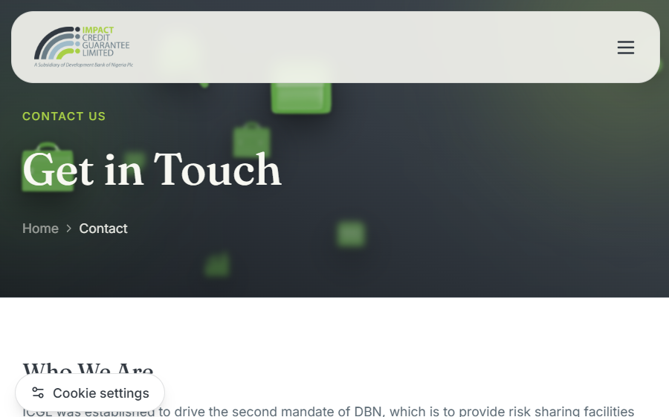
Contact page screenshot

Policies and content filters
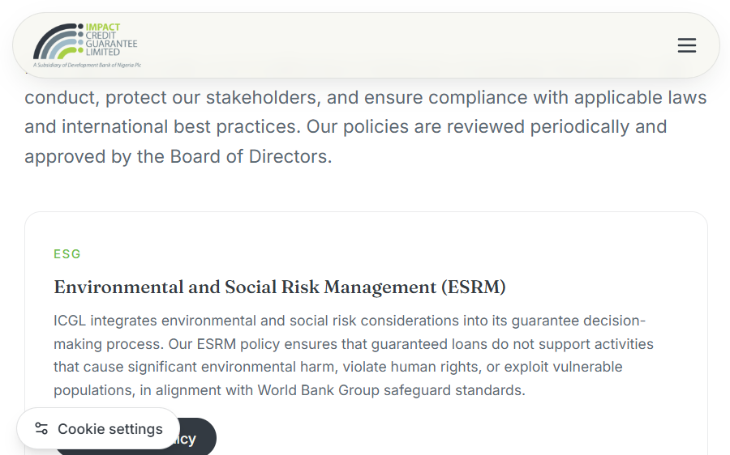
Policies page with policy actions
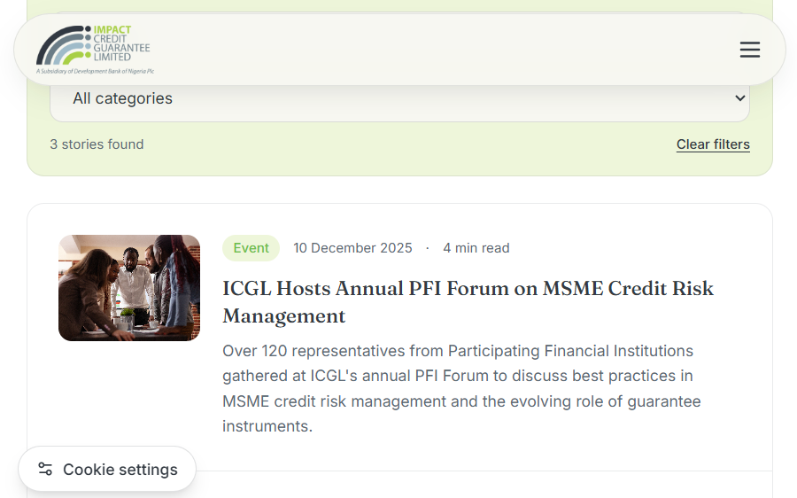
News keyword filter for MSME showing the matching result summary
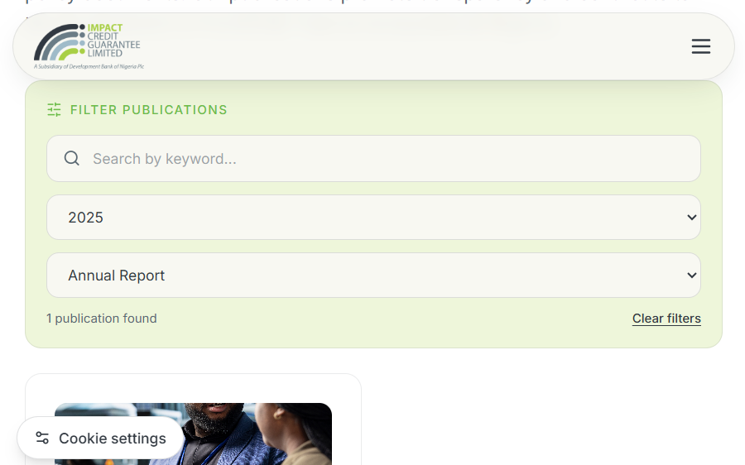
Publications filtered to 2025 Annual Reports

5. Browser/runtime notes
â€¢ The local browser logged React Router v6 future-flag warnings. They did not prevent the tested pages from rendering.
â€¢ The Contacts page includes a Google Maps iframe, which depends on external service/network availability.
â€¢ Screenshots were produced by the local browser capture environment; confirm the same assets, map, links, and visual treatment on staging.

6. Follow-up evidence required
1. Run npm ci and npm run build from a clean checkout/CI runner.
2. Run the completed regression suite once automated tests exist.
3. Verify direct navigation and SPA fallback on the actual hosting platform.
4. Execute all P0 UAT cases, including full cookie categories/reload, form handoffs, document downloads, responsive and keyboard/screen-reader flows.
5. Repeat policy/document checks after the policy owner confirms whether the shared PDF mapping is correct.

Operations and Release Guide

1. Prerequisites
â€¢ Node.js LTS version supported by Vite 5 (Node 18+; use the current organization-approved LTS).
â€¢ npm.
â€¢ Repository dependencies installed from the committed package-lock.json.
â€¢ A browser for local manual checks.
Do not copy local .env values into public client code or publish local environment files. The current site does not have an application API/backend configured.

2. Local development
From the repository root:
Code / configuration excerpt:
npm ci
npm run dev
Vite prints the local URL. Stop the development server with Ctrl+C in the terminal where it is running.

3. Build and preview
Code / configuration excerpt:
npm run build
npm run preview
npm run build writes the static production bundle to dist/. npm run preview serves that output locally. The build emits a bundle-size advisory for a JavaScript chunk over 500 kB; review the analyzer/performance impact when optimizing.
There is no configured npm test, lint, or type-check script in package.json at this baseline. A successful build verifies bundling, not all user workflows.

4. Deployment assumptions
1. Publish the contents of dist/ to an approved static hosting/CDN target.
2. Configure rewrite/fallback behavior so nested SPA paths resolve to index.html.
3. Ensure hashed assets under dist/assets/ are served with correct MIME types and caching.
4. Keep the entry HTML revalidated or short-lived so it references the current hashed assets; immutable caching is appropriate for content-hashed assets.
5. Use HTTPS in production.
6. Confirm hosting headers, CSP and any privacy/security headers with the hosting/security owners; no production hosting platform is defined in this repository.
7. Smoke-test the deployed domain and all critical routes before announcing release.

5. Release checklist

Before build
â€¢ [ ] Approved content, impact metrics, dates, addresses and all phone/email destinations.
â€¢ [ ] Current approved PDFs and publication assets attached to the correct controls.
â€¢ [ ] Policy owner has confirmed that the Whistleblowing card opens its approved document (the current mapping uses the Anti-Bribery & Corruption PDF).
â€¢ [ ] Contact and complaints submission behavior accurately described and approved.
â€¢ [ ] Cookie preference behavior and any optional tracking integrations reviewed.
â€¢ [ ] No secrets or private values included in client-side assets.

Build and verification
â€¢ [ ] Clean dependency install (npm ci).
â€¢ [ ] Production build (npm run build) succeeds.
â€¢ [ ] Review warnings, especially bundle-size advisory.
â€¢ [ ] Execute P0 QA/regression cases and complete UAT/sign-off.
â€¢ [ ] Verify direct route loads, policy PDFs, images/videos and external links against staging.
â€¢ [ ] Check keyboard navigation, reduced motion and phone/tablet layouts.
â€¢ [ ] Review browser console/network for failed asset, map, font and script requests.

Deploy and recover
â€¢ [ ] Record release identifier, build time, deployment URL and approver.
â€¢ [ ] Deploy only the generated dist/ output.
â€¢ [ ] Run post-deploy smoke on Home, Eligibility, Impact, Contact, News, Publications, Policies, Privacy, Whistleblowing and Complaints.
â€¢ [ ] Confirm SPA fallback, HTTPS, caching and expected consent state on a clean browser profile.
â€¢ [ ] If release is faulty, restore the previously approved static artifact using the hosting provider's rollback mechanism; retain incident details and rerun smoke checks.

6. Content and asset maintenance
â€¢ Shared structured data: edit src/data/content.js or src/data/pfiLogos.js.
â€¢ Page-specific content: edit the relevant component in src/pages/.
â€¢ Policy documents: store approved PDFs in src/assets/files/, import them from the Policies page, and verify each link opens the matching document.
â€¢ Publications: the current cards are local data in src/pages/resources/Publications.jsx; update metadata and attach actual file links before presenting a working download control.
â€¢ Images: prefer existing optimized assets, meaningful alt text for informative images, and decorative empty alt text only for decorative imagery.
â€¢ Screenshots in this documentation are review evidence; recapture after substantial page or feature changes and update their descriptions.

7. Runtime support and limitations
â€¢ The application is client-side; there are no application logs or server-side submission receipts in this codebase.
â€¢ Contact form success is local UI state only; complaints uses a mailto: handoff.
â€¢ Cookie choices are browser-local storage. If analytics/marketing tags are added, ensure they do not execute until consent and test the network behavior.
â€¢ Google Maps, external social links and outbound organization sites can fail independently of the SPA.
â€¢ Maintain a separate deployment/hosting runbook for DNS, TLS, CDN, backups, alerting and access control once the production host is selected.

7. Open decisions and production readiness
Resolve or formally accept these implementation boundaries before production reliance:
Contact form: local success state only; no server-side delivery is configured.
Complaints form: mailto handoff; the visitor must send email and the site receives no delivery acknowledgement.
Publications: Download affordances currently have no wired publication target.
Whistleblowing policy: currently uses the Anti-Bribery & Corruption PDF; obtain policy-owner confirmation or supply the approved Whistleblowing document.
Cookie preferences: localStorage stores choices; optional categories do not gate tracking scripts in this repository.
Quality automation: no unit, integration, lint, type-check or end-to-end test runner is configured.
Performance: build succeeds with a Vite advisory for a minified JavaScript chunk over 500 kB.
Acceptance recommendation: complete P0 QA/UAT, approve content and policy mapping, confirm form/download behavior, and sign off responsive/accessibility testing before declaring release acceptance.

8. Source documentation register
docs/README.md
docs/architecture.md
docs/quality-assurance.md
docs/uat.md
docs/test-evidence.md
docs/operations.md

