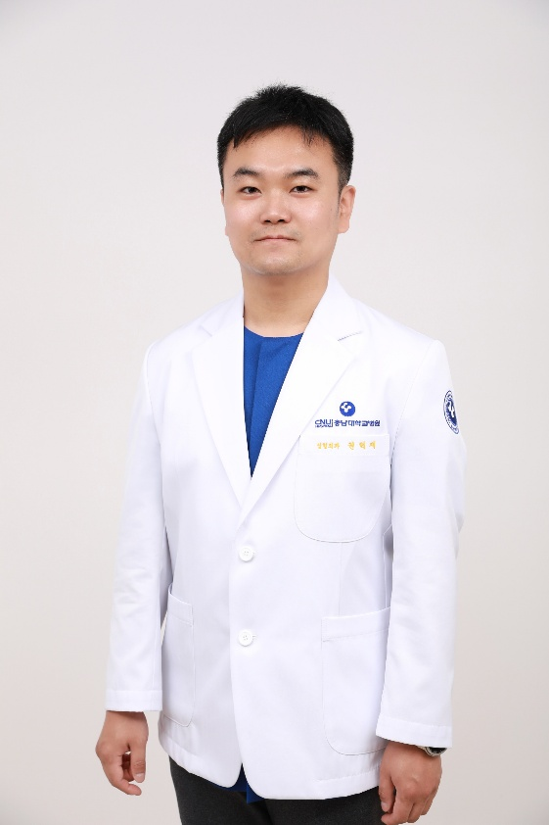
Curriculum Vitae

Hyeokjae Kwon, M.D., Ph.D.
Clinical Assistant Professor
Department of Plastic and Reconstructive Surgery
Chungnam National University Hospital, Daejeon, South Korea

Mobile: (82) 10-2601-0642
Office: (82) 42-280-7380
E-mail: kwon.hyeokjae@cnuh.co.kr
Google Scholar: https://scholar.google.com/citations?user=ouc34HsAAAAJ

EDUCATION
2021.09. ~ 2023.08. Ph. D. in Medicine, Chungnam National University, South Korea
2010.03. ~ 2014.02. M.D./ M.S. in Medicine, Chungnam National University, South Korea
2006.03. ~ 2010.02. B.S. in Computer Science, KAIST, South Korea

PROFESSIONAL EXPERIENCEs
Mar. 2024 ~ Present Clinical Assistant Professor, Department of Plastic and Reconstructive Surgery, Chungnam National University Hospital, Daejeon, South Korea
May 2022 ~ Feb. 2024 Clinical Fellow, Department of Plastic and Reconstructive Surgery, Chungnam National University Hospital, Daejeon, South Korea
Apr. 2021 ~ Apr. 2022 Army Medical Officer, 1115th Engineer Group, Second Operations Command, Republic of Korea Army
Apr. 2019 ~ Apr. 2021 Army Medical Officer, 7th Airborne Special Forces Brigade, Republic of Korea Army
Mar. 2015 ~ Feb. 2019 Residency in Plastic and Reconstructive Surgery, Chungnam National University Hospital, Daejeon, South Korea
Mar. 2014 ~ Feb. 2015 Medical internship, Chungnam National University Hospital, Daejeon, South Korea

JOURNAL AND REPORT
- Kim J, Kim J-H, Kwon H.
Iatrogenic lung overinflation resulting in pneumothorax and pneumoperitoneum during oxygen therapy post-general anesthesia: A case report.
Medicine (Baltimore). 2025;104(29):e43410. https://doi.org/10.1097/MD.0000000000043410
- Kwon H, Kim S, Oh S-H, Ha Y, Song S-H.
Outcomes of reconstructing lower lid defects using midface lifting and full-thickness skin grafts.
J Craniofac Surg. 2025; In press. https://doi.org/10.1097/SCS.0000000000011579
- Kyung H, Park JY, Lee B, Kim J, Oh S-H, Kim S, Ha Y, Kwon H, Lee KC, Song S-H.
The effect of a collagen–elastin implantation on infraorbital hollowing in lower lid surgery for aging patients.
J Craniofac Surg. 2025; In press. https://doi.org/10.1097/SCS.0000000000011579
- Lee B, Xu L, Oh S-H, Ha Y, Kwon H, Lee KC, Kim SY, Seo CW, Kim S*, Song S-H*.
AI-driven eyeball exposure rate (EER) analysis: A useful tool for assessing ptosis surgery effectiveness.
PLoS One. 2025;20(3):e0319577. https://doi.org/10.1371/journal.pone.0319577
- Ha Y, Kim D, Kwon H, Kim S, Song S-H, Oh S-H, Kim J-H, Yang HJ, Kyung H*.
Anterolateral thigh free flap using modified turbocharging method: a case report.
Front Surg. 2024;11:1273843. https://doi.org/10.3389/fsurg.2024.1273843
- Kim J, Kim D, Oh S-H, Kwon H.
Virtual reality for preoperative patient education: Satisfaction, usability, and impact on burnout from the perspective of new nurses.
World J Clin Cases. 2024;12(28):6204–6216. http://dx.doi.org/10.12998/wjcc.v12.i28.6204
- Kyung HW, Lee S, Kwon H, Kim S, Kim J-H, Song S-H, Oh S-H, Yang HJ, Ha Y*.
The effect of botulinum toxin A on NADPH oxidase system and ischemia reperfusion injury.
Plast Reconstr Surg. 2024;154(1):100e–111e. https://doi.org/10.1097/PRS.0000000000010956
- Ha Y, Kim J-H, Kim J, Kwon H.
Non-surgical treatment of diabetic foot ulcers on the dorsum of the foot with polydeoxyribonucleotide (PDRN) injection: Two cases.
World J Clin Cases. 2024;12(20):4446–4451. http://dx.doi.org/10.12998/wjcc.v12.i20.4446
- Kim J, Kwon H, Kim S, Song S-H, Oh S-H, Ha Y*.
Improved flap perfusion and hemostasis after postoperative embolization in free flap surgery: A case report.
Arch Hand Microsurg. 2024;29(2):127–131. https://doi.org/10.12790/ahm.24.0005
- Kwon H, Song B, Ha Y, Kim S, Oh S-H, Seo YJ, Song S-H.
Customized reconstruction of lower eyelid defects.
J Craniofac Surg. 2024;35(1):233–236. https://doi.org/10.1097/SCS.0000000000009807
- Song B, Kwon H, Kim S, Ha Y, Oh S-H, Song S-H*.
Introduction of deep learning-based infrared image analysis to marginal reflex distance-1 measurement method: Clinical validation study.
J Clin Med. 2023;12(23):7466. https://doi.org/10.3390/jcm12237466
- Park Y, Kwon H, Kim S, Song S-H, Oh S-H, Ha Y*.
Reconstruction of a medium-sized congenital melanocytic nevus defect using a thin thoracodorsal artery perforator free flap: A case report.
Arch Aesthetic Plast Surg. 2023;29(4):226–229. https://doi.org/10.14730/aaps.2023.00941
- Song B, Kim J, Kwon H, Kim S, Oh S-H, Ha Y*, Song S-H*.
Smartphone-based LiDAR application for easy and accurate wound size measurement.
J Clin Med. 2023;12(18):6042. https://doi.org/10.3390/jcm12186042
- Kwon H, Lee J, Park YS, Oh S-H*, Kim J*.
Effects of preoperative education using virtual reality on preoperative anxiety and information desire: A randomized clinical trial.
J Clin Monit Comput. 2023;37:1401–1407. https://doi.org/10.1007/s10877-023-00988-5
- Kwon H, Lee S, Kim J, Song S-H*.
Efficacy and safety of stromal vascular fraction on scar revision surgery: A prospective study.
J Dermatol Treat. 2023;34(1):2171260. https://doi.org/10.1080/09546634.2023.2171260
- Kwon H, Lee S, Kim S, Song S-H*, Oh S-H, Kim J-H, Kyung H, Yang HJ, Ha Y*.
Reconstruction of complex knee wounds with a distally based gracilis flap and gastrocnemius myocutaneous flap: A case report.
Front Surg. 2023;10:1109936. http://doi.org/10.3389/fsurg.2023.1109936
- Kwon H, Ko G, Choi J, Ha Y, Kim S, Kim J-H, Oh S-H, Song S-H.
Aesthetic removal of foreign body granulomas of forehead via pretrichial approach.
J Craniofac Surg. 2022;33(5):1591–1595. http://doi.org/10.1097/SCS.0000000000008530
- Choi J, Ko G, Kwon H, Ha Y, Kim S, Kyung H, Oh S-H, Song S-H.
Minimally invasive removal of facial foreign body granulomas.
Arch Aesthetic Plast Surg. 2022;28(1):24–30. https://doi.org/10.14730/aaps.2021.00346
- Song S-H, Kwon H, Oh S-H, Kim S-J, Park J, Kim S-I.
Open reduction of zygoma fractures with the extended transconjunctival approach and T-bar screw reduction.
Arch Plast Surg. 2018;45(4):325–332. http://doi.org/10.5999/aps.2018.00311
- Oh S-H, Kwon H, Kim SJ, Kyung H, Seo YJ, Lew DH, Song S-H.
Bilateral interdigitated pacman flap for round and oval facial defects.
J Craniomaxillofac Surg. 2018;46(6):1032–1036. https://doi.org/10.1016/j.jcms.2018.04.012
- Kyung H, Kwon H, Song S-H, Oh S-H.
Reconstruction using local flaps for penoscrotal defects after ablation of skin lesions.
J Wound Manag Res. 2018;14(1):37–43. https://doi.org/10.22467/jwmr.2017.00220
- Jeong JY, Kwon H, Piao Y, Oh S-H.
A new method for stabilizing the columellar strut used in rhinoplasty: The trans-septal columellar stabilizing suture.
J Oral Maxillofac Surg. 2018;76(1):165–168. https://doi.org/10.1016/j.joms.2017.07.145

Honors and Awards
Feb 2024 — Excellence Award for Medical Record Documentation, Chungnam National University Hospital, Daejeon, South Korea
Aug 2022 — Excellent Research Award, Graduate School of Chungnam National University, Daejeon, South Korea
Mar 2023 — Outstanding Reviewer Award, Journal of Wound Management and Research

Certifications
Nov. 2024 Fellow of Korea Wound Academy (FKWA), Korean Wound Management Society
Dec. 2022 Certified Physician in Biomedical Informatics, Korea Society of Medical Informatics (KOSMI)

Professional Memberships
Regular Member, Korean Society of Plastic and Reconstructive Surgeons (KSPRS)
Regular Member, Korean Wound Management Society

Professional Activities
Reviewer, Journal of Wound Management and Research (JWMR)
Reviewer, Archives of Plastic Surgery (APS)

