1. cmd를 켠 후에 cd C:\Bitnami\wampstack-8.0.3-1\mysql\bin를 입력하면

2. mysql> 이라고 뜬다.

3. CREATE DATABASE opentutorials CHARACTER SET utf8 COLLATE utf8_general_ci;

4. use opentutorials;

5. CREATE TABLE topic (

-> id int(11) NOT NULL AUTO_INCREMENT,

-> title varchar(255) NOT NULL ,

-> description text NULL ,

-> created datetime NOT NULL ,

-> PRIMARY KEY (id)

-> );

6. show tables;

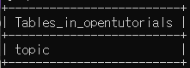

7. desc topic;

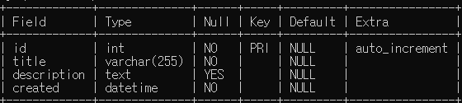

8. INSERT INTO topic (title, description, created) VALUES('html', 'html이란 무엇인가?', now());

//데이터 넣기

9. SELECT * FROM topic;

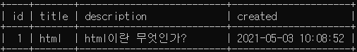

10. INSERT INTO topic (title, description, created) VALUES('css', 'html 꾸주는 언어', now());

//데이터 넣기

11. SELECT * FROM topic;

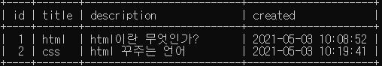

12. SELECT * FROM topic WHERE id=2;

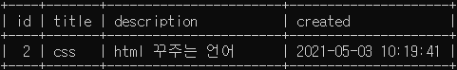

13. SELECT * FROM topic WHERE id=1 or id=2;

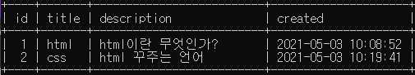

14. SELECT * FROM topic ORDER BY id DESC;

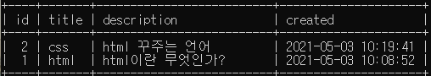

15. SELECT * FROM topic ORDER BY id ASC;

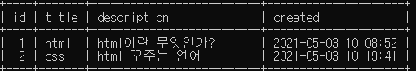

16. UPDATE topic SET title='cascading style sheet', description='아름다움을 위한 언어' WHERE id=2;

// 데이터 수정하기

17. SELECT * FROM topic;

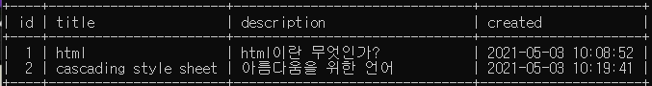

18. DELETE FROM topic WHERE id=2;

// 데이터 삭제하기

19. SELECT * FROM topic;

