Explicit Notch–proneural dynamics set the tempo, not the onset, of lateral-inhibition patterning
Hyeonje Yang
Department of Biological Sciences, Seoul National University, Seoul, Republic of Korea (yanghj0206@snu.ac.kr). Revised manuscript draft, October 2026.

Abstract
Lateral inhibition through Notch–Delta signalling turns small differences between neighbouring cells into alternating cell states. Most models compress the steps downstream of Notch activation into one or two effective variables. We ask which predictions change when the activated-Notch and proneural steps are kept as separate dynamical variables. Our model has four variables per cell: Delta, Notch receptor, activated Notch, and proneural activity. Cells sit on a periodic six-neighbour contact lattice. We prove that the homogeneous steady state is unique for all positive parameters. We also prove that the static (zero-frequency) gain of the feedback loop is always largest for the three-sublattice spatial mode, so this mode is the only one that can lose stability first through a zero eigenvalue. These onset properties depend only on static input–output responses. Collapsing the proneural layer, or both downstream layers, by quasi-steady-state elimination therefore leaves the stationary instability boundary exactly unchanged. What the explicit layer changes is the dynamics. Rescaling the proneural turnover rate leaves the critical Notch production rate fixed while the pattern growth rate varies over three decades. Across a 4000-point Latin-hypercube parameter sample, the reduced model overestimates the growth rate at every unstable point (median 4.9-fold) and predicts instabilities absent from the full model. Twelve sampled points are unstable even though the static gain is below one. Each has two eigenvalues in the right half-plane, which a Nyquist test detects and a static test cannot. Patterning onset is thus a static property of the circuit, while its tempo is set by the slowest downstream step.

1. Introduction
In lateral inhibition, Delta on one cell activates Notch on its neighbours, and Notch signalling represses the proneural activity that drives Delta expression. Small differences between adjacent cells are amplified into a spatial pattern of signal-sending and signal-receiving states [1, 2]. In Drosophila sensory-organ development this antagonism acts through Achaete–Scute proneural self-stimulation and Notch/Enhancer-of-split repression [3–6].
Mathematical models of this process usually compress everything downstream of receptor–ligand binding into one or two effective variables, such as a “Notch activity” that directly represses Delta [1, 7–9]. For such models, the conditions under which the homogeneous state loses stability are well understood. The coupled system is decomposed into eigenmodes of the cell-contact graph, and each mode is tested separately [1, 10, 13]. Equivalently, instability of a mode follows from a static (zero-frequency) input–output gain of a single cell multiplied by the corresponding graph eigenvalue [11, 12]. On the triangular contact graph of a hexagonal tissue, the most negative graph eigenvalue belongs to a three-sublattice pattern, not a checkerboard [13]. Two-dimensional contact coupling has also been analysed directly [14].
These results leave a question open. When the activated-Notch and proneural steps are kept as separate dynamical variables, which predictions actually differ from those of a reduced model? Retaining more variables gives more parameters to vary. It does not by itself show that the extra dynamics matter for patterning.
We answer this question for a four-variable Delta–Notch–activated-Notch–proneural model. We do not claim the stability machinery as new. The factorisation of each mode’s characteristic polynomial into a static loop gain (Section 3.1) is a standard Schur-complement identity, and it is equivalent to the graph-based static-gain conditions of [11, 12]. We use it to separate predictions that depend only on static responses from predictions that depend on downstream timescales. Four results follow:
- Uniqueness. The homogeneous steady state is unique for every positive parameter set.
- Mode selection. The static loop gain is largest at the most negative graph eigenvalue for every parameter set. Stationary onset therefore always selects the three-sublattice mode, even though cis inhibition and trans depletion of ligand make the gain a non-trivial function of the mode.
- Shared onset. Any matched reduction that slaves the downstream layer to quasi-steady state has the same stationary boundary as the explicit model.
- Different dynamics. The explicit layer changes the pattern growth rate, often by large factors, and changes the set of instabilities that do not pass through a zero eigenvalue. We identify the sampled parameter sets at which a static test fails, and explain each one.

2. Model and spatial modes

2.1 Equations
Each cell $i$ carries four concentrations: Delta ligand $D_{i}$, Notch receptor $N_{i}$, activated Notch (NICD-like signalling activity) $A_{i}$, and proneural activity $S_{i}$. All are dimensionless, as is time $t$. The dynamics are
$$\begin{matrix}{\dot{D}}_{i} & =λ_{D} h_{D}(S_{i})−d_{D}D_{i}−f_{D}D_{i} s_{N,i}−k_{c}N_{i}D_{i}, \\ {\dot{N}}_{i} & =λ_{N}−d_{N}N_{i}−f_{N}N_{i} s_{D,i}−k_{c}N_{i}D_{i}, \\ {\dot{A}}_{i} & =−d_{A}A_{i}+f_{N}N_{i} s_{D,i}, \\ {\dot{S}}_{i} & =−d_{S}S_{i}+λ_{S} h_{S}(A_{i}),\end{matrix} (1)$$
where sD,i=j∼i​Dj and sN,i=j∼i​Nj are sums over the six contact neighbours of cell $i$. The production terms use Hill functions: $h_{D}(S)=1/[1+(K_{d}/S)^{n_{D}}]$ is increasing (proneural activity drives Delta) and $h_{S}(A)=1/[1+(A/K_{d})^{n_{S}}]$ is decreasing (activated Notch represses proneural activity).
The 13 positive parameters are:
- $λ_{D},λ_{N},λ_{S}$: maximal production rates of Delta, Notch and proneural activity;
- $d_{D},d_{N},d_{A},d_{S}$: first-order loss rates;
- $f_{N}$: trans activation of Notch by neighbouring Delta, which consumes the receptor and produces $A$;
- $f_{D}$: trans depletion of Delta by neighbouring Notch;
- $k_{c}$: cis mutual inactivation of Notch and Delta in the same cell;
- $K_{d}$: the half-saturation constant shared by both Hill functions;
- $n_{D},n_{S}$: the Hill coefficients.
The baseline parameter set $p_{0}$ (Table 1) is a literature-inspired operating point that is not fitted to a particular tissue. The main continuation parameter is the Notch production rate $λ_{N}$, with all other parameters held at $p_{0}$. We refer to three reference points: $p_{0}$ ($λ_{N}=1$), P2 ($λ_{N}=2$) and P3 ($λ_{N}=5.623$).

2.2 Contact graph and spatial modes
Cells occupy a $24×24$ periodic array. Cell $(r,c)$ contacts the six cells at offsets $(±1,0)$, $(0,±1)$, $(−1,+1)$ and $(+1,−1)$, which is the contact graph of a hexagonal tiling (Fig. 1B). Let $W$ be the adjacency matrix of this graph ($W_{ij}=1$ if cells $i$ and $j$ touch). Because $W$ is symmetric and every cell has $z=6$ neighbours, its eigenvalues $μ$ lie in $[−6,6]$. Its eigenvectors are plane waves indexed by integers $(m,n)$, $0≤m,n<24$, with wavevector components $k_{1}=2πm/24$ and $k_{2}=2πn/24$ and
$$μ(m,n)=2\text{cos}k_{1}+2\text{cos}k_{2}+2\text{cos}(k_{1}−k_{2}) (2)$$
(Fig. 1D). The uniform mode $(m,n)=(0,0)$ has $μ=6$. The minimum $μ=−3$ occurs only at $(m,n)=(8,16)$ and $(16,8)$. The real combinations of these two plane waves divide the lattice into three interpenetrating sublattices (Fig. 1C). On this non-bipartite graph, this three-sublattice pattern plays the role that a checkerboard plays on a square lattice [13].
Let $x^{*}=(D^{*},N^{*},A^{*},S^{*})$ be a homogeneous steady state of (1). A perturbation of the form $δx_{i}(t)=v_{i} ξ(t)$, where $v$ is an eigenvector of $W$ with eigenvalue $μ$, obeys $\dot{ξ}=J_{μ}ξ$ with a $4×4$ matrix $J_{μ}$ (Methods, Eq. 6). The neighbour sums enter $J_{μ}$ only through $μ$, so the stability of the 2304-dimensional lattice linearisation reduces to the eigenvalues of one $4×4$ block per distinct graph eigenvalue. There are 54 distinct values of $μ$ on the $24×24$ lattice. We write
$$λ_{pattern}=\underset{μ≠6}{\text{max}} \text{max} Re eig(J_{μ})$$
for the growth rate of the fastest nonuniform mode. The homogeneous state is unstable to spatial patterning when $λ_{pattern}>0$.

2.3 The homogeneous steady state is unique
At a homogeneous state, $s_{D}=6D$ and $s_{N}=6N$. Solving the $N$, $A$ and $S$ equations in turn expresses $N$, $A$ and $S$ as monotone functions of $D$, and the steady state is a root of
$$\begin{matrix}F(D) & =λ_{D}h_{D}​(S(D))−D [ d_{D}+(6f_{D}+k_{c})N(D) ], \\ N(D) & =\frac{λ_{N}}{d_{N}+(6f_{N}+k_{c})D}, S(D)=\frac{λ_{S}}{d_{S}} h_{S}​(\frac{6f_{N}N(D) D}{d_{A}}).\end{matrix} (3)$$
$F$ is strictly decreasing, with $F(0)>0$ and $F(λ_{D}/d_{D})<0$ (Supplementary Note 1). For every positive parameter set the homogeneous steady state therefore exists, is unique, and lies in $0<D^{*}<λ_{D}/d_{D}$. We compute it by Brent bracketing on that interval.
This corrects the earlier version of this analysis, which used a multistart nonlinear solver and counted solver failures as “no steady state”. In the 4000-point parameter sample (Section 3.2), 733 points had been discarded in this way. All of them have a steady state, with residual below $3×{10}^{−15}$.

3. Results

3.1 The static loop gain fixes the stationary onset and the selected mode
To identify which part of the circuit controls stability, we split the four variables of each mode into a “plant” $z=(D,N,A)$ and the proneural feedback state $S$:
$$\dot{z}=A_{μ}z+b S, \dot{S}=c^{⊤}z−d_{S}S. (4)$$
Here $A_{μ}$ is the upper-left $3×3$ block of $J_{μ}$. The vector $b$ carries proneural activity into Delta production, $b=(λ_{D}h_{D}′(S^{*}),0,0)^{⊤}$. The vector $c$ carries activated Notch into proneural repression, $c^{⊤}=(0,0,−λ_{S}|h_{S}′(A^{*})|)$. The open-loop transfer function around the $S→D→A⊣S$ loop is $L_{μ}(s)=c^{⊤}(sI−A_{μ})^{−1}b/(s+d_{S})$, and its zero-frequency value
$$G(μ)=L_{μ}(0)$$
is the static loop gain of mode $μ$. The Schur complement gives the standard identity
$$\text{det}(sI−J_{μ})=\text{det}(sI−A_{μ}) (s+d_{S}) [ 1−L_{μ}(s) ], \text{det}J_{μ}=\text{det}(A_{μ}) (−d_{S}) [ 1−G(μ) ]. (5)$$
Three properties make this identity informative here (proofs in Supplementary Note 1):
(i) The plant is always stable. $A_{μ}$ is Hurwitz (all its eigenvalues have negative real part) for every $μ∈[−6,6]$ and every positive parameter set. Cis inactivation and trans depletion couple $D$ and $N$, but this subsystem cannot destabilise any mode on its own when Delta production is held fixed. Every instability involves the proneural loop.
(ii) The static gain counts eigenvalue parity. Because $\text{det}(A_{μ})(−d_{S})>0$, the sign of $1−G(μ)$ is the sign of $\text{det}J_{μ}$. So $G(μ)=1$ exactly when $J_{μ}$ has a zero eigenvalue, and $G(μ)>1$ exactly when $J_{μ}$ has an odd number of positive real eigenvalues. $G(μ)<1$ is not a stability certificate. It is compatible with a complex pair, or two real eigenvalues, in the right half-plane (Section 3.3). The complete test for a mode is the Nyquist criterion [15]. Since the open loop has no unstable poles, the number of unstable eigenvalues of $J_{μ}$ equals the number of clockwise encirclements of $+1$ by $L_{μ}(iω)$.
(iii) The static gain is largest at the most negative graph eigenvalue. Writing out the cofactors gives $G(μ)=K n(μ)/Δ(μ)$. Here $K>0$, $n(μ)=6k_{c}D^{*}−μ(d_{N}+k_{c}D^{*})$ is linear and decreasing in $μ$, and $Δ(μ)>0$ is the determinant of the $D$–$N$ block, which is quadratic in $μ$. A concavity argument (Supplementary Note 1) shows that $G(μ)<G(μ_{\text{min}})$ for every $μ>μ_{\text{min}}$, and that $G(6)<0$. This holds for every positive parameter set and every regular contact graph. Two consequences follow. Along any parameter path that starts from a stable homogeneous state, the first stationary instability is always in the three-sublattice mode ($μ=−3$). The uniform mode can never lose stability through a zero eigenvalue, which agrees with uniqueness of the steady state. In single-channel lateral-inhibition models $G(μ)$ is simply proportional to $−μ$ and this ordering is immediate [1, 11]. Here the neighbour coupling has two channels, trans activation and trans depletion, and with cis inactivation $G(μ)$ becomes a ratio of linear and quadratic functions of $μ$. Part (iii) shows that these extra channels never change the selected mode.
Fig. 2A shows $G(μ)$ across the full spectrum at four values of $λ_{N}$. The maximum is always at $μ=−3$, and $G$ is negative near $μ=6$. As $λ_{N}$ increases, the leading eigenvalue of $J_{−3}$ crosses zero (Fig. 2B) at the same point where $G(−3)$ crosses one (Fig. 2C). The two crossings, located by separate root-finding, give $λ_{N}^{c}=1.304815343$ and agree to $1×{10}^{−15}$, as identity (5) requires. The uniform mode keeps a leading eigenvalue of $−0.100$ over $λ_{N}∈[0.5,6.5]$. At P2, $G(−3)=1.809$ and the three-sublattice mode grows at rate $0.103067$.

3.2 Which kinetic steps set the static margin
Because the stationary boundary is $G(−3)=1$, the parameters that move it are those that change the static gain. $G(μ)$ factorises exactly into three stage gains (Methods, Eq. 7):
- $κ_{D}=λ_{D}h_{D}′(S^{*})$, from proneural activity to Delta production;
- $T_{μ}$, the static response of activated Notch in the neighbouring cells to Delta production in mode $μ$, including the $N$-mediated cis and trans paths;
- $κ_{S}=λ_{S}|h_{S}′(A^{*})|/d_{S}$, from activated Notch to proneural repression.
Each logarithmic sensitivity $∂\text{ln}G(−3)/∂\text{ln}p$ splits accordingly. The split includes each parameter’s indirect effect through the shift of the steady state (Fig. 3A).
At $p_{0}$ the largest static sensitivities belong to the downstream parameters:
parameter | $∂\text{ln}G(−3)/∂\text{ln}p$
$n_{S}$ | $+6.9$
$d_{A}$ | $−5.3$
$λ_{N}$ | $+5.3$
$K_{d}$ | $−3.5$
$λ_{S}$ | $−1.8$
$d_{S}$ | $+1.8$
The cis/trans parameters $f_{N}$, $k_{c}$ and $f_{D}$ are below 0.5 in magnitude. The stage decomposition shows why the downstream parameters dominate. Each acts on more than one stage at once, through the steady state. For example, raising $n_{S}$ steepens proneural repression and also moves $S^{*}$ onto a steeper part of $h_{D}$. One-parameter continuations over a 100-fold range cross the boundary only for $K_{d},d_{A},d_{S},λ_{S},λ_{N}$ and $n_{S}$ (Fig. S2). On two-parameter maps the contour $λ_{pattern}=0$ coincides with $G(−3)=1$ at all 1875 grid points (Fig. 3C,D). This ranking describes the present operating point. It does not claim that cis/trans interactions are unimportant in Notch biology [2, 7, 8].
The comparison in Fig. 3B anticipates Section 3.4. Static quantities depend on $λ_{S}$ and $d_{S}$ only through their ratio $λ_{S}/d_{S}$, so their static sensitivities are equal and opposite ($∓1.80$). Their effects on the growth rate $λ_{pattern}$ are not ($−0.060$ and $+0.044$), because $d_{S}$ also sets how fast the proneural stage relaxes.
Global sample. Over a 4000-point Latin-hypercube sample of all 13 parameters (each rate within $[0.1,10]×p_{0}$, log-uniform; Hill coefficients in $[1,6]$), 1453 points (36.3%) are unstable to a spatial mode. At every one of them the dominant mode is $μ=−3$. The earlier figure of 30.3% excluded the 733 points discussed in Section 2.3. The fraction depends on the sampling measure and is not a biological probability.

3.3 Where the static gain is not enough
$G(−3)>1$ and $λ_{pattern}>0$ agree at 3988 of the 4000 sampled points (Fig. 4A). At each of the 12 exceptions, $G(−3)<1$ while the $μ=−3$ block has exactly two right-half-plane eigenvalues. Six are complex pairs and six are pairs of real eigenvalues (Fig. 4C). An even number of unstable eigenvalues leaves $\text{det}J_{−3}>0$, so by (5) the static gain stays below one. The mismatches are therefore not cases in which “another mode dominates”. In all 12, as at every unstable point, the dominant mode is $μ=−3$. They are instabilities of the tested mode that are invisible at zero frequency.
Point 1730 is an example. There $G(−3)=0.366$, but $J_{−3}$ has eigenvalues $0.159±0.262i$. Its Nyquist curve crosses the real axis at $L_{−3}(iω)=1.56$ when $ω=0.36$, and together with its mirror image it encircles $+1$ twice (Fig. 4B). The stationary instability at P2 encircles $+1$ once, and $p_{0}$ not at all. Counting encirclements reproduces the eigenvalue count at all 4000 points. The parameter sets of these 12 points are listed in the deposited data.
Is another pattern ever selected? By property (iii), no other nonuniform mode can be the first to undergo a stationary instability. Non-stationary instabilities are not covered by that argument, so we searched 40 000 further random parameter sets: 20 000 from the same box and 20 000 from a box ten times wider in every rate. Of these, 13 047 were unstable to a spatial mode. In none was a mode other than $μ=−3$ dominant, or unstable while $μ=−3$ was stable. The only other mode we found unstable is the uniform mode, which at 45 of the 4000 sampled points has a complex pair in the right half-plane, corresponding to synchronous oscillation. All 45 points are also unstable to the three-sublattice mode.

3.4 What the explicit downstream layer adds
To isolate the role of the downstream dynamics, we compared the full model with two matched reductions (Methods):
- DNA: proneural activity is slaved to activated Notch, $S=(λ_{S}/d_{S})h_{S}(A)$. This gives a three-variable Notch–Delta–reporter model of the type studied in [2, 7].
- DN: $A$ is also slaved, giving two variables.
Both reductions only impose $\dot{S}=0$ (and $\dot{A}=0$) cell by cell, so they have exactly the same steady states as (1), homogeneous or patterned. Their mode-resolved Jacobians are Schur complements of $J_{μ}$, and $\text{det}J_{μ}$ equals $−d_{S}\text{det}J_{μ}^{DNA}$ and $d_{A}d_{S}\text{det}J_{μ}^{DN}$. The full model and both reductions therefore share the stationary boundary, the critical $λ_{N}$, and the selected mode. Section 3.1 and the boundary in Section 3.2 do not need the explicit downstream dynamics. A reduced model with the same static input–output response predicts them exactly.
The explicit dynamics matter for timing. Consider the one-parameter family $(λ_{S},d_{S})→α(λ_{S},d_{S})$. It leaves $S=(λ_{S}/d_{S})h_{S}(A)$, every steady state and every $G(μ)$ unchanged, and only rescales how fast proneural activity relaxes. As $α→∞$ the model approaches the DNA reduction. As $α→0$ the plant equilibrates quickly relative to $S$, and the growth rate of mode $μ$ approaches $d_{S}[G(μ)−1]$ (Supplementary Note 1). The static gain sets whether a mode grows, and the slowest downstream step sets how fast. Along this family at P2, $λ_{N}^{c}=1.304815343$ for every $α$ from ${10}^{−2}$ to ${10}^{4}$, while the growth rate of the three-sublattice mode ranges from $8×{10}^{−4}$ to $1.59$ (Fig. 5A). At the baseline timescales ($α=1$) the explicit model lies close to the slow-proneural limit: it grows at $0.103$, against $0.081$ from $d_{S}[G−1]$. The DNA and DN reductions predict $1.597$ (15.5-fold faster) and $11.28$ (109-fold).
The same holds across the global sample (Fig. 5B). The DNA reduction is unstable wherever the full model is unstable, and grows faster at every one of those points (median 4.9-fold, interquartile range 2.6–13.0). It is also unstable at 26 points where the full model is stable, all with $G(−3)<1$. These are non-stationary instabilities that the finite proneural relaxation removes. For the DN reduction the median overestimate is 216-fold, with 47 spurious instabilities.
Nonlinear simulations confirm both statements (Fig. 5C,D). We started each model at P2 on the exact $μ=−3$ eigenvector of its own Jacobian, at relative Delta amplitude ${10}^{−6}$ (Methods). The amplitude of the three-sublattice component then grows at the predicted rate from $t=0$:
model | predicted | fitted | fitting window
full | 0.103067 | 0.103077 | $[0,67.25]$
DNA reduction | 1.597479 | 1.597504 | $[0,4.5]$
The fitting window is fixed in advance and drawn in the figure. The pattern reaches 10% relative amplitude at $t=110.8$ in the full model and at $t=7.3$ in the reduction. The two models then settle onto the same three-sublattice steady state, with a maximum difference of $7×{10}^{−11}$ in the final Delta field. The explicit proneural layer changes when the pattern appears, but not whether or which pattern appears.

4. Discussion
Relation to existing approaches. Table 2 summarises what each level of description predicts. Graph-based static-gain criteria [11, 12] and our $G(μ)$ test the same zero-frequency loop; the identity $\text{det}J_{μ}=\text{det}J_{loc}\text{det}(I−μK)$, with $K$ the static input–output gain of an isolated cell, links them directly (Methods). They locate stationary onset and its mode. A matched reduced model reproduces both exactly, because it has the same static responses. What neither captures is (a) the growth rate, which depends on downstream timescales that the static responses do not constrain, and (b) instabilities that do not pass through a zero eigenvalue. These are the predictions that specifically require the explicit activated-Notch and proneural dynamics. In the sampled region, collapsing the proneural layer always overestimates the speed of patterning and sometimes predicts patterning where the full model has none.
Biological reading. In this model the proneural stage is often the slowest step, and its turnover sets the tempo of symmetry breaking. When it is slow, the growth rate is approximately $d_{S}[G(−3)−1]$: the excess static gain times the proneural relaxation rate. A perturbation that changes proneural protein stability while preserving the steady-state dose–response of the circuit should therefore change the timing of fine-grained patterning without shifting the threshold at which it occurs. A perturbation that changes a static gain, such as the steepness or position of proneural repression ($n_{S}$, $K_{d}$), should shift the threshold itself. These are qualitative, model-based expectations. The parameter values are not fitted to a tissue.
What is and is not new. The mode-by-mode linear analysis and the Schur/static-gain identity are standard [1, 10–12, 15]. Stability to uniform perturbations combined with instability to a patterned mode is a generic feature of lateral-inhibition models. So is the growth of a linear instability into a finite-amplitude pattern. We report neither as a finding. The contributions here are:
- uniqueness of the steady state for all positive parameters;
- the proof that cis inactivation and two-channel trans coupling cannot change the stationarily selected mode;
- the separation of static predictions, which reductions share exactly, from dynamic ones, which they do not;
- a quantitative account of where a static test fails and why.
Limitations. Parameters are literature-inspired operating points, not fits. Periodic boundaries remove edge effects and nucleation sites. Property (iii) covers stationary onset only; non-stationary selection was examined numerically, not proved. The model describes continuous signalling states. “Sender-like” and “receiver-like” refer to the two Delta levels of the final pattern, not to irreversible fate commitment, which would need an additional switch.

5. Methods
Mode-resolved Jacobian. At a homogeneous steady state $x^{*}$,
$$J_{μ}=\left(\begin{matrix}−d_{D}−(6f_{D}+k_{c})N^{*} & −D^{*}(k_{c}+f_{D}μ) & 0 & λ_{D}h_{D}′(S^{*}) \\ −N^{*}(k_{c}+f_{N}μ) & −d_{N}−(6f_{N}+k_{c})D^{*} & 0 & 0 \\ f_{N}N^{*}μ & 6f_{N}D^{*} & −d_{A} & 0 \\ 0 & 0 & −λ_{S}|h_{S}′(A^{*})| & −d_{S}\end{matrix}\right). (6)$$
This block was checked against a finite-difference Jacobian of the full lattice. The characteristic polynomial from (5) matches $\text{det}(sI−J_{μ})$ to ${10}^{−13}$ in its coefficients.
Stage gains. With $T_{μ}=[A_{μ}^{−1}]_{A,D}=f_{N}N^{*}n(μ)/[d_{A}Δ(μ)]$,
$$G(μ)=κ_{D} T_{μ} κ_{S}. (7)$$
Logarithmic sensitivities of $G(−3)$ and of $λ_{pattern}$ were computed by central differences in $\text{ln}p$, with steps ${10}^{−4}$ and ${10}^{−2}$ respectively.
Graph input–output form. Writing $J_{μ}=J_{loc}+μBC$, where $B$ carries the neighbour sums $(s_{D},s_{N})$ into a cell and $C$ reads out $(D,N)$, Sylvester’s identity gives $\text{det}J_{μ}=\text{det}J_{loc}\text{det}(I−μK)$ with $K=−CJ_{loc}^{−1}B$. We verified this to ${10}^{−15}$ relative error.
Critical point. The value of $λ_{N}$ at which the leading eigenvalue of $J_{−3}$ crosses zero, and the value at which $G(−3)=1$, were each found by Brent’s method on $[1.2,1.4]$ with tolerance ${10}^{−13}$.
Global sample. 4000 points were drawn by Latin-hypercube sampling [16] (SciPy qmc.LatinHypercube, seed 20260817) [17] over the ranges given in Table 1. For each point we computed:
- the unique steady state (Section 2.3);
- the leading eigenvalue of $J_{μ}$ for all 54 distinct $μ$;
- $G(−3)$;
- the number of right-half-plane eigenvalues of $J_{−3}$, both directly and from the winding number of $1−L_{−3}(iω)$ on a logarithmic frequency grid.
The random search of Section 3.3 used the same procedure with a fixed seed.
Reductions. The DNA reduction replaces $S$ by $(λ_{S}/d_{S})h_{S}(A)$ in the Delta production term. The DN reduction also replaces $A$ by $f_{N}Ns_{D}/d_{A}$. Their Jacobians are the Schur complements of $J_{μ}$ with respect to the eliminated variables.
Nonlinear simulations. The $24×24$ lattice ($2304$ equations for the full model) was integrated with the adaptive DOP853 method [17] at relative and absolute tolerances ${10}^{−9}$ and ${10}^{−11}$. The initial state was $x_{i}(0)=x^{*}+ε v\text{cos}ϕ_{i}$, with:
- $v$ the real eigenvector of the leading eigenvalue of $J_{−3}$ (or of its DNA reduction);
- $ϕ_{i}=2π(8r_{i}+16c_{i})/24$;
- $ε$ chosen so that the Delta component has relative amplitude ${10}^{−6}$.
The whole vector $v$ is scaled by one number. Scaling each component by its steady-state value, as in the earlier version, does not give an eigenvector, and it adds a transient with an early slope of 0.44 instead of 0.103 at P2 (Fig. S1). The read-out is the amplitude of the $(m,n)=(8,16)$ Fourier component of $D−\overset{‾}{D}$. Its logarithm was fitted from $t=0$ to the first time the amplitude reached ${10}^{−3}D^{*}$, a rule fixed before the runs.
Code and data. All code, data and figure scripts are at https://github.com/HyeonjeYang/notch-delta-feedback-patterning, together with a test suite of 341 checks. The checks include every analytic statement above, evaluated on random parameter sets. docs/MANUSCRIPT_NUMBERS.md gives the script and file behind every number. The version that accompanied the first submission is preserved in the repository’s archive/ folder.

Supplementary material
Supplementary Note 1 (proofs of uniqueness, of properties (i)–(iii), of the reduction identities and of the slow-proneural limit) corresponds to docs/THEORY.md in the repository and is to be typeset as a supplement.

Acknowledgements
I sincerely thank Professor Philip Nelson for helpful discussions and thoughtful feedback on this work.

References
- J. R. Collier, N. A. M. Monk, P. K. Maini, J. H. Lewis. Pattern formation by lateral inhibition with feedback: a mathematical model of Delta–Notch intercellular signalling. J. Theor. Biol. 183, 429–446 (1996). doi:10.1006/jtbi.1996.0233
- D. Sprinzak et al. Cis-interactions between Notch and Delta generate mutually exclusive signalling states. Nature 465, 86–90 (2010). doi:10.1038/nature08959
- C. V. Cabrera. Lateral inhibition and cell fate during neurogenesis in Drosophila: the interactions between scute, Notch and Delta. Development 109, 733–742 (1990). doi:10.1242/dev.109.3.733
- J. Culí, J. Modolell. Proneural gene self-stimulation in neural precursors: an essential mechanism for sense organ development that is regulated by Notch signaling. Genes Dev. 12, 2036–2047 (1998). doi:10.1101/gad.12.13.2036
- B. Jennings, J. de Celis, C. Delidakis, A. Preiss, S. Bray. Role of Notch and achaete-scute complex in the expression of Enhancer of split bHLH proteins. Development 121, 3745–3752 (1995). doi:10.1242/dev.121.11.3745
- F. Corson, L. Couturier, H. Rouault, K. Mazouni, F. Schweisguth. Self-organized Notch dynamics generate stereotyped sensory organ patterns in Drosophila. Science 356, eaai7407 (2017). doi:10.1126/science.aai7407
- D. Sprinzak, A. Lakhanpal, L. LeBon, J. Garcia-Ojalvo, M. B. Elowitz. Mutual inactivation of Notch receptors and ligands facilitates developmental patterning. PLoS Comput. Biol. 7, e1002069 (2011). doi:10.1371/journal.pcbi.1002069
- P. Formosa-Jordan, M. Ibañes. Competition in Notch signaling with cis enriches cell fate decisions. PLoS One 9, e95744 (2014). doi:10.1371/journal.pone.0095744
- U. Binshtok, D. Sprinzak. Modeling the Notch response. Adv. Exp. Med. Biol. 1066, 79–98 (2018). doi:10.1007/978-3-319-89512-3_5
- H. J. Wearing, M. R. Owen, J. A. Sherratt. Mathematical modelling of juxtacrine patterning. Bull. Math. Biol. 62, 293–320 (2000). doi:10.1006/bulm.1999.0152
- M. Arcak. Pattern formation by lateral inhibition in large-scale networks of cells. IEEE Trans. Autom. Control 58, 1250–1262 (2013).
- A. S. Rufino Ferreira, M. Arcak. A graph partitioning approach to predicting patterns in lateral inhibition systems. SIAM J. Appl. Dyn. Syst. 12, 2012–2031 (2013). doi:10.1137/130910142
- E. Teomy, D. A. Kessler, H. Levine. Ordered hexagonal patterns via Notch–Delta signaling. Phys. Biol. 18 (6) (2021). doi:10.1088/1478-3975/ac28a4
- F. Berkemeier, K. M. Page. Coupling dynamics of 2D Notch–Delta signalling. Math. Biosci. 360, 109012 (2023). doi:10.1016/j.mbs.2023.109012
- K. J. Åström, R. M. Murray. Feedback Systems: An Introduction for Scientists and Engineers, 2nd ed. Princeton University Press (2021).
- M. D. McKay, R. J. Beckman, W. J. Conover. A comparison of three methods for selecting values of input variables in the analysis of output from a computer code. Technometrics 21, 239–245 (1979). doi:10.1080/00401706.1979.10489755
- P. Virtanen et al. SciPy 1.0: fundamental algorithms for scientific computing in Python. Nat. Methods 17, 261–272 (2020). doi:10.1038/s41592-019-0686-2

Tables
Table 1. Parameters. Baseline $p_{0}$ and global-sample ranges.
parameter | meaning | $p_{0}$ | sampled range
$λ_{D}$ | max. Delta production | 5.0 | 0.5–50 (log)
$λ_{N}$ | Notch production | 1.0 | 0.1–10 (log)
$λ_{S}$ | max. proneural production | 1.0 | 0.1–10 (log)
$K_{d}$ | half-saturation (both Hill functions) | 0.3 | 0.03–3 (log)
$n_{D}$ | Hill coefficient, $S→D$ | 3 | 1–6 (linear)
$n_{S}$ | Hill coefficient, $A⊣S$ | 3 | 1–6 (linear)
$d_{D}$, $d_{N}$ | Delta, Notch loss | 0.1, 0.1 | 0.01–1 (log)
$d_{A}$ | activated-Notch loss | 1.0 | 0.1–10 (log)
$d_{S}$ | proneural loss | 0.1 | 0.01–1 (log)
$f_{D}$ | trans depletion of Delta | 0.05 | 0.005–0.5 (log)
$f_{N}$ | trans activation of Notch | 0.6 | 0.06–6 (log)
$k_{c}$ | cis mutual inactivation | 0.35 | 0.035–3.5 (log)
Table 2. What each level of description predicts (yes: predicted exactly; no: not predicted).
prediction | static graph criterion / $G(μ)$ | matched reduction (DNA, DN) | explicit D–N–A–S
stationary onset ($λ_{N}^{c}$) | yes | yes (identical) | yes
mode selected at stationary onset | yes (property iii) | yes (identical) | yes
growth rate / time to pattern | no | no (4.9-fold median overestimate) | yes
non-stationary instabilities | no (12 missed) | no (26 spurious, DNA) | yes
set of patterned steady states | no | yes (identical set) | yes

Figures
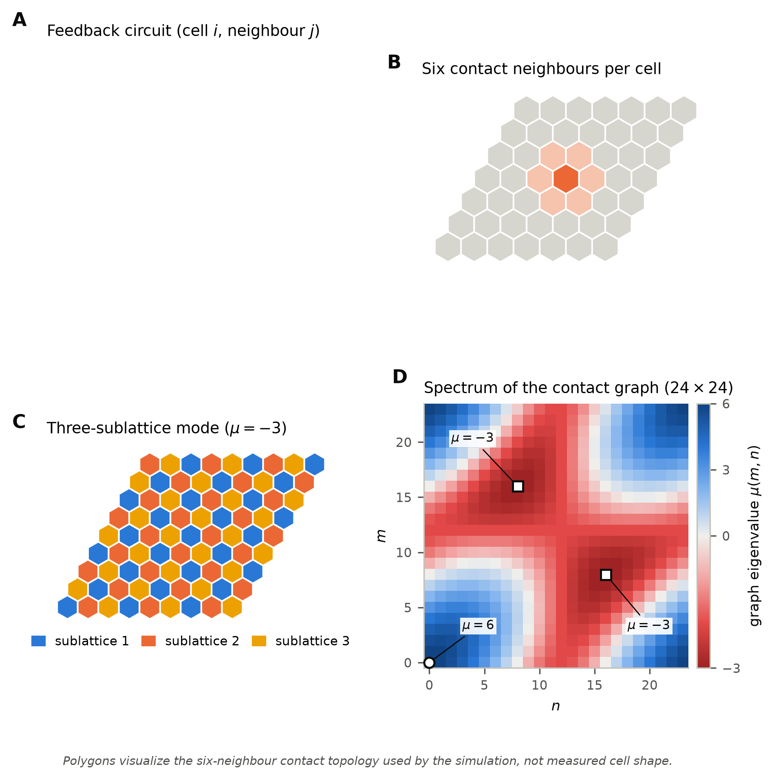
Figure 1. Circuit and contact geometry. (A) The intracellular circuit of cell $i$ and its contacts with a neighbour $j$. Proneural activity $S$ drives Delta $D$. Neighbouring Delta activates Notch $N$, producing activated Notch $A$. $A$ represses $S$. Cis inactivation couples $D$ and $N$ within a cell. (B) Each cell contacts six neighbours (hexagonal tiling; polygons show contact topology, not measured cell shape). (C) The three-sublattice pattern spanned by the $μ=−3$ eigenvectors. (D) Eigenvalue $μ(m,n)$ of the contact adjacency matrix over all $24×24$ plane-wave indices $(m,n)$ (Eq. 2). Circle: uniform mode, $μ=6$. Squares: the two three-sublattice modes, $μ=−3$.
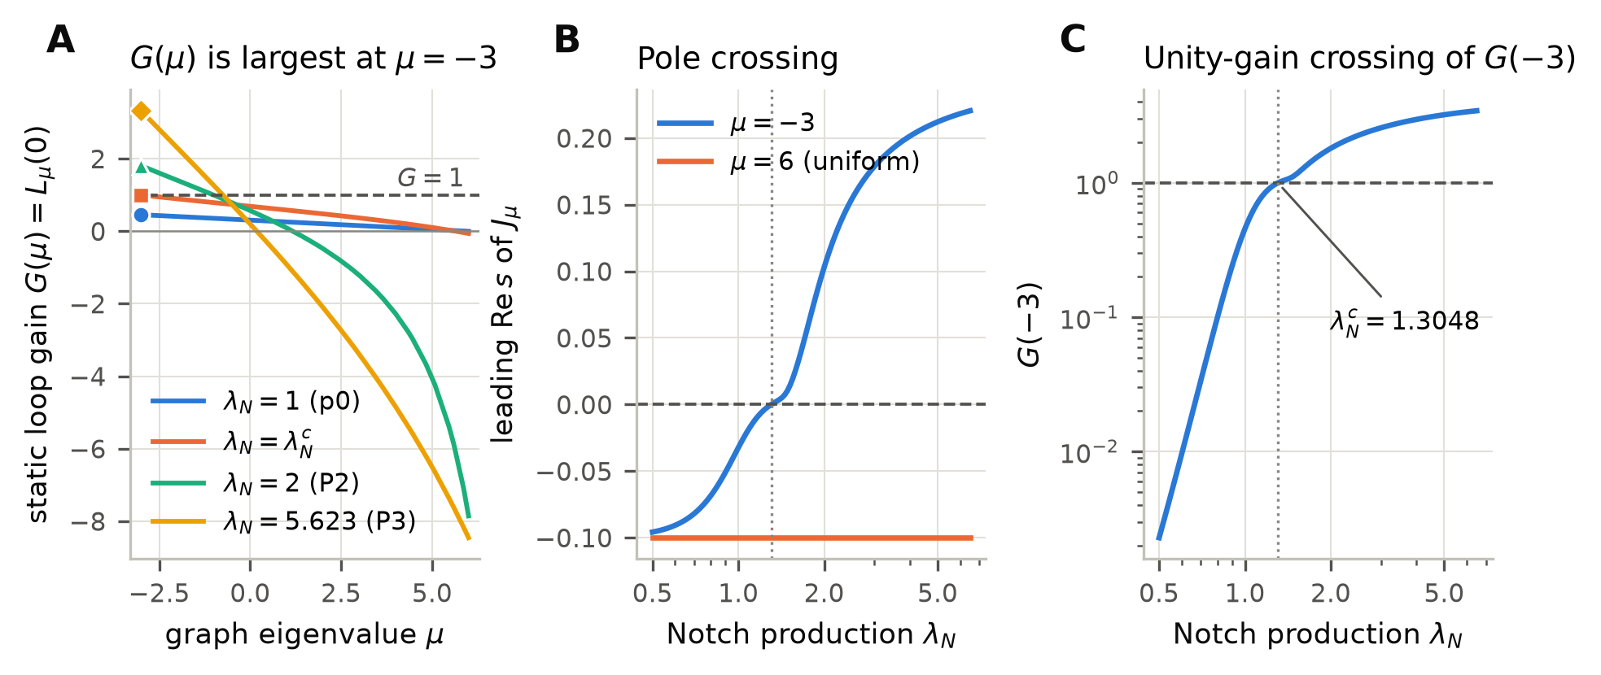
Figure 2. The static loop gain fixes stationary onset and the selected mode. (A) Static loop gain $G(μ)$ over every distinct graph eigenvalue at $λ_{N}=1$ ($p_{0}$), $λ_{N}^{c}$, 2 (P2) and 5.623 (P3). Markers show the maximum, which is at $μ=−3$ in every case. Dashed line: $G=1$. (B) Leading eigenvalue of $J_{μ}$ for $μ=−3$ and $μ=6$ as $λ_{N}$ varies, all other parameters at $p_{0}$. Dotted line: $λ_{N}^{c}$. (C) $G(−3)$ versus $λ_{N}$. It crosses one at $λ_{N}^{c}=1.304815343$, where the eigenvalue in (B) crosses zero.
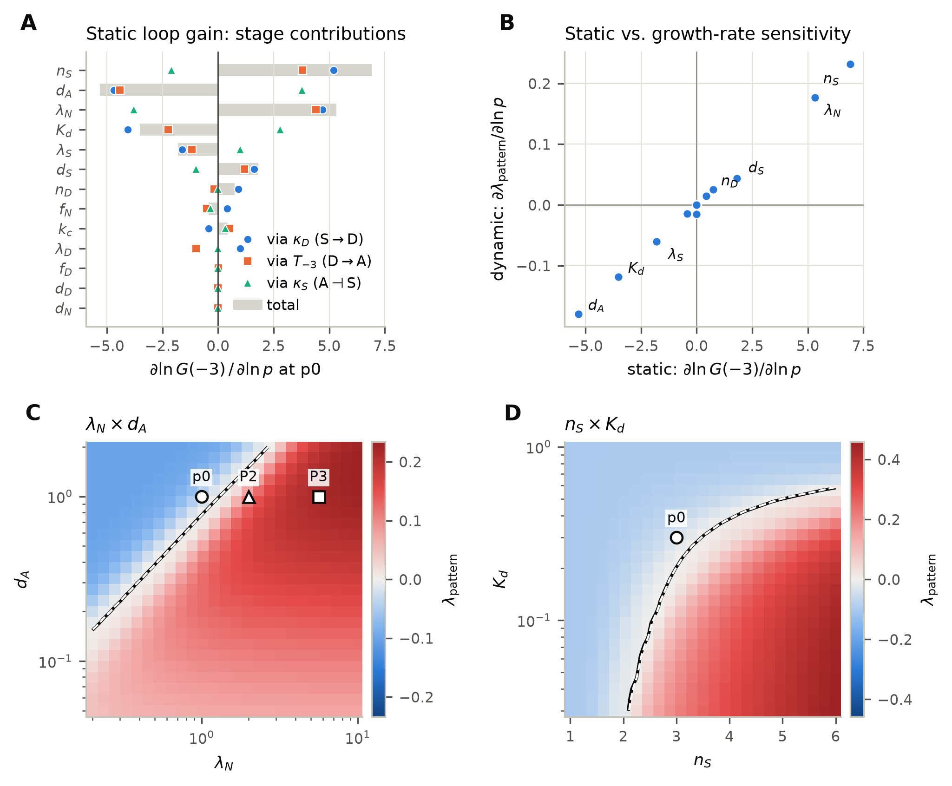
Figure 3. Kinetic control of the static margin. (A) Logarithmic sensitivity of $G(−3)$ to each parameter at $p_{0}$ (bars), split into contributions through the three stage gains $κ_{D}$, $T_{−3}$ and $κ_{S}$ (markers). (B) Static sensitivity, $∂\text{ln}G(−3)/∂\text{ln}p$, against growth-rate sensitivity, $∂λ_{pattern}/∂\text{ln}p$. $λ_{S}$ and $d_{S}$ have equal and opposite static effects but unequal effects on the growth rate. (C, D) $λ_{pattern}$ on the $(λ_{N},d_{A})$ and $(n_{S},K_{d})$ planes, other parameters at $p_{0}$. Black contour: $λ_{pattern}=0$. Dashed white contour: $G(−3)=1$. The two coincide.
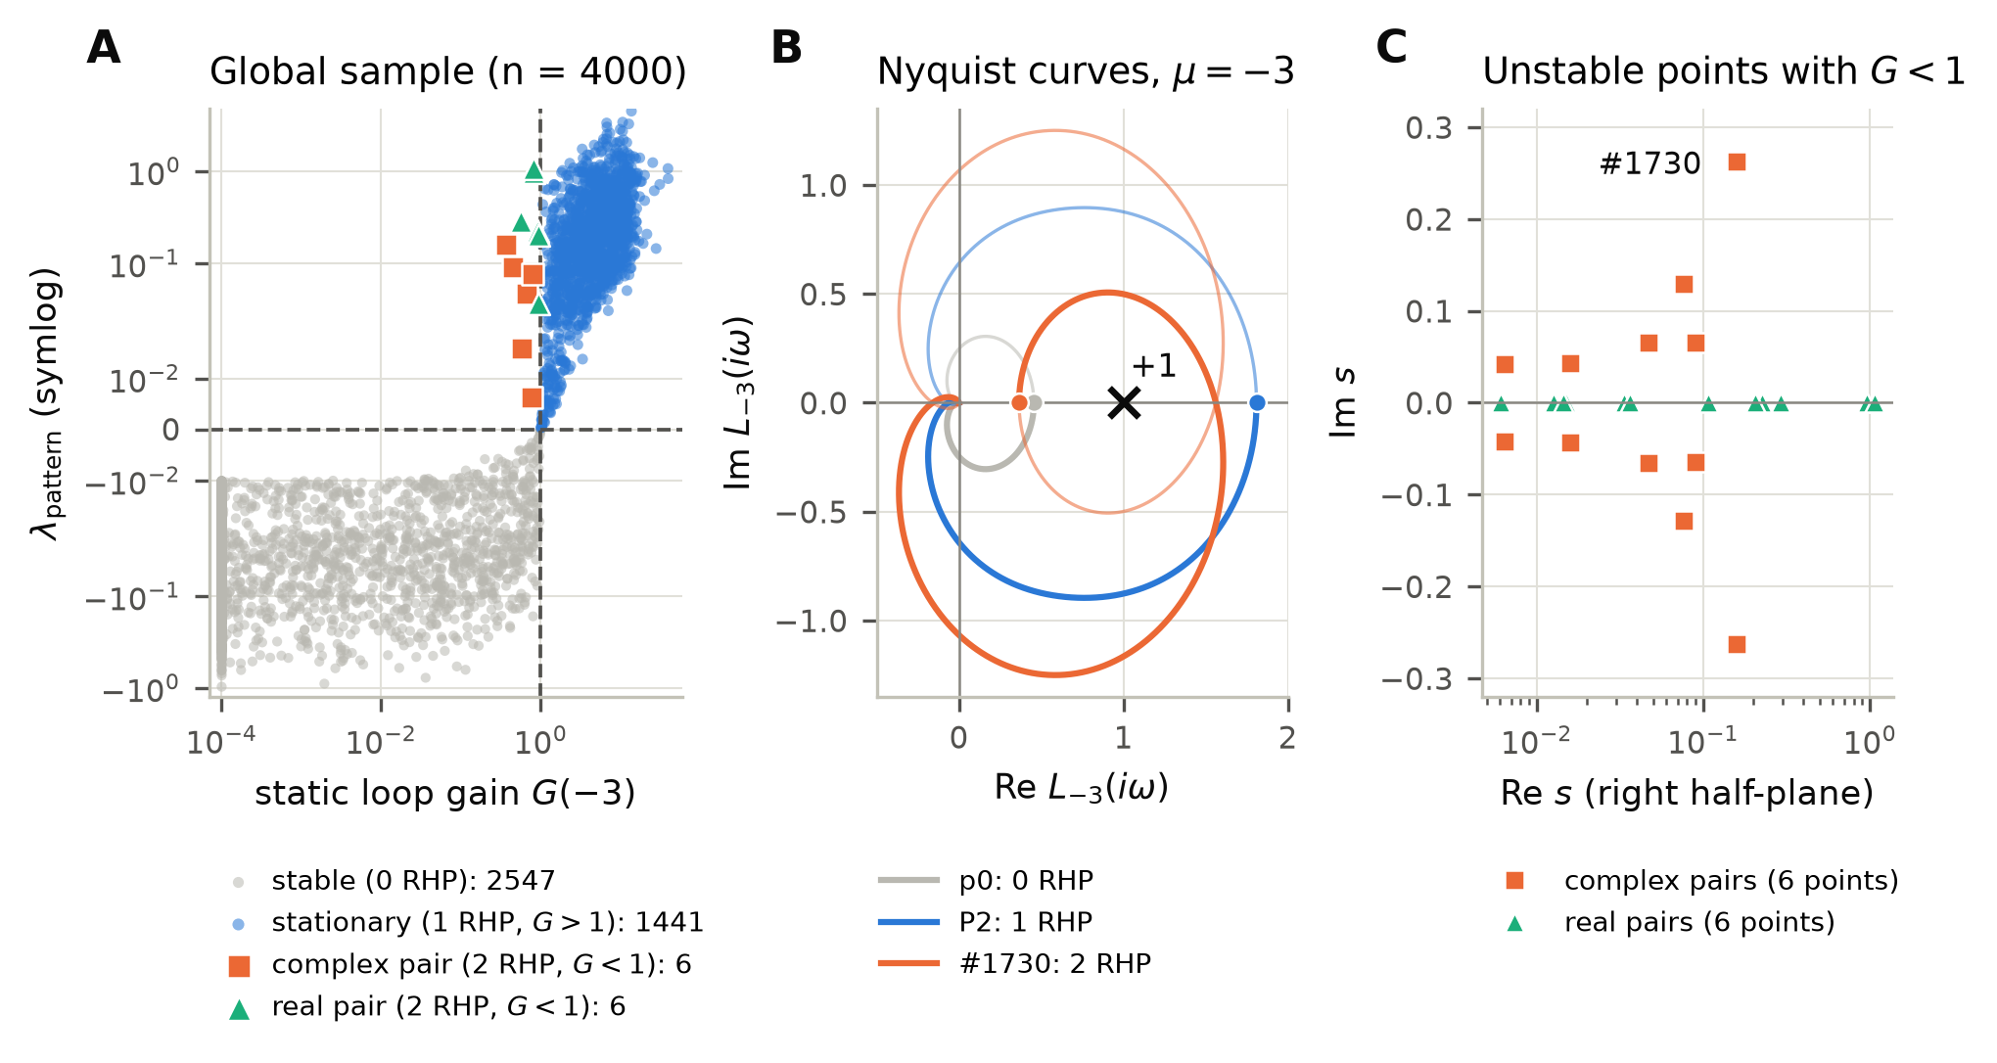
Figure 4. Instabilities that the static gain misses. (A) All 4000 global-sample points, plotted as $G(−3)$ against $λ_{pattern}$ (values of $G<{10}^{−4}$, all stable, are drawn at ${10}^{−4}$). Points are coloured by the number of right-half-plane (RHP) eigenvalues of $J_{−3}$. Twelve points are unstable with $G<1$; each has exactly two RHP eigenvalues. (B) Nyquist curves $L_{−3}(iω)$ (bold: $ω≥0$; light: mirror image) for $p_{0}$, P2, and point 1730 ($G=0.366$). Dots: $G=L_{−3}(0)$. Each curve encircles $+1$ once per RHP eigenvalue. (C) RHP eigenvalues of the twelve points: six complex pairs and six real pairs.
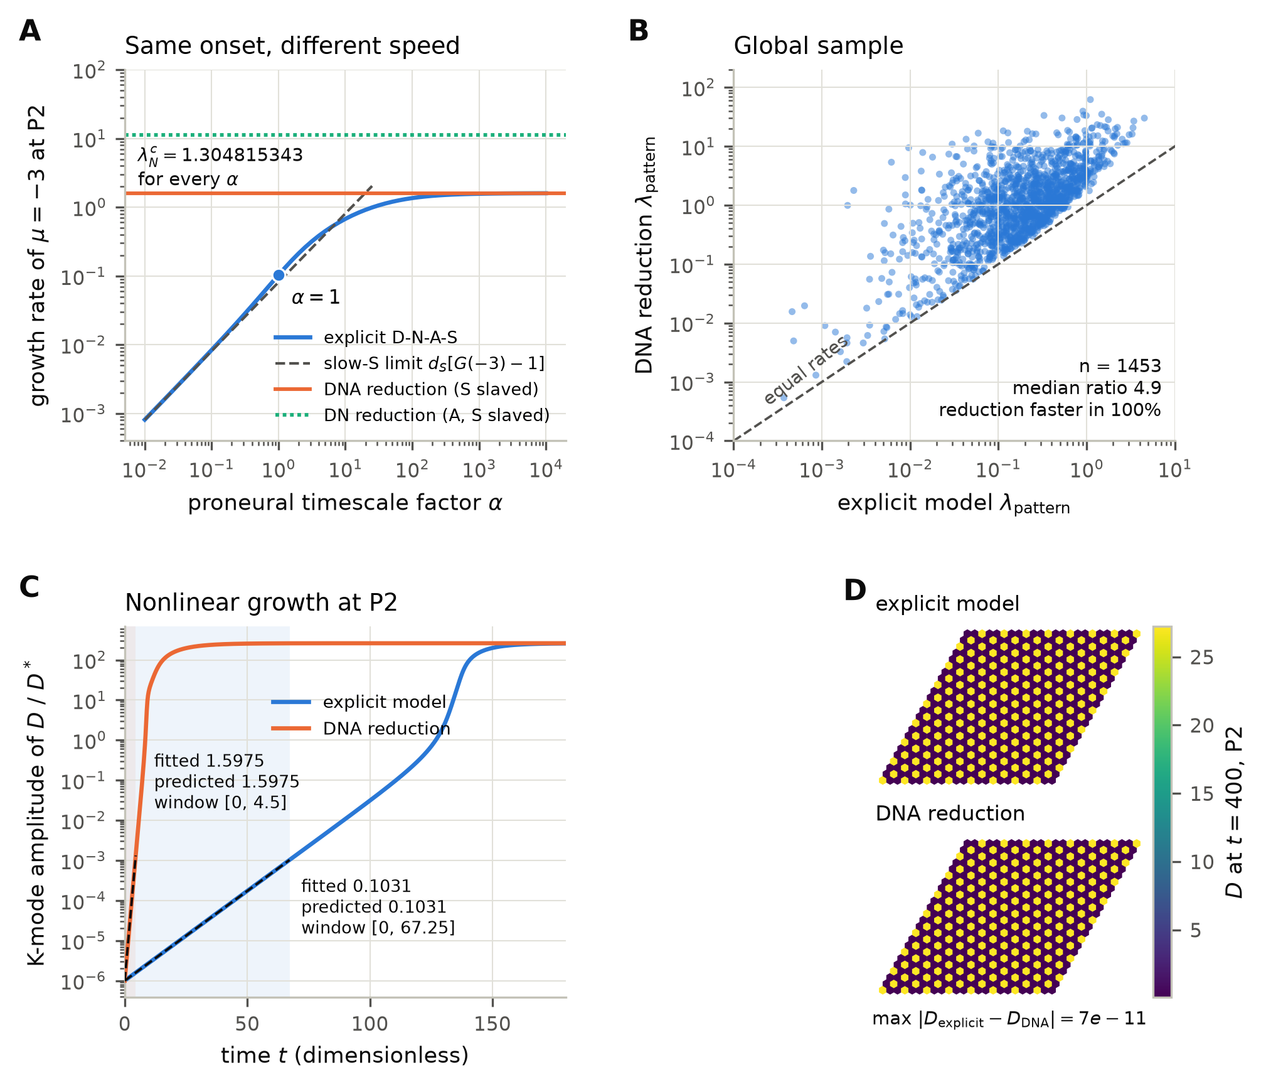
Figure 5. The explicit downstream layer sets the tempo, not the onset. (A) Growth rate of the $μ=−3$ mode at P2 along the family $(λ_{S},d_{S})→α(λ_{S},d_{S})$, which leaves every steady state, every $G(μ)$ and $λ_{N}^{c}$ unchanged. Dashed: slow-proneural limit $d_{S}[G(−3)−1]$. Horizontal lines: matched DNA and DN reductions. (B) Growth rate of the DNA reduction against the full model at all 1453 global-sample points where both are unstable. Dashed line: equal rates. (C) Nonlinear simulations at P2. Amplitude of the three-sublattice component of $D$ (relative to $D^{*}$), for the full model and the DNA reduction, each started on its own exact eigenvector. Shaded spans: prespecified fitting windows. Dashed lines: predicted growth. (D) Final Delta fields of the two simulations, which coincide.
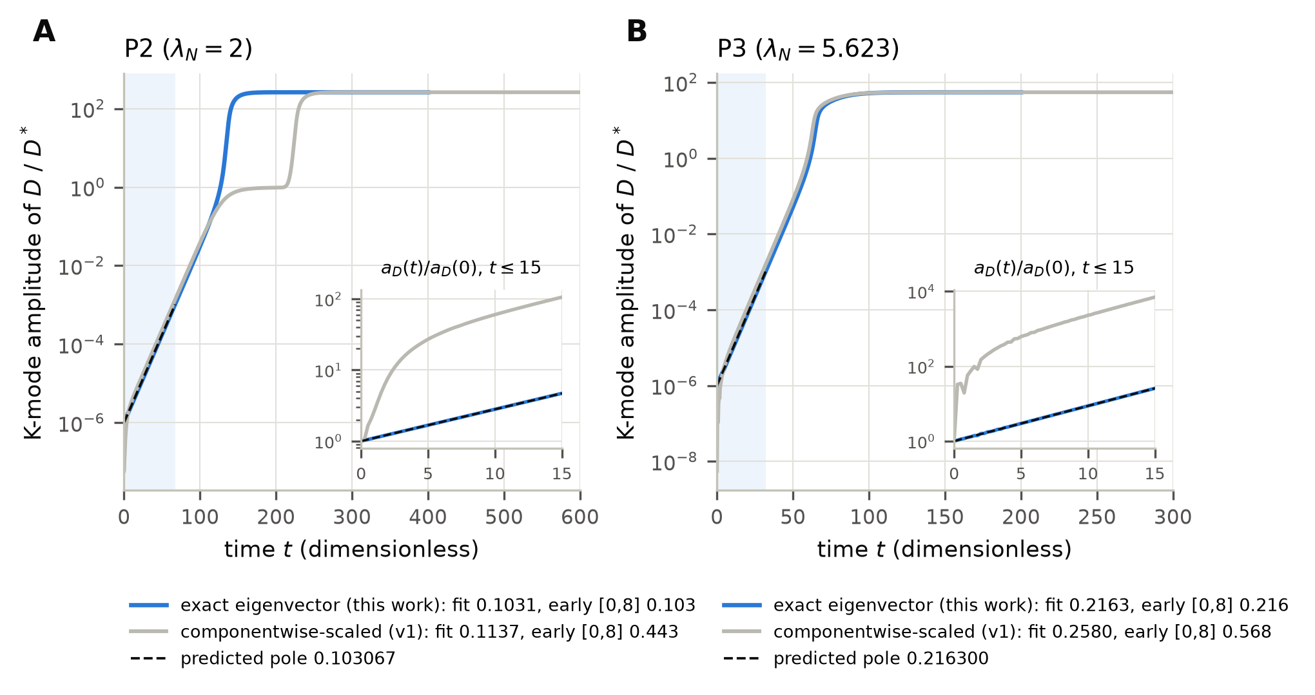
Figure S1. Initial-state comparison. Growth of the three-sublattice amplitude at P2 (A) and P3 (B), started on the exact eigenvector or on the eigenvector scaled componentwise by the steady state (earlier protocol). Insets: $t≤15$, normalised to the initial amplitude. The componentwise start excites the other poles of $J_{−3}$. Its early slope (0.44 at P2, 0.57 at P3) differs from the predicted 0.103 and 0.216.
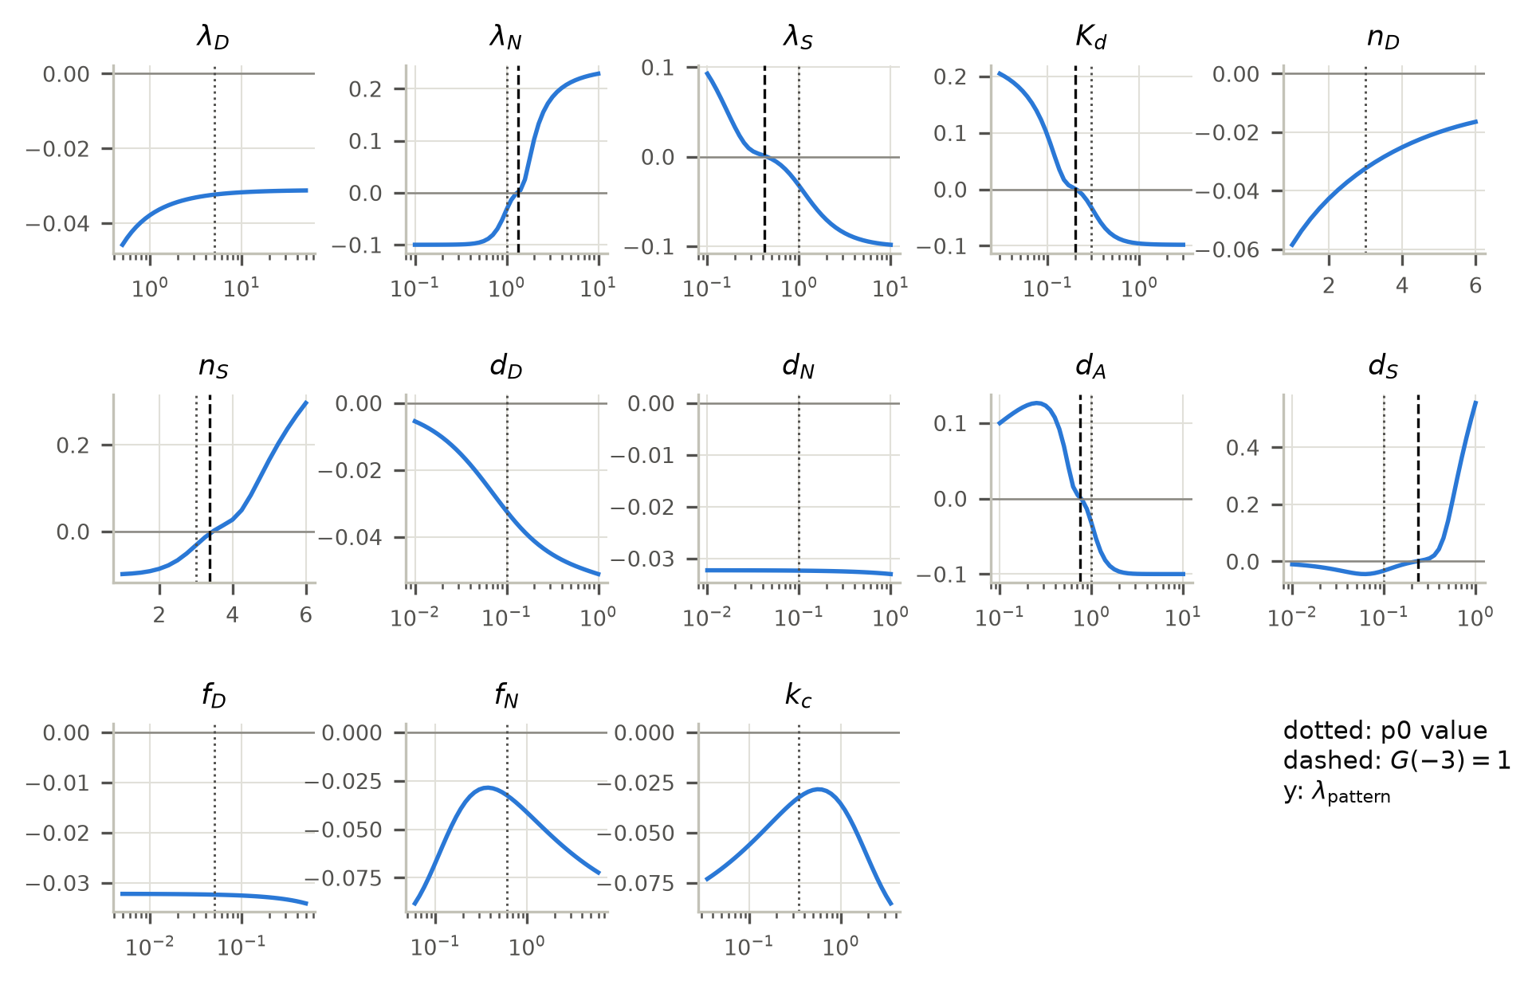
Figure S2. One-parameter continuations. $λ_{pattern}$ as each parameter is varied about $p_{0}$ (rates $0.1$–$10×$; Hill coefficients 1–6). Dotted: $p_{0}$ value. Dashed: $G(−3)=1$, which coincides with $λ_{pattern}=0$ wherever a crossing occurs.

