Supplementary Material
Global versus Dimension-Specific Scaling in Normalized Matrix Factorization under Rating Sparsity

Supplementary Table S1. MovieLens 100K predictive performance (mean ± SD over 10 initialization seeds).
Retention | Model | RMSE | MAE
100% | BiasOnly | 0.9504 $±$ 0.0001 | 0.7544 $±$ 0.0002
100% | BiasMF | 0.9568 $±$ 0.0026 | 0.7530 $±$ 0.0027
100% | CosineMF | 0.9223 $±$ 0.0019 | 0.7303 $±$ 0.0015
100% | NormalizedMF | 0.9178 $±$ 0.0016 | 0.7270 $±$ 0.0013
75% | BiasOnly | 0.9608 $±$ 0.0002 | 0.7649 $±$ 0.0002
75% | BiasMF | 0.9775 $±$ 0.0037 | 0.7725 $±$ 0.0042
75% | CosineMF | 0.9401 $±$ 0.0030 | 0.7464 $±$ 0.0024
75% | NormalizedMF | 0.9357 $±$ 0.0024 | 0.7428 $±$ 0.0019
50% | BiasOnly | 0.9782 $±$ 0.0002 | 0.7805 $±$ 0.0002
50% | BiasMF | 1.0039 $±$ 0.0042 | 0.7995 $±$ 0.0044
50% | CosineMF | 0.9686 $±$ 0.0021 | 0.7709 $±$ 0.0022
50% | NormalizedMF | 0.9635 $±$ 0.0018 | 0.7665 $±$ 0.0018
25% | BiasOnly | 1.0108 $±$ 0.0007 | 0.8099 $±$ 0.0005
25% | BiasMF | 1.0361 $±$ 0.0028 | 0.8347 $±$ 0.0031
25% | CosineMF | 1.0186 $±$ 0.0030 | 0.8165 $±$ 0.0029
25% | NormalizedMF | 1.0126 $±$ 0.0025 | 0.8116 $±$ 0.0025
10% | BiasOnly | 1.0529 $±$ 0.0000 | 0.8603 $±$ 0.0000
10% | BiasMF | 1.0660 $±$ 0.0016 | 0.8683 $±$ 0.0019
10% | CosineMF | 1.0664 $±$ 0.0024 | 0.8663 $±$ 0.0025
10% | NormalizedMF | 1.0601 $±$ 0.0018 | 0.8626 $±$ 0.0019

Supplementary Table S2. MovieLens 1M predictive performance (mean ± SD over 5 initialization seeds).
Retention | Model | RMSE | MAE
100% | BiasOnly | 0.9272 $±$ 0.0001 | 0.7367 $±$ 0.0001
100% | BiasMF | 0.8849 $±$ 0.0006 | 0.6964 $±$ 0.0004
100% | CosineMF | 0.8789 $±$ 0.0008 | 0.6950 $±$ 0.0007
100% | NormalizedMF | 0.8782 $±$ 0.0007 | 0.6948 $±$ 0.0007
75% | BiasOnly | 0.9415 $±$ 0.0001 | 0.7504 $±$ 0.0001
75% | BiasMF | 0.9027 $±$ 0.0007 | 0.7106 $±$ 0.0010
75% | CosineMF | 0.8915 $±$ 0.0011 | 0.7060 $±$ 0.0010
75% | NormalizedMF | 0.8918 $±$ 0.0009 | 0.7064 $±$ 0.0008
50% | BiasOnly | 0.9633 $±$ 0.0003 | 0.7668 $±$ 0.0004
50% | BiasMF | 0.9332 $±$ 0.0018 | 0.7366 $±$ 0.0019
50% | CosineMF | 0.9329 $±$ 0.0021 | 0.7404 $±$ 0.0016
50% | NormalizedMF | 0.9312 $±$ 0.0019 | 0.7395 $±$ 0.0015
25% | BiasOnly | 1.0070 $±$ 0.0000 | 0.8069 $±$ 0.0001
25% | BiasMF | 1.0015 $±$ 0.0036 | 0.8011 $±$ 0.0033
25% | CosineMF | 0.9870 $±$ 0.0047 | 0.7882 $±$ 0.0041
25% | NormalizedMF | 0.9860 $±$ 0.0041 | 0.7874 $±$ 0.0037
10% | BiasOnly | 1.0529 $±$ 0.0000 | 0.8632 $±$ 0.0000
10% | BiasMF | 1.0556 $±$ 0.0003 | 0.8627 $±$ 0.0004
10% | CosineMF | 1.0621 $±$ 0.0015 | 0.8624 $±$ 0.0014
10% | NormalizedMF | 1.0571 $±$ 0.0012 | 0.8608 $±$ 0.0011

Supplementary Fig. S1. Deviation between realized and nominal training retention across datasets.
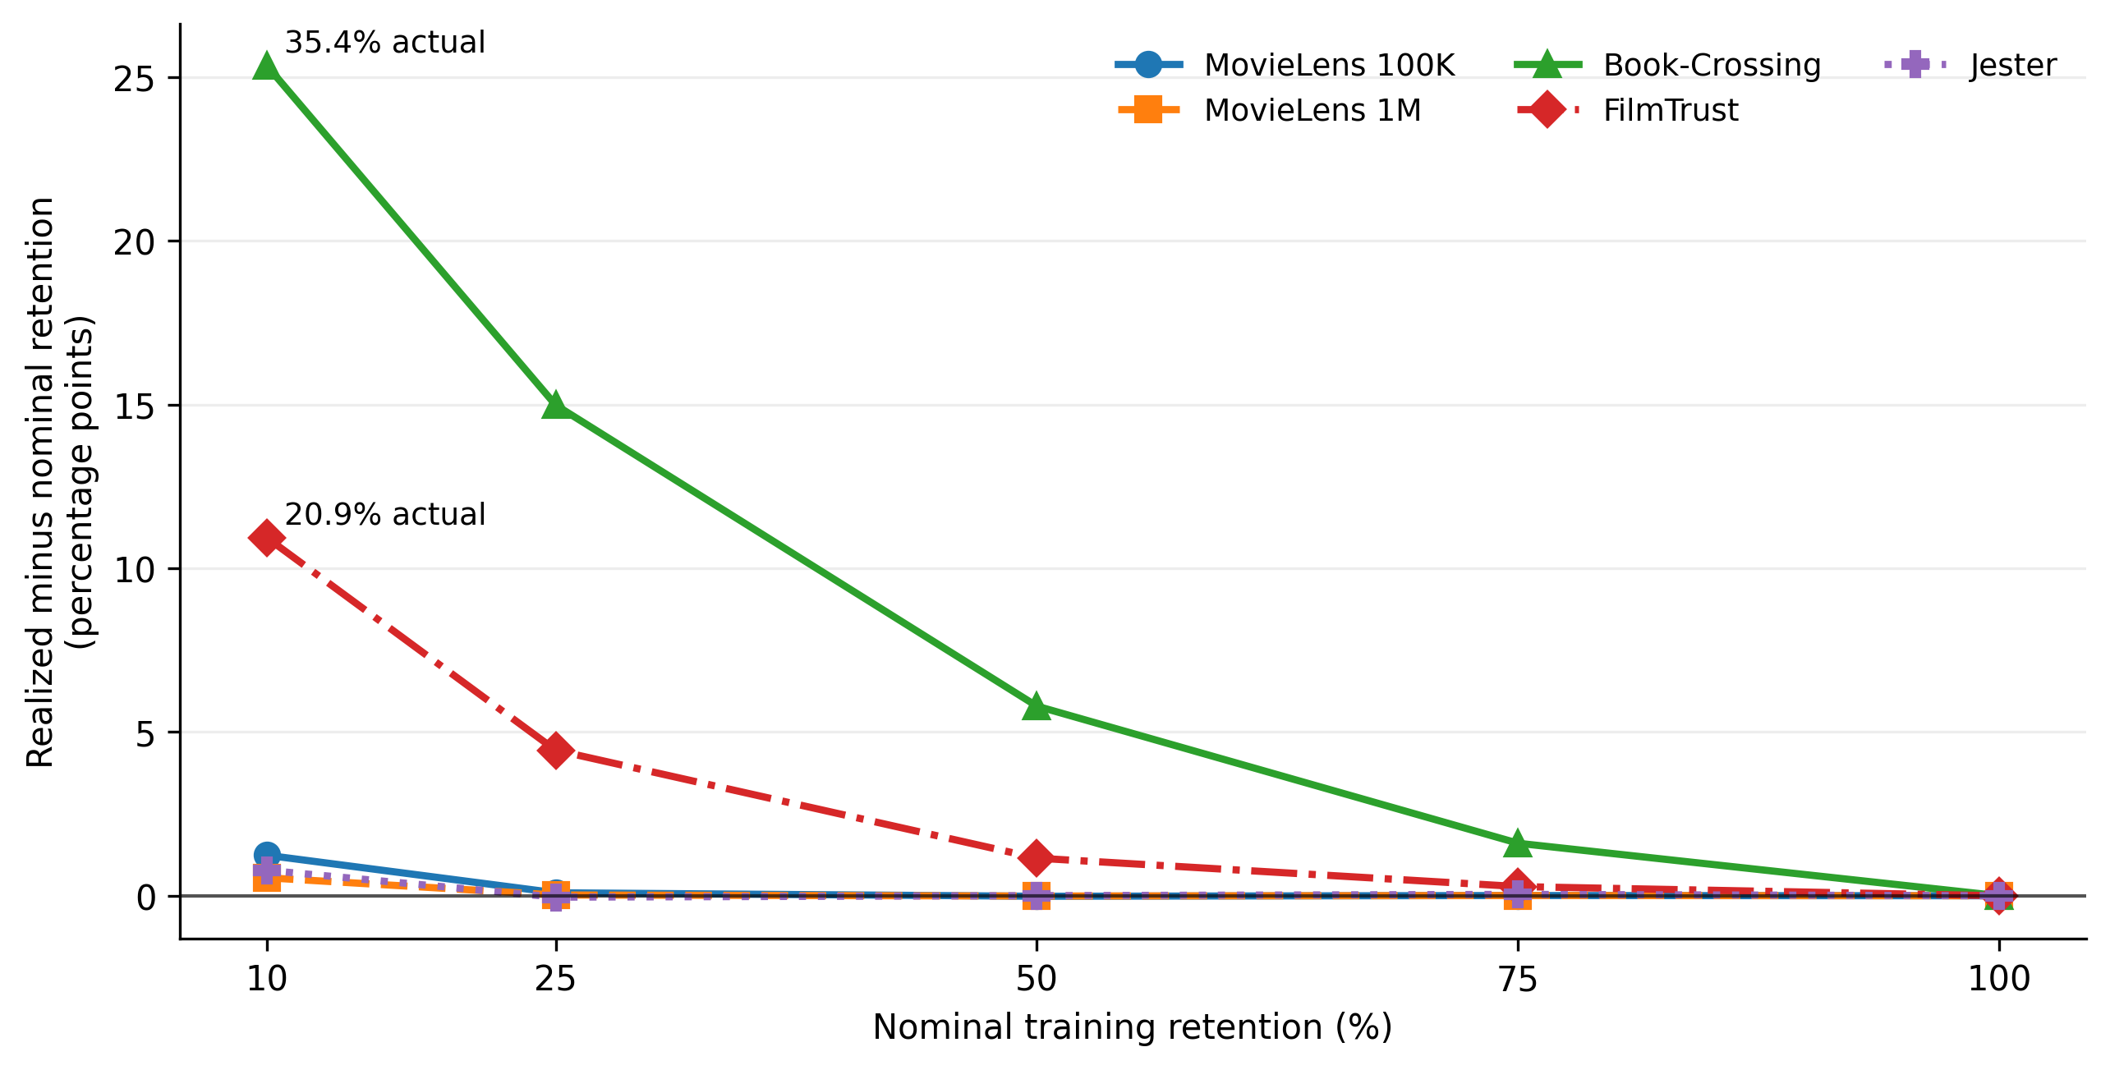
Positive values indicate that the minimum-history constraint forced more training observations to be retained than the nominal target. The effect is largest for Book-Crossing and FilmTrust at low nominal retention.

