- 행렬(matrix) & 벡터(vector) 표기

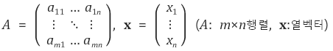

- 정방 행렬(square matrix)

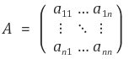

- 단위 행렬 (identity matrix)

http://cfile29.uf.tistory.com/image/217A003D524BB3BC178A83

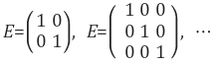

* 전치 행렬(transpose of a matrix)
* http://cfile25.uf.tistory.com/image/21496F42524BB86B0298E5
* http://cfile5.uf.tistory.com/image/241E6C3D524BB8AC1BFAFB
* http://cfile9.uf.tistory.com/image/2752BF3E524BB8C102FA75
* http://cfile1.uf.tistory.com/image/260D7049524BBC780CADB3
* 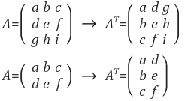

- 행렬식(determinant) : 정방행렬에 대해서만 정의됨

http://cfile4.uf.tistory.com/image/2526654E524BD1A016A75B

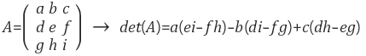

http://cfile24.uf.tistory.com/image/27062F4B524BD6EA303A32

http://cfile27.uf.tistory.com/image/237FF748524BD706395CBD

http://cfile28.uf.tistory.com/image/2706884C524BD7232508D7

http://cfile23.uf.tistory.com/image/2510D247524BDCC013C81D

http://cfile26.uf.tistory.com/image/230A174F524BD75F19E328

Inner Product

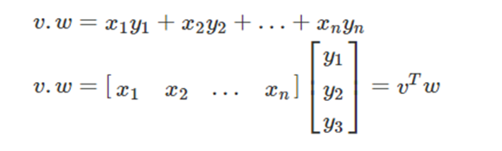

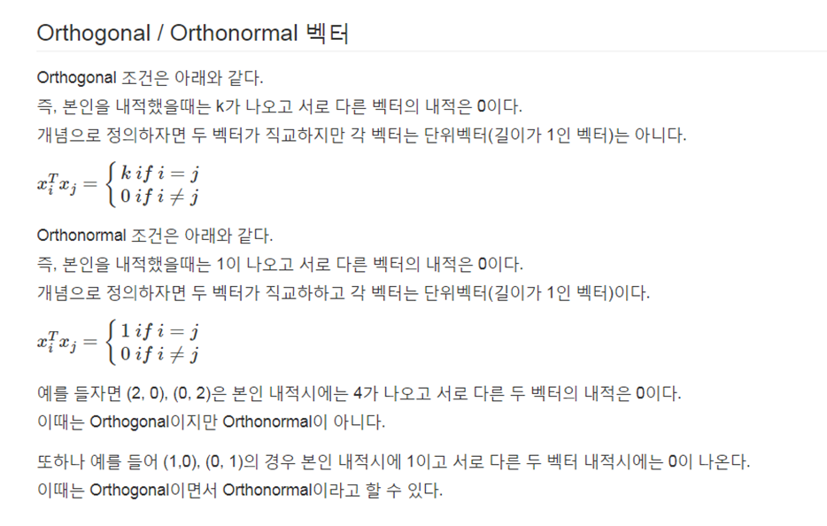

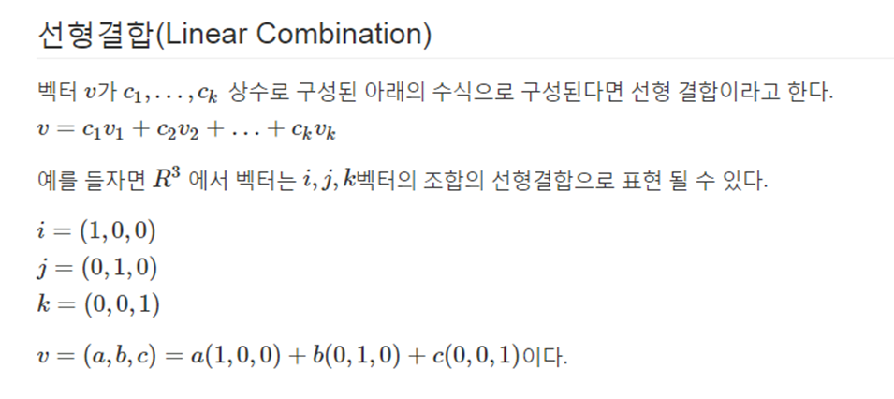

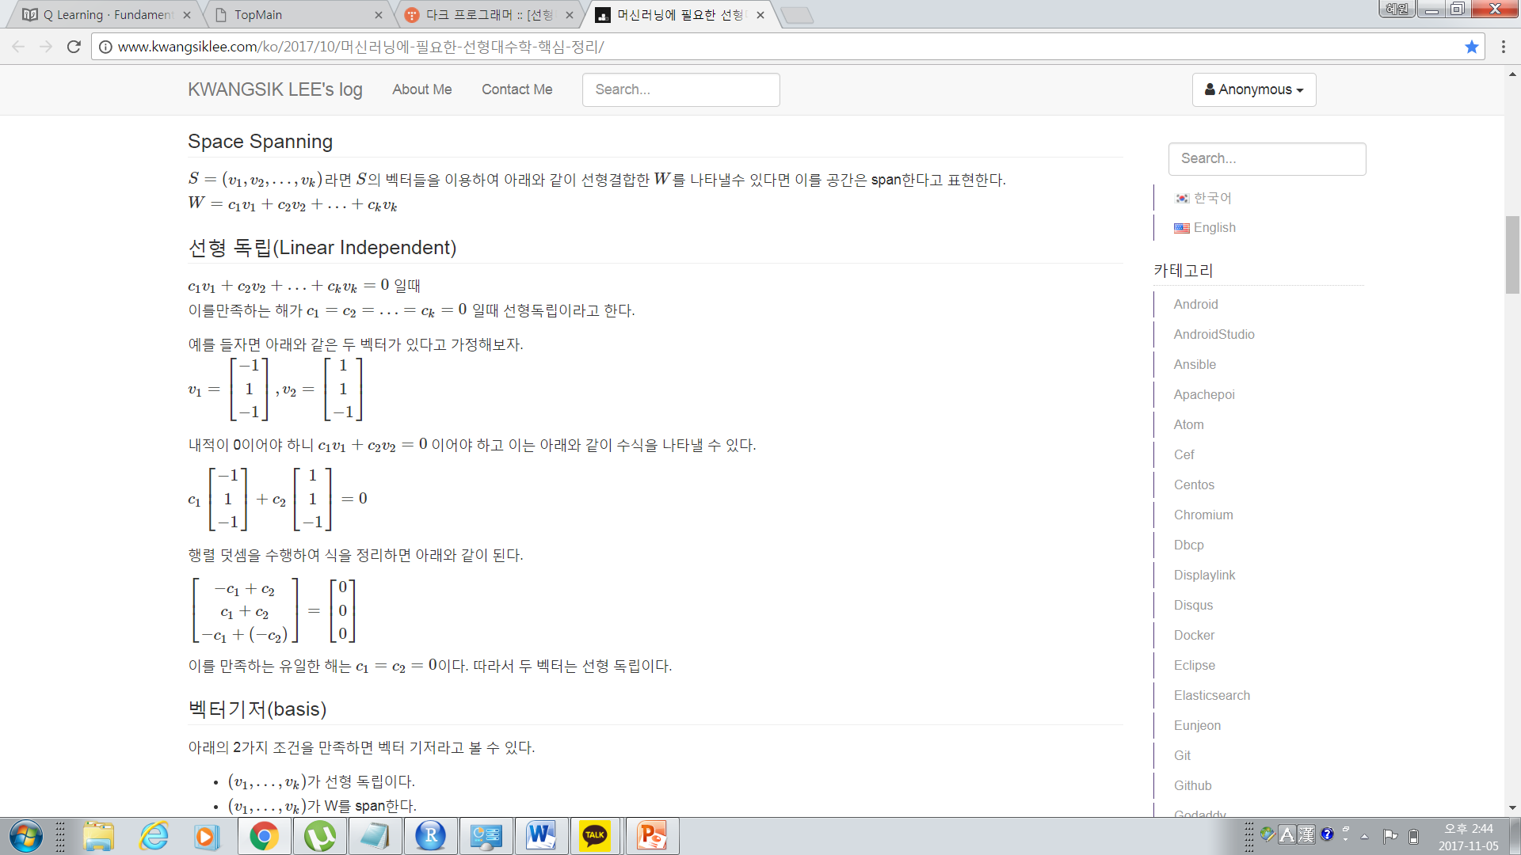

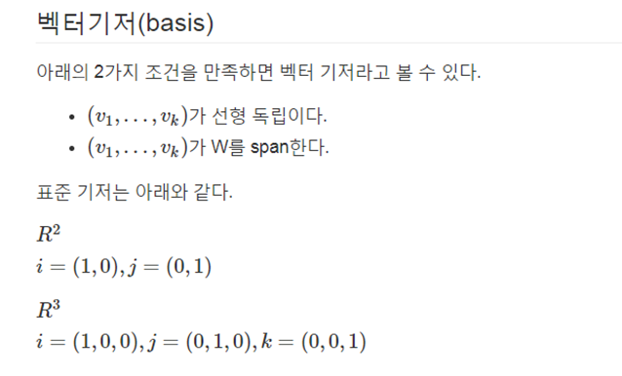

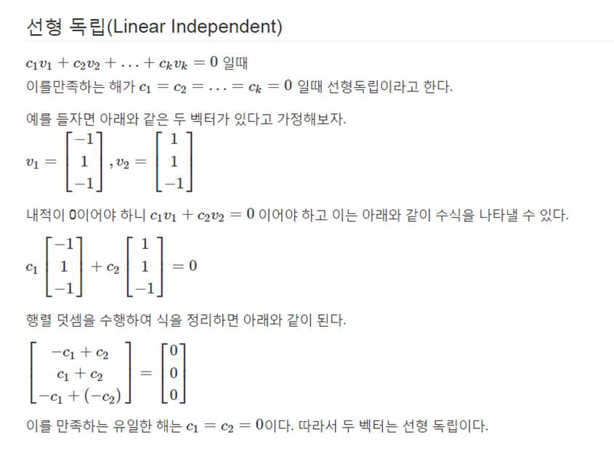

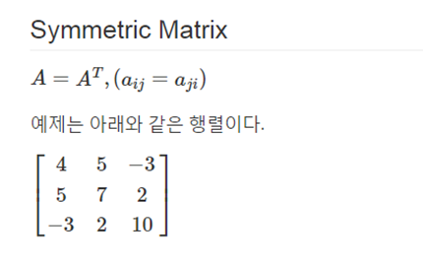

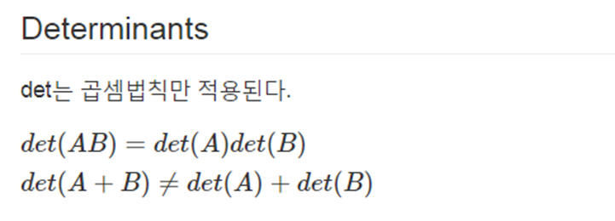

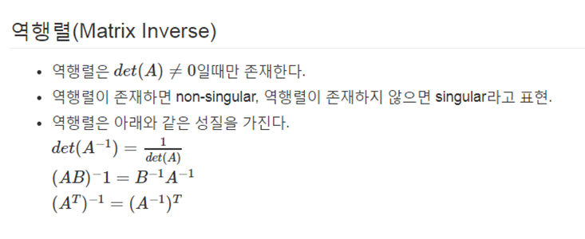

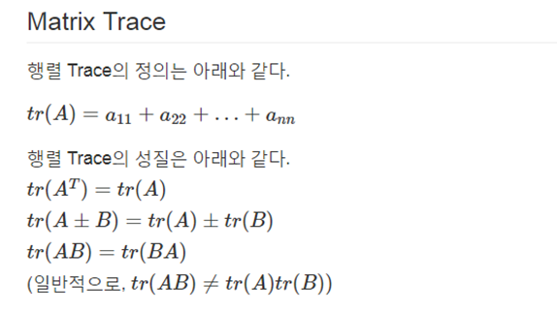

## Rank of Matrix

정방행렬의 부분 행렬로써 det가 0이 아닌 가장 큰 dimension의 크기를 rank라고 말한다.

