CPP好像不是一个特定的electrodes的计算，而是一类electrodes的总称
The criterion of accumulator
- peaked at the response latency and its rate of rise depended on the difficulty of the decisions, two key characteristics of a decision variable according to accumulator models (see also Loughnane et al., 2016)
Neural signature
CPP and fMRI
Two lines：1）exam the generalization of CPP;
2) find signature of EV: what is your standard?
Correlation of modeling and EEG data
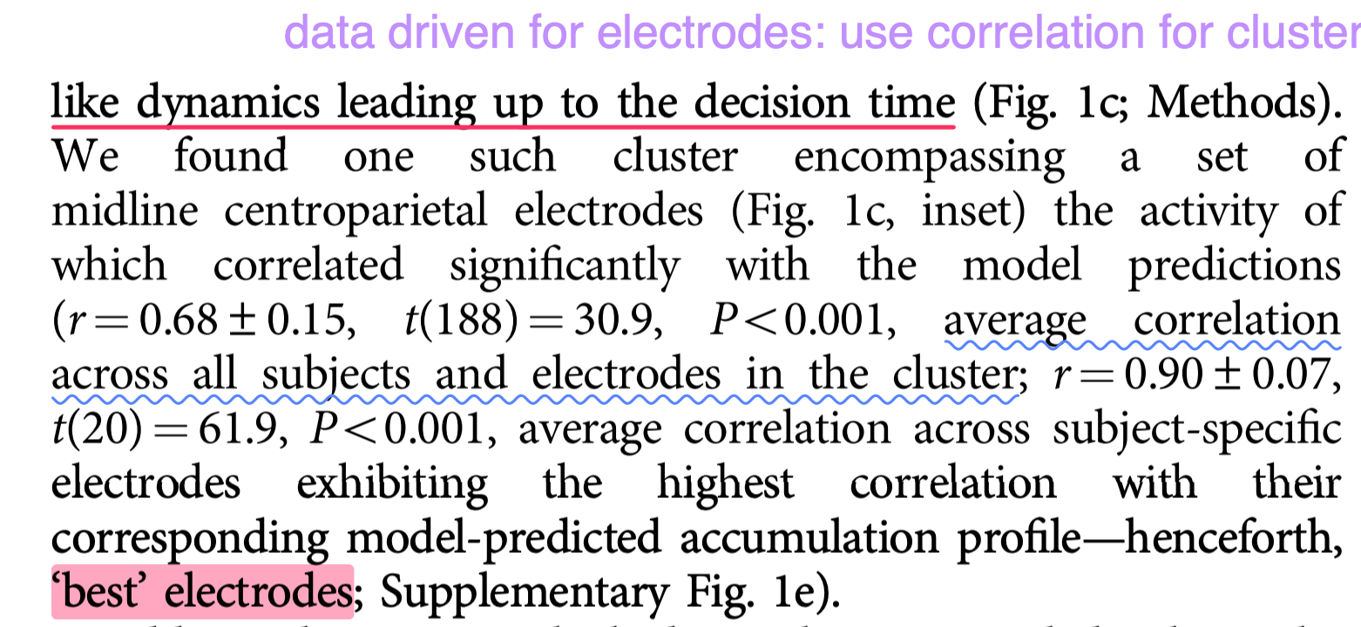

biomarker:
produce by certain organism. this organism was relative to some things.
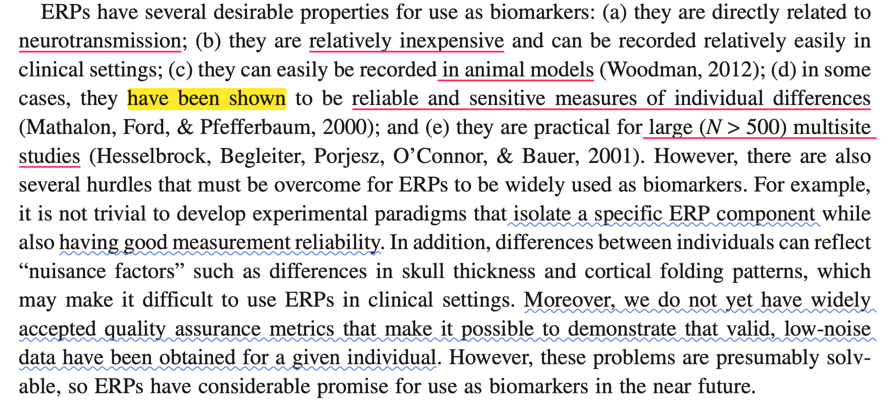
(Steven Luck, 2012)

In the paper of 24 NHB
Core: the process before deciding is mixed by appraisal and evidence accumulation.
The way to prove the mixed component is following:
- PCA by behavioral data
- Regression stimulus-locked and response-locked amplitude by PC1 and PC2
- The evidence is cluster-based permutation tests on resulting t-statistics at group level.
- Spatial and temporal separation
The criteria of evidence accumulation:
- Ramping towards a temporally common peak immediately before response
- Greater activity leading up to a response on harder choice trials

12 initial paper
- This signal could be continuously tracked in parallel with fully dissociable sensory encoding and motor preparation signals, and could be systematically perturbed mid-flight during decision formation.
- Domain general——sensory modality and stimulus features, even in the absence of overt action
- Simple perceptual decision
Directly represent decision process itself.
Task: isolate sensory evidence and evidence accumulation

Criterion：
- 1 temporal integration of sensory: compare with summed SSVEP
- The second essential characteristic of a decision variable is that the time of commitment and action execution is determined by its amplitude reaching a threshold or criterion level. Whatever rt condition, they reached a fixed threshold. Using permutation distribution. Better predictor of rt.
- the condition more difficult, the amplitude lower. In difficult condition, the selected trials are “lucky trial” which is easy. So, the author claims that the variability is larger and trials in difficult condition has higher start point which causes lower amplitude.——interesting to explore whether in all experiments have the same results.
- add perturbation to conform the true effect instead of artefact.——just used the perturbation to confirm.
- only be responsive to goal-relevant sensory information.
- CPP and P300 share the same features, but P300 represents the sudden onsets
In this paper, the author first use SSVEP to confirm that both CPP and LHB represent sensory accumulation. Then employing permutation method to get the second characters: reaching a certain threshold.
Next, they isolate LHB and CPP using signal detection theory. In the condition of false alarm, CPP can isolate different conditions but LHB not. What’s more, CPP has lower amplitude for difficult condition
Finally, compare CPP and LHB in non-move task, and CPP and SSVEP in general domain task. They found CPP is a evidence accumulation signal which does not depend on certain type of stimulus and movement.
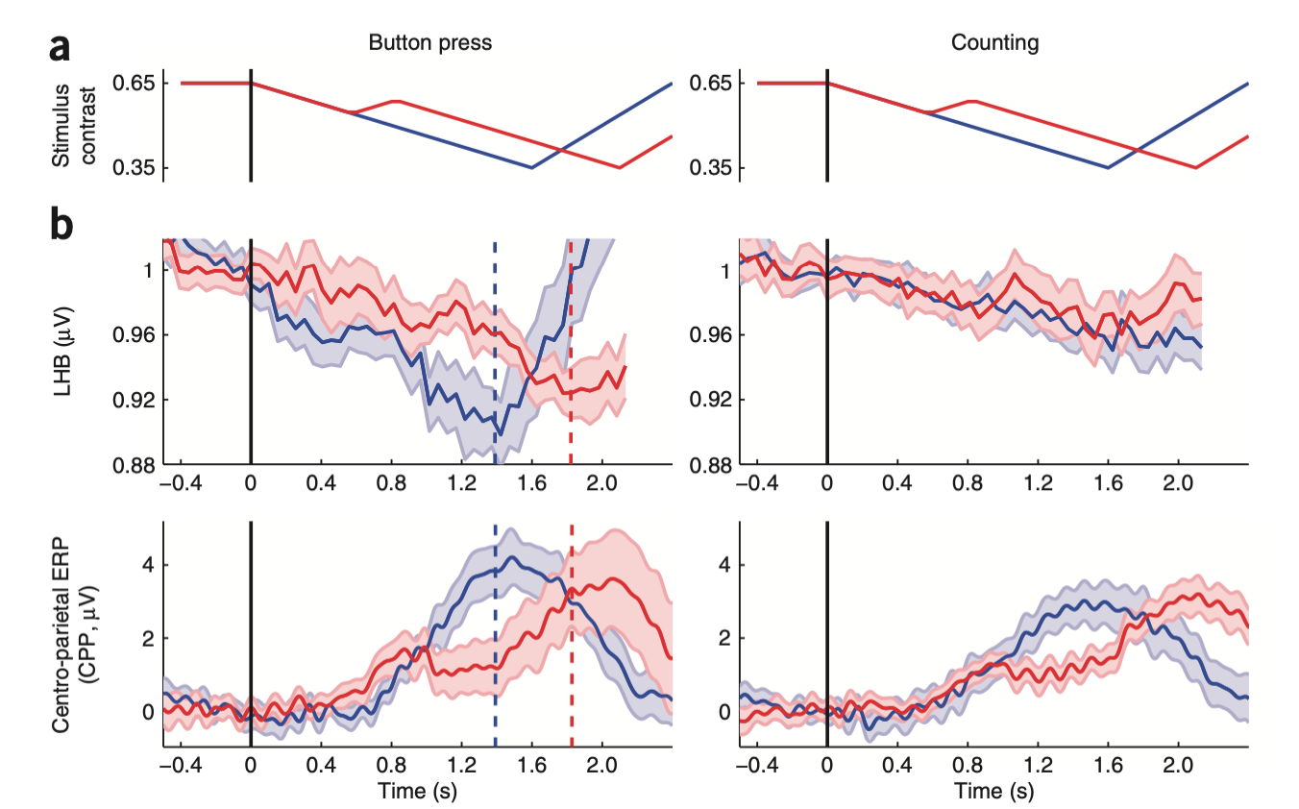
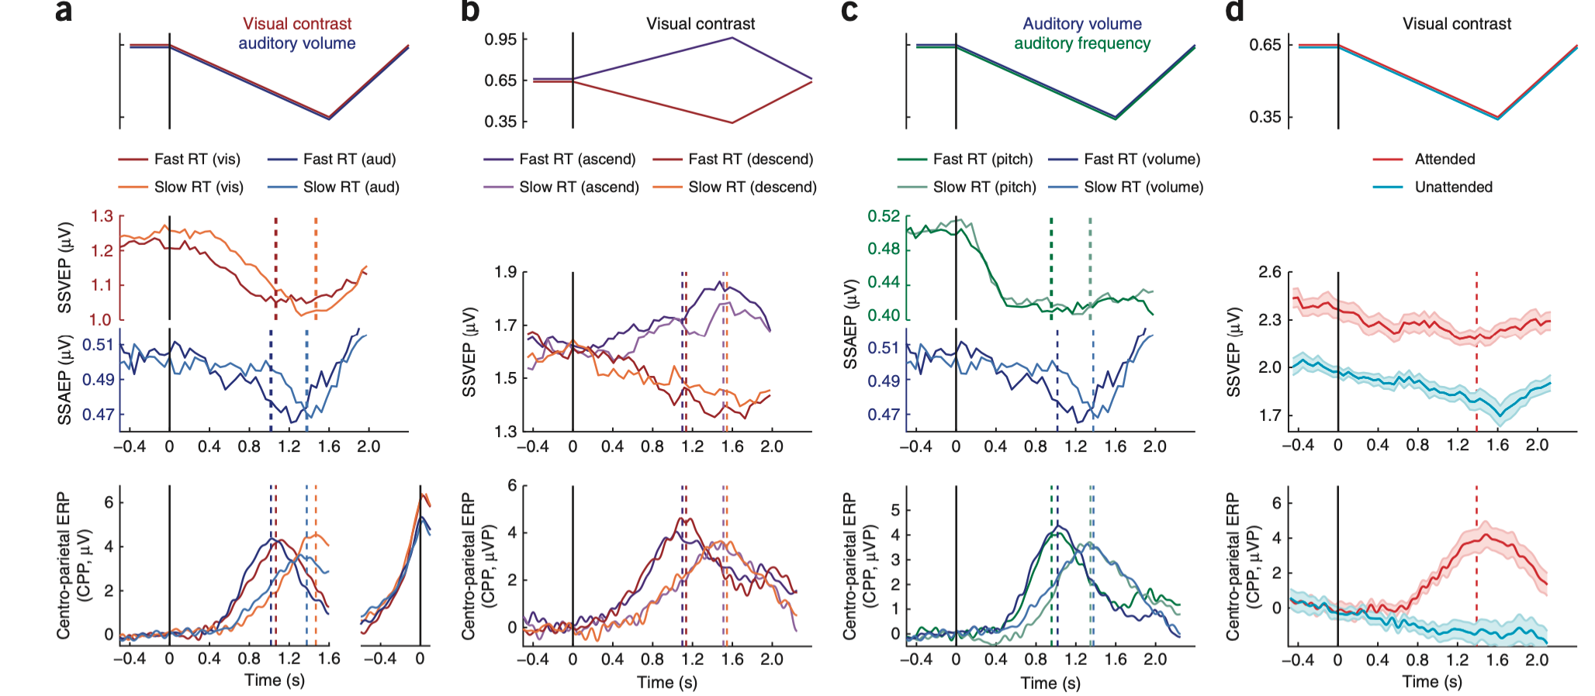
Mid vag 2019:
In a similar vein, Pisauro et al. (2017) examined the dynamics of the CPP in a value-based decision task, using simultaneous EEG and fMRI. Using each in-dividual’s average predicted accumulation dynamics, they uncovered a correlate of evidence accumulation in posterior parietal electrodes that bears quite some similarity to the CPP, in the sense that it arose from similar centroparietal areas and peaked at the time of the response after a gradually increasing trajectory. This EEG signature was associated with BOLD activity in the posterior medial frontal cortex.
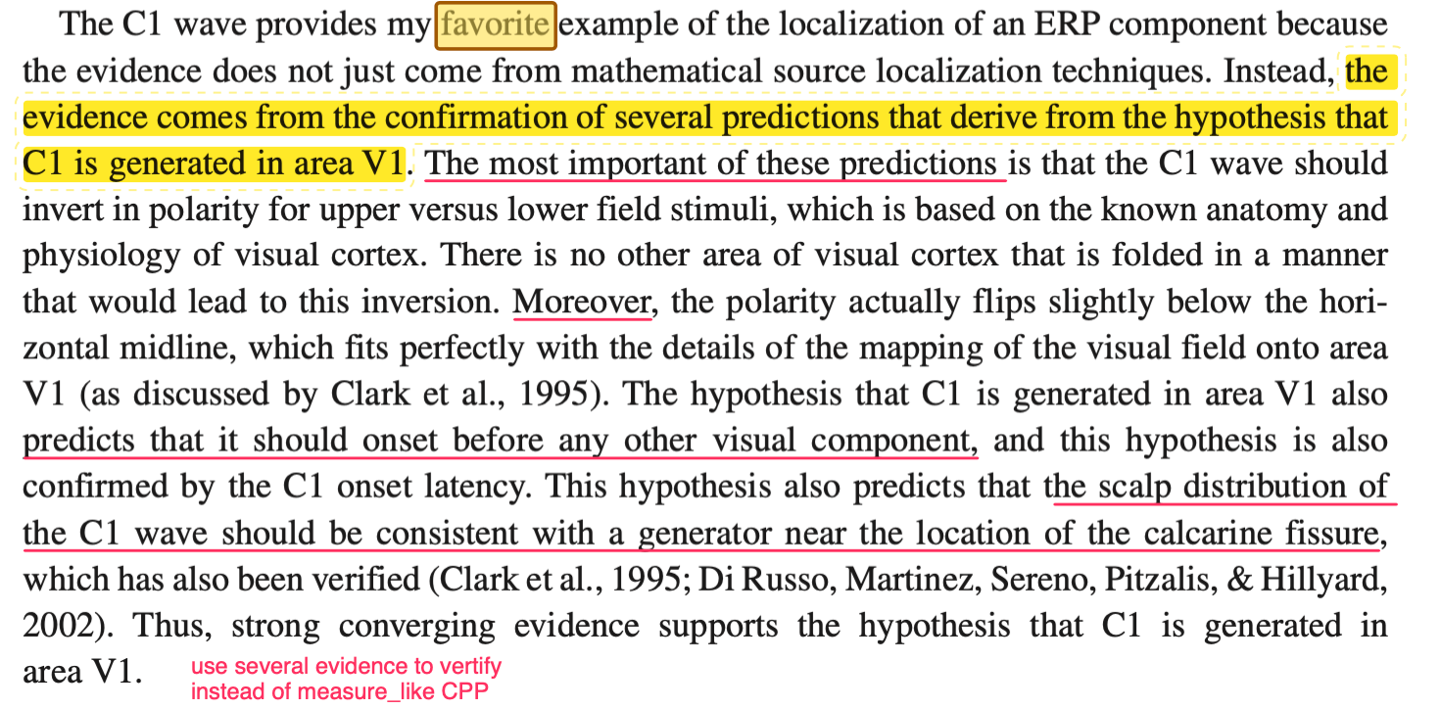
Traditional logical for evidence
support for the idea that the CPP reflects a decision-general process of evidence accumulation comes from numerous studies that have demonstrated that the P300/P3/P3b is a
signal very similar to the CPP (Twomey et al., 2015) in its topography
(centro-parietal), as well as its dynamics (both are a large-amplitude
potential that increases until the response, and peaking around
300–600 ms post-stimulus).——It is weird to define the time for CPP.
Accumulator evidence
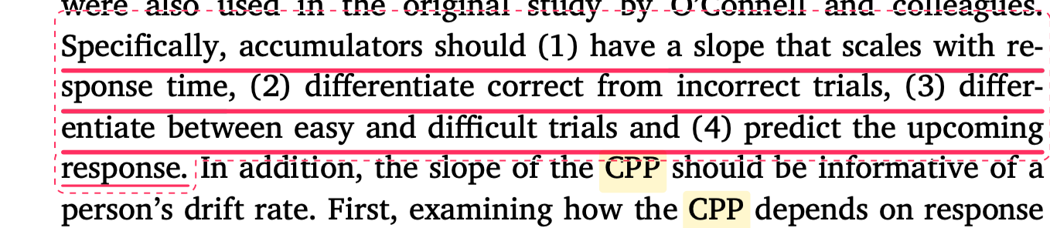
ECoG
The large-scale CPP signal that is consistent with evidence accu-mulation suggests it should be easy to find a neural correlate of evi-dence accumulation in electrocorticography (ECoG) signals, which have a much higher spatial resolution.
Stimulus-locked

Is there neural evidence for an evidence accumulation process in memory decisions?

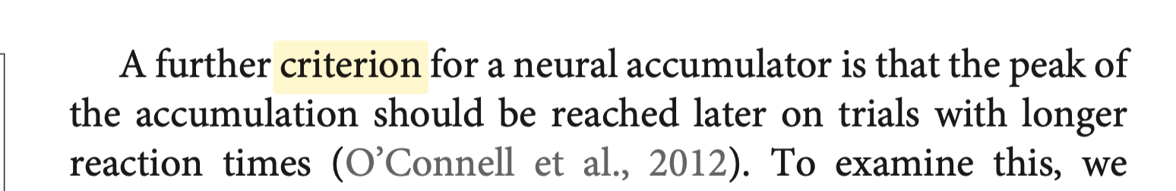
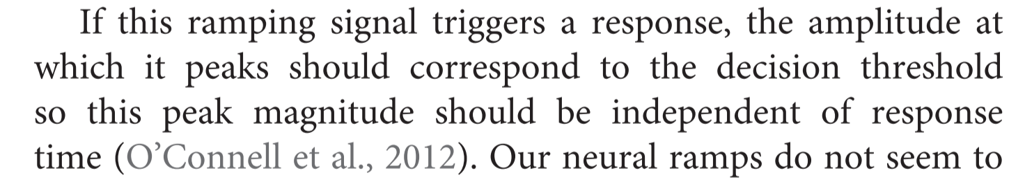
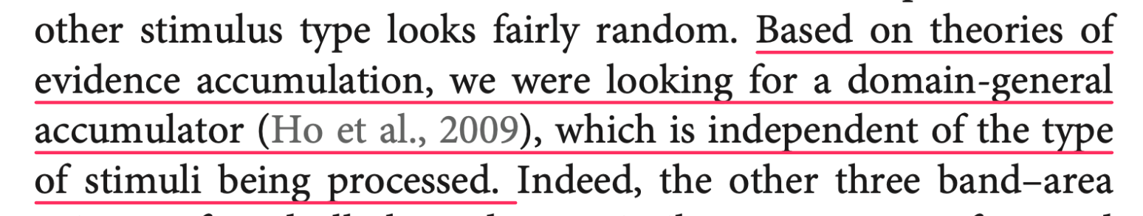
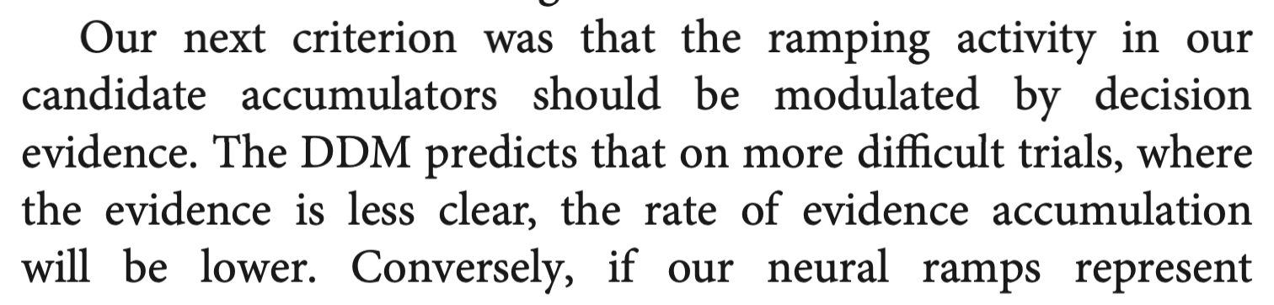
Be evidence accumulation first

