**原始照片 資料前處理 預測結果**

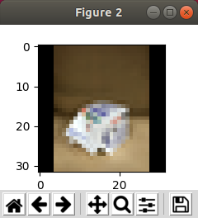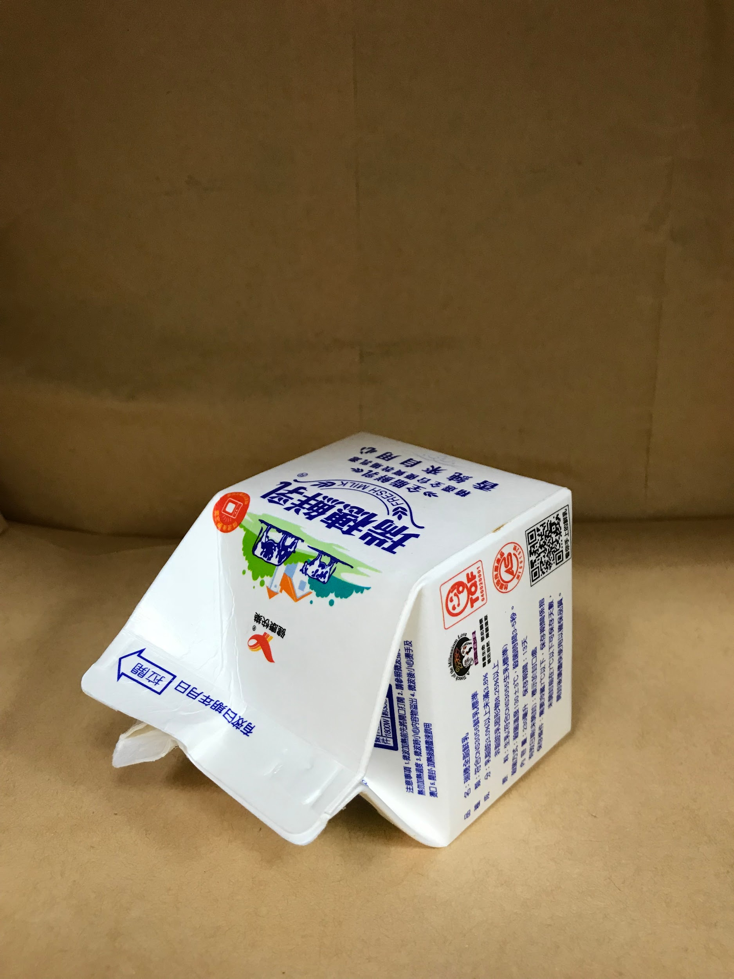

**label: papper**

**predict: papper**

**plastic Probability:0.142619759**

**papper Probability:0.758977592**

**glass Probability:0.015549849**

**iron Probability:0.075718872**

**aluminum Probability:0.007133988**