1. Each row of the table below shows a pair of DVH. The first column indicates the patient. The second to the fourth column is where you mark the comparison of the two plans by double-clicking the corresponding cell.

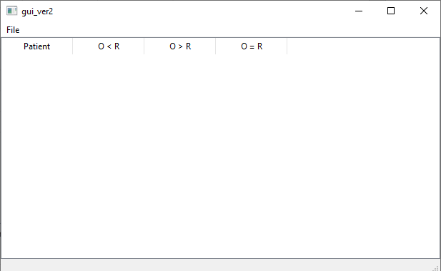

2. To load the DVH, please click the File tab on the top-left corner. Then, click the Load Figs tab to select the folder that stores all the DVH of all the patients (‘**./dvh-plots/**’ is the folder that you need to select).

 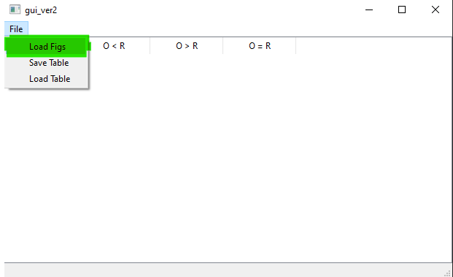

The resulting table will look like the fig below and by double-clicking the patient cell, you will get the corresponding DVH.

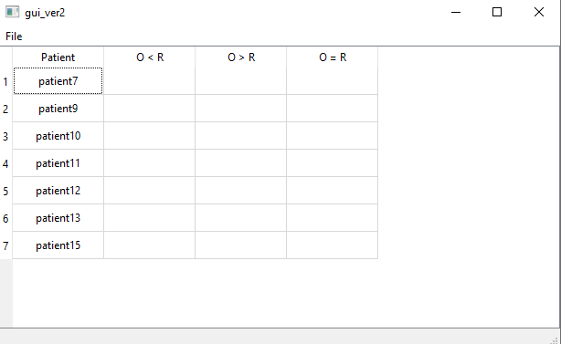

3. To show only the selected organ on the DVH, double-clicking the organ name in the legend. To add more organs to compare, click on the organ name in the legend once.

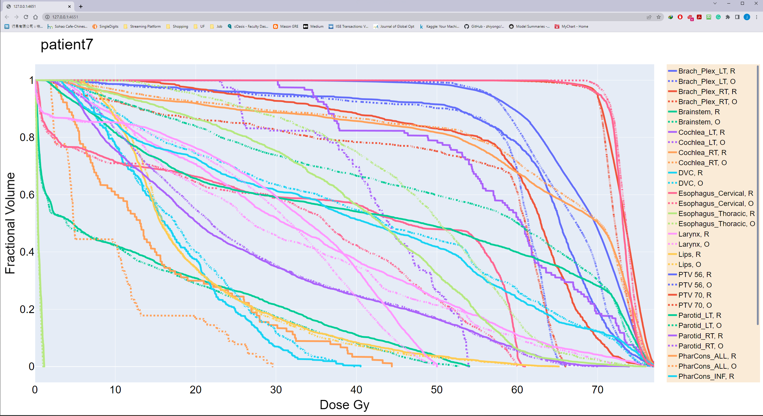

4. To save the table, click File and select Save Table tab. To load the table, click Load Table instead.

Note that the table will automatically be saved as **.csv file** and no need to add an extension and the GUI could only load the **.csv file**.

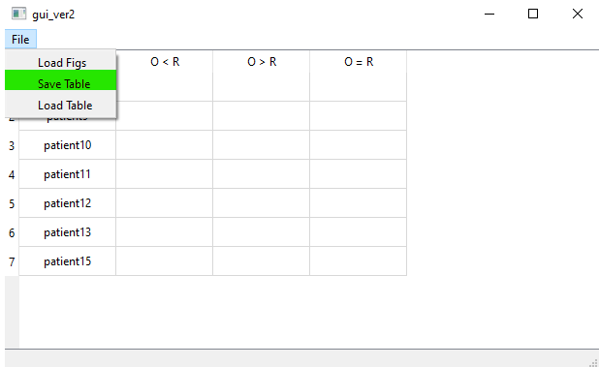

5. To load the previously saved result, just click the Load Table tab under the File tab.