**IBM Phase 5**

**Project Title:** COVID19 Cases Analysis

### **Project Overview:**

**Objective:**  
The project aims to analyze and understand COVID-19 trends and impacts using data analysis tools such as IBM Cognos. The goal is to derive insights from the data collected and visualized, aiding in understanding the patterns and effects of the pandemic on different parameters.

**Design Thinking Process:**

Design thinking is a problem-solving methodology that prioritizes a user-centric approach, encouraging innovation and creative solutions to challenges. Applying design thinking to analyze COVID-19 cases involves a human-centered approach to understanding, ideating, and implementing strategies. Here's a structured design thinking process tailored for COVID-19 analysis:

* **Empathize**:
* **Understand Stakeholders**:
* Identify and understand the various stakeholders involved—public health officials, medical professionals, policymakers, communities, and individuals impacted by COVID-19.
* **Gather User Insights**:
* Conduct interviews, surveys, and observations to empathize with the challenges faced by different groups affected by the pandemic. Gather qualitative and quantitative data to comprehend their needs, concerns, and experiences.
* **Define**:
* **Problem Framing**:
* Based on the insights gathered, define the specific problems, challenges, and opportunities related to COVID-19 analysis. This could involve issues related to data accuracy, resource allocation, vaccination strategies, public awareness, etc.
* **Create Personas**:
* Develop personas representing different groups affected by COVID-19 to better understand their motivations, behaviors, and needs.
* **Ideate**:
* **Brainstorm Solutions**:
* Engage a diverse team to brainstorm potential solutions to the identified challenges. Encourage a free flow of ideas without judgment. Consider innovative ways to analyze, visualize, and utilize COVID-19 data for various purposes.
* **Prototype Solutions**:
* Create simple prototypes or mock-ups of potential solutions, which could be new dashboards, reporting systems, or innovative data visualization methods.
* **Testing Ideas**:
* Test the prototype solutions with a smaller group of users or stakeholders. Collect feedback to understand what works and what needs improvement. This could involve creating sample reports or dashboards using COVID-19 data and iterating based on user feedback.
* **Test**:
* **Iterate and Refine**:
* Analyze the feedback received during the testing phase and refine the prototype solutions. Iterate on the design based on user suggestions and insights.
* **Verify Feasibility**:
* Ensure that the refined solutions are feasible and scalable within the constraints of available data, resources, and technical capabilities.
* **Implement**:
* **Rollout Strategy**:
* Develop a plan for the implementation of the refined solutions. This might involve training users, setting up the necessary infrastructure in tools like IBM Cognos, and gradually introducing the new system for COVID-19 data analysis.
* **Monitor and Adapt**:
* Continuously monitor the implemented solutions, gather feedback, and make necessary adaptations based on user experiences and changing requirements.
* **Evaluate**:
* **Assess Impact**:
* Evaluate the impact of the implemented solutions on COVID-19 data analysis. Measure key performance indicators related to better decision-making, resource allocation, and public health outcomes.
* **Learn and Share Insights**:
* Document the learnings from the design thinking process and share insights to aid future analyses or strategies related to managing the pandemic.

Applying design thinking principles to COVID-19 analysis helps create more user-centric, effective, and innovative solutions to address the multifaceted challenges posed by the pandemic.

**Development Phases:**

* **Analysis Objectives:**
* Identify key metrics (e.g., infection rates, mortality rates, vaccination rates, etc.).
* Analyze impacts on different demographics (age, gender, socio-economic status).
* Explore the correlation between government interventions and infection rates.

**Data Collection Process:**

* Gather data from reliable sources such as WHO, CDC, government health departments, and academic research.
* Collect information on infection rates, mortality rates, vaccination data, and demographic details.
* Organize and clean the data for analysis.

**DATASET:** <https://www.kaggle.com/datasets/chakradharmattapalli/covid-19-cases>

**Data PreProcessing:**

**1.**

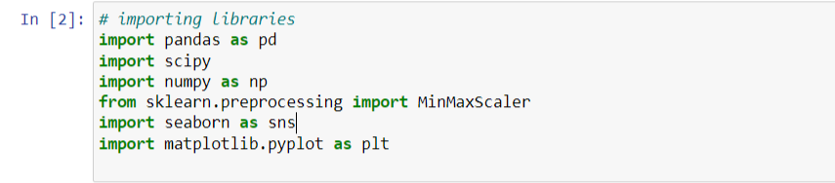

2.

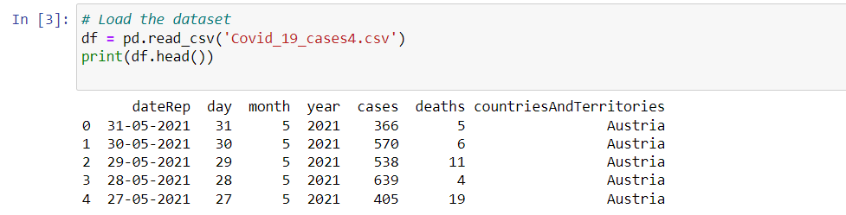

3.

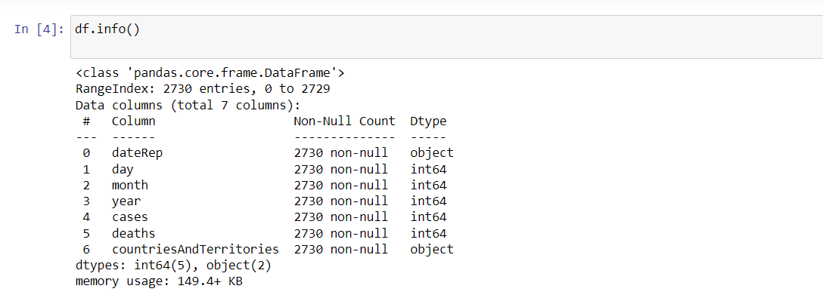  
4.

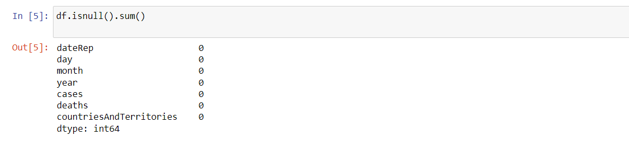

5.

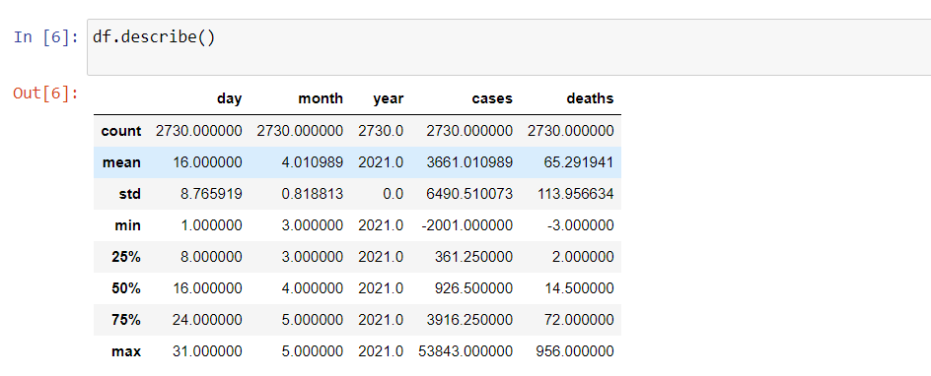  
6.

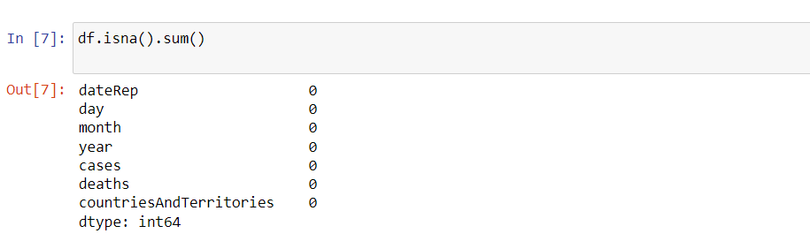  
7.

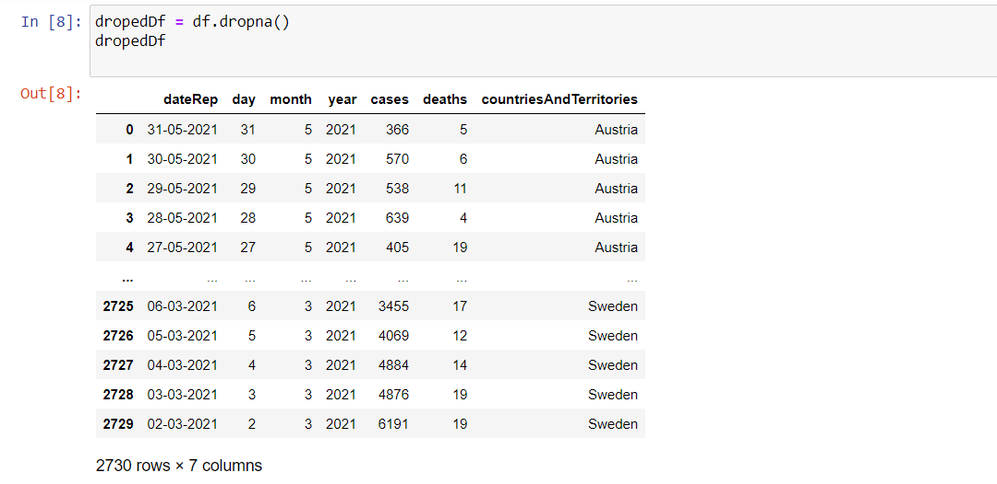  
8.

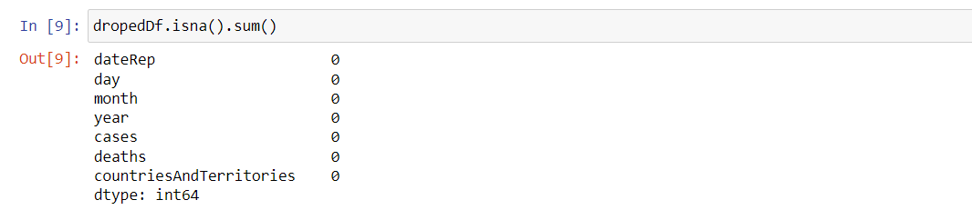

9.

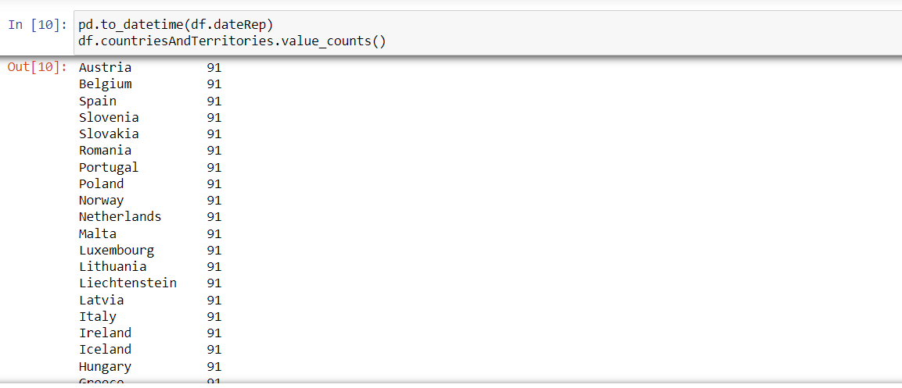  
10.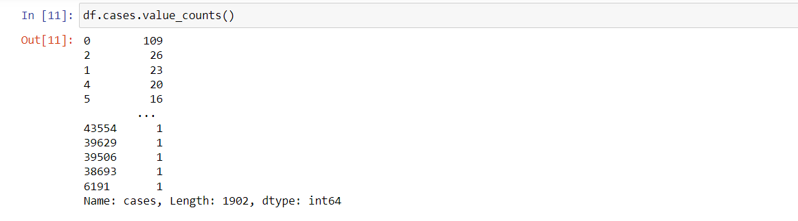  
11.

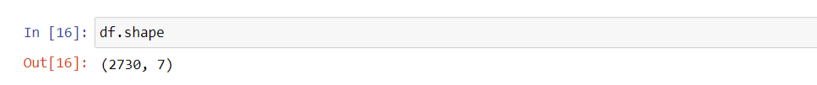

12.

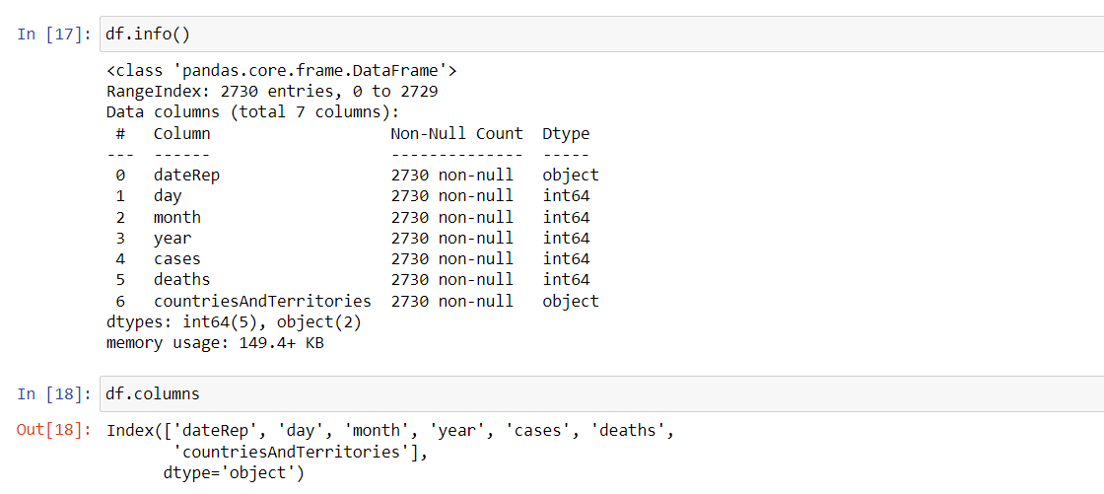  
  
**Data Visualization using IBM Cognos:**

* Utilize IBM Cognos to create dashboards and reports for visual representation of the data.
* Generate visualizations like graphs, charts, and maps to illustrate trends and patterns.
* Implement interactive features for deeper exploration of the data.

1.BubbleChart:

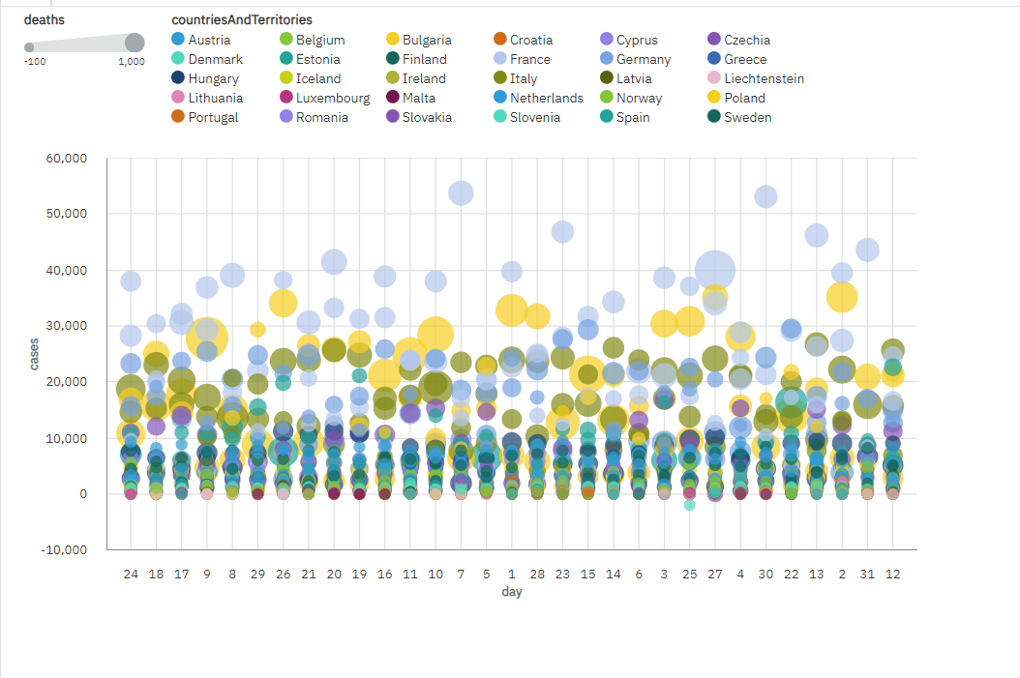

2.AreaPlot:

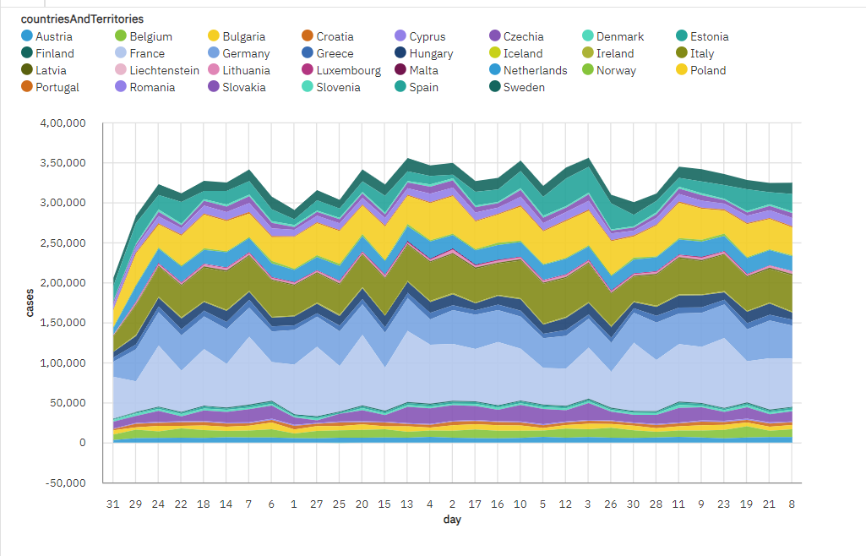

3.ScatterPlot:

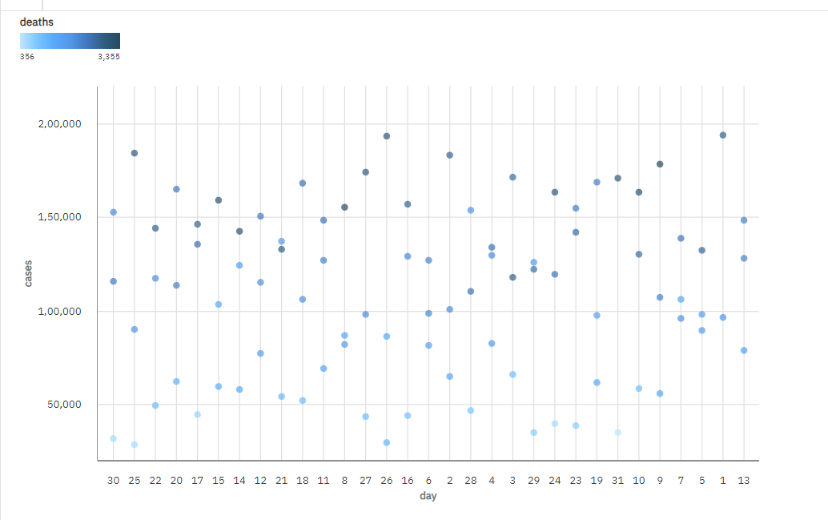

4.BarChart:

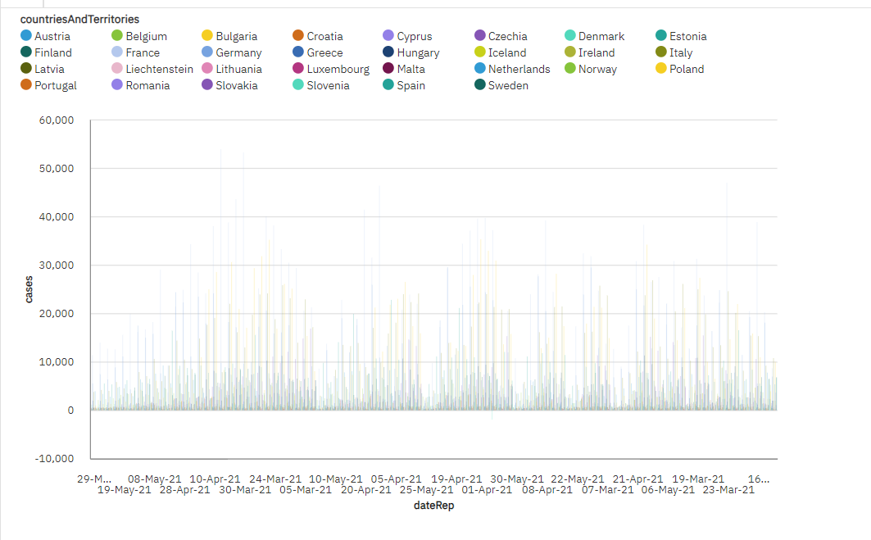  
5.PieChart:

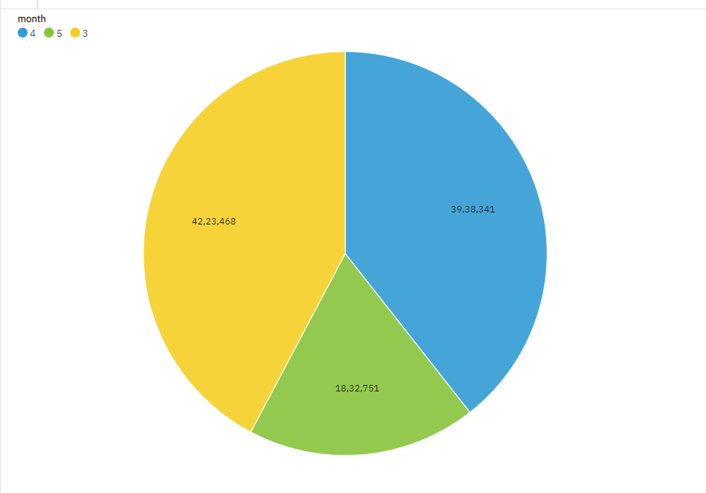

**6.LinePlot:**

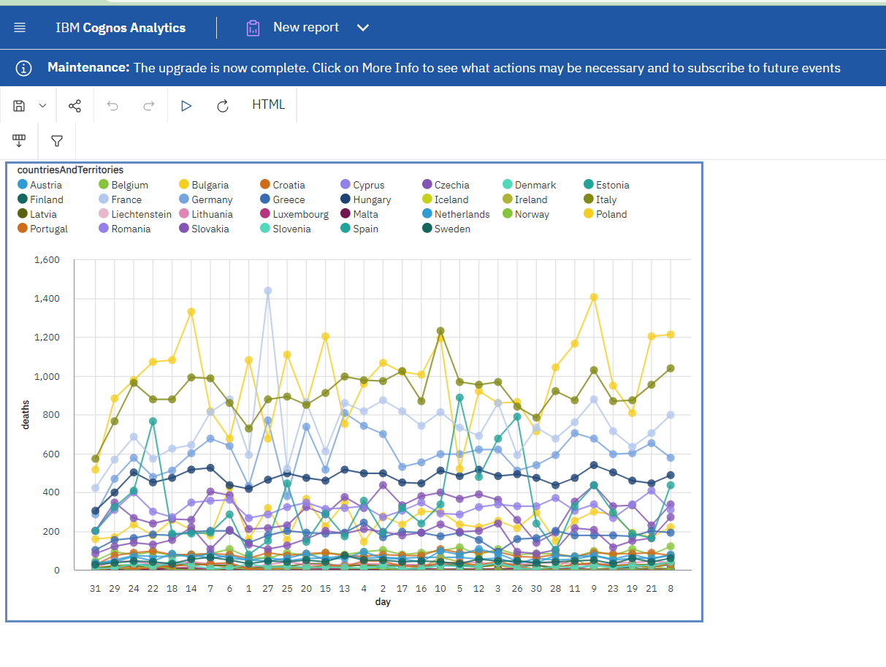  
**7.HeatMap:**

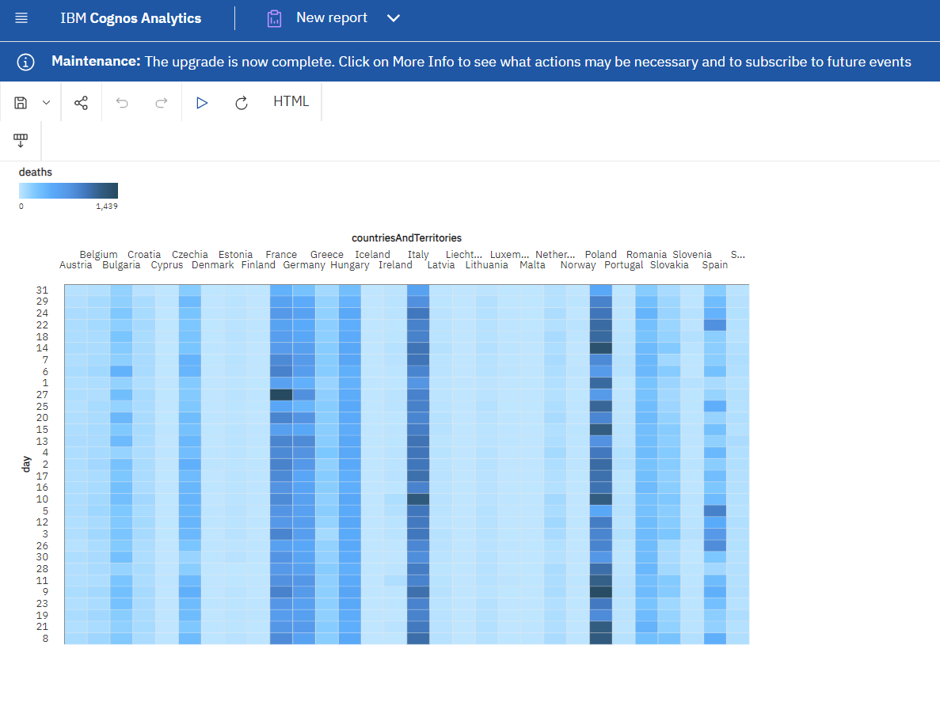

**Insights Generated from Comparison:**

* Identify hotspots and trends in infection rates over time and geography.
* Analyze the effectiveness of vaccination drives and their impact on reducing infection rates.
* Explore how different demographic groups are affected and if there are disparities in impacts.

**DashBoard:**

**1.**

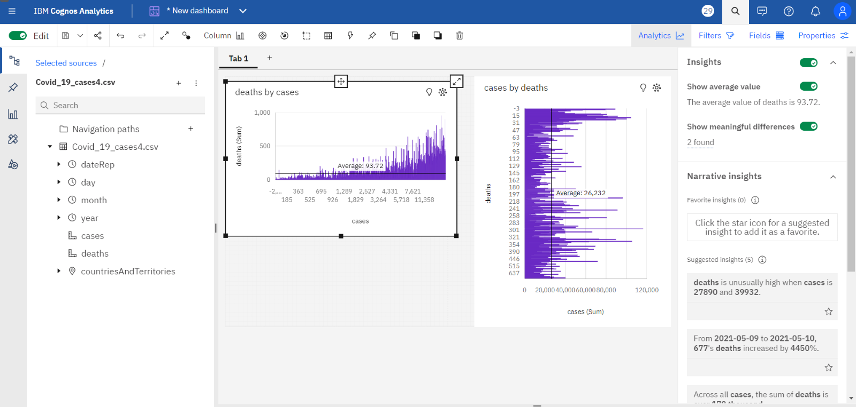

2.

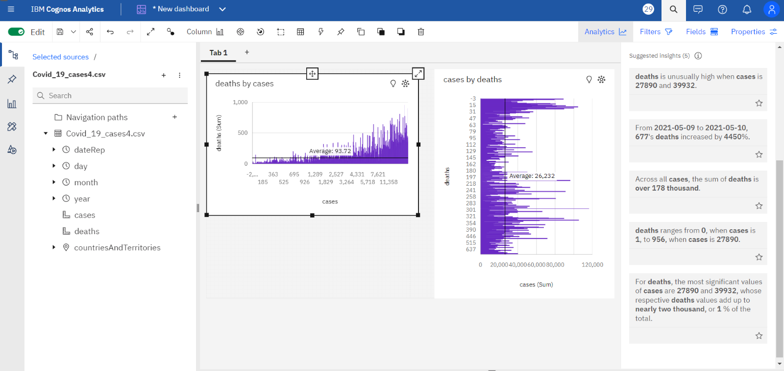

3.  
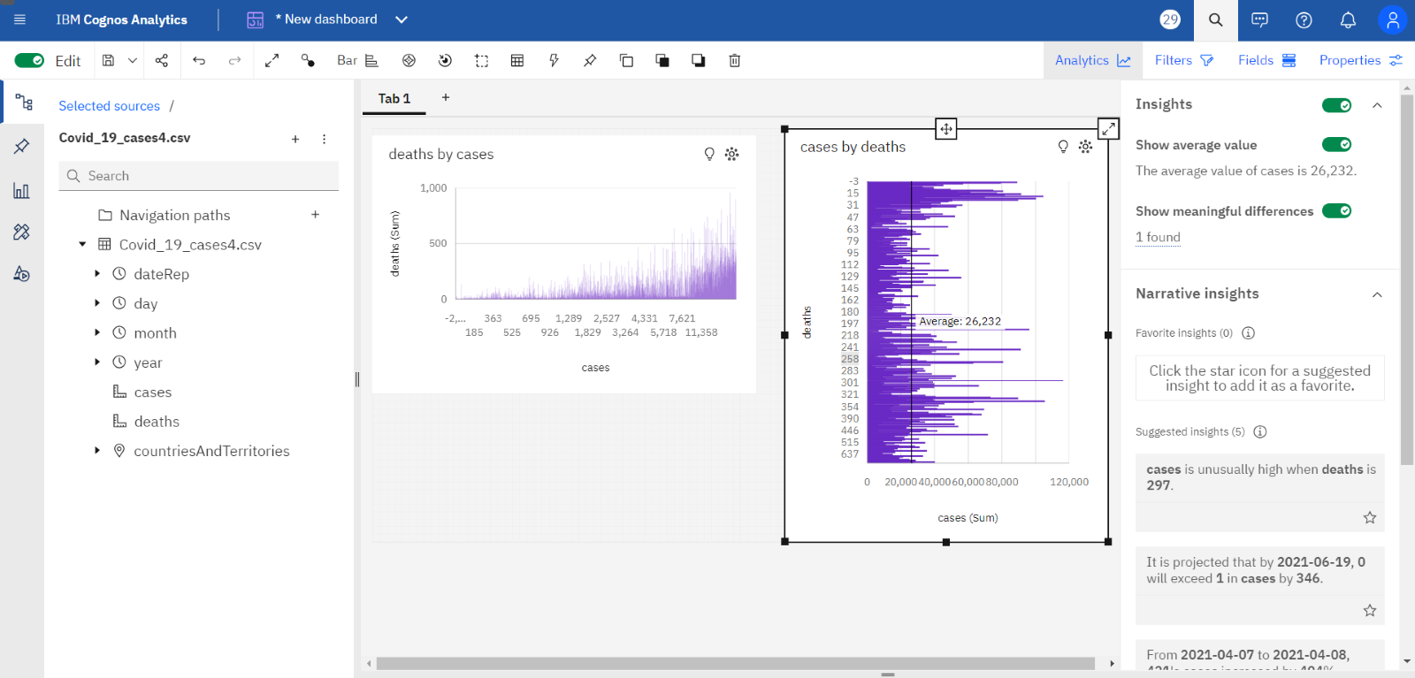

4.

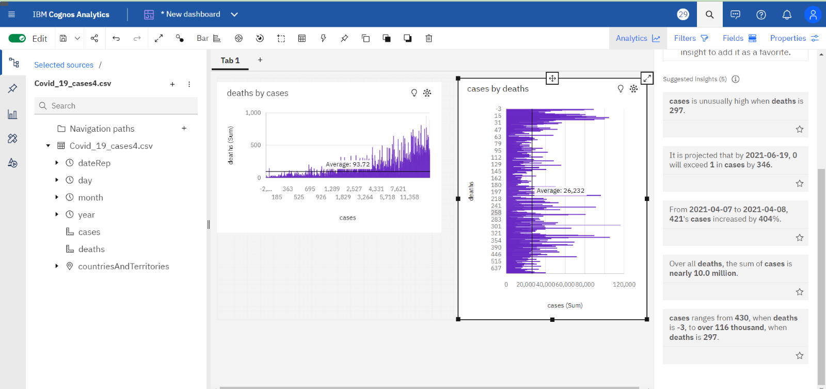

In the above dashboard I have created the barchart and colum chart from which many insights has been got have been inclued in sreenshots.

DashBoard Link:

<https://us3.ca.analytics.ibm.com/bi/?perspective=dashboard&id=i2156B887BF8544A0A0D80E7A2106EB35&objRef=i2156B887BF8544A0A0D80E7A2106EB35&options%5BdisableGlassPrefetch%5D=true&options%5Bcollections%5D%5BcanvasExtension%5D%5Bid%5D=com.ibm.bi.dashboard.canvasExtension&options%5Bcollections%5D%5BfeatureExtension%5D%5Bid%5D=com.ibm.bi.dashboard.core-features&options%5Bcollections%5D%5Bbuttons%5D%5Bid%5D=com.ibm.bi.dashboard.buttons&options%5Bcollections%5D%5Bwidget%5D%5Bid%5D=com.ibm.bi.dashboard.widgets&options%5Bcollections%5D%5BcontentFeatureExtension%5D%5Bid%5D=com.ibm.bi.dashboard.content-features&options%5Bcollections%5D%5BsaveServices%5D%5Bid%5D=com.ibm.bi.dashboard.saveServices&options%5Bcollections%5D%5Btemplates%5D%5Bid%5D=com.ibm.bi.dashboard.templates&options%5Bcollections%5D%5BvisualizationExtension%5D%5Bid%5D=com.ibm.bi.dashboard.visualizationExtensionCA&options%5Bcollections%5D%5BboardModel%5D%5Bid%5D=com.ibm.bi.dashboard.boardModelExtension&options%5Bcollections%5D%5BcontentTypes%5D%5Bid%5D=com.ibm.bi.dashboard.contentTypes&options%5Bcollections%5D%5BserviceExtension%5D%5Bid%5D=com.ibm.bi.dashboard.serviceExtension&options%5Bcollections%5D%5BlayoutExtension%5D%5Bid%5D=com.ibm.bi.dashboard.layoutExtension&options%5Bcollections%5D%5BcolorSetExtensions%5D%5Bid%5D=com.ibm.bi.dashboard.colorSetExtensions&options%5Bconfig%5D%5Bproduct%5D=CA&options%5Bconfig%5D%5BeditPropertiesLabel%5D=true&options%5Bconfig%5D%5BenableCustomVisualizations%5D=true&options%5Bconfig%5D%5BassetTags%5D%5B%5D=dashboard&options%5Bconfig%5D%5BfilterDock%5D=true&options%5Bconfig%5D%5BshowMembers%5D=true&options%5Bconfig%5D%5Bupgrades%5D=dashboard-core%2Fjs%2Fdashboard%2Fupgrades&options%5Bconfig%5D%5BassetType%5D=exploration&options%5Bconfig%5D%5BgeoService%5D=CA&options%5Bconfig%5D%5BsmartTitle%5D=true&options%5Bconfig%5D%5BnavigationGroupAction%5D=true&options%5Bconfig%5D%5BenableDataQuality%5D=false&options%5Bconfig%5D%5BmemberCalculation%5D=false&isAuthoringMode=false&boardId=i2156B887BF8544A0A0D80E7A2106EB35>

**Mean And Standard Deviation:**

**Program:**

import numpy as np

import pandas as pd

df=pd.read_csv('Covid_19_cases4.csv')

df.head()

**Output:**

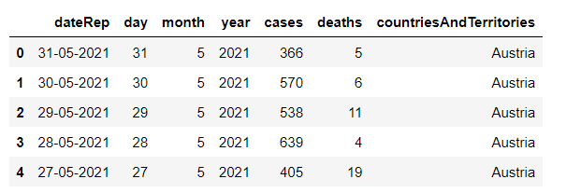

**Program:**

data = df['cases']

data

**Output:**

0 366  
1 570  
2 538  
3 639  
4 405  
 ...   
2725 3455  
2726 4069  
2727 4884  
2728 4876  
2729 6191  
Name: cases, Length: 2730, dtype: int64

**Program:**

mean_cases = np.mean(data)

mean_cases

**Output:**

3661.010989010989

**Program:**

std_dev_cases = np.std(data)

std_dev_cases

**Output:**

6489.321226114741

**Program:**

data2=df['deaths']

data2

**Output:**

0 5  
1 6  
2 11  
3 4  
4 19  
 ..  
2725 17  
2726 12  
2727 14  
2728 19  
2729 19  
Name: deaths, Length: 2730, dtype: int64

**Program:**

mean_deaths = np.mean(data2)

mean_deaths

**Output:**

65.29194139194139

**Program:**

std_dev_deaths = np.std(data2)

std_dev_deaths

**Output:**

113.93576096804071

### **Understanding COVID-19 Trends and Impacts:**

**Insights:**

* **Epidemiological Patterns:** Understanding the spread rate, identifying hotspots, and predicting potential outbreak areas.
* **Vaccination Impact:** Analyzing the effectiveness of vaccination campaigns on infection rates and severity.
* **Demographic Disparities:** Identifying vulnerable groups or demographics facing higher risks.
* **Policy Effectiveness:** Evaluating the success of various government interventions and their impact on controlling the spread.

**Impact of Insights:**

* Aid policymakers in making informed decisions regarding targeted interventions.
* Help healthcare professionals prepare for and manage resources based on predicted trends.
* Empower the public with knowledge to make informed decisions regarding safety measures.

By comprehensively analyzing COVID-19 data and visualizing insights using IBM Cognos, the project can play a crucial role in understanding and mitigating the impacts of the pandemic.

### **Conclusion:**

The project's primary objective is to employ data analysis methodologies, utilizing tools like IBM Cognos, to comprehensively understand the trends and impacts of the COVID-19 pandemic. The process involves a structured approach encompassing design thinking principles and sequential development phases.

By employing the design thinking process, the project ensures a human-centric approach. It begins by understanding the stakeholders' needs, defining the problem areas, ideating on data collection and analysis methods, prototyping the process, and iterating continuously. This iterative cycle allows for flexibility and adaptation in response to changing data and requirements.

The development phases include setting clear analysis objectives such as identifying key metrics, exploring demographic impacts, and assessing the correlation between interventions and infection rates. The data collection process focuses on obtaining reliable data from various sources and organizing it for analysis. The visualization using IBM Cognos involves creating interactive and informative visual representations to better comprehend the data.

The insights derived from this project are instrumental in understanding COVID-19 trends and impacts. These insights encompass epidemiological patterns, vaccination effectiveness, demographic disparities, and the evaluation of policy interventions. Understanding these insights aids in predicting and addressing hotspots, assessing the success of vaccination campaigns, identifying vulnerable demographics, and evaluating policy effectiveness.

In essence, the insights derived from this comprehensive analysis play a vital role in guiding policymakers, healthcare professionals, and the general public in making informed decisions. They provide a deeper comprehension of the pandemic's complexities, enabling more targeted and effective interventions, resource allocation, and individual safety measures.

Ultimately, this project's methodology and analysis contribute to a better understanding of COVID-19's multifaceted impacts and trends, serving as a crucial tool in the global effort to manage and mitigate the effects of the pandemic.