**Hyndrance Daily Report**

**Daily Output:**

1. **Expected Layout**

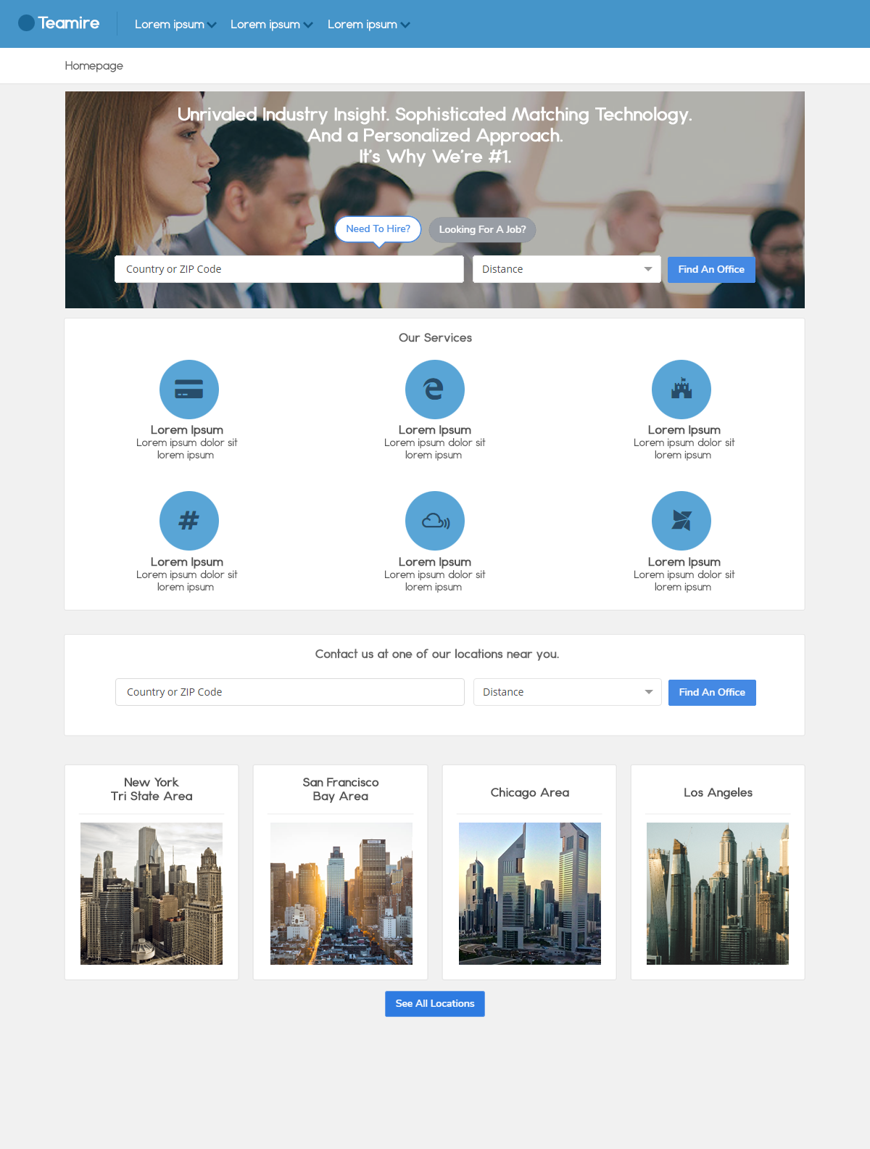

*Disclaimer: This is the expected output of the homepage. This is also subject to change.*

* We will be using material design in creating the layout of the website.
* You can also suggest the color scheme that will be used in the website.

1. **Basic Site Structure**
   * **Basic Flowchart**
     + **Employee Flowchart**

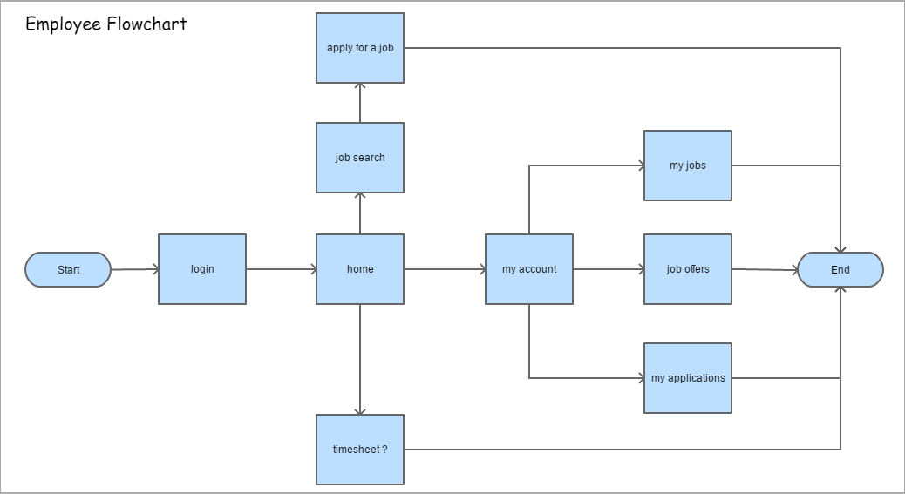

* + - **Employer**

