**Hyndrance Daily Report**

**Note:** These screenshots are what we have done so far. They are all functional and we are still working on to improve them. This is not the final design of the layout yet. We will update soon the design when our designer finishes the layout per pages. We will temporarily upload it to a free web hosting site for your team to see its user experience.

**Tasks Done:**

* [**www.teamire.com**](http://www.teamire.com) **website under construction**
* **Backup for existing website except for the database**

**Features Checklist:**

* **User Login**
* **Update user profile**
* **Post Job**
* **Search Job**

**Page Screenshots:**

1. **Login Page**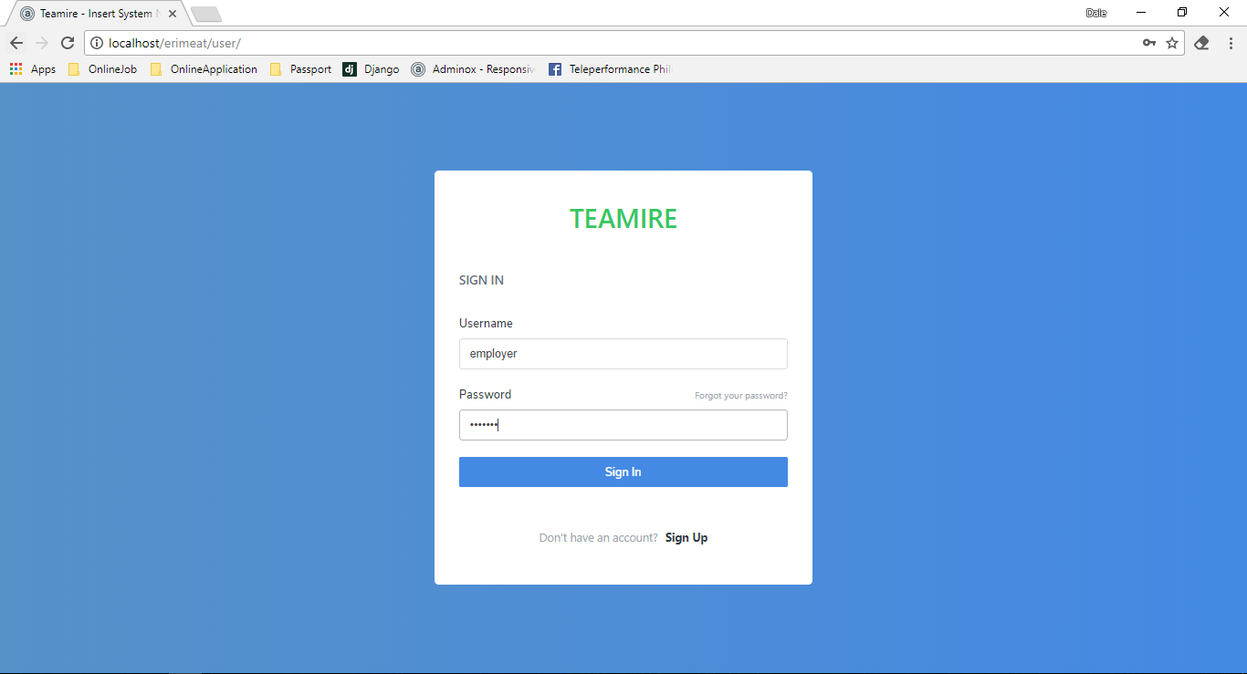

*Disclaimer: Layout our subject to change since we are still waiting for the final layout from the designer.*

1. **Home Page**

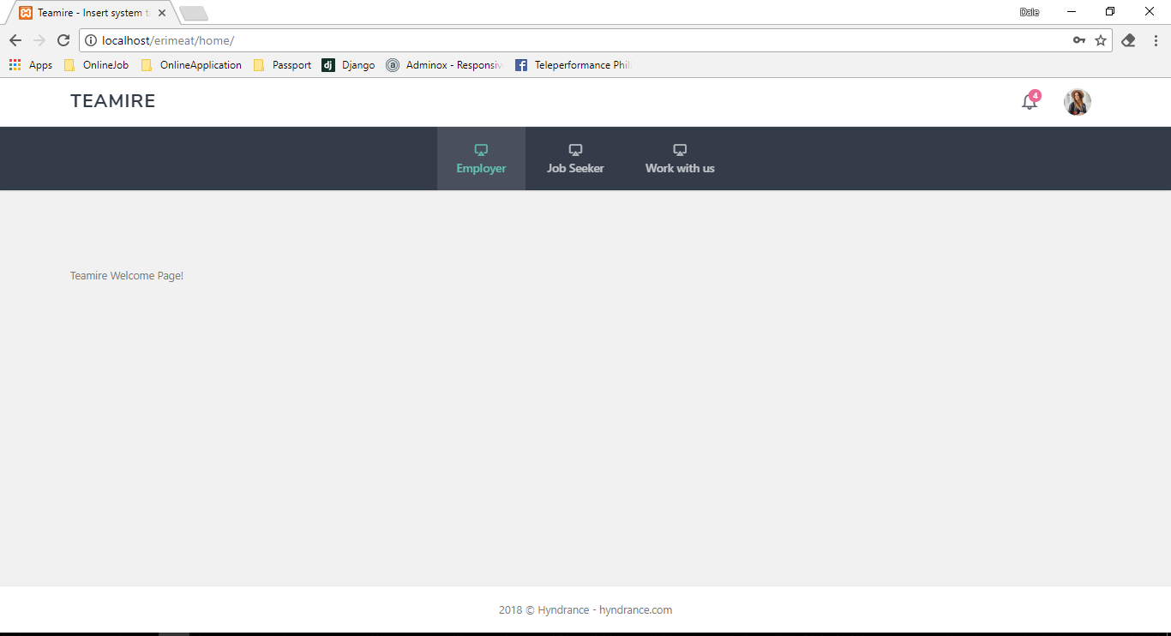

*Disclaimer: Layout our subject to change since we are still waiting for the final layout from the designer.*

1. **User Profile** 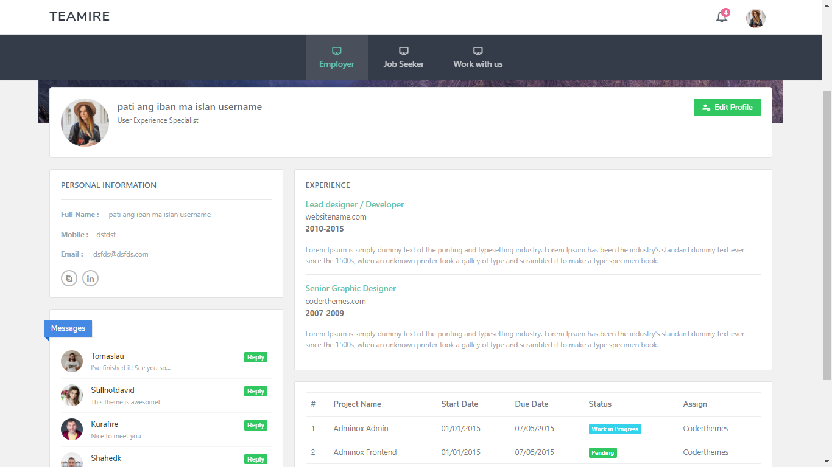

*Disclaimer: Layout our subject to change since we are still waiting for the final layout from the designer.*

1. **Update User Profile**

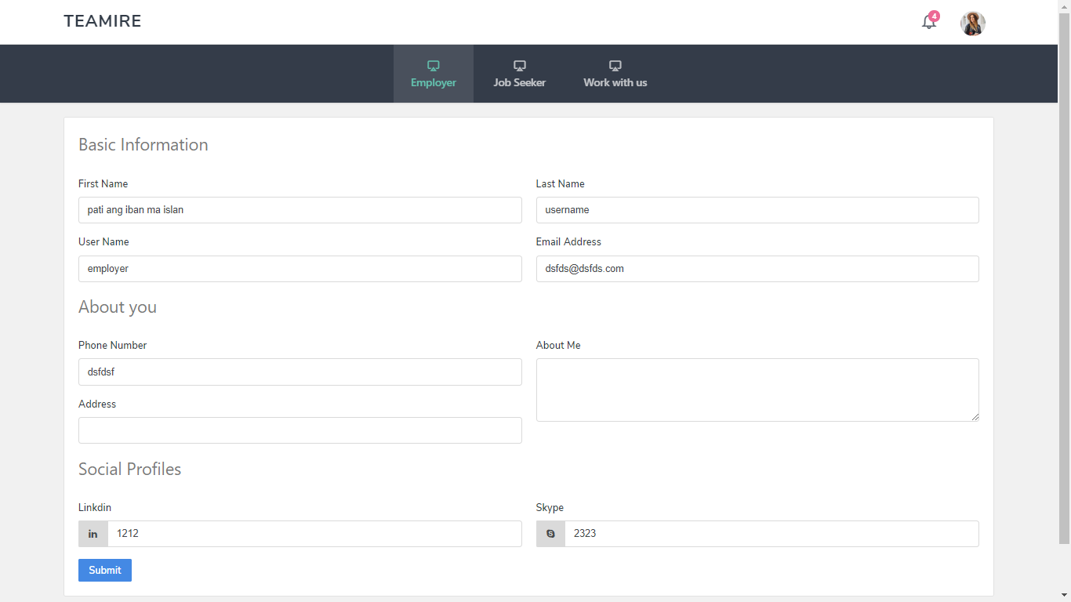

*Disclaimer: Layout our subject to change since we are still waiting for the final layout from the designer.*

1. **Post Job (Employer)**

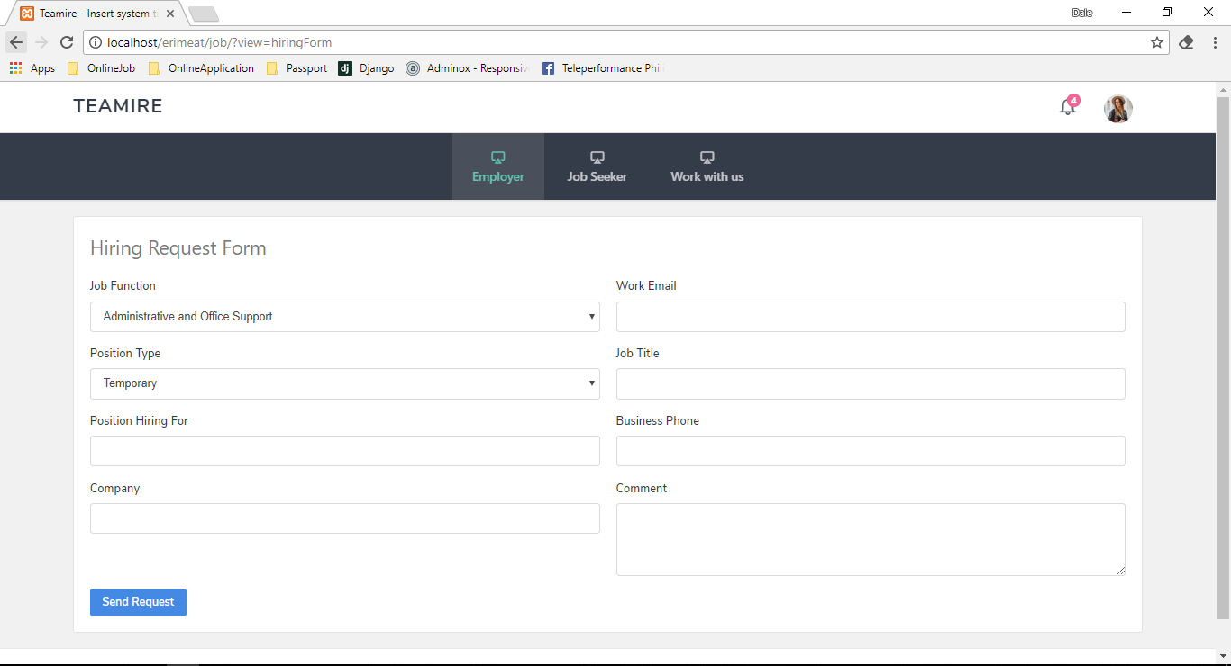

*Disclaimer: Layout our subject to change since we are still waiting for the final layout from the designer.*

1. **Search Job (Employee)**

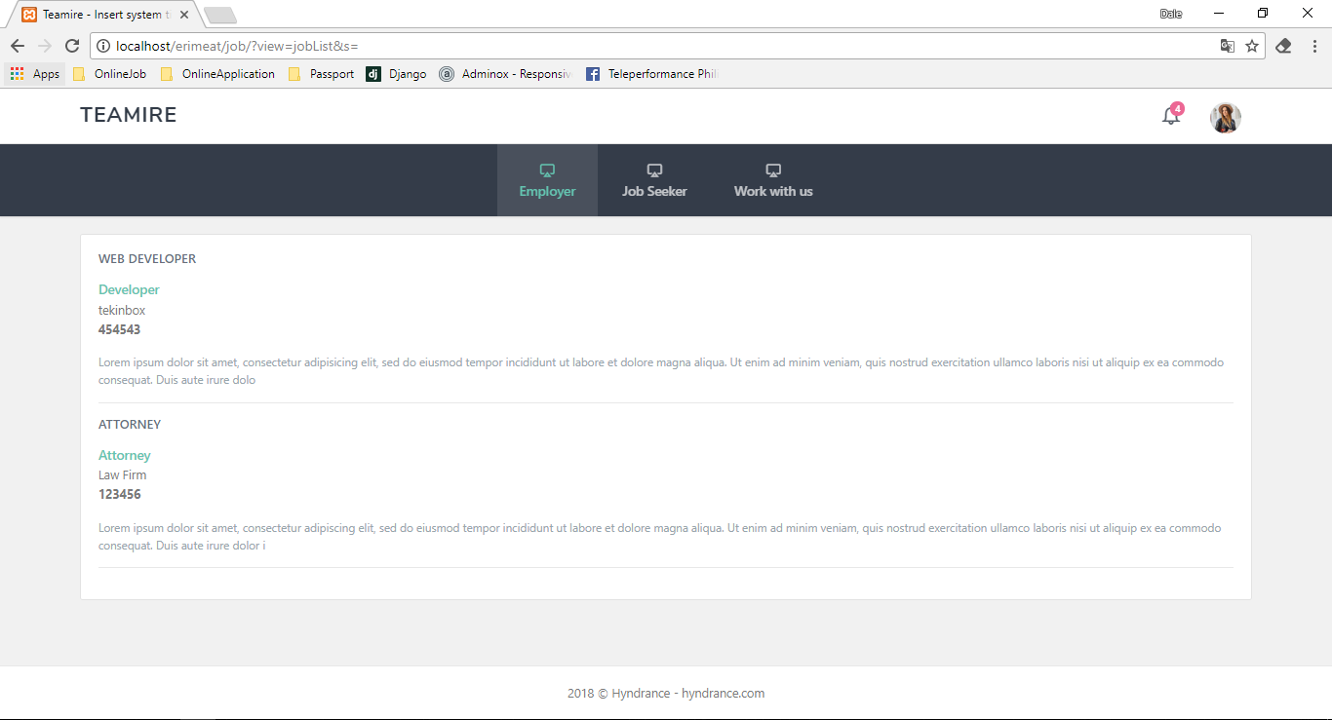

*Disclaimer: Layout our subject to change since we are still waiting for the final layout from the designer.*

1. Website Under Construction

