Hynox Campus Technical Architecture & Product Documentation Handbook
Official Technical Specification and System Topology Manual

CHAPTER 1 — PLATFORM OVERVIEW

1.1 What is Hynox Campus?
Hynox Campus is an enterprise-grade multi-tenant educational portal designed to bridge physical classroom instruction with hands-on labs, automated assignment validation, and industry-aligned placement readiness.

1.2 Vision & Business Goal
The primary objective of Hynox Campus is to raise student job-readiness by linking theoretical academic milestones to verifiable coding outputs ("proof-of-work"). From a business standpoint, Hynox Campus operates as a B2B SaaS platform that institutions (colleges, schools, vocational centers) purchase to manage, track, and accelerate their students' progress.

1.3 Multi-Tenant Architecture & Institution-Based Learning Model
Hynox Campus employs a strict multi-tenant isolation pattern using a Tenant ID. The system contains distinct schemas to segregate database domains, ensuring:
- Data Privacy: One institution cannot query or view another institution's data.
- Content Reusability: Master content templates can be safely duplicated into institution-specific courses.
- Auditing & Governance: Complete tracking of user and admin actions within each tenant.

1.4 Hierarchical Content Delivery Structure
The hierarchy follows a strict parent-child relationship cascading down from the Super Admin to the individual learning activities:

CHAPTER 2 — COMPLETE SYSTEM ARCHITECTURE
Hynox Campus is organized into six major functional domains to split responsibilities, secure multi-tenant boundaries, and scale learning workloads:

1. Core: Manages identity, RBAC (Role-Based Access Control), audit logging, and core profiles.
2. Institution: Models physical schools/colleges, administrative configurations, and status indicators.
3. Library: Operates as a master template library, holding decoupled reusable educational materials.
4. Academic: Stores the localized tenant-specific curriculum mapping programs, courses, modules, and lessons.
5. Delivery: Operates the live instruction plane, defining cohorts, student enrollments, course assignments, and lesson completion trackers.
6. Learning: Orchestrates hands-on evaluation workflows, containing activities (Quizzes, Projects, and Programming Challenges).

2.1 Domain-Level Architecture Flow
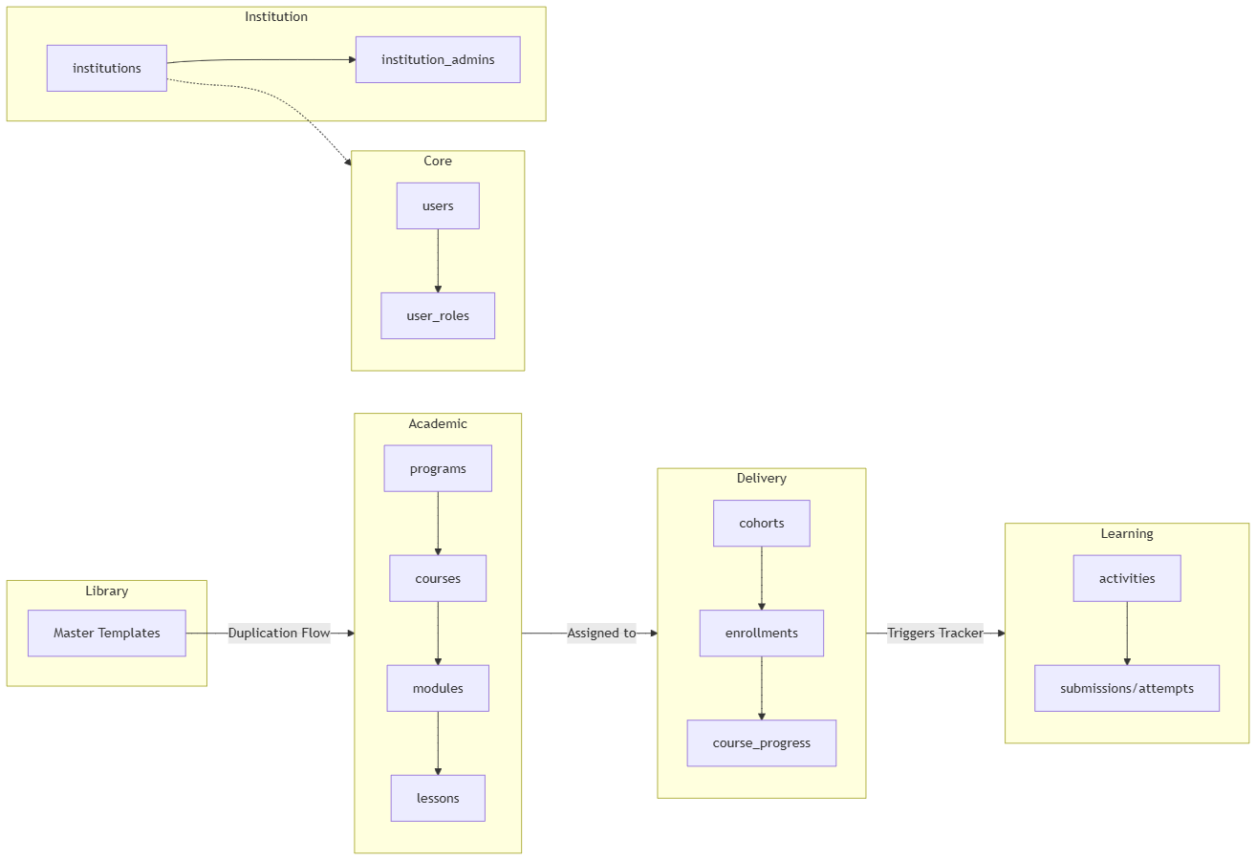

CHAPTER 3 — CORE SCHEMA
The core schema handles security boundaries, authorization, audit tracks, and account onboarding.

3.1 Core Schema Table Definitions

core.users
- Purpose: Represents consolidated user profiles matching identity providers.
- Columns:
  - id (UUID, PK): Unique identifier.
  - auth_user_id (UUID, FK -> auth.users.id): References Supabase auth system.
  - full_name (TEXT): User's legal name.
  - email (TEXT, Unique): Primary registration email.
  - tenant_id (UUID, FK -> institution.institutions.id): Active tenant membership.
  - status (TEXT, FK -> core.user_statuses.code): E.g., active, invited.
  - deleted_at (TIMESTAMPTZ): Soft-delete indicator.

core.roles
- Purpose: Roles used to assign capabilities.
- Seed Values: super_admin (Priority 100), institution_admin (Priority 80), trainer (Priority 60), student (Priority 10), public (Priority 0).

core.user_roles
- Purpose: Junction table mapping users to roles.
- Columns: user_id (UUID, FK), role_id (UUID, FK).

core.permissions
- Purpose: Granular system permission strings (e.g., course:create, submission:review).

core.role_permissions
- Purpose: Mappings of permissions to roles.

core.user_invitations
- Purpose: Manages secure onboarding links generated for bulk-provisioned students.
- Columns: id, user_id, token (UUID), expires_at, status (created, sent, accepted, expired), invitation_type.

core.audit_logs
- Purpose: Immutable audit record of critical actions.
- Columns: id, tenant_id, event_type (e.g., invitation_accepted), actor_user_id, metadata (JSONB).

3.2 Core ER Diagram
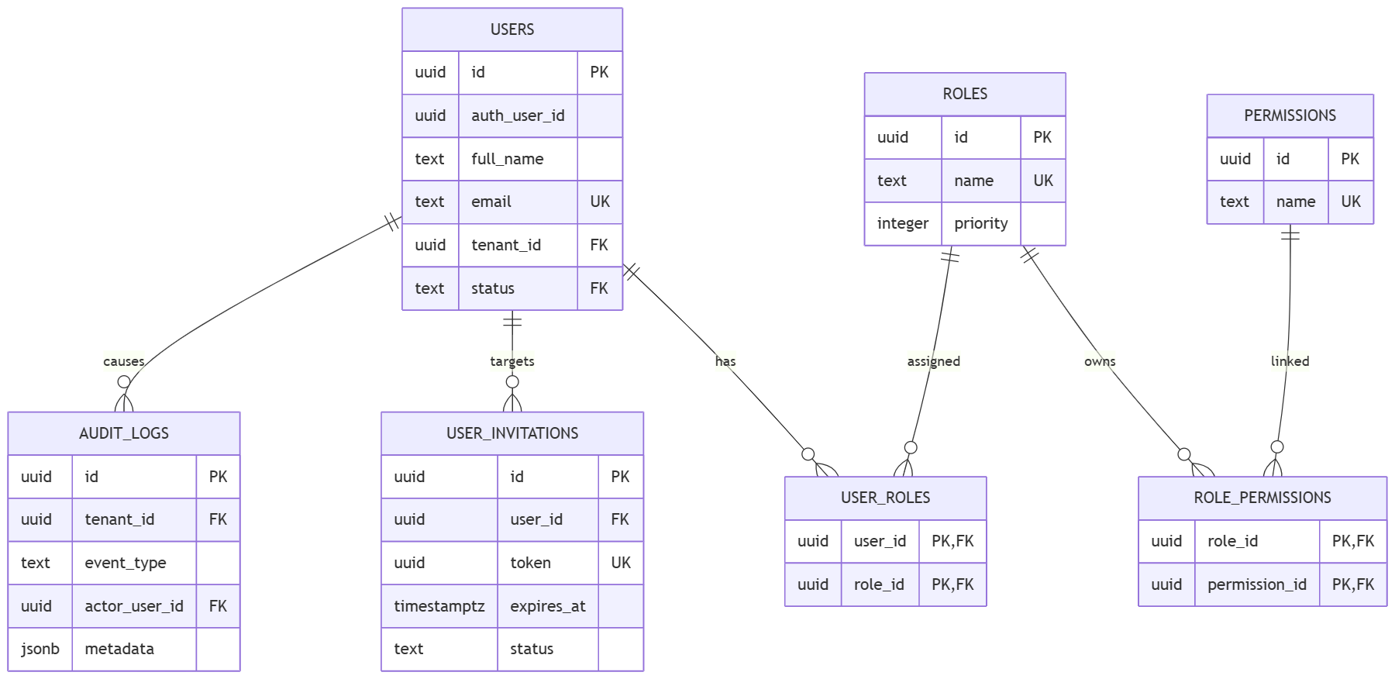

CHAPTER 4 — INSTITUTION SCHEMA
The institution schema encapsulates tenant metadata, campus administrators, and operational state mappings.

4.1 Schema Tables
- `institution.institutions`: Stores the organization name, unique code (e.g., VIT-CH), subdomain slug, and address.
- `institution.institution_admins`: Mapping table associating institution administrators to specific institutions.
- `institution.institution_types`: Lookup table (e.g., school, college, university, training_center, corporate_partner).
- `institution.institution_statuses`: Lookup table (e.g., active, inactive, suspended, onboarding).

4.2 Institution Onboarding Workflow

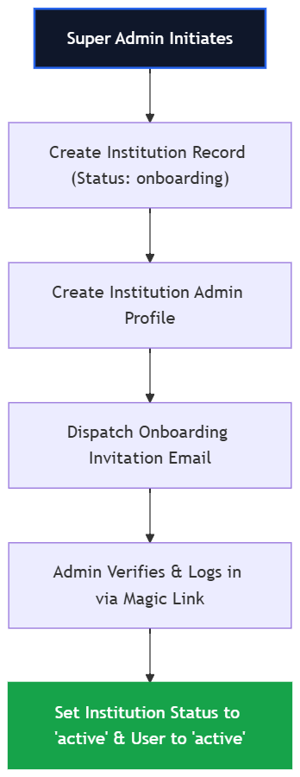

CHAPTER 5 — LIBRARY SCHEMA
The library schema acts as a Global Reusable Master Content Library. Decoupled from any physical tenant, it holds master templates of courses and lessons curated by subject matter experts.

5.1 Tables
- `library.course_templates`: Blueprint for courses containing standard descriptions, learning objectives, and categories.
- `library.module_templates`: Blueprint for modules.
- `library.lesson_templates`: Blueprint for lessons (video placeholders, texts).
- `library.resource_templates`: Decoupled PDFs, cheatsheets, and files.
- `library.template_categories` & `template_tags`: Mappings for categorization.

5.2 Template Versioning
Every master template contains a version indicator (e.g., v1.2.0). When updates are made to a master template, the version increments. Localized copies inside academic.courses store the template ID and version they duplicated from to track drift.

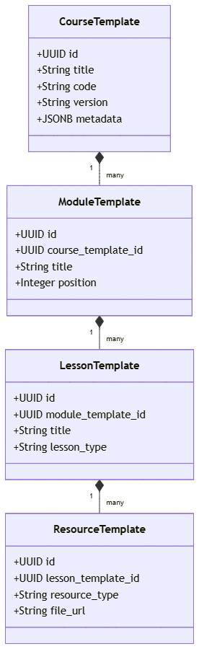

CHAPTER 6 — LIBRARY → ACADEMIC DUPLICATION FLOW
When an institution purchases a course program, the library templates are cloned (deep-copied) into the academic schema. This creates localized copies that trainers can modify without affecting the master template.

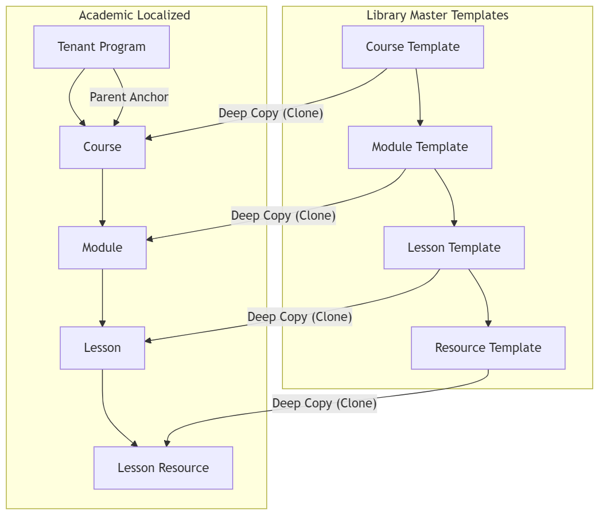

Duplication Rules:
1. Relationships are preserved via matching foreign keys.
2. Tenant ID and Institution ID are written into all cloned tables.
3. Templates are assigned unique UUIDs on cloning to avoid collision.

CHAPTER 7 — ACADEMIC SCHEMA
The academic schema contains the curriculum outline mapped to the institution's tenant scope.

7.1 Table Definitions
- `academic.programs`: High-level degree or track (e.g., "B.Tech Computer Science V1").
- `academic.courses`: A course associated with a program (e.g., "Full-Stack Web Development").
- `academic.course_instructors`: Junction mapping trainers to courses.
- `academic.modules`: Chapters within a course.
- `academic.lessons`: Lectures, labs, or assignments.
- `academic.lesson_resources`: Supporting materials like videos, slide PDFs, and markdown sheets.

7.2 Academic ERD
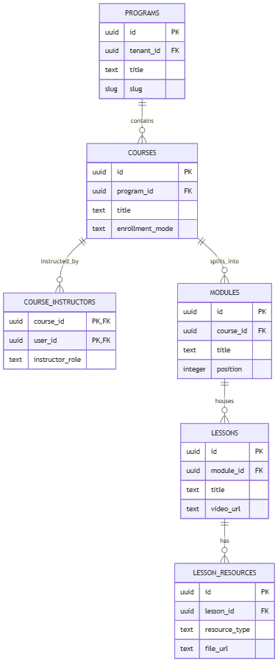

CHAPTER 8 — DELIVERY SCHEMA
The delivery schema manages live deployment. It converts the academic curriculum outline into an active cohort-based delivery plane for students.
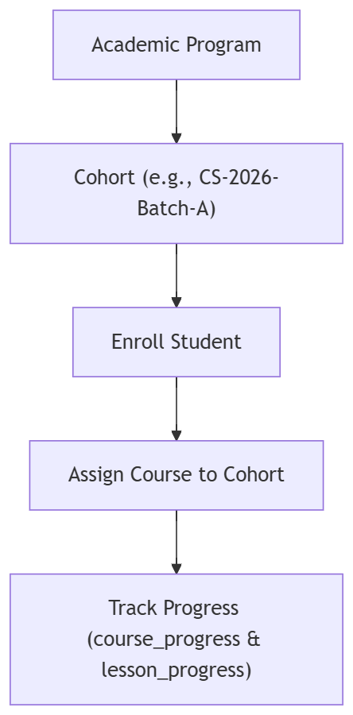

8.1 Schema Tables
- `delivery.cohorts`: Groups of students traversing a program at the same time.
- `delivery.enrollments`: Maps students to a cohort.
- `delivery.course_assignments`: Determines when a course goes live for a cohort.
- `delivery.lesson_progress`: Tracking table recording if a lesson is not_started, in_progress, or completed.
- `delivery.course_progress`: Aggregate progress tracker calculated from lesson completions.

CHAPTER 9 — LEARNING SCHEMA
The learning schema orchestrates student evaluation actions. It decouples activities from the academic lessons structure to support multiple homework types.

9.1 Activity Hierarchy and Decoupling
An activity record represents a wrapper for an assessment. It contains a FK link to a lesson. The details of the activity reside in its specific sub-table based on the type:

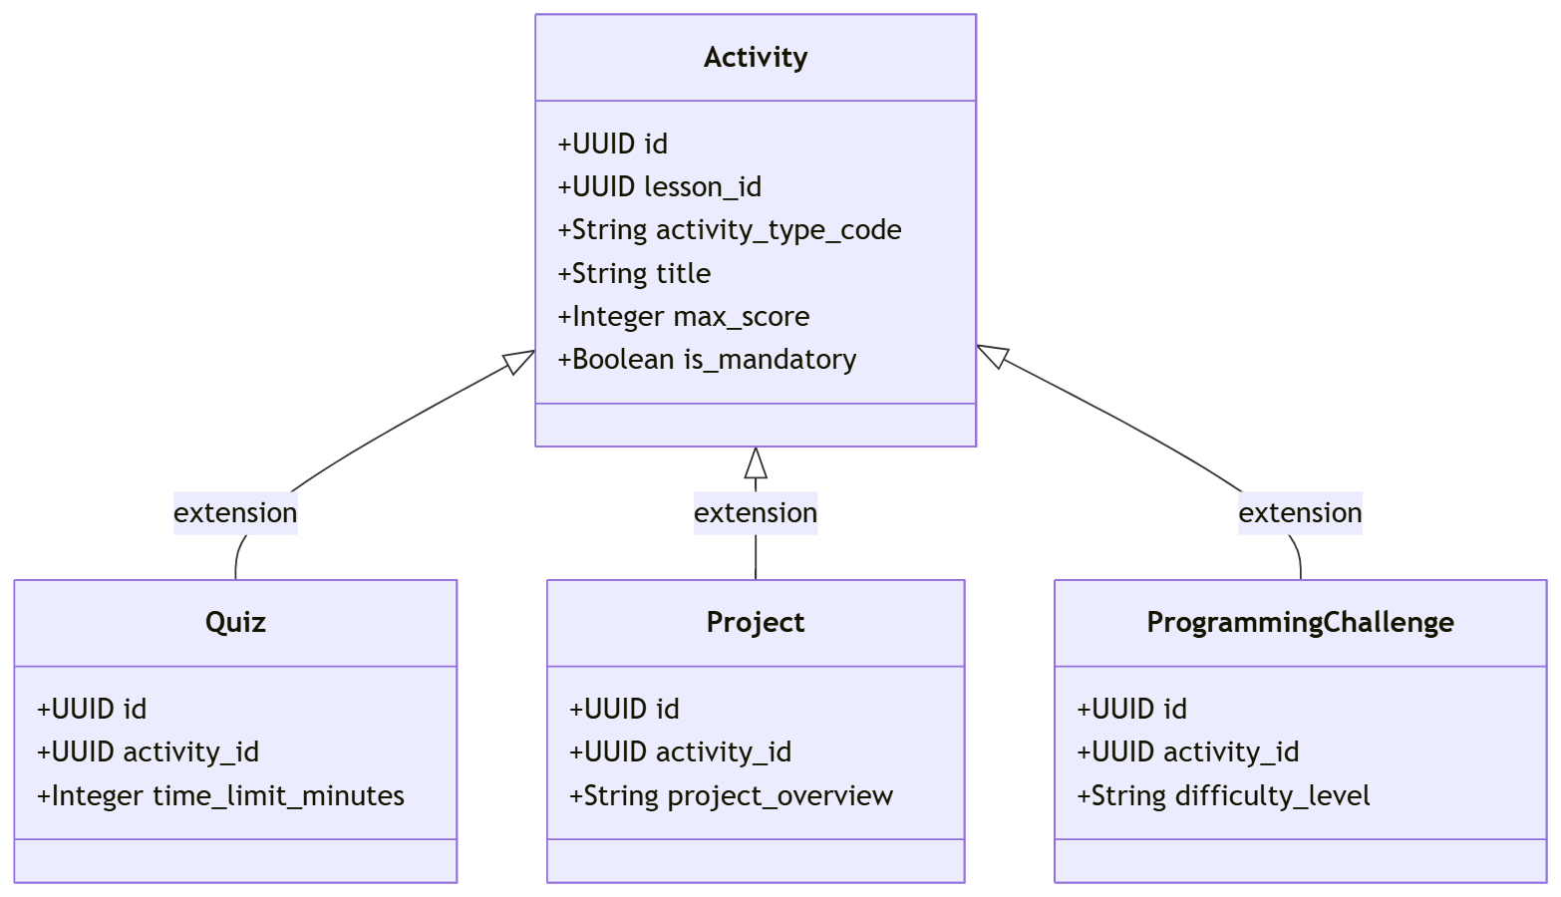

- `learning.activities`: Parent wrapper defining title, scoring limits, and schedules.
- `learning.activity_assignments`: Maps activities to cohorts.
- `learning.student_activity_progress`: Real-time state tracker (points scored, completion status).

CHAPTER 10 — QUIZ SYSTEM
Quizzes provide instant automated knowledge validation.

10.1 Table Outlines
- `learning.quizzes`: Holds settings like time limits, shuffle settings, and maximum attempts.
- `learning.quiz_questions`: Questions linked to a quiz (types: single_choice, multiple_choice, true_false, short_answer).
- `learning.quiz_options`: Answer options for choice questions.
- `learning.quiz_attempts`: Records student submissions and scores.
- `learning.quiz_answers`: Selected answers submitted during an attempt.

10.2 Quiz Workflow
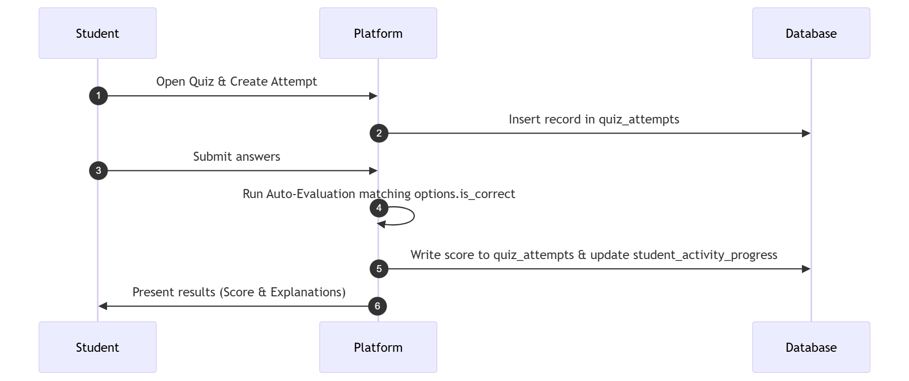

CHAPTER 11 — PROJECT SYSTEM
Projects evaluate larger practical development assignments, utilizing peer, trainer, or Git check verification steps.

11.1 Tables
- `learning.projects`: Contains the requirements, deliverables, templates, and instructions.
- `learning.project_submissions`: Student's submission record (stores GitHub repo link, deployment live URL, and student notes).
- `learning.project_reviews`: Review records containing score, feedback text, and status (pending, approved, rejected, revision_requested).

11.2 Project Submission Workflow
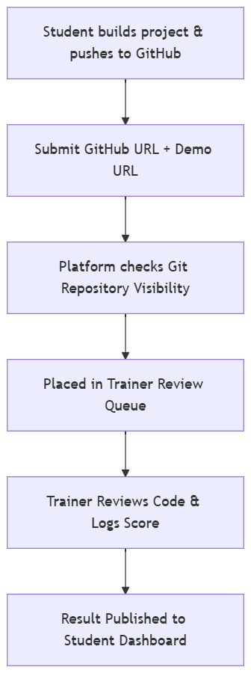

CHAPTER 12 — PROGRAMMING CHALLENGE SYSTEM
This acts as a LeetCode-style evaluation engine, where code submitted by a student is executed against test cases in an isolated environment.

12.1 Tables
- `learning.programming_challenges`: Problem description, starter template code, and run limits (time/memory).
- `learning.challenge_examples`: Sample inputs and outputs shown to the student.
- `learning.challenge_test_cases`: Inputs and expected outputs (includes hidden test cases used for final grading).
- `learning.challenge_submissions`: Stores the submitted code, language (javascript, python, etc.), and status.
- `learning.challenge_submission_results`: Grading totals (test cases passed/failed, run time, and points scored).
- `learning.challenge_test_case_results`: Performance metrics on individual test cases.
- `learning.challenge_execution_queue`: Queue entry managing execution scheduling.
- `learning.challenge_execution_logs`: Compiling and runtime errors.

12.2 Challenge Evaluation Flow
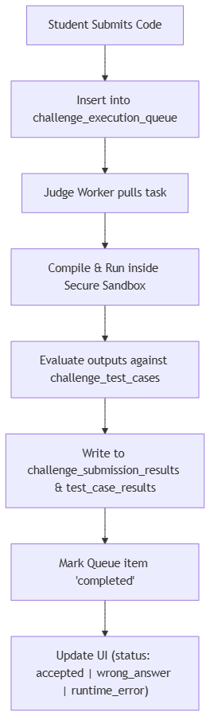

CHAPTER 13 — JUDGE ENGINE ARCHITECTURE
The Judge Engine executes untrusted student code safely, asynchronously, and accurately.

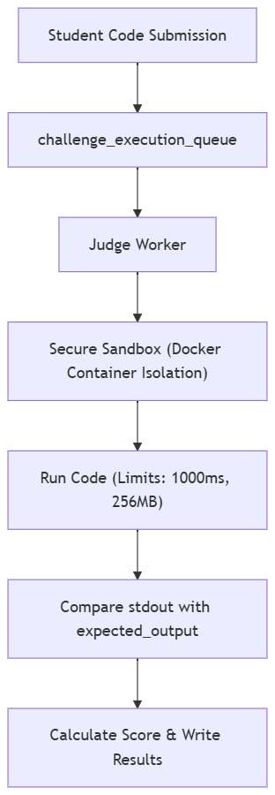

13.1 Key Architectural Components
1. The Queue: Uses challenge_execution_queue table rows as a message broker. Employs Postgres transactional locking (SELECT ... FOR UPDATE SKIP LOCKED) to coordinate multiple concurrent judge workers.
2. The Sandbox: Code executes inside isolated Docker containers. Network access is disabled to prevent database leaks or scraping.
3. Execution Limits: Execution terminates if it exceeds time_limit_ms (Time Limit Exceeded) or memory_limit_mb (Memory Limit Exceeded).
4. Result Processing: Results are compiled and updated in the database, triggering triggers that refresh the student's progress and career score metrics.

CHAPTER 14 — DASHBOARD ARCHITECTURE
Hynox Campus implements isolated, focused workspaces customized to four user personas:

14.1 Persona Access Flows
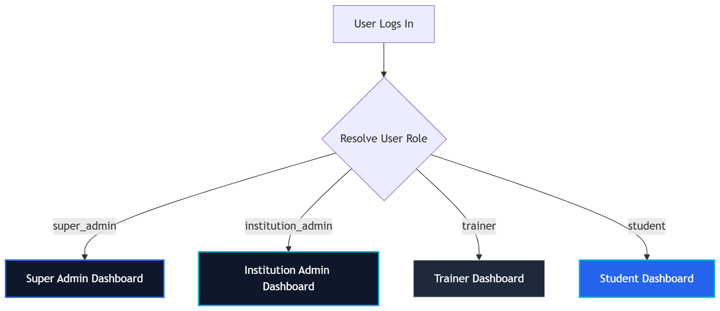

14.2 Dashboard Modules
- Super Admin Dashboard: Manage institutions, review system audit logs, and deploy global courses to the master Library.
- Institution Admin Dashboard: Provision trainers, create cohorts, import student spreadsheets, and track overall department placements.
- Trainer Dashboard: Review student github submissions, add learning activities (Quizzes/Projects), and view student progress.
- Student Dashboard: Course roadmaps, code playground, resume builder, placement prep utilities, and public portfolio.

CHAPTER 15 — STUDENT JOURNEY
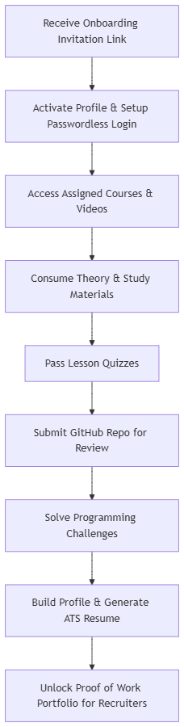

CHAPTER 16 — TRAINER JOURNEY
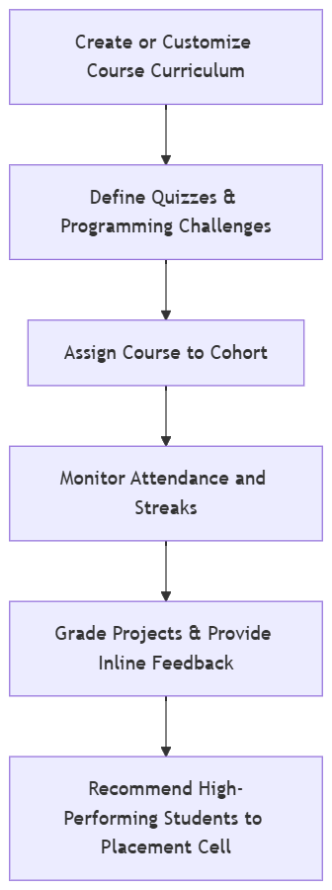

CHAPTER 17 — ADMIN JOURNEY
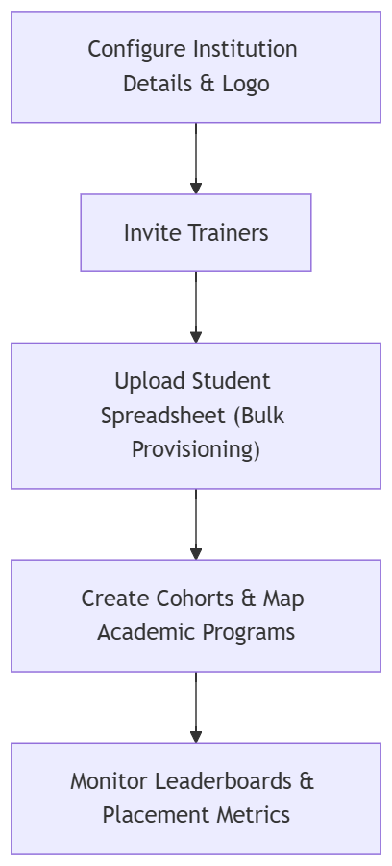

CHAPTER 18 — ROLE-BASED ACCESS MATRIX
Access is controlled via permissions mapped to user roles in core.role_permissions.

Permission / Functionality | Super Admin | Institution Admin | Trainer / Teacher | Student
Manage Institutions | ✅ | ❌ | ❌ | ❌
System-wide Audit Logs | ✅ | ❌ | ❌ | ❌
Publish Master Templates | ✅ | ❌ | ❌ | ❌
Provision Users & Trainers | ✅ | ✅ | ❌ | ❌
Configure Cohorts | ✅ | ✅ | ❌ | ❌
Edit Localized Courses | ✅ | ✅ | ✅ | ❌
Grade Submissions | ❌ | ❌ | ✅ | ❌
Attempt Quizzes & Labs | ❌ | ❌ | ❌ | ✅
Build Resumes | ❌ | ❌ | ❌ | ✅

CHAPTER 19 — DATABASE RELATIONSHIP DIAGRAMS
The relationships between schemas are mapped below to show how foreign key constraints maintain data integrity:

19.1 Core & Institution Relationships
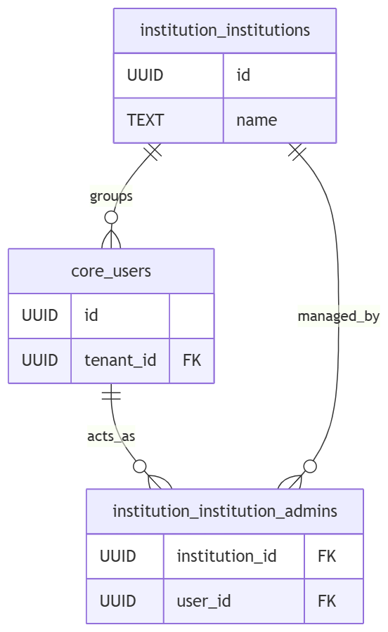

19.2 Academic, Delivery & Learning Connectors
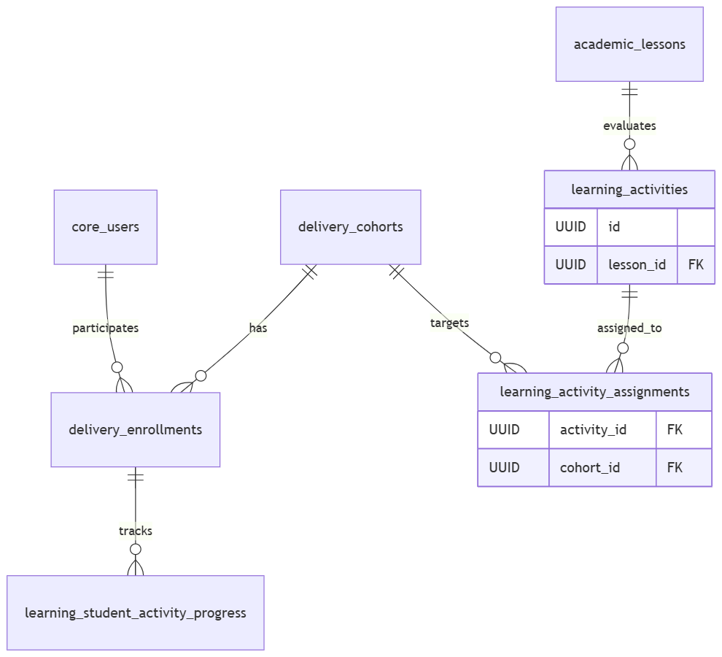

CHAPTER 20 — COMPLETE DATA FLOW
The diagram below details how data flows end-to-end through the platform—from initial tenant onboarding to master content duplication, active student completion, and placement dispatch:

