/\*------------------------------------------------------------------

Lab 1 Submission

Linked Lists -- Find max element and if list is in ascending order

Created by Hyo Lee

Student ID: 002292770

01/12/2016

-------------------------------------------------------------------\*/

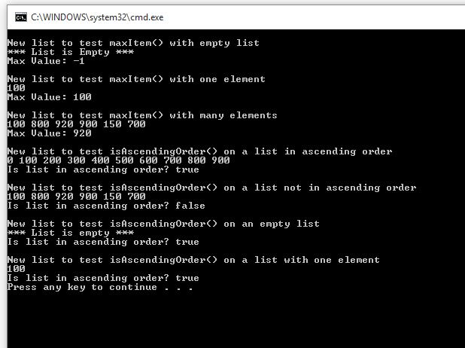

Tests 1 through 3 test the ElementType maxItem() function. The first test was run on an empty list which as required returns a message to notify the user that the list was empty and returns the max value as -1. The 2nd test was run on a list with 1 element which returns the one and only element in the list as the max value. The 3rd test was run on an unsorted list with multiple elements where it correctly returns the max value of 920.

Tests 4 through 7 test the bool is AscendingOrder() function. The 4th test was run on an ascending list from 0 – 900 where the list correctly returns true. The 5th test was run on an unsorted list with multiple values where it correctly returns false. The 6th test was run on an empty list and returns true. The last test was run on a list with one element of 100 and it too correctly returns true as required.