/\*---------------------------------------------------------------------

Programming Assignment 1 Submission

Linked Lists -- Asks a user to enter a text string and display the

Number of substrings that start with A and end with B.

Created by Hyo Lee

Student ID: 002292770

01/12/2016

----------------------------------------------------------------------\*/

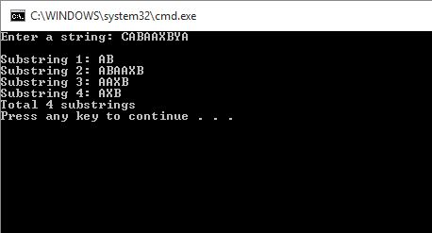

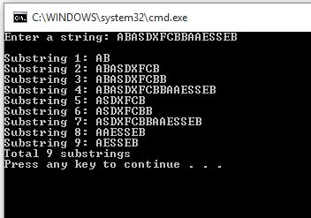

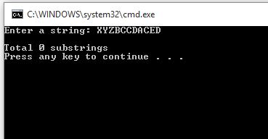

The 1st screenshot shows the same substrings output from the sample run provided to us. The 2nd screenshot is another example of correct substrings output with the string input of ABAXDXFCBBAAESSEB which correctly outputs 9 substrings. The 3rd screenshot uses the same string input XYZBCCDACED which produces 0 substrings because there are no ‘A’ chars followed by ‘B’ chars.