/\*---------------------------------------------------------------------

Lab 2 (a) Submission

Stacks -- Read a string from user input and reverse the sequence

of characters using stacks.

Created by Hyo Lee

Student ID: 002292770

01/19/2016

----------------------------------------------------------------------\*/

Screenshot 1 shows the same results as the example in the Lab write up.

CSUMB is entered and the output correctly displays in reverse as BMUSC.

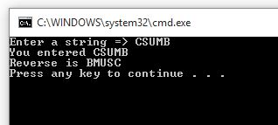

Screenshot 2 shows several words separated by a space and other characters.

