/\*------------------------------------------------------------------------------------

Lab 6 Submission

Searching - Search for user input number using Linear search and Iterative and Binary

search functions.

Created by Hyo Lee

Student ID: 002292770

02/16/2016

-------------------------------------------------------------------------------------\*/

Linear Search function with Input: { 4, 2, 10, 13, 2, 5, 6, 1, 0, -3 } correctly locates last element -3.

Iterative Binary Search function with Input: { 2, 4, 5, 7, 13, 14, 15, 23 } correctly locates last element 23.

Recursive Binary Search function with Input: { 2, 4, 5, 7, 13, 14, 15, 23 } correctly locates first element 2.

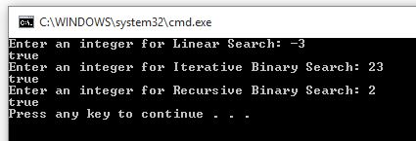

Linear Search function with Input: { 4, 2, 10, 13, 2, 5, 6, 1, 0, -3 } correctly returns false for search value: 55.

Iterative Binary Search function with Input: { 2, 4, 5, 7, 13, 14, 15, 23 } correctly returns false for search value: 55.

Recursive Binary Search function with Input: { 2, 4, 5, 7, 13, 14, 15, 23 } correctly returns false for search value: 55.

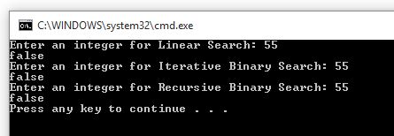

User input validation correctly accepts only integer values.

