/\*------------------------------------------------------------------------------------

Programming Assignment 6 Submission

Sorting Algorithm 2 - The CoolSort function sorts an array in ascending order

at time complexity O(n^3/2) by sorting at varying step sizes.

Created by Hyo Lee

Student ID: 002292770

02/16/2016

-------------------------------------------------------------------------------------\*/

Input array [62 83 18 53 07 17 95 86 47 69 25 28] correctly sorted at step size H = [5].

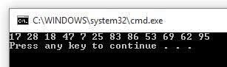

Input array [62 83 18 53 07 17 95 86 47 69 25 28] correctly sorted at step size H = [5, 3].

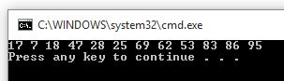

Input array [62 83 18 53 07 17 95 86 47 69 25 28] correctly sorted at step size H = [5, 3, 1].

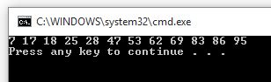

Sample test case 1, Input array [2, 5, 6, 4, 10, 9, 8, 1, 10, 5] correctly sorted at step size H = [5].

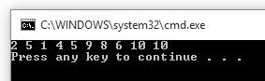

Sample test case 1, Input array [2, 5, 6, 4, 10, 9, 8, 1, 10, 5] correctly sorted at step size H = [5, 3]. (No change)

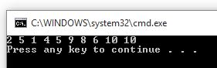

Sample test case 1, Input array [2, 5, 6, 4, 10, 9, 8, 1, 10, 5] correctly sorted at step size H = [5, 3, 1].

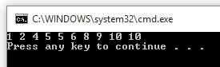

Sample test case 2, Input array [2, 5, 9, 4, 10, 7, 8, 1, 11, 5] correctly sorted at step size H = [5].

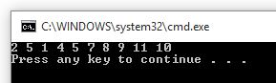

Sample test case 2, Input array [2, 5, 9, 4, 10, 7, 8, 1, 11, 5] correctly sorted at step size H = [5, 2].

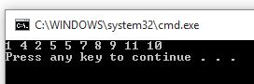

Sample test case 2, Input array [2, 5, 9, 4, 10, 7, 8, 1, 11, 5] correctly sorted at step size H = [5, 2, 1].

