/\*------------------------------------------------------------------------------------

Programming Assignment 6 Submission

Binary Search Trees - Use recursion to search, order, and count the nodes in a

Binary Search Tree.

Created by Hyo Lee

Student ID: 002292770

02/23/2016

-------------------------------------------------------------------------------------\*/

Input: 50, 20, 10, 30, 60, 80, 70

The output correctly uses the search()/searchAux() functions recursively and returns “Found” if the node is located in the BST. The functions also correctly output “Not Found” if the node is not in the BST. After the user is finished searching, the inOrder()/inOrderAux() & preOrder()/preOrderAux() functions recursively traverse the BST and output the nodes InOrder and PreOrder. Finally, the nodeCount()/nodeCoutAux() functions recursively traverse and output the total count of the nodes in the BST.

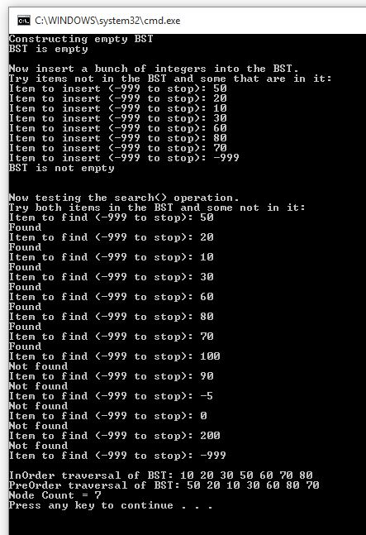

Sample run with empty tree.

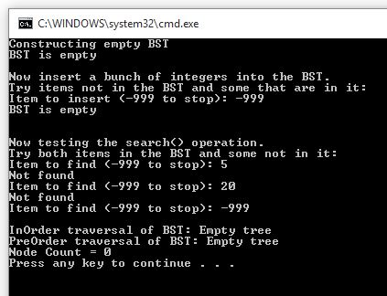

Sample run with one Root Node.

