PHW2

고효진 - 안세훈 - 안정우 - 허서윤

**1. Source Code**

| import numpy as np  import pandas as pd  import matplotlib.pyplot as plt  from matplotlib import cm  from sklearn.preprocessing import MinMaxScaler  from sklearn.preprocessing import StandardScaler  from sklearn.preprocessing import RobustScaler  from sklearn.preprocessing import MaxAbsScaler  from sklearn.preprocessing import LabelEncoder  from sklearn.preprocessing import OneHotEncoder  from sklearn.cluster import KMeans  from sklearn.cluster import DBSCAN  from sklearn.cluster import MeanShift  from sklearn.mixture import GaussianMixture  from sklearn.cluster import estimate_bandwidth  from pyclustering.cluster.clarans import clarans;  from sklearn.metrics.cluster import homogeneity_score, completeness_score, v_measure_score  from sklearn import metrics  from sklearn.metrics import silhouette_score  from sklearn.metrics import silhouette_samples  from sklearn.model_selection import GridSearchCV  from sklearn.neighbors import NearestNeighbors  from kneed import KneeLocator  import warnings  warnings.filterwarnings(action='ignore')  # Preprocessing  def findMissingValue(df):  # check missing value  # only 'totla_bedrooms' has missing values, fill median  df.total_bedrooms.fillna(df.total_bedrooms.median(), inplace=True)  return df  # function for set hyper parameters and run find_best  def setCombination():  # Scaler List  standard = StandardScaler()  minMax = MinMaxScaler()  robust = RobustScaler()  maxAbs = MaxAbsScaler()  scalers = {"standard scaler": standard, "minMax scaler": minMax, "robust scaler": robust, "maxAbs scaler": maxAbs}  # Encoder List  label = LabelEncoder()  oneHot = OneHotEncoder()  encoders = {"label encoder": label, "one-hot encoder": oneHot}  # Model List  kmeans = KMeans()  gmm = GaussianMixture()  dbscan = DBSCAN()  meanshift = MeanShift()  models = {"kmeans": kmeans,  #"clarans": [],  "gmm": gmm,  "dbscan": dbscan,  "meanshift": meanshift  }  # Parameters  params_dict = {"kmeans": {"n_clusters": [x for x in range(3, 5)]},  "gmm": {"n_components": [x for x in range(3, 5)]},  "dbscan": {"eps": [0.1, 0.5]},  "meanshift": {"bandwidth": [1, 2]}  }  return scalers, encoders, models, params_dict  def knee_method(X):  nearest_neighbors = NearestNeighbors(n_neighbors=11)  neighbors = nearest_neighbors.fit(X)  distances, indices = neighbors.kneighbors(X)  distances = np.sort(distances[:, 10], axis=0)  fig = plt.figure(figsize=(5, 5))  plt.plot(distances)  plt.xlabel("Points")  plt.ylabel("Distance")  plt.savefig("Distance_curve.png", dpi=300)  plt.title("Distance curve")  plt.show()  i = np.arange(len(distances))  knee = KneeLocator(i, distances, S=1, curve='convex', direction='increasing', interp_method='polynomial')  fig = plt.figure(figsize=(5, 5))  knee.plot_knee()  plt.xlabel("Points")  plt.ylabel("Distance")  plt.show()  print(distances[knee.knee])  def purity_scorer(target, y_pred):  contingency_matrix = metrics.cluster.contingency_matrix(target, y_pred)  score = np.sum(np.amax(contingency_matrix, axis=0)) / np.sum(contingency_matrix)  def silhouette_scorer(estimator, X):  labels = estimator.fit_predict(X)  score = silhouette_score(X, labels, metric='euclidean')  return score  def display_silhouette_plot(X, labels):  sil_score = metrics.silhouette_score(X, labels, metric='euclidean')  n_clusters_ = len(set(labels)) - (1 if -1 in labels else 0)  print("For n_clusters =", n_clusters_, "The average silhouette score is :", sil_score)  # compute the silhouette scores for each sample  sample_silhouette_values = silhouette_samples(X, labels)  fig, ax1 = plt.subplots()  fig.set_size_inches(18, 7)  ax1.set_xlim([-0.1, 1])  ax1.set_ylim([0, len(X) + (n_clusters_ + 1) * 10])  y_lower = 10  for i in range(n_clusters_):  ith_cluster_silhouette_values = sample_silhouette_values[labels == i]  ith_cluster_silhouette_values.sort()  size_cluster_i = ith_cluster_silhouette_values.shape[0]  y_upper = y_lower + size_cluster_i  color = cm.nipy_spectral(float(i) / n_clusters_)  ax1.fill_betweenx(np.arange(y_lower, y_upper), 0, ith_cluster_silhouette_values, facecolor=color,  edgecolor=color, alpha=0.7)  ax1.text(-0.05, y_lower + 0.5 * size_cluster_i, str(i))  y_lower = y_upper + 10  ax1.set_title("The silhouette plot for the various clusters")  ax1.set_xlabel("The silhouette coefficient values")  ax1.set_ylabel("Cluster label")  ax1.axvline(x=sil_score, color="red", linestyle='--')  ax1.set_yticks([])  ax1.set_xticks([-0.1, 0, 0.2, 0.4, 0.6, 0.8, 1])  plt.suptitle(("Silhouette analysis for clustering on sample data with n_clusters = %d" % n_clusters_),  fontsize=14, fontweight='bold')  plt.show()  return sil_score  def featureCombination(df, index):  if index == 0:  feature = df[['housing_median_age', 'total_rooms', 'total_bedrooms']]  elif index == 1:  feature = df[['population', 'households', 'median_income']]  elif index == 2:  feature = df[['population', 'ocean_proximity']]  elif index == 3:  feature = df[['population', 'median_income']]  elif index == 4:  feature = df[['households', 'median_income']]  elif index == 5:  feature = df[['total_rooms', 'total_bedrooms']]  elif index == 6:  feature = df[['median_income', 'ocean_proximity']]  elif index == 7:  feature = df[['median_income', 'total_rooms']]  return feature  # function for store combination that has the best accuracy  def findBestCombination(df, scalers, encoders, models, params_dict):  best_combination = {}  best_score = 0  # Sample Data  for index in range(1):  X = featureCombination(df, index)  feature = X.columns.tolist()  print(f'\n[feature: {feature}]')  num_cols = X.select_dtypes(include=['int64', 'float64']).columns.to_list() # numerical value  cat_cols = X.select_dtypes(include=['object']).columns.to_list() # categorical value  # find the best parameter by using grid search  for scaler_key, scaler in scalers.items():  scaled_X = scaler.fit_transform(X[num_cols])  print(f'\n[scaler: {scaler_key}]')  # Label encoding if there are categorical values.  if 'ocean_proximity' in X.columns :  label=LabelEncoder()    encoded_X=label.fit_transform(X[cat_cols])  print(encoded_X)  encoded_X=encoded_X.reshape(-1,1)    # add encoded_x to scaled_x  scaled_X=np.concatenate((scaled_X, encoded_X), axis=1)  print(f'[encoder: label encoder]\n')  #print(scaled_X )  knee_method(scaled_X)  for model_key, model in models.items():  print(f'\n[model: {model_key}]')  cv = [(slice(None), slice(None))]  if (model_key == 'clarans'):  clarans_obj = clarans(scaled_X, 6, 3, 5)  clarans_obj.process()  clst = clarans_obj.get_clusters()  label = []  for i in range(len(clst)):  for j in clst[i]:  label.insert(j, i)  if (best_score < score):  best_score = score  best_X = scaled_X  best_label = label  target_dict = {'silhouette': score,  'scaler': scaler_key,  'model': model_key,  'param': {'n_cluster':6,'local minima':3},  'feature': feature  }      else: # Grid Search    grid = GridSearchCV(estimator=model,  param_grid=params_dict[model_key],  scoring=silhouette_scorer,  cv=cv)  grid.fit(scaled_X)  print(f'best_parameters: {grid.best_params_}')  score = grid.best_score_  if (best_score < score):  best_score = score  best_X = scaled_X  best_label = grid.best_estimator_    target_dict = {'silhouette': score,  'scaler': scaler_key,  'model': model_key,  'param': grid.best_params_,  'feature': feature  }    list_size = 10  list_size -= 1  flag = False  # save accuracy  if model_key not in best_combination.keys():  best_combination[model_key] = []  if len(best_combination[model_key]) <= list_size:  best_combination[model_key].append(target_dict)  # insert accuracy  elif best_combination[model_key][-1]['silhouette'] < score:  for i in range(1, list_size):  if best_combination[model_key][list_size - 1 - i]['silhouette'] > score:  best_combination[model_key].insert(list_size - i, target_dict)  best_combination[model_key].pop()  flag = True  break  if flag is False:  best_combination[model_key].insert(0, target_dict)  best_combination[model_key].pop()  print(f'silhouette score: {score}', end='')  print()  return best_combination, best_X, best_label  # read data  df = pd.read_csv("housing.csv")  # preprocessing  df = findMissingValue(df)  # set scalers, models, params, k values  scalers, encoders, models, params_dict = setCombination()  # get best combination dictionary  best_result, best_X, best_label = findBestCombination(df, scalers, encoders, models, params_dict)  print("\n\n-----------result-----------")  print("[Best Results]")  best_score = 0  for model_name, result_list in best_result.items():  print(model_name)  for result in result_list:  print(result)  if (best_score < result['silhouette']):  best_score = result['silhouette']  best_combi = result  print()  print("[Best Combination]")  print(best_combi)  display_silhouette_plot(best_X, best_label.fit_predict(best_X)) |
| --- |

**2. The structure of the program**

**<Used Functions>**

findMissingValue(df)

- drop NAN

- Split feature and target

- return drop_df, numerical data, categorical data

setCombination(X, y)

- set scaler list

- set encoder list

- set model list

- set parameters

- return scalers, encoders, models, pramas_dict

purity_scorer(target, labels)

- return purity score

silhouette_scorer(estimator, X)

- return silhouette score

dispaly_silhouette_plot(X, labels)

- display silhouette plot

- return silhouette score

featureCombination(df, index)

- select feature

- return selected_feature

findBestCombination(df, scalers, encoders, models, params_dict)

- find the best parameter by using grid search

- return best combination dictionary, best_score for silhouette, best_score for purity

**<Procedure (Main Function)>**

For in Features-> [N features]

For in Scalers -> [Standard Scaler, MinMax Scaler, Robust Scaler, MaxAbsScaler]

if there are categorical value, Label encoding

For in Models -> [kmeans, gmm, clarans, dbscan, meanshift

For in Parameters -> Grid Search(for each parameters)

test method **-> silhouette, purity**

Print best combination

**3. Output**

Result for each iteration(representative image)

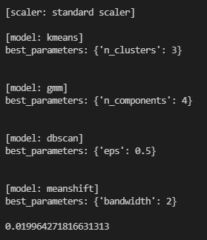

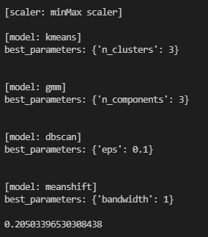

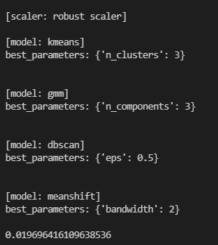

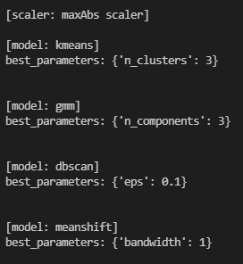

**Best result**

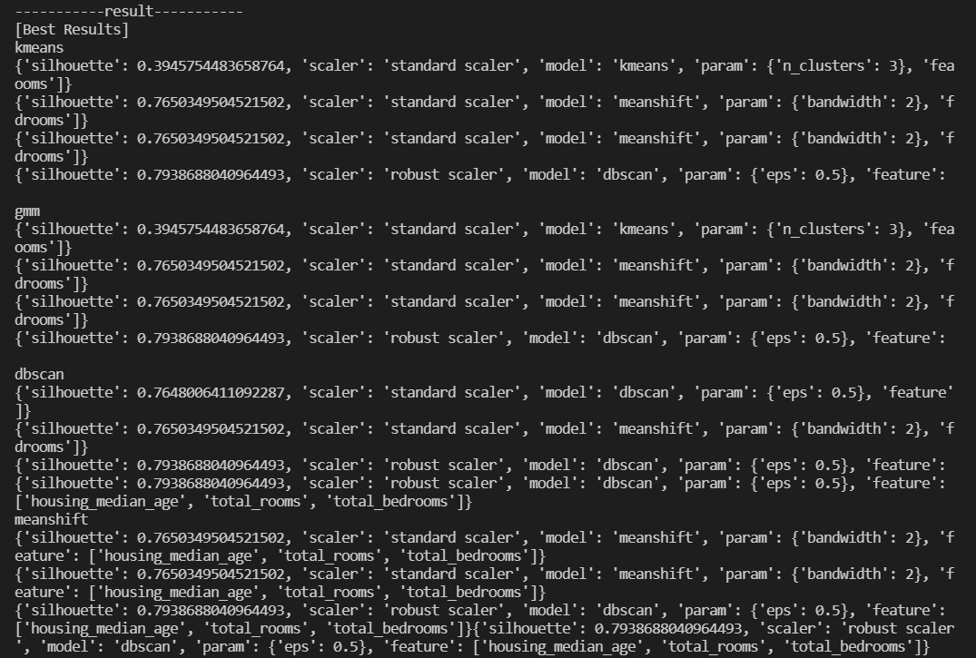



**silhouette score for best parameter**

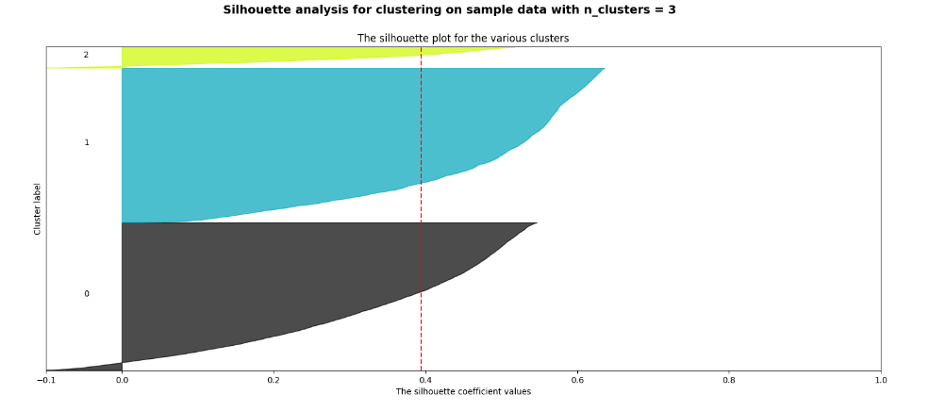

**Knee point**

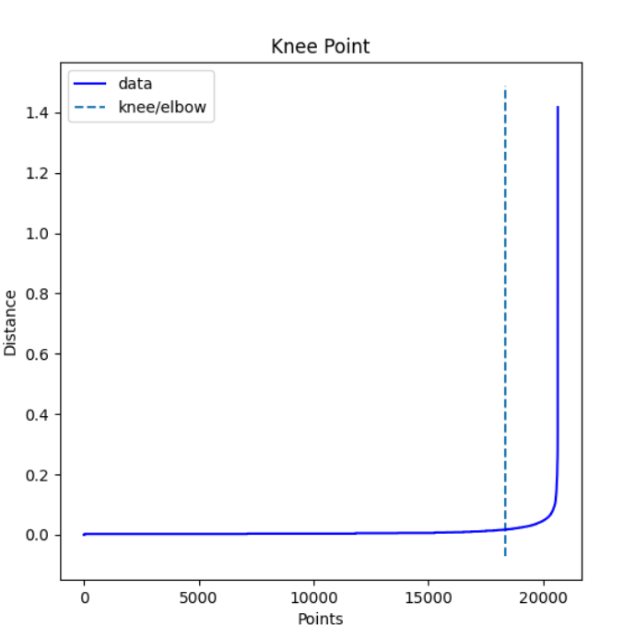

**4. Result**

Best combination feature is house_median_age, total_rooms, total_bedrooms. These are features related to **the condition of the house**. Best combination scaler is robust scaler, and clustering model is dbscan, param is 0.5. And cluster value is 2, average silhouette score is 0.7938688040964493.