# Threads test

1. Difficulty 0
   * 45 threads
   * 60 threads
   * 75 threads
   * 90 threads
2. Difficulty 3
   * 45 threads
   * 60 threads
   * 75 threads
   * 90 threads
3. Analysis

## 1. Difficulty 0

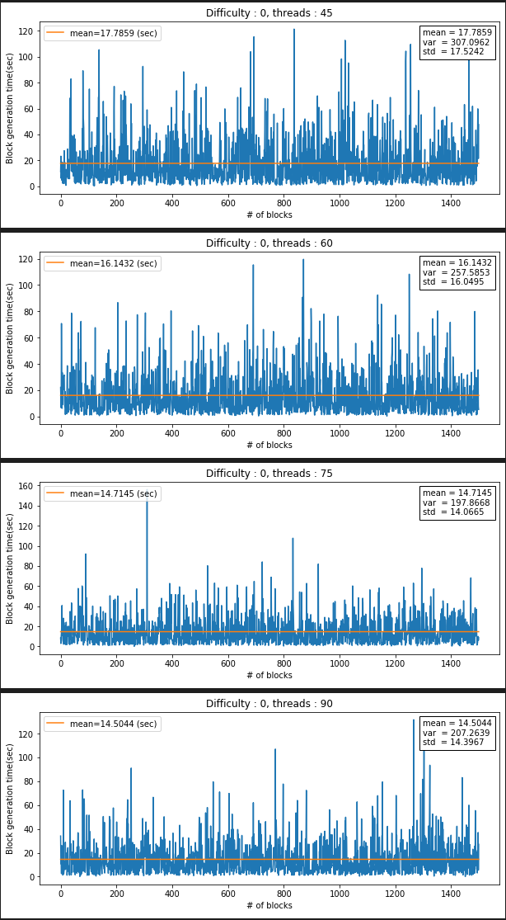

## 2. Difficulty 3

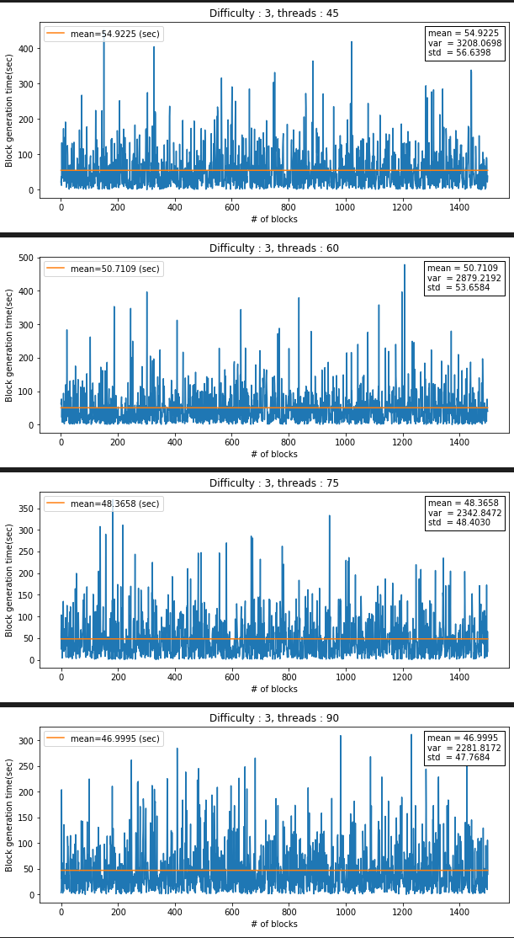

## 3. Analysis

### Difficulty 0

#### Probability distribution

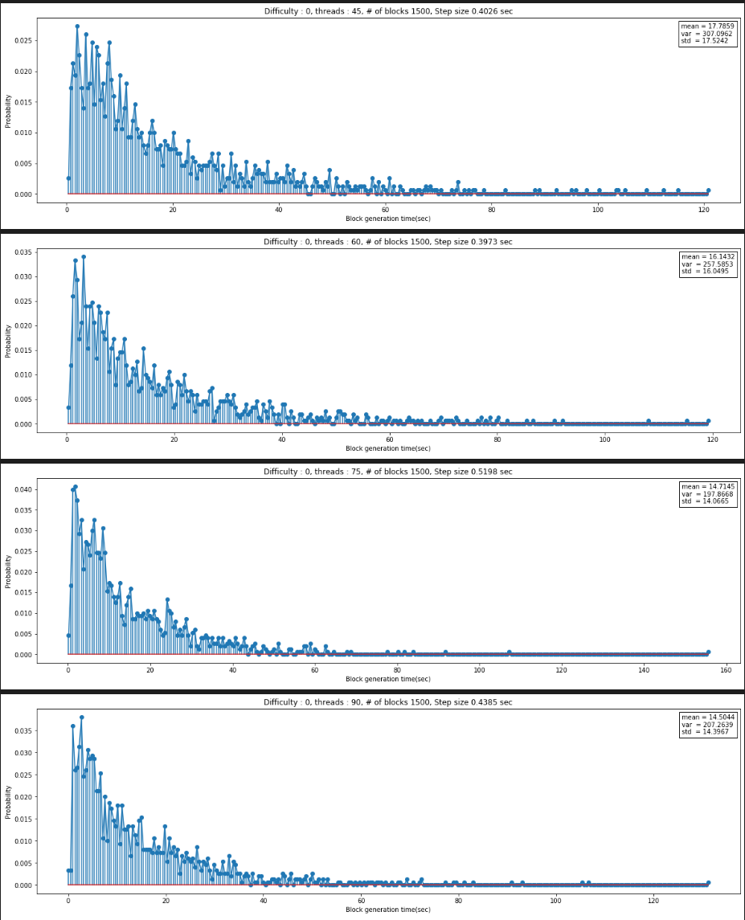

#### Moving average

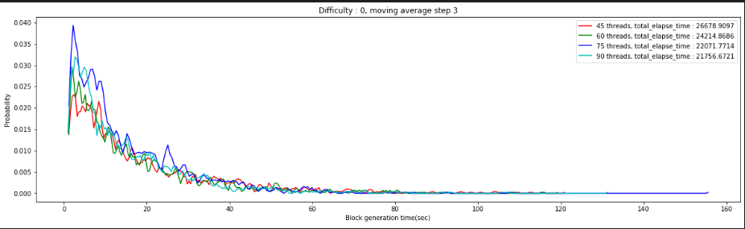

#### Cumulative distribution

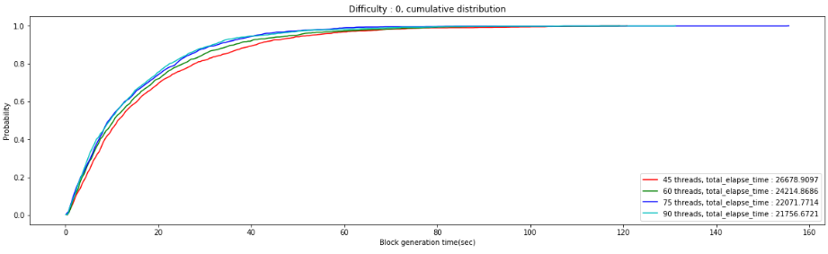

#### Log distribution with regression

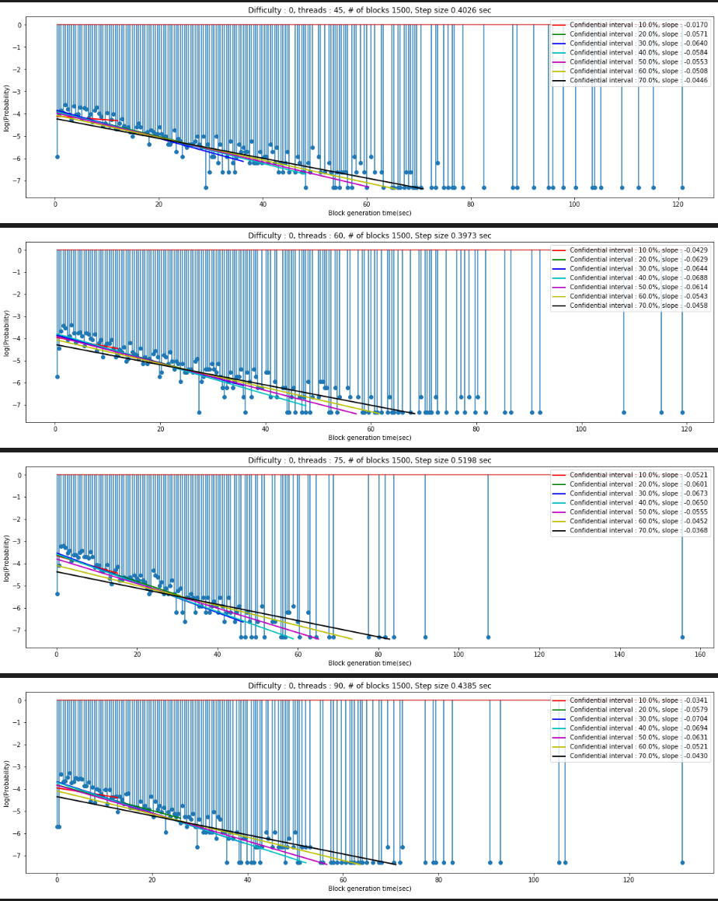

### Difficulty 3

#### Probability distribution

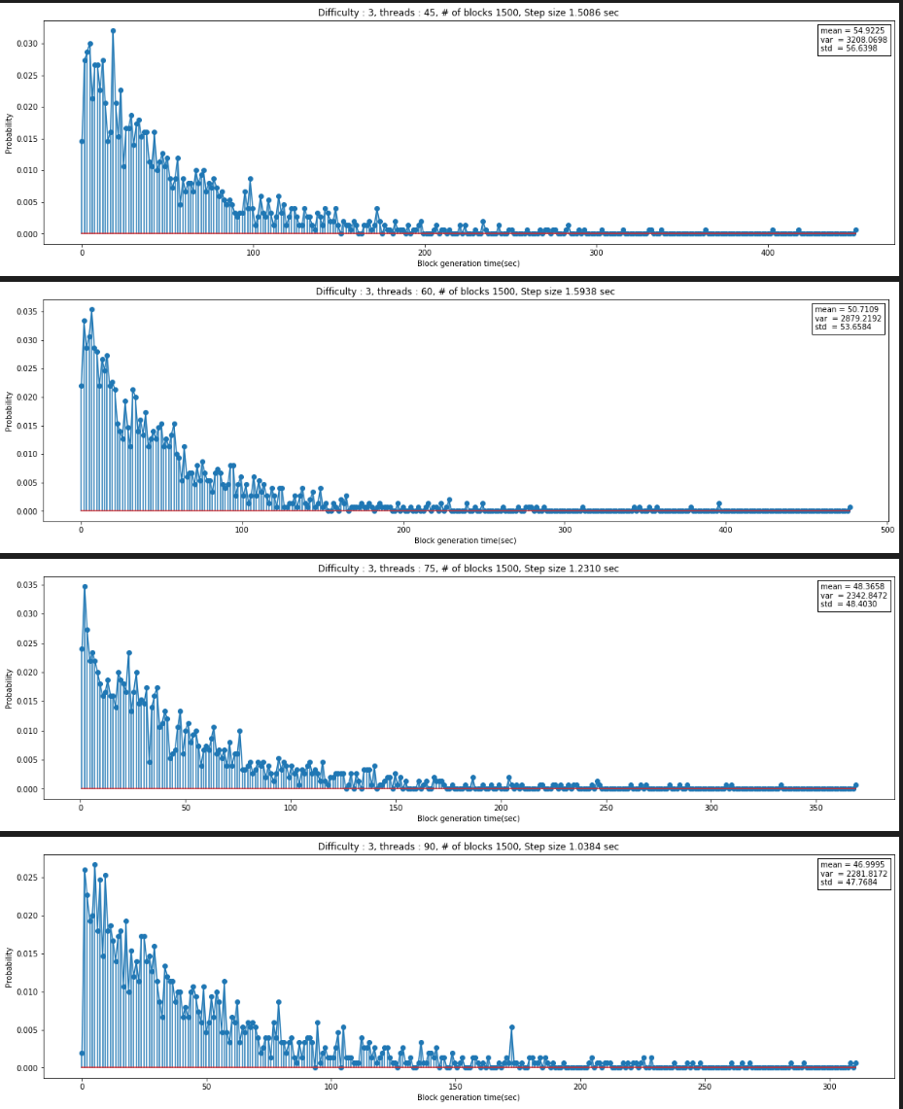

#### Moving average

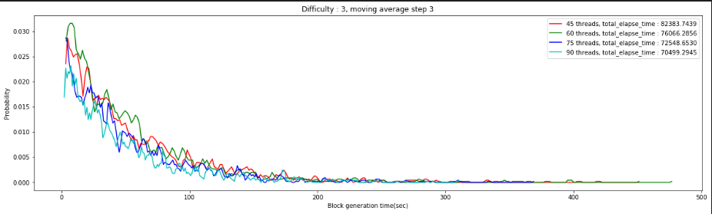

#### Cumulative distribution

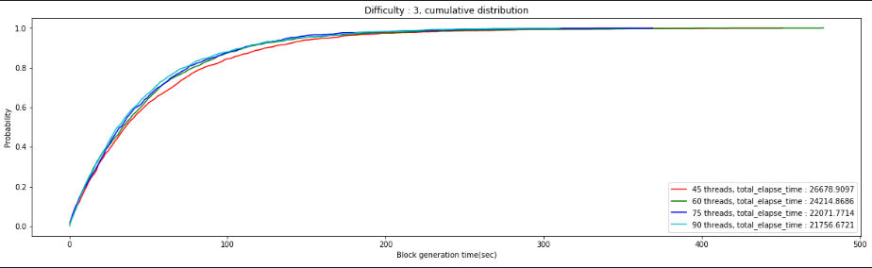

#### Log distribution with regression

