**UNIVERSIDAD DE INGENIERÍA Y TECNOLOGÍA**



**Curso:**

Arquitectura de computadoras’

Laboratorio 02

Estudiante:

Chavez Zapata, Lenin Gerardo

Profesora:

Adanaqué Infante, Luz Antuanet

Lima, 16 de septiembre de 2023

**Question 1:**

Waveform: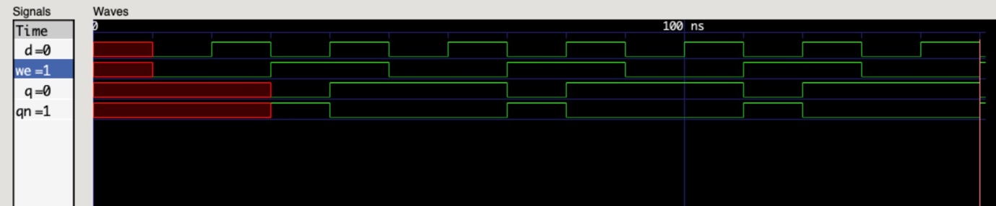

Table:

|  |  |  |
| --- | --- | --- |
| / | Analysis | Synthesis |
| Cells | 5 | 6 |
| Ports | 4 | 4 |
| Nets | 8 | 8 |

**Question 2:**

Waveform:

RTL schematic:

Table:

|  |  |  |
| --- | --- | --- |
| / | Analysis | Synthesis |
| Cells | 3 | 7 |
| Ports | 4 | 4 |
| Nets | 6 | 9 |

**Question 3:**

RTL schematic:

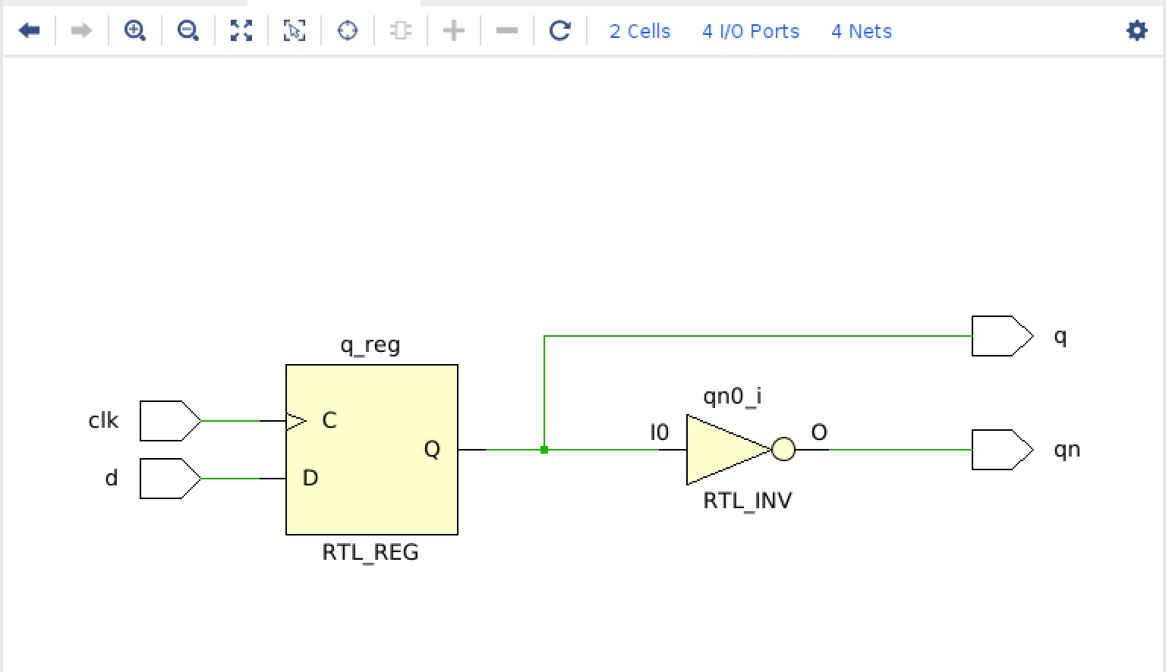

Table:

|  |  |  |
| --- | --- | --- |
| / | Analysis | Synthesis |
| Cells | 2 | 7 |
| Ports | 4 | 4 |
| Nets | 4 | 11 |

**Question 4:**

**Behavioral:**

RTL schematic:

Table:

|  |  |  |
| --- | --- | --- |
| / | Analysis | Synthesis |
| Cells | 4 | 11 |
| Ports | 6 | 6 |
| Nets | 6 | 15 |

**Structural:**

RTL schematic:

Table:

|  |  |  |
| --- | --- | --- |
| / | Analysis | Synthesis |
| Cells | 4 | 22 |
| Ports | 6 | 6 |
| Nets | 6 | 24 |

Implementación en la Basys3:

