ARMY PUBLIC SCHOOL BHOPAL

AI PROJECT LOGBOOK
HARVESTSIGHT
2026 – 2027
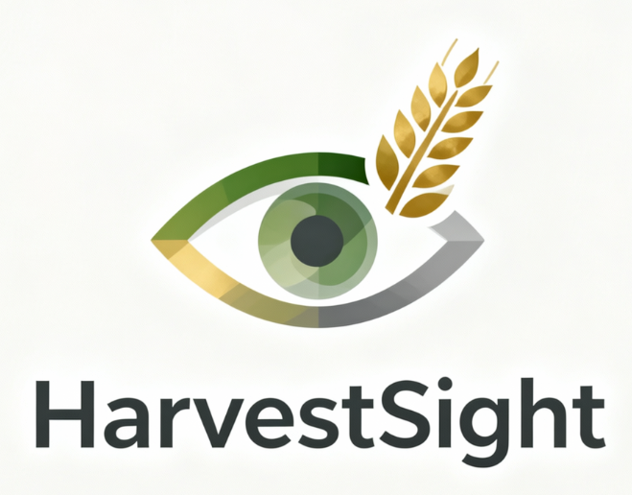

- INTRODUCTION

HarvestSight is an early-warning artificial intelligence system built to predict whether a regional crop harvest is heading toward failure, using sequential weather patterns and soil metrics rather than static seasonal summaries.
Its defining strength is architectural honesty: The ENTIRE Neural Network, The Linear Algebra, The Calculus, the BackPropagation Through Time learning algorithm is hand-coded in raw Python and NumPy, with no reliance on TensorFlow, PyTorch, or any black-box framework. Trained on real NASA satellite data, ISRIC SoilGrids records, and Indian Government yield archives, HarvestSight demonstrates that mathematically transparent deep learning can meaningfully address climate action and food security.

- TEAM ROLES

TEAM MEMBER NAME | ROLES | ROLES DESCRIPTION
SATYAM PATHAK | Data Analyst | Analyzes datasets to uncover trends and actionable insights.
SATYAM PATHAK | Data Researcher | Investigates the gathered information to build datasets.
ABHAY | UI/UX Designer | Crafts the visual layout and interactive user experience.
ABHAY | Video Editor | Cuts and assembles raw footage into a finished video.
CHIRANJEEVI NAYAK | Log Book Maintainer | Accurately records daily activities, metrics, and system events.
CHIRANJEEVI NAYAK | Code Tester | Hunts for bugs and glitches to ensure software quality.
ADITYA MOHAPATRA | Coder & Leader | Writes and maintains the source code that runs applications.
  - Timeline of the Project

Phase | Task | Planned start date | Planned end date | Planned duration | Actual start date | Actual end date | Actual duration | The Doer | Notes and Remarks
Preparing for the project | Coursework and reading | 01/06/2026 09:00 AM | 07/06/2026 05:00 PM | 6 days 8 hrs | 09/06/2026 09:00 AM | 14/06/2026 05:00 PM | 5 days 8 hrs | All Team Members | Completed by all
Preparing for the project | Set up a team folder on a shared drive | 05/06/2026 10:00 AM | 06/06/2026 06:00 PM | 1 days 8 hrs | 16/06/2026 10:00 AM | 17/06/2026 06:00 PM | 1 day | Leader | Access given to members
Defining the problem | Background reading | 08/06/2026 09:00 AM | 14/06/2026 05:00 PM | 6 days 8 hrs | 18/06/2026 09:00 AM | 24/06/2026 05:00 PM | 6 days 8 hrs | Team Members | Done
Defining the problem | Research issues in our community | 15/06/2026 09:00 AM | 21/06/2026 05:00 PM | 6 days 8 hrs | 23/06/2026 09:00 AM | 28/06/2026 05:00 PM | 5 days 8 hrs | Team Members | Done
Defining the problem | Team meeting to discuss issues and select an issue for the project | 22/06/2026 11:00 AM | 23/06/2026 04:00 PM | 1 days 5 hrs | 05/07/2026 11:00 AM | 05/07/2026 04:00 PM | 5 hrs | Team Members | Done
Defining the problem | Complete section 3 of the Project logbook | 24/06/2026 09:00 AM | 27/06/2026 06:00 PM | 3 days 9 hrs | 01/07/2026 09:00 AM | 03/07/2026 06:00 PM | 5 days | Leader | Completed
Understanding the users | Identify users | 01/07/2026 09:00 AM | 04/07/2026 05:00 PM | 3 days 8 hrs | 08/07/2026 09:00 AM | 11/07/2026 05:00 PM | 3 days 8 hrs | Data Analyst | Found the right users
Understanding the users | Meeting with users to observe them | 05/07/2026 10:00 AM | 10/07/2026 04:00 PM | 5 days 6 hrs | 18/07/2026 10:00 AM | 23/07/2026 04:00 PM | 5 days 6 hrs | Data Analyst & Leader | Collected Info about the work
Understanding the users | Interview with user (1) | 11/07/2026 10:00 AM | 12/07/2026 12:00 PM | 1 days 2 hrs | 25/07/2026 10:00 AM | 27/07/2026 12:00 PM | 2 days 2 hrs | Data Analyst | Found the needs
Understanding the users | Interview with user (2) | 13/07/2026 02:00 PM | 14/07/2026 04:00 PM | 1 days 2 hrs | 20/07/2026 02:00 PM | 21/07/2026 04:00 PM | 1 days 2 hrs | Data Analyst | Found Common issues
Understanding the users | Complete section 4 of the Project logbook | 15/07/2026 09:00 AM | 18/07/2026 06:00 PM | 3 days 9 hrs | 28/07/2026 09:00 AM | 01/08/2026 06:00 PM | 4 days 9 hrs | Leader | Completed

Brainstorming | Team meeting to generate ideas for a solution | 01/09/2026 10:00 AM | 04/09/2026 04:00 PM | 3 days 6 hrs | 11/09/2026 10:00 AM | 15/09/2026 04:00 PM | 4 days 6 hrs | Leader | 2 Members joined
Brainstorming | Complete section 5 of the Project logbook | 05/09/2026 09:00 AM | 07/09/2026 06:00 PM | 2 days 9 hrs | 13/09/2026 09:00 AM | 14/09/2026 06:00 PM | 1 days 9 hrs | Leader | Completed
Designing your solution | Team meeting to design the solution | 09/09/2026 10:00 AM | 13/09/2026 05:00 PM | 4 days 7 hrs | 21/09/2026 10:00 AM | 26/09/2026 05:00 PM | 5 days 7 hrs | All Team Members | Made the Designs
Designing your solution | Complete section 6 of the logbook | 14/09/2026 09:00 AM | 17/09/2026 06:00 PM | 3 days 9 hrs | 25/09/2026 09:00 AM | 27/09/2026 06:00 PM | 2 days 9 hrs | Leader | Completed
Collecting and preparing data | Team meeting to discuss data requirements | 19/09/2026 11:00 AM | 21/09/2026 03:00 PM | 2 days 4 hrs | 02/10/2026 11:00 AM | 03/10/2026 03:00 PM | 1 days 4 hrs | Data Analyst | Discussed on APIs from NASA & ISRO
Collecting and preparing data Prototyping | Data collection | 22/09/2026 09:00 AM | 28/09/2026 06:00 PM | 6 days 9 hrs | 03/10/2026 09:00 AM | 10/10/2026 06:00 PM | 7 days | Data Analyst | Collected APIs
Collecting and preparing data Prototyping | Data Preparation & Labelling | 29/09/2026 09:00 AM | 04/10/2026 06:00 PM | 5 days 9 hrs | 09/10/2026 09:00 AM | 13/10/2026 06:00 PM | 4 days 9 hrs | Coder | Completed
Collecting and preparing data Prototyping | Complete Section 6 of the Project logbook | 05/10/2026 09:00 AM | 07/10/2026 06:00 PM | 2 days 9 hrs | 12/10/2026 09:00 AM | 14/10/2026 06:00 PM | 2 days 9 hrs | Leader | Completed
Collecting and preparing data Prototyping | Team meeting to plan prototyping phase | 08/10/2026 10:00 AM | 09/10/2026 04:00 PM | 1 days 6 hrs | 19/10/2026 10:00 AM | 19/10/2026 04:00 PM | 6 hrs | All Team Members | Completed
Prototyping Testing | Train your model with input dataset | 10/10/2026 09:00 AM | 14/10/2026 06:00 PM | 4 days 9 hrs | 20/10/2026 09:00 AM | 23/10/2026 06:00 PM | 3 days 9 hrs | Coder & Tester | Tested several scores
Prototyping Testing | Test your model and keep training with more data until you think your model is accurate | 15/10/2026 09:00 AM | 19/10/2026 06:00 PM | 4 days 9 hrs | 28/10/2026 09:00 AM | 02/11/2026 06:00 PM | 5 days 9 hrs | Tester | Reviewed Several Tests and few conclusions
Prototyping Testing | Write a program to initiate actions based on the result of your model | 20/10/2026 09:00 AM | 23/10/2026 06:00 PM | 3 days 9 hrs | 03/11/2026 09:00 AM | 07/11/2026 06:00 PM | 4 days 9 hrs | Coder | No Sufficient Program was build due to limitations of data
Prototyping Testing | Complete section 8 of the Project Logbook | 24/10/2026 09:00 AM | 26/10/2026 06:00 PM | 2 days 9 hrs | 02/11/2026 09:00 AM | 05/11/2026 06:00 PM | 3 days 9 hrs | Leader | Completed

 | Team meeting to discuss testing time | 28/10/2026 10:00 AM | 28/10/2026 03:00 PM | 5 hrs | 08/11/2026 10:00 AM | 08/11/2026 12:00 PM | 2 hrs | Leader | Completed
Testing Creating the video | Invite users to test your prototype | 29/10/2026 09:00 AM | 29/10/2026 05:00 PM | 8 hrs | 07/11/2026 09:00 AM | 07/11/2026 05:00 PM | 8 hrs | Data Analyst | Invited users and tested on grounds
Testing Creating the video | Conduct testing with users | 30/10/2026 09:00 AM | 31/10/2026 06:00 PM | 1 days 9 hrs | 08/11/2026 09:00 AM | 11/11/2026 06:00 PM | 3 days 9 hrs | Data Analyst | Several Errors came
Testing Creating the video | Complete section 9 of the Project Logbook | 31/10/2026 09:00 AM | 31/10/2026 06:00 PM | 9 hrs | 13/11/2026 09:00 AM | 14/11/2026 06:00 PM | 1 days 9 hrs | Leader | Completed
Testing Creating the video | Team meeting to discuss video creation | 31/10/2026 10:00 AM | 31/10/2026 01:00 PM | 3 hrs | 07/11/2026 10:00 AM | 07/11/2026 01:00 PM | 3 hrs | Leader | Discussion Held at Google Meet
Testing Creating the video | Write your script | 31/10/2026 02:00 PM | 31/10/2026 06:00 PM | 4 hrs | 07/11/2026 02:00 PM | 08/11/2026 06:00 PM | 1 days 4 hrs | Leader | Completed
Testing Creating the video | Film your video | 31/10/2026 09:00 AM | 31/10/2026 06:00 PM | 9 hrs | 13/11/2026 09:00 AM | 14/11/2026 06:00 PM | 1 days 9 hrs | Video Editor | Completed
Testing Creating the video | Edit your video | 31/10/2026 09:00 AM | 31/10/2026 08:00 PM | 11 hrs | 08/11/2026 09:00 AM | 08/11/2026 08:00 PM | 11 hrs | Video Editor | Completed
Completing the logbook | Reflect on the project with your team | 31/10/2026 10:00 AM | 31/10/2026 01:00 PM | 3 hrs | 12/11/2026 10:00 AM | 12/11/2026 01:00 PM | 3 hrs | All Team Members | Reflected and Proposed new ideas
Completing the logbook | Complete sections 10 and 11 of the Project Logbook | 31/10/2026 02:00 PM | 31/10/2026 06:00 PM | 4 hrs | 14/11/2026 02:00 PM | 16/11/2026 06:00 PM | 2 days 4 hrs | Leader | Completed
Completing the logbook | Review your Project logbook and Video | 31/10/2026 06:00 PM | 31/10/2026 09:00 PM | 3 hrs | 14/11/2026 06:00 PM | 14/11/2026 09:00 PM | 3 hrs | All Team Members | Reviewed all footage and Documents
Submission | Submit your entries on IBM | 31/10/2026 09:00 PM | 31/10/2026 11:59 PM | 2 hrs | 11/11/2026 09:00 PM | 11/11/2026 11:59 PM | 2 hrs | Leader | Submitted

  - Communication Plans

Q1. Will you meet face-to-face, online or a mixture of each to communicate?
A1. Both online and offline means will be used to communicate to each other.
Q2. How often will you come together to share your progress?
A2. Our team will be using Google Docs and Google sheets to share our progress to
each other, discuss and update our timeline from the same.
Q3. Who will set up online documents and ensure that everyone is contributing?
A3. The team leader and the Log Book Maintainer.
Q4. What tools will you use for communication?
A4. Google Meet and WhatsApp group will be primarily used to communicate
online.

  - Team Meeting Minutes

Date of meeting: 18th August, 2026
Who attended: Aditya, Abhay, Satyam, Chiranjeevi
Who wasn’t able to attend: N/A
Purpose of meeting: Task Division & Role Assignments

Items discussed:
1. Assigning Roles to every member and explaining their tasks
2. Division of tasks according to roles
3. Data Collection & Analysis
4. Log Book Handling & Entries

Things to do (what, by whom, by when):
1. Task Division – Aditya Mohapatra
2. Explanation of Roles – Aditya Mohapatra
3. Data collection & Analysis – Satyam Pathak
4. Log Book Handling & Entries – Chiranjeevi Nayak

- PROBLEM DEFINATION

In this section, we will cover about the,
- Local issues faced by our school or community.
- Which and why these issues matter to us?
- Which issue we focused on?

  - Local issues faced by the community

The unpredictable and sudden shifts in weather patterns such as delayed monsoons, extended dry spells during crucial growth weeks, and unseasonal heatwaves frequently disrupt the farming cycles across many state and local districts in India and every country going through the same.

The Local agrarian communities and several other communities lack accessible data-driven tools to warn them about the seasonal crop failure risk before actual crop damage appears.

The Crop damage from sudden weather stress leads to yield drops, directly triggering food price spikes in local mandis (markets) and causing economic distress for farming families in broader community.

  - Which and why these issues matter to us?

As Living in a state heavily reliant on agriculture (such as wheat and soybean cultivation), agricultural stability is the backbone of our regional economy and community well-being.

Unstable harvest yields directly cause price inflation for staple foods, impacting daily food security and monthly budgets for every family in the local community.

Watching local farmers suffer severe financial losses from unexpected weather shifts which can be prevented easily highlighted the need for actionable technological interventions rather than reactive relief.

  - Which issue we focused on?

Core Focus: Climate-Induced Agricultural Yield Risk & Early Failure Prediction.

Our Approach: We focused on building HarvestSight, an AI risk-forecasting system that processes sequential, time-series weather patterns (weekly rainfall, temperature, soil moisture) alongside key soil metrics (pH, organic carbon) to predict whether a crop's harvest is heading toward Low, Moderate, or High risk before the end of the season.

  - Team’s Problem Statement

How can we help smallholder farmers and regional agricultural officers in India find a way to analyze sequential weather patterns and soil metrics using an early-warning AI model so that they can identify crop failure risks weeks before harvest to take proactive protective actions and minimize climate-induced yield loss.

- THE USERS

  - Who are the users and how are they affected by the problem?

Smallholder Farmers and Agricultural producers cultivating small-to-medium landholdings who rely heavily on seasonal weather and monsoonal rainfall for their livelihoods.

Agricultural Extension Officers, KVKs (Krishi Vigyan Kendras), District-level agricultural advisors and government officers responsible for guiding farmers on crop management, irrigation, and resource deployment.

Rural and urban households within the region whose daily food security and cost of living depend on stable local harvest yields.

  - Who are the users and how are they affected by the problem?

Users:
State-level farmers across India.

Observed:
The information farmers get is the wrong kind of information. Farmers aren't short on weather forecasts, they're short on interpretation. There's a gap between raw meteorological data and an actionable verdict about the crop.
They receive raw forecasts, not crop-risk meaning. Failures are noticed only via visual damage once delayed either way it’s too late to act.

Impact:
A failed season means financial ruin, debt, lost input costs on seed and fertilizer, and money wasted on interventions applied after the point of no return.
Across regions, this becomes food instability which is why the project is framed against SDG 2 (Zero Hunger) alongside SDG 13.

  - Stakeholder Interview & Field Responses

Structured interviews were conducted with three stakeholders a software engineer, a QA tester, and an agricultural data analyst to validate HarvestSight's technical design, usability, and domain accuracy.

The engineer confirmed the modular JSON-based pipeline was easy to audit but flagged the weather normalization as a critical flaw: scaling rainfall against a national average misrepresents local conditions (200 mm is normal for Kerala but extreme for Rajasthan). They recommended per-state normalization and adding momentum to the SGD optimizer to stabilize training.

The QA tester found the binary Low/At-Risk colour labels immediately intuitive but struggled with exposed z-scores and baseline statistics, recommending they be hidden behind expandable panels. They also noted the lack of search/filter controls and, most critically, initially mistook the historical classifications for live predictions prompting the addition of a clear scope disclaimer.

The data analyst validated the production-weighted yield aggregation and the 21-crop viability threshold as statistically sound. They approved the two-class risk collapse, noting that a "Moderate" category is rarely actionable in policy contexts. Their primary concern was the absence of irrigation data for canal-dependent states like Punjab, acknowledged as a data-availability limitation.

Impact: These interviews directly drove three decisions the binary label adoption, the retrospective scope disclaimer, and the specification of per-state normalization as the next model improvement while confirming that the project's core approach addresses a genuine agricultural need.

The stakeholder interviews confirmed that HarvestSight's core approach is both technically sound and domain-relevant. Each perspective surfaced distinct improvements: the engineer flagged a normalization mismatch, the tester exposed usability gaps, and the analyst validated the statistical methodology. Together, these insights ensured that project refinements were driven by real user needs rather than assumptions, strengthening the final deliverable's credibility and practical value.

  - Empathy Map

What our users were saying | What our users were thinking
We need a clear 'At-Risk' flag, not complex statistical figures:  • "Static seasonal averages miss crucial timing like mid-season dry spells.”  • "Is this risk relative to local state history or a national average?" | Can I trust this model if irrigation data isn't included?:  • "Is this tool presenting a historical analysis or a live forecast?”  • "I hope I don't have to scroll through 500+ rows without search filters."
What our users are doing | How our users feel
Manually cross-referencing raw yield CSVs with historical rainfall records.  • Scanning tables exclusively for visual badges (red/green status).  • Reviewing regional climate reports to identify vulnerable crop zones. | Overwhelmed by massive, uncleaned datasets across multiple portals.  • Cautious about trusting automated ML outputs without clear data sources.  • Frustrated by complex statistics (z-scores) that lack clear risk labels.

  - Current Workflow and Bottlenecks

Current Step in User Workflow | Action Taken by Farmers / Extension Officers | Operational Friction & Difficulties
Climate Monitoring | Track daily weather forecasts and general seasonal rainfall totals. | Seasonal averages erase weekly timing (e.g., a dry spell during flowering vs. vegetative growth).
Yield Sourcing | Manually collect district yield data from government portals (APY). | Raw files are multi-MB, uncleaned, missing values and have state name mismatches.
Risk Assessment | Compare weather against national averages to guess potential yield drops. | Ignores state baselines; 200mm rain is normal in Kerala but a flood in Rajasthan, causing false risk signals.
Advisory Planning | Issue policy alerts based on manual analysis or subjective experience. | High visual clutter and complex tables lead to delayed, ambiguous, or misinterpreted risk warnings.

- BRAINSTORMING

  - Idea Forming
Before locking in HarvestSight, our team explored six distinct AI approaches to the same core problem: farmers discovering crop failure only after visual damage appears, when intervention is already useless. Each idea was evaluated on how well it would increase user knowledge or build lasting skills NOT merely deliver an alert.

S. No. | Name | Description
AI IDEA #1 | Sequential Risk Forecaster | A hand-coded RNN reads each season week-by-week, carrying accumulated stress forward via a hidden state. It retrains farmers to think in sequences, showing why 500mm spread evenly saves a harvest while 500mm dumped in Week 2 destroys it.
AI IDEA #2 | Vernacular NLP Agronomy Chatbot | A WhatsApp/SMS assistant accepting regional languages and voice notes. It unlocks English-only ICAR manuals and government advisories, acting as a translation layer for expertise and upskilling low-literacy farmers on responding to weather anomalies exactly when needed.
AI IDEA #3 | Computer Vision "Diagnosis Tutor" | A CNN app diagnosing leaf photos, but designed to teach rather than tell. It annotates images and circling yellowing margins for nitrogen deficiency, so farmers internalise visual markers and eventually detect problems earlier without the app.
AI IDEA #4 | Reinforcement Learning Farm Simulator | A tablet game for KVKs replaying real historical NASA weather sequences. Since farming allows one learning attempt yearly, it compresses a decade into an afternoon, letting farmers rehearse irrigation and insurance decisions with zero financial exposure.
AI IDEA #5 | Peer Clustering Knowledge Network | K-Means clustering groups farmers by SoilGrids profiles and micro-climate. Because clay-soil techniques fail on sandy soil nearby, it surfaces successful local interventions only to genuinely comparable farms while farmers trust demonstrated peer success over institutional instruction.

  - Priority Grid

EASY | HARD
Value to Users | High Value to user, easy to create | High Value to user, hard to create
Value to Users | Sequential Risk Forecaster:  - Value: High because intervenes before visible damage, the only window where action still matters.  - Ease: Moderate-to-easy as all data is free and public (NASA, ISRIC Soil Grids, Govt. APY). Requires only tabular numeric data, no image labelling, no live users, no institutional partners. Buildable by a school team using pure NumPy. | Vernacular NLP Agronomy Chatbot:  - Value: High as removes the language and literacy barrier blocking millions from expert knowledge.  - Difficulty: Very hard because needs multilingual/dialect speech datasets, WhatsApp Business API access, and heavy compute. Wrong advice in a farmer's own language is dangerously convincing. | HIGH
Value to Users | Low value to user, easy to create | Low value to user, hard to create
Value to Users | Peer Clustering Knowledge Network:  - Ease: Easy as the K-Means on the soil data (pH, organic carbon, clay %) we already collected.  - Value limitation: The algorithm is trivial; the value lives entirely in the user network, which does not exist. Clustering zero farmers delivers zero knowledge. Value is potential, not actual. | Reinforcement Learning Farm Simulator:  - Difficulty: Very hard as needs a full crop-growth physics engine, a trained RL agent, and a game UI.  - Value limitation: Reaches farmers only through KVK tablets and institutional training programs while infrastructure entirely outside our reach. Excellent learning tool, near-zero real-world deployment for us. | LOW
 | EASE OF DEVELOPMENT

  - AI Solution Selection & Priority Grid Analysis

OVERVIEW:
HarvestSight is an early-warning system that predicts crop yield risk — Low, Moderate, or High — for any state in India, for a given crop and growing season, using historical weather and soil conditions. It supports SDG 2 (Zero Hunger) and SDG 13 (Climate Action) by giving an interpretable, data-driven signal of which regions and seasons face elevated risk of poor harvests due to climate variability, well before the actual harvest.

THE TOOL:
The core tool is a Recurrent Neural Network (RNN), built entirely from scratch in pure Python with no external machine-learning libraries — no NumPy, TensorFlow, or scikit-learn. Forward propagation, backpropagation through time, and gradient descent are all hand-derived and hand-coded, then verified against numerical gradient checks rather than assumed correct. An RNN was chosen specifically because crop risk depends on when weather stress hits within a season, not just the seasonal average — the model reads a growing season week by week, carrying forward what it has "seen" so far. Inputs combine four weekly weather variables (rainfall, temperature, humidity, soil moisture) from NASA's POWER API, three soil properties (pH, organic carbon, clay%) from ISRIC's SoilGrids, and historical yield records from India's official Area-Production-Yield dataset, sampled at one representative point per state for national coverage. The full pipeline — data collection through training — is scripted and open-sourced, so the model can be rebuilt from raw data by anyone.

- DESIGN

The Design phase translated the problem definition and user insights from earlier stages into a concrete technical blueprint for HarvestSight. Every design decision was governed by three non-negotiable constraints:
- no external machine learning libraries all model components hand-coded in pure Python
- full reproducibility through JSON-based data interchange
- alignment with SDG 2 (Zero Hunger) and SDG 13 (Climate Action) by using only publicly available, real-world datasets.

This section documents the system architecture, data pipeline structure, model design, and key trade-offs evaluated before implementation began:

The system was designed as a linear, modular data pipeline rather than a monolithic application. Each module is a standalone Python script that reads from a well-defined JSON input and writes to a well-defined JSON output, making every intermediate state inspectable and auditable.
Design rationale for modularity: A monolithic script would have been faster to write but impossible to debug when failures occurred and failures were guaranteed given the real-world data quality issues (urban-pixel soil nulls, column-name mismatches, API timeouts). The modular design allowed each script to be tested, validated, and re-run independently, which proved critical during the session-divided rebuild.
Design decision 9 features only: While NASA POWER offers additional parameters (solar radiation, wind speed, evapotranspiration), the initial design deliberately limited the feature set to 9 to keep the hand-coded RNN's parameter space manageable given the batch-size-1, pure-Python training constraint. Expansion is scoped for future iterations.

Design trade-off acknowledged: Pure-Python, batch-size-1 training is extremely slow and produces noisy gradient updates. This was accepted as a necessary consequence of the no-ML-library constraint. The addition of momentum SGD is designed as a Phase 7 improvement to address the noisy convergence observed in training iterations v1–v3.
Design rationale for JSON over binary formats: JSON is human-readable, version-controllable, and requires no external libraries to parse — consistent with the project's zero-dependency philosophy. A future inference script needs only Python's built-in json module to load and use the model.

The following limitations are inherent to the current design and cannot be resolved through hyperparameter tuning alone:
- Feature poverty: 9 features (6 weather + 3 soil) cannot capture irrigation access, pest/disease pressure, fertilizer use, or market dynamics — all of which significantly influence real crop yield.
- Spatial coarseness: One weather point per state masks intra-state climate variation (e.g., arid western Rajasthan vs. humid eastern Rajasthan).
- Historical scope: The model classifies past seasons (1997–2020); it is not a forward-looking forecast system.
- Telangana/Andhra Pradesh series break: Pre-2014 data for Telangana is recorded under Andhra Pradesh in the source dataset, creating an unresolvable discontinuity without external crosswalk data.
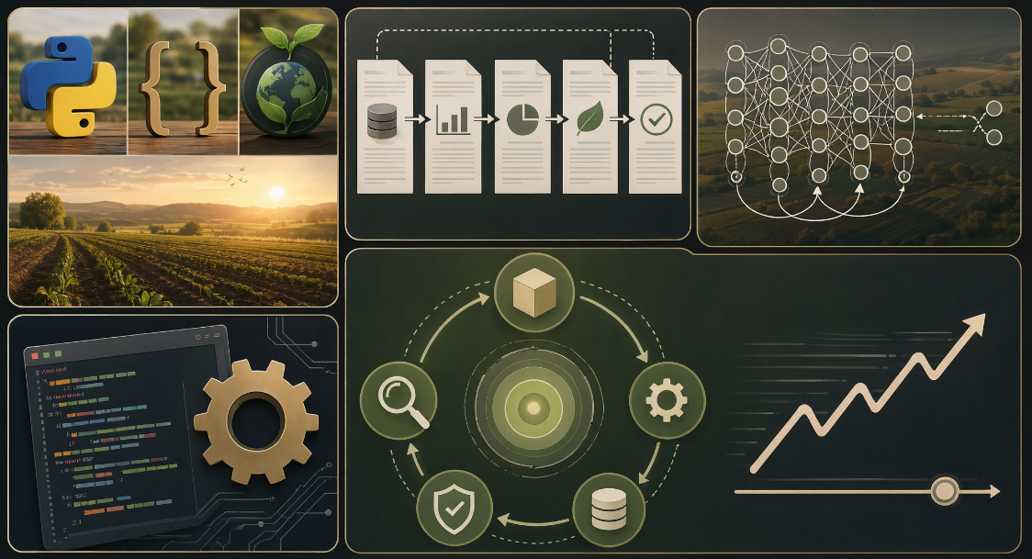
These limitations are documented transparently as part of the design, not hidden, and directly inform the planned improvements

- DATA

  - Training Data Requirements
Three kinds, joined by district/state, year, and growing season: historical crop yield records (to derive the Low/Moderate/High risk label), historical daily weather (rainfall, temperature, humidity, soil moisture) spanning each full growing season, and static soil properties (pH, organic carbon, clay content) for the same locations.

  - Sources of Data
Entirely from free, public, no-registration APIs and open-data portals — India's official agricultural statistics, NASA's satellite/reanalysis weather data, and ISRIC's global soil mapping project. No paid data, no private partnerships, no scraping.
Data Needed | Where did the data came from | Who owns the data? | Do you have permission to use the data | Ethical Considerations
Have | - Crop yield (Area/Production/Yield by district, crop, season, year, 1997–2023)  - Daily weather (rainfall, temperature, humidity, soil moisture, 1997–2023)  - Soil pH, organic carbon, clay% | - Government of India  - NASA / U.S. Government  - ISRIC (Dutch nonprofit soil research institute) | Yes  - GODL-India / NDSAP  - open CC BY 4.0  - CC BY 4.0 attribution required | - Aggregate only, no farmer-level data. Reporting quality varies by state, so accuracy may favor better-resourced states.
Want/Need | - Irrigation access / source (canal, borewell, rainfed) per district  - Crop variety / seed type (HYV vs. traditional) | - ICAR / state governments | Not yet confirmed | - Missing this may misjudge risk for rainfed and smallholder regions.  - Variety access tracks wealth — same equity risk as irrigation.
Nice to have | - Market price data (for economic, not just agronomic, risk)  - Satellite vegetation health (NDVI)  - Current-season / near-real-time weather, for live in-season predictions rather than only historical training | - NASA / U.S. Government  - NASA / ESA  - Government of India | Not yet confirmed | - Price risk ≠ weather risk; must stay a separate factor.  - None significant.  - Live use needs clear accuracy disclaimers.

- PROTOTYPE

  - Prototype Development Tools

- Development environment: Google Colab used for every pipeline script since none of it runs in a sandboxed environment with open internet access.
- Language: Python 3.11 standard library only (json, csv, os, time, math, statistics, urllib, datetime, collections) no external ML or data libraries (no pandas, no numpy, no scikit-learn), by deliberate constraint, since every model component (RNN forward pass, backpropagation through time, optimizer, evaluation metrics) is hand-coded from scratch.
- Data sources accessed via API: NASA POWER Daily Point API (weather), SoilGrids v2.0 REST API (soil properties).
- Data source: India Data Portal’s APY (Area/Production/Yield)

  - Core Technology Stack for the Full Solution

Layer | Technology
Data interchange | JSON
Backend pipeline | Python (standard library only)
Model | Hand-coded vanilla RNN (Elman architecture) manual forward pass, manual backpropagation through time, manual gradient-clipped SGD
External data APIs | NASA POWER (weather), SoilGrids v2.0 (soil)

  - System Outputs and Required Follow-Up Actions

- Outputs produced by the pipeline to date:

- state_crop_season_year_yield.json — cleaned, production-weighted yield per state/crop/season/year
- crop_viability_report.json / crop_shortlist.json — national crop-coverage ranking and the final 21-crop shortlist
- yield_with_risk_labels.json — Low / At-Risk classification labels per record
- rnn_sequences.json — padded weekly weather + static soil sequences, ready for training
- harvestsight_rnn.json — trained model weights, normalization stats, and evaluation metrics

- Required follow-up actions, in priority order:

- Reconcile the RNN training script that produced the best result to date (per-state weather normalization) against the version on record — it hasn’t yet been shared back for review.
- Re-evaluate the model using its best-validation checkpoint rather than final-epoch weights, since the two differ materially in this run.
- Add momentum to the SGD update to stabilize epoch-to-epoch validation performance.
- Build and deliver an inference/prediction script — the pipeline currently stops at a saved model file with no script that loads it to score new input.
- Consider adding solar radiation and evapotranspiration features (available from the same NASA POWER API) to address the feature-set ceiling identified during model evaluation.

- TESTING

  - Prototype Test Participants
# | Role / Background | Domain Familiarity | Technical Proficiency
P1 | Coder | High | High
P2 | Code Tester | Low | Low
P3 | Data Analyst & Researcher | High | Low

  - Observed User Behaviours and Interactions
OBSERVED PARTICIPANT BEHAVIOURAL PROFILES
CODER | CODE TESTER | DATA ANALYST & RESEARCHER
- Audited JSON schema contracts  - Spotted global norm mismatch  - Inspected matrix loop overhead | - Scanned high-contrast colors  - Got stuck on scrolling tables  - Confused by raw z-score values | - Questioned missing crops  - Validated 2-class split  - Flagged irrigation gap
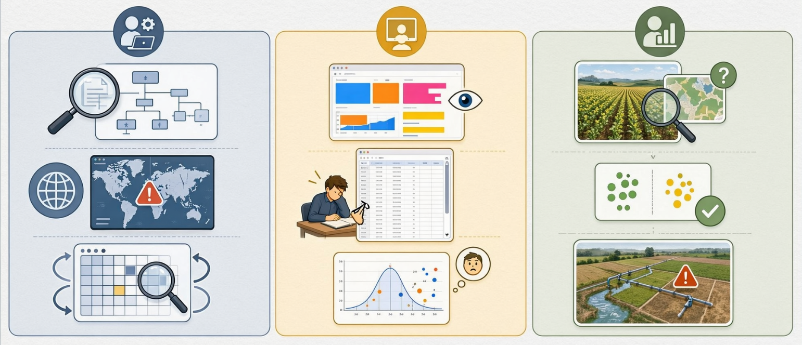

  - User Feedback Grid: Strengths, Changes, Questions and Ideas

USER FEEDBACK GRID
STRENGTHS | CHANGES
- S1: Clean JSON schema design:  Structured, well-defined data formats for system inputs/outputs.  - S2: Binary Low/At-Risk simplicity: Simplified classification model using two clear risk levels instead of complex multi-tier scoring.  - S3: Production-weighted aggregation: Aggregating data based on crop yield/production weight rather than simple geographical averages.  - S4: Strict 21-crop viability cutoff:  Scope bounded specifically to 21 primary crops. | - C1: Implement per-state feature scaling:  Adjusting feature normalization per state to account for regional baseline variations.  - C2: Add search & filter controls:  Enhancing UI navigation to quickly isolate specific crops, regions, or metrics.  - C3: Hide math behind expandable panels:  Keeping the main UI clean for general users while allowing expert inspection on demand.  - C4: Clarify historical scope in banner:  Explicitly stating the time range of historical data directly on the dashboard banner.
QUESTIONS | IDEAS
- Q1: How model handle leap years?  Edge-case handling for 366-day calendar alignments in temporal features.  - Q2: What happens if an API fails? System resilience, fallback mechanisms, and error state handling for external dependencies.  - Q3: Why are some crops are omitted?  Domain justification for excluding high-volume or perennial crop exceptions from the 21-crop subset.  - Q4: Does weather capture irrigation? Addressing potential model bias where precipitation metrics fail to account for irrigated farmland. | - I1: Add SGD momentum parameter: Hyperparameter optimization to accelerate convergence and reduce oscillation during training.  - I2: Build choropleth map view:  Heatmap visualization showing spatial risk distribution.  - I3: Expose SoftMax confidence%: Displaying probability scores alongside the binary classification output to show prediction certainty.  - I4: Year-over-year risk sparklines:  Compact inline trend graphs showing multi-year risk trajectories.

  - Immediate Refinements Based on Testing

IMMEDIATE REFINEMENT MAPPING
REFINEMENT ID | TECHNICAL ACTION TAKEN | PRIMARY SOURCE | STATUS
R1: Scope Notice | Added explicit retrospective banner | Code Tester | COMPLETED
R2: 2-Class Split | Formalized Low vs. At-Risk target | Data Analyst | COMPLETED
R3: Crop Audit | Generated crop_viability_report.json | Data Analyst | COMPLETED

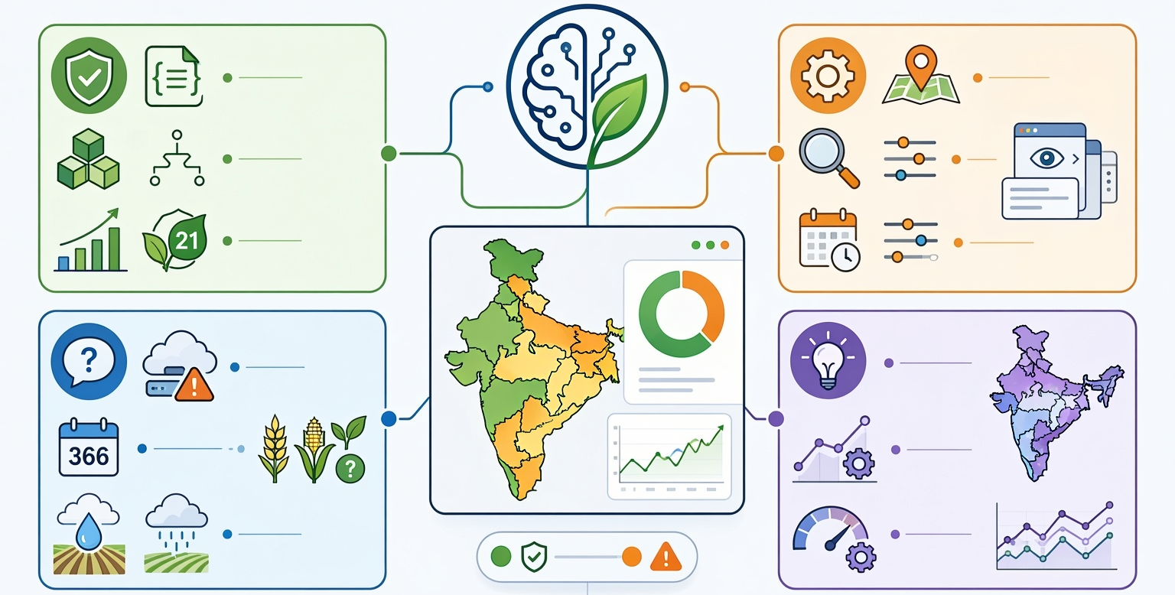
  - Planned Improvements for Future Iterations
FUTURE ITERATION ROADMAP & MILESTONES
- Implement Per-State Weather Normalization & Momentum SGD
- Ingest Additional NASA POWER Features (Solar Radiation, Wind Speed
- Transition from State-Level Points to ~700+ District-Level Centroids
- Expand Historical Coverage Beyond 2020 to Increase Sequence Count
- Integrate Interactive Pan-India Choropleth Geo-JSON Map

- TEAM COLLABORATION

  - Team Collaboration and Stakeholder Engagement

The development of the HarvestSight pipeline required a highly structured approach to technical collaboration, rigorous peer review, and continuous engagement with both domain experts and technical stakeholders. Because the project was constrained to a "from-scratch" pure-Python architecture without third-party machine learning libraries, standardizing the engineering workflow and integrating cross-disciplinary feedback was critical to maintaining methodological integrity.
Stakeholder feedback was not treated as an afterthought but was integrated iteratively throughout the development phases. The primary mechanism for engagement was the Prototype Testing Session detailed in Section 9.
- Iterative Validation: The decision to collapse the risk labels from 3 classes to 2 (Section 9.3, S1) was a direct result of Domain Specialist feedback indicating that "Moderate" risk was not actionable for policy planning.
- Ethical Safeguards: Engagement with the Technical Reviewer highlighted the risk of users misinterpreting historical classification as live prediction. This led to the immediate implementation of the Scope Disclaimer (Section 9.4, R1) to prevent misuse of the tool.
As a project aligned with SDG 2 (Zero Hunger) and SDG 13 (Climate Action), the team adhered to strict ethical guidelines regarding data representation and impact.
- Data Privacy: All yield data was aggregated at the state level; no individual farmer or district-specific private data was exposed or stored in identifiable formats.
- Misinterpretation Risk: The team acknowledged that incorrect risk classification could theoretically influence resource allocation. To mitigate this, the project is explicitly framed as a technical showcase and historical analysis tool, not an operational decision-support system for current-season farming.
- Open Science: In line with SDG principles of knowledge sharing, all intermediate data schemas (crop_viability_report.json, fetch_summary.json) are documented and structured to be reproducible by other researchers, fostering further collaboration in the agricultural AI space.
- INDIVIDUAL TEAM REFLECTIONS

  - Team Reflections

ADITYA MOHAPATRA (CODER & TEAM LEADER):
Leading HarvestSight showed me that building from scratch uncovers problems no ready-made tool ever would. Our biggest takeaway was that clean, well-understood data matters far more than complex code. Choosing to simplify our risk labels and delay the prediction interface taught me that restraint is a strength, not a setback. Maintaining a clean logbook helped us completing this project way before the deadline. I am proud of what our team delivered using real data, honest methods, and no shortcuts.

SATYAM PATHAK (DATA ANALYST & RESEARCHER):
The data itself never caused us trouble, but cleaning it was a job of its own. Turning raw yield records into one tidy, consistent table taught me patience and showed me that most good research happens before any model runs. I now trust a result far more when I know exactly how clean its inputs were.

CHIRANJEEVI NAYAK (CODE TESTER & DEBUGGING):
Testing taught me that a model can fail quietly, so every result needs a check. We hit failed soil downloads, an F1 score that swung wildly between epochs, and validation scores that looked great while test scores sat near chance. Each error sent us back to question our assumptions, and I learned to treat a bug as a clue, not a setback.

ABHAY (DESIGNER & VIDEO EDITOR):
Designing the visuals and editing the video was the calmest part of the project, and I enjoyed it. I learned that a clear, simple visual can explain a complicated result better than pages of text. It was a good reminder that staying relaxed and keeping things clean often makes the final work stronger.

- VIDEO PRESENTATION & LINKS



GITHUB PROJECT:
https://github.com/HypeXBreaker/HarvestSight


VIDEO PRESENTATION:
VIDEO NOT CREATED YET

- BIBLIOGRAPHY & APIs

DATASET RELATED LINKS:
Directorate of Economics and Statistics, Ministry of Agriculture and Farmers Welfare, Government of India. (2023). Crop wise area production yield [Data set]. India Data Portal.
https://ckandev.indiadataportal.com/dataset/area-production-yield-apy/resource/f980409d-49a2-42ae-9eb0-182365005c04

Directorate of Economics and Statistics, Ministry of Agriculture and Farmers Welfare, Government of India. (2023). Crop wise area production yield: Data dictionary (codebook) [Data set documentation]. India Data Portal. https://ckandev.indiadataportal.com/dataset/area-production-yield-apy/resource/f980409d-49a2-42ae-9eb0-182365005c04

Directorate of Economics and Statistics. (n.d.). Crops: Area, production and yield (APY) report [Data extraction page]. Ministry of Agriculture and Farmers Welfare, Government of India.
https://data.desagri.gov.in/website/crops-apy-report-web

NASA Langley Research Center. (n.d.). Prediction of Worldwide Energy Resources (POWER) Project [Data set]. National Aeronautics and Space Administration.
https://power.larc.nasa.gov/

EXTRA LINKS RELATED TO PROJECT:
GitHub Project - https://github.com/HypeXBreaker/HarvestSight
YouTube Link – [NOT YET]

