WEEK 1
Data Cleaning & Preliminary Analysis
Turning raw environmental observations into an analysis-ready dataset

Project detail | Value
Project | New York Air Quality Analysis using R
Dataset | airquality — R datasets package
Prepared by | Internship Project Submission
Study period | May to September 1973

A practical and reproducible study of daily air-quality conditions in New York.

Executive Summary
This week focused on understanding and preparing the New York air-quality dataset before advanced analysis. It contains 153 daily observations and realistic issues such as missing values, extreme readings, different measurement scales, and separate month/day fields. Every decision was coded in R so that the work is transparent and reproducible.
Week 1 outcome: Identified 44 missing cells, zero duplicate rows, and 2 potential ozone outliers; prepared descriptive and complete-case versions.

1. Dataset Selection and Context
The built-in R airquality dataset records ozone concentration, solar radiation, wind speed, and maximum temperature in New York from May to September 1973. Ozone is the main response because high ground-level ozone represents poor air conditions. Temperature, wind, and solar radiation are treated as possible explanatory variables.
Variable | Meaning | Type | Unit
Ozone | Mean ozone concentration | Numeric | ppb
Solar.R | Solar radiation | Numeric | Langleys
Wind | Average wind speed | Numeric | mph
Temp | Maximum temperature | Numeric | °F
Month / Day | Calendar fields | Integer | —

2. Initial Inspection in R
data(airquality)
aq_raw <- airquality
str(aq_raw)
dim(aq_raw)
summary(aq_raw)
colSums(is.na(aq_raw))
sum(duplicated(aq_raw))
Audit item | Verified result
Dimensions | 153 rows × 6 original columns
Missing Ozone | 37
Missing Solar.R | 7
Missing Wind / Temp | 0
Duplicate rows | 0
Complete modeling rows | 111

3. Cleaning Decisions
Issue | Decision and reason
Missing values | Median-impute Ozone and Solar.R for descriptive work; use complete cases for inference so the target is not artificial.
Outliers | IQR fences were -49.9 to 131.1. Keep original readings because extreme pollution days may be genuine.
Date | Combine 1973, Month, and Day into a proper Date field.
Categories | Create readable month labels and Moderate/Warm/Hot temperature bands.
Scaling | Create a temperature z-score for scale-independent comparison.

library(dplyr)
aq_clean <- aq_raw %>% mutate(
Ozone=ifelse(is.na(Ozone),median(Ozone,na.rm=TRUE),Ozone),
Solar.R=ifelse(is.na(Solar.R),median(Solar.R,na.rm=TRUE),Solar.R),
Temp_Z=as.numeric(scale(Temp)),
Temp_Level=cut(Temp,c(-Inf,75,85,Inf),labels=c("Moderate","Warm","Hot")),
Month_Name=factor(Month,5:9,c("May","June","July","August","September")),
Date=as.Date(paste(1973,Month,Day,sep="-")))

4. Preliminary Analysis
Variable | Valid N | Mean | Median | SD | Minimum | Maximum
Ozone | 116 | 42.13 | 31.50 | 32.99 | 1.0 | 168.0
Solar.R | 146 | 185.93 | 205.00 | 90.06 | 7.0 | 334.0
Wind | 153 | 9.96 | 9.70 | 3.52 | 1.7 | 20.7
Temp | 153 | 77.88 | 79.00 | 9.47 | 56 | 97

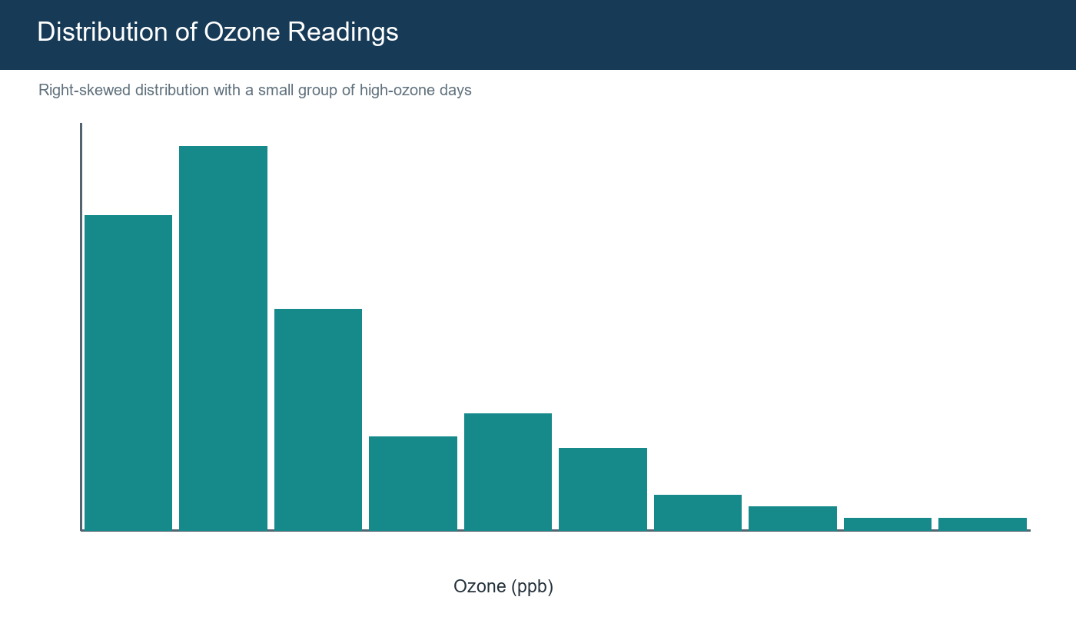
Figure 1. Ozone is right-skewed, supporting a median-based descriptive imputation.
Relationship | Pearson correlation
Ozone–Temperature | 0.699
Ozone–Wind | -0.612
Ozone–Solar radiation | 0.348

The early evidence suggests that hotter days tend to have higher ozone, whereas windier days tend to have lower ozone. These are associations rather than proof of causation, and they provide the questions for later weeks.

5. Challenges and Learning
- Missing outcome values should not automatically be imputed for model evaluation.
- An outlier can be meaningful evidence rather than an error.
- Readable factors and a real date field simplify later charts.
- Reproducible code is safer than manual spreadsheet editing.

6. Conclusion
Week 1 produced a documented, analysis-ready dataset without hiding the limitations of the source. Week 2 uses the same data to communicate patterns through purposeful visualizations.

References
- R Core Team. R: A Language and Environment for Statistical Computing.
- R datasets package. airquality: New York Air Quality Measurements.
- Wickham, H. ggplot2: Elegant Graphics for Data Analysis.
- Rdatasets archive: https://vincentarelbundock.github.io/Rdatasets/

Portal Submission Description (200+ words)
This report presents the first stage of my internship project, focusing on data cleaning, preprocessing, and preliminary analysis using R. I selected the New York air-quality dataset from the standard R datasets package. It contains 153 daily observations collected between May and September 1973 and includes ozone, solar radiation, wind speed, and temperature. I chose it because it combines a meaningful environmental topic with realistic data-quality problems, especially missing values and unusually high ozone readings. The report begins with a structured audit using str(), dim(), summary(), is.na(), and duplicate checks. I document every issue and explain the reasoning behind each cleaning decision in simple language. Missing ozone and solar-radiation values are replaced by their medians only in the descriptive working copy, while complete observations are retained separately for later statistical modeling. Potential outliers are detected through the IQR method. Instead of deleting them, I keep the original measurements because extreme pollution days may be genuine and informative. The report also demonstrates z-score normalization, factor encoding, readable month labels, temperature categories, and creation of a proper date variable. R code, verified output tables, descriptive statistics, correlation results, and a visual of the ozone distribution are included. The main preliminary finding is that ozone is positively associated with temperature and negatively associated with wind. Overall, the report creates a transparent, reproducible foundation for the visualization and predictive modeling completed in the following weeks.
Use: Copy this section into the portal description field while uploading this Word file.

