WEEK 2
Data Visualization & Insight Communication
Explaining environmental patterns through purposeful charts

Project detail | Value
Project | New York Air Quality Analysis using R
Dataset | airquality — R datasets package
Prepared by | Internship Project Submission
Study period | May to September 1973

A practical and reproducible study of daily air-quality conditions in New York.

Executive Summary
This report turns the cleaned measurements into a visual story. Each graph answers one question: how ozone is distributed, how it relates to temperature, when monthly levels are highest, and how readings change day by day. The design uses consistent colors, honest scales, clear units, and short interpretations for a non-technical reader.

1. Data Preparation and Theme
library(dplyr)
library(ggplot2)
aq_viz <- airquality %>% mutate(
Date=as.Date(paste(1973,Month,Day,sep="-")),
Month_Name=factor(Month,5:9,c("May","June","July","August","September")))
theme_set(theme_minimal(base_size=12))
Design choice: Blue and teal show the data; gold is reserved for trend emphasis. Titles communicate the point rather than only naming the chart type.

2. Ozone Distribution
ggplot(aq_viz,aes(Ozone)) +
geom_histogram(bins=10,fill="#168A8A",color="white",na.rm=TRUE) +
labs(title="Distribution of Ozone Readings",x="Ozone (ppb)",y="Frequency")
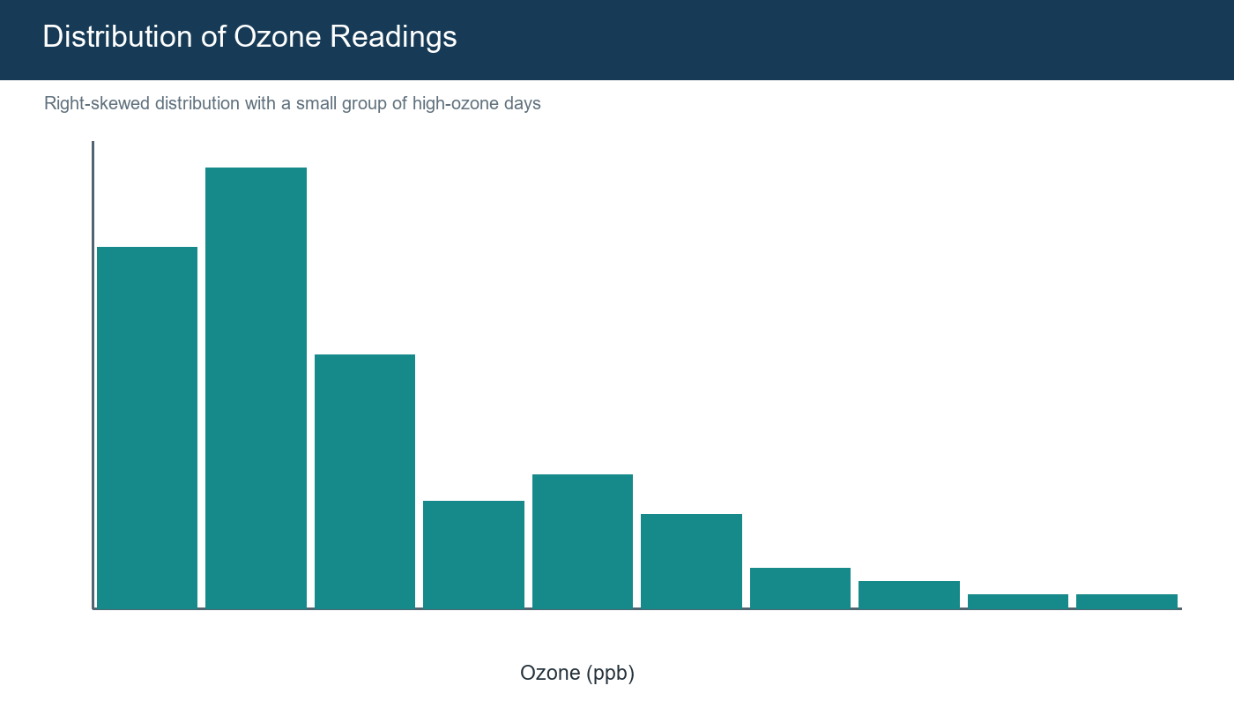
Figure 1. Most readings are low to moderate, with a longer high-value tail.
A histogram is appropriate because the question concerns the frequency and shape of one continuous variable. The skew also explains why median imputation was selected in Week 1.

3. Temperature and Ozone
ggplot(aq_viz,aes(Temp,Ozone)) +
geom_point(color="#168A8A",alpha=.75,na.rm=TRUE) +
geom_smooth(method="lm",se=FALSE,color="#E6A23C",na.rm=TRUE) +
labs(title="Temperature and Ozone Move Together",x="Temperature (°F)",y="Ozone (ppb)")
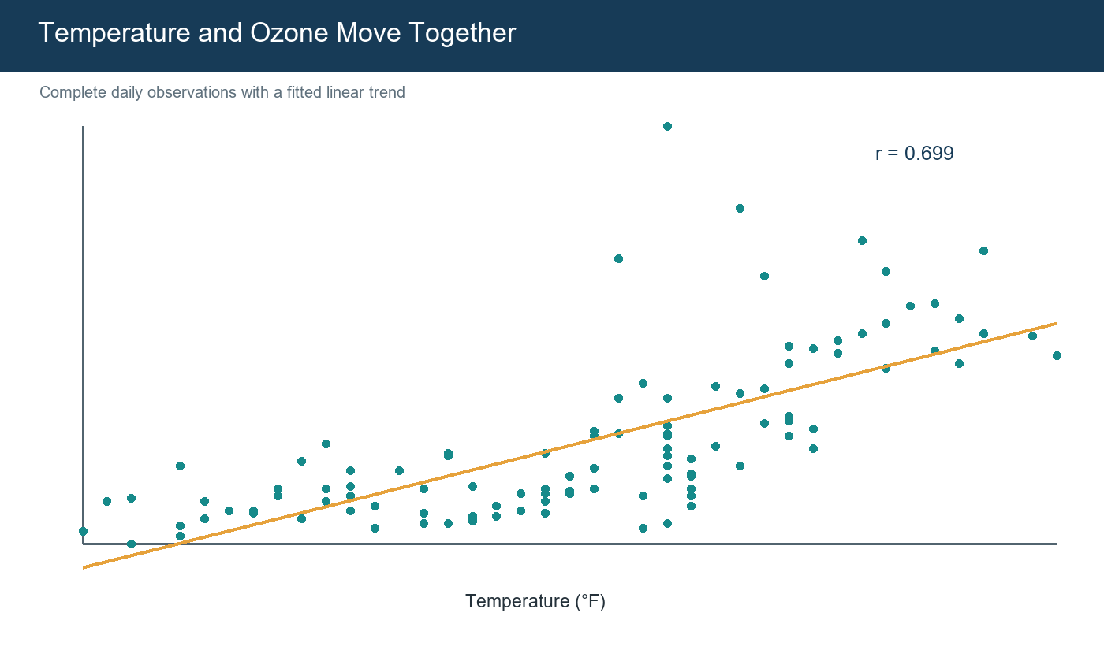
Figure 2. Scatter plot with fitted trend; complete-case correlation appears in the corner.
The upward pattern and r = 0.699 indicate a strong positive association. The remaining vertical spread shows that temperature alone cannot explain every high-ozone day.

4. Monthly Comparison
monthly <- aq_viz %>% group_by(Month_Name) %>%
summarise(Mean_Ozone=mean(Ozone,na.rm=TRUE))
ggplot(monthly,aes(Month_Name,Mean_Ozone)) +
geom_col(fill="#173B57") + geom_text(aes(label=round(Mean_Ozone,1)),vjust=-.4)
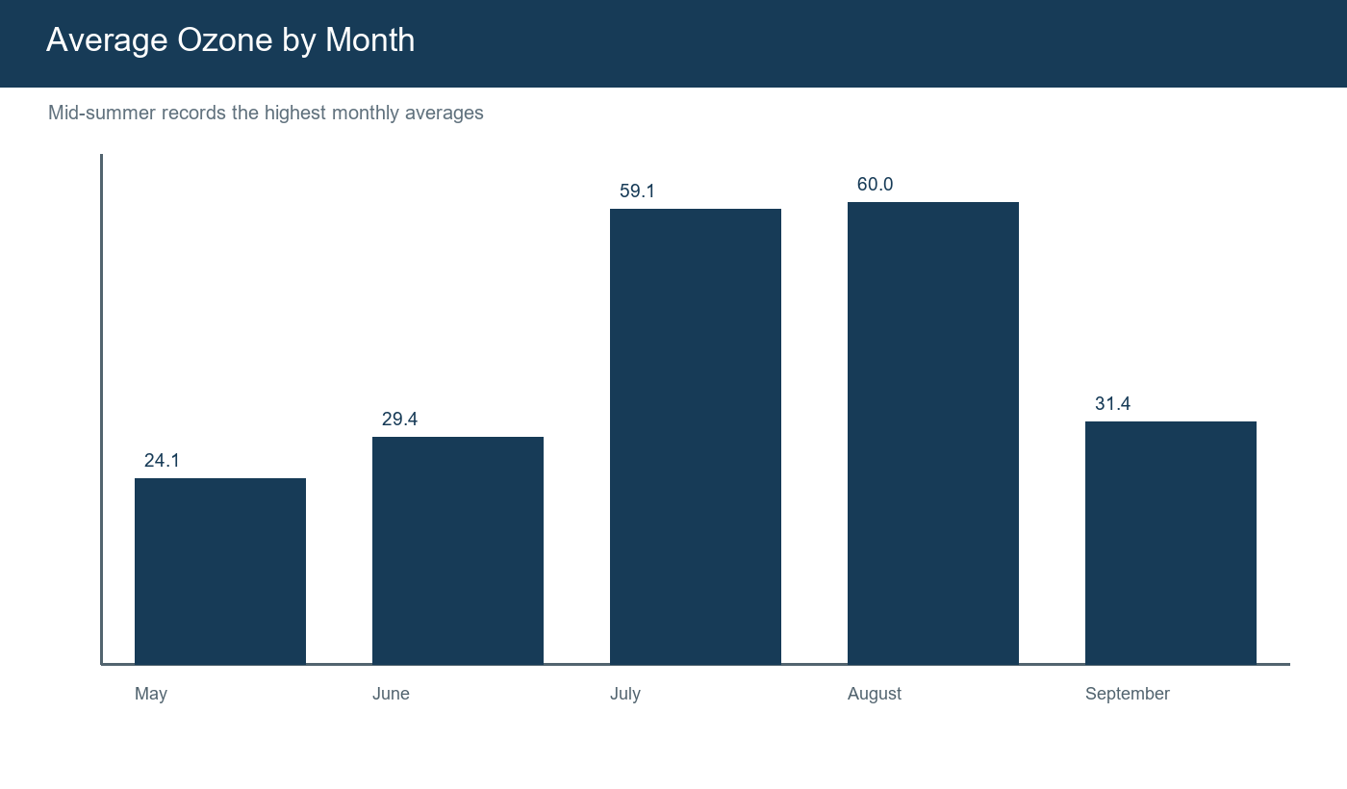
Figure 3. Monthly averages show a clear mid-summer peak.
The bars begin at zero, avoiding exaggerated differences. Exact labels allow both a visual and numerical comparison.

5. Daily Pattern
ggplot(aq_viz,aes(Date,Ozone)) +
geom_line(color="#168A8A",na.rm=TRUE) +
geom_point(color="#173B57",size=1.2,na.rm=TRUE)
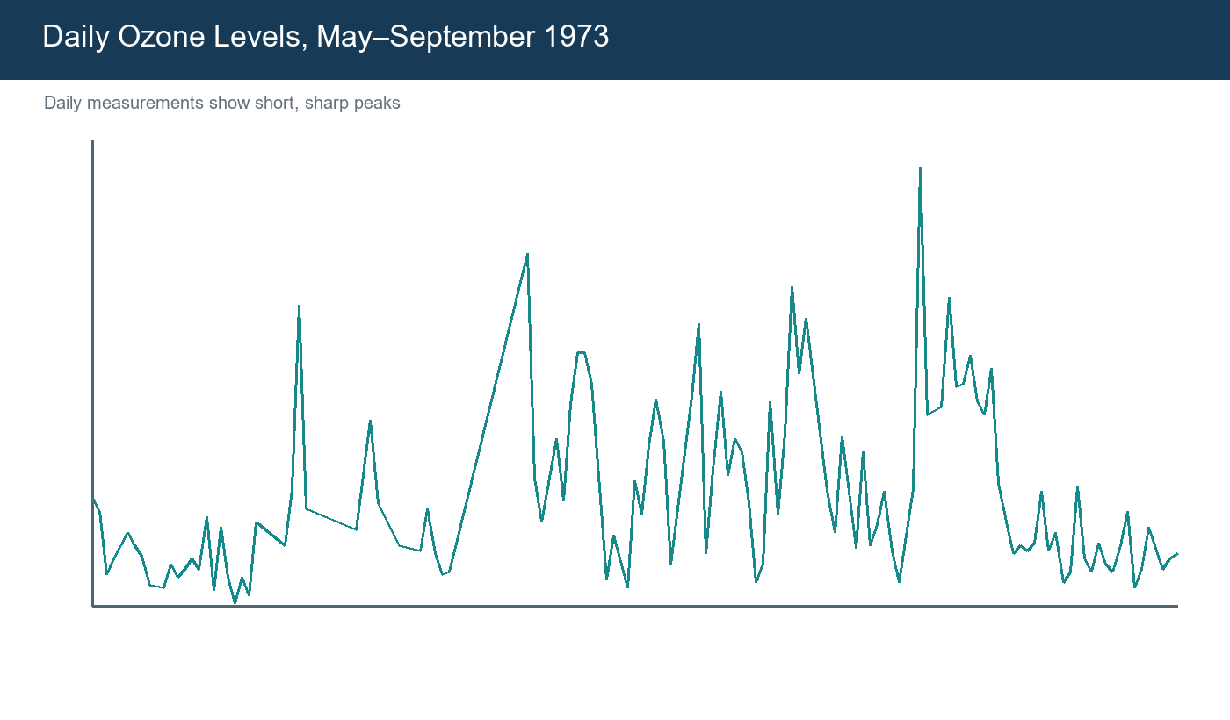
Figure 4. Daily readings reveal short peaks that monthly averages can hide.
The time view adds an important warning: the season does not change smoothly. Missing readings remain visible instead of being silently treated as measured values.

6. Communication Principles
Principle | Application
One question per chart | Each visual has one analytical purpose.
Honest scales | Bar chart starts at zero and units are shown.
Consistent design | A restrained palette is used throughout.
Visible uncertainty | Scatter and daily variation are not hidden.
Plain-language interpretation | Every chart is followed by a short takeaway.

7. Key Insights
- Ozone has a right-skewed distribution with several very high days.
- Temperature and ozone have a strong positive association (r = 0.699).
- July and August form the high-ozone part of the study period.
- Daily volatility shows why averages should not be viewed alone.
- The visuals support using temperature, wind, and solar radiation in Week 3.

8. Conclusion
The visual analysis creates a connected story rather than a collection of unrelated charts. It shows meaningful seasonal and weather relationships while preserving variation and uncertainty.

References
- R Core Team. R: A Language and Environment for Statistical Computing.
- R datasets package. airquality: New York Air Quality Measurements.
- Wickham, H. ggplot2: Elegant Graphics for Data Analysis.
- Rdatasets archive: https://vincentarelbundock.github.io/Rdatasets/

Portal Submission Description (200+ words)
This Week 2 report continues my New York air-quality internship project and focuses on data visualization and communication using R. I used the cleaned dataset prepared in Week 1 and designed visualizations that answer practical questions instead of adding charts without a clear purpose. The report includes a histogram, a scatter plot with a fitted linear trend, a monthly bar chart, and a daily time-series chart. Every graph is supported by reproducible ggplot2 code, clear titles, labeled axes, and a plain-language interpretation. The histogram explains the right-skewed ozone distribution and supports the earlier choice of median-based treatment for descriptive missing values. The temperature-versus-ozone scatter plot shows a strong positive association, with a complete-case correlation of approximately 0.70, while the spread of points makes it clear that temperature does not explain every high-ozone day. The monthly chart highlights the mid-summer peak, especially around July and August. The daily time-series view reveals short spikes and variation that would be hidden by monthly averages. I used a consistent blue, teal, and gold visual theme and avoided unnecessary decorative elements so the charts remain professional and readable. I also explain why each chart type was selected and how zero-based bar scales, visible units, consistent colors, and concise captions support honest communication. Overall, the report demonstrates how carefully designed R graphics can translate technical environmental measurements into a meaningful narrative for technical as well as non-technical readers.
Use: Copy this section into the portal description field while uploading this Word file.

